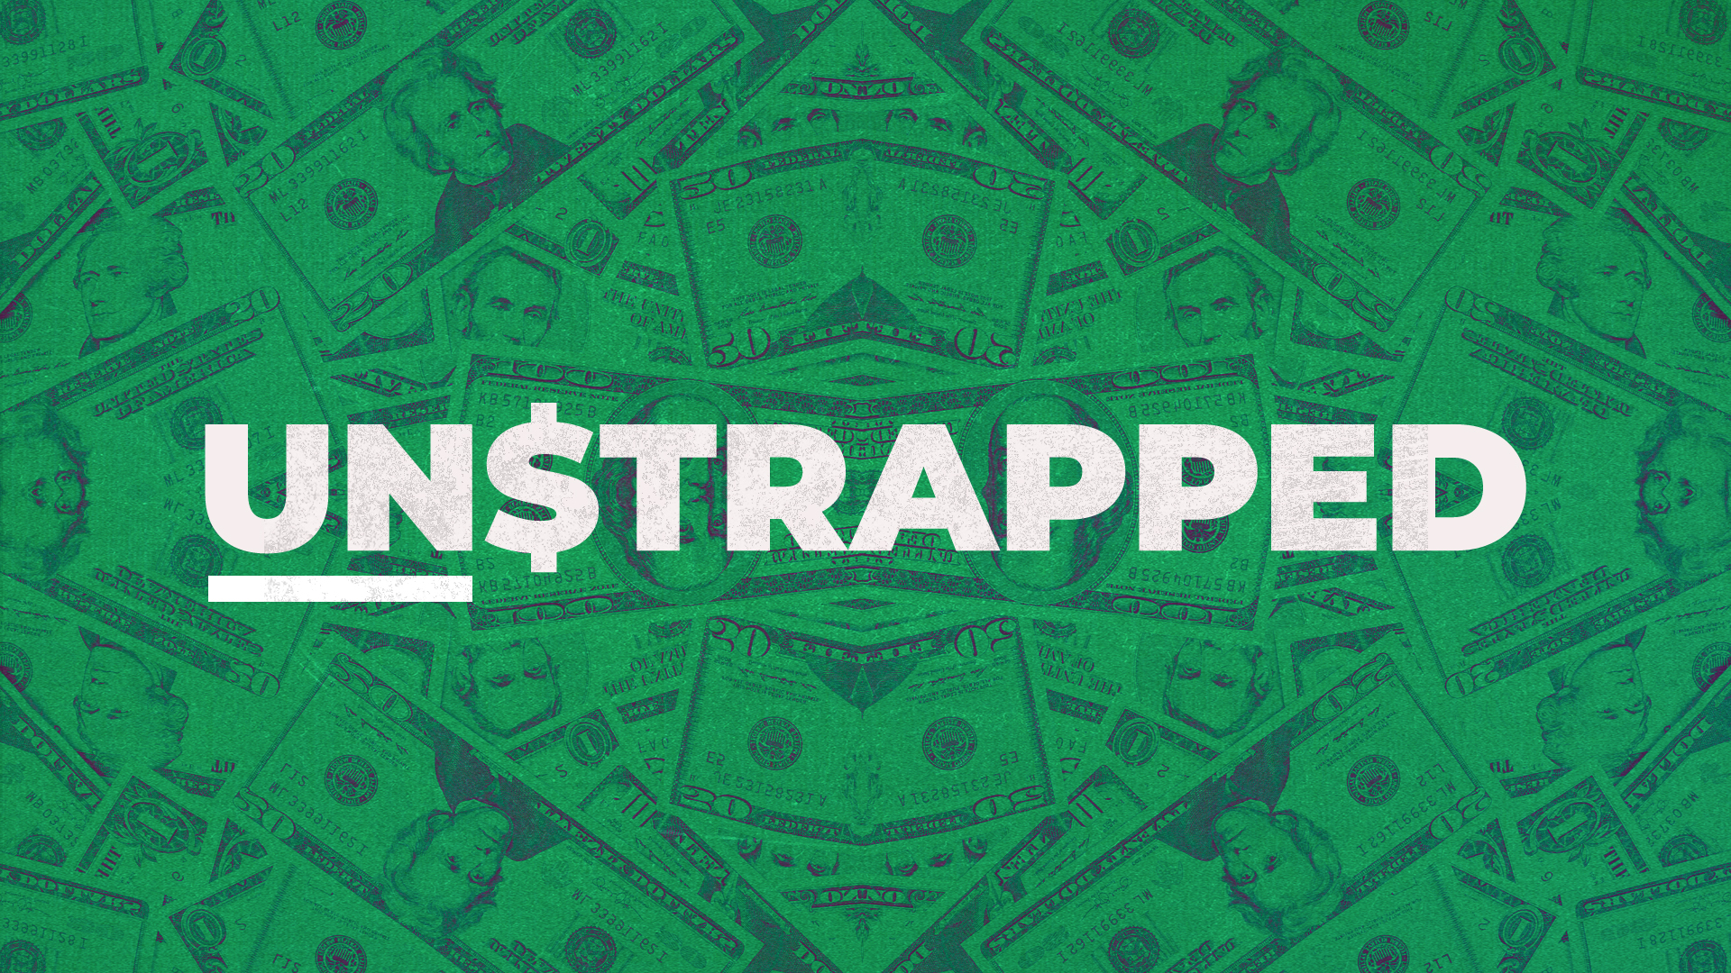

April 3, 2022

Matthew 5:42 - Give to those who ask, and don’t turn away from those who want to borrow. (NLT)

Learning #1: Debt is not painted in the best light in the bible.

Proverbs 22:7 - The rich rule over the poor, and the borrower is slave to the lender. (NIV)

Proverbs 21:17 -Those who love pleasure become poor; those who love wine and luxury will never be rich. (NLT)

Learning #2: We are constantly sold discontentment and instant gratification.

Luke 16:11 - And if you are untrustworthy about worldly wealth, who will trust you with the true riches of heaven? (NLT)

Psalm 37:21 - The wicked borrow and never repay, but the godly are generous givers. (NLT)

Proverbs 27:1 - Don’t brag about tomorrow, since you don’t know what the day will bring. (NLT)

Proverbs 24:3 - A house is built by wisdom and becomes strong through good sense. (NLT)

Learning #3: We need to come face to face with the reality of our finances.

Proverbs 18:13 - Spouting off before listening to the facts is both shameful and foolish. (NLT)

Learning #4: A budget is a tool we use to exercise control over our spending.

Proverbs 21:5 - Good planning and hard work lead to prosperity, but hasty shortcuts lead to poverty. (NLT)

Proverbs 21:20 - There is treasure to be desired and oil in the dwelling of the wise; but a foolish man spendeth it up. (KJV)

Learning #5: Disciplined savings each month will add up very quickly.

Proverbs 22:3 - A prudent person foresees danger and takes precautions. The simpleton goes blindly on and suffers the consequences. (NLT)

Genesis 41:55 - Eventually, however, the famine spread throughout the land of Egypt as well. And when the people cried out to Pharaoh for food, he told them, “Go to Joseph, and do whatever he tells you.” (NLT)

Learning #6: Live on less than you make.

