The “Three Circles” Evangelism Tool

Why do we share the Gospel?
So then, if anyone is in Christ, he is a new creation; what is old has passed away—look, what is new has come! And all these things are from God who reconciled us to himself through Christ, and who has given us the ministry of reconciliation. In other words, in Christ God was reconciling the world to himself, not counting people’s trespasses against them, and he has given us the message of reconciliation. Therefore, we are ambassadors for Christ, as though God were making His plea through us. We plead with you on Christ’s behalf, “Be reconciled to God!” (2 Corinthians 5:17-20 NET)

Our Identity (Command #1):
- We are New Creations
- We are Ambassadors for Christ

With whom do we share?
The jailer called for lights, rushed in and fell trembling before Paul and Silas. He then brought them out and asked, “Sirs, what must I do to be saved?”
They replied, “Believe in the Lord Jesus, and you will be saved—you and your household.” Then they spoke the word of the Lord to him and to all the others in his house. At that hour of the night the jailer took them and washed their wounds; then immediately he and all his household were baptized. The jailer brought them into his house and set a meal before them; he was filled with joy because he had come to believe in God—he and his whole household. (Acts 16:25-34)
My Household – Greek: Oikos: My Oikos Map:
Close family
ME
Extended family
Friends
Co-Workers
Service Professionals
Anyone God guides us to

Am I praying regularly for the people in my Oikos?
Suggestion: set a daily alarm as a reminder to pray.

How do we get started sharing?
3 (& ½) Kick-Off Questions:
1) Is there anything that I can pray about for you?
2a) Have you every wondered why these problems seem to happen so often?
Or
2b) May I ask you, do you feel like you are close to God or far away from Him?
2c) Has anyone ever shared the Gospel with you?
3) May I share a quick illustration that explains…?

What do we share?
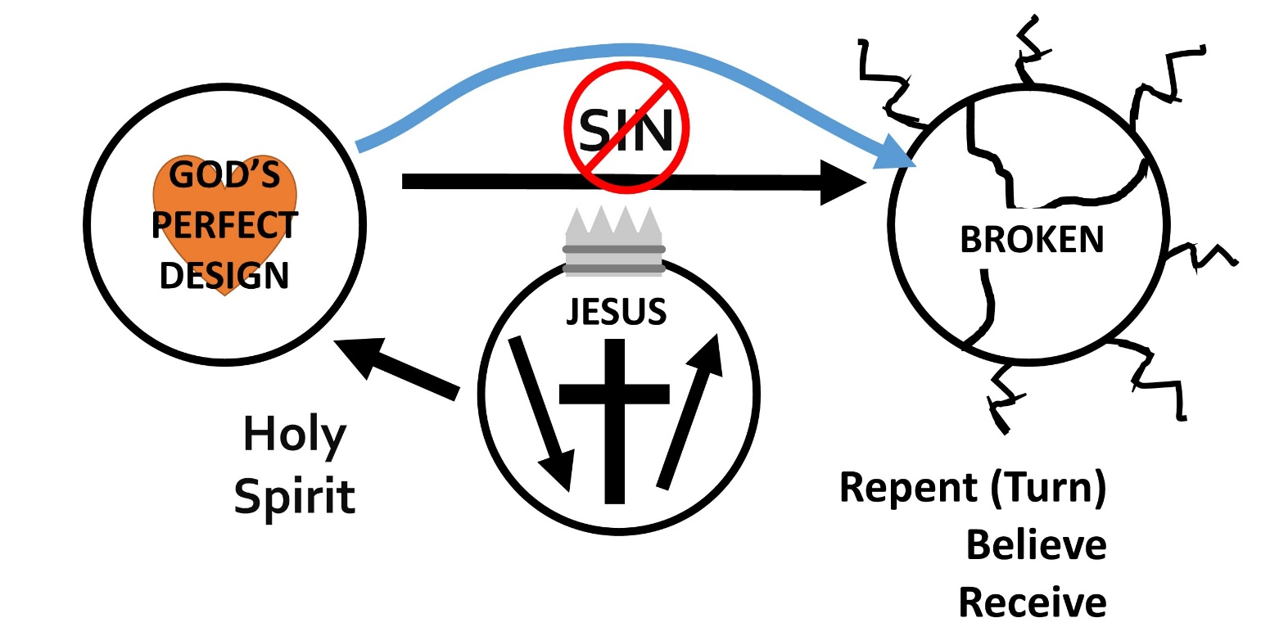
- Draw top right circle; discuss we are living in a broken world.
- Draw to left circle: brokenness was not God’s design: He wanted man to live in a dependent love relationship with Him.
- Man rebelled, disobeyed and sin entered the world; write sin, draw arrow.
- We sense this separation and brokenness and try to fix it with all sorts of efforts, money, power, recreation, sex, drugs and even spirituality. All fall short.
- God was not content to leave us like this because He loves us. Draw third circle. He sent His One and only Son into the world; write Jesus, draw arrow down. Jesus was God, underline God.
- He lived a perfect life according to God’s design, underline each. And then he allowed Himself to be crucified to fix our sin problem and brokenness and to restore our relationship with God. Draw cross. He rose from the grave on the third day to prove that he has power over sin and death.
- We must respond by repenting (turning) from trying to solve the problem of sin and brokenness on our own. Believe that Jesus died and rose again to pay for our sins. And to receive Him as the Lord of our lives (draw crown).
- When we do this we are given the Holy Spirit to understand the things of God and to empower us to live in God’s perfect design as He intends. We are to then continue to grow and to go back into the broken world to tell others this good news.

Three Possible Responses (plus one):
When they heard about the resurrection of the dead, some of them sneered, but others said, "We want to hear you again on this subject." That ended Paul’s discussion with them, but a few men became followers of Paul and believed. (Acts 17:32-34)

Some sneered – Red light Lovingly move on

We would hear more – Yellow light Keep walking with them
share more about Jesus

Some Believe – Green light Teach Command #1

What if by their answer you learn they are already a Believer?
Show them the “Three Circles” and encourage them get to “on mission”

