August 9, 2020 Compassionate Living in Turbulent Times
Part 11… Ministry of Reconciliation
The Grace Connection

Remember Our Calling, Our Task
2 Corinthians 5:14,18 … For Christ’s love compels us, and has given us the MINISTRY OF RECONCILIATION… And He has committed to us the MESSAGE OF RECONCILIATION.
WE ARE AMBASSADORS FOR CHRIST!

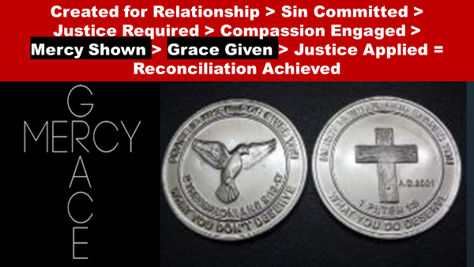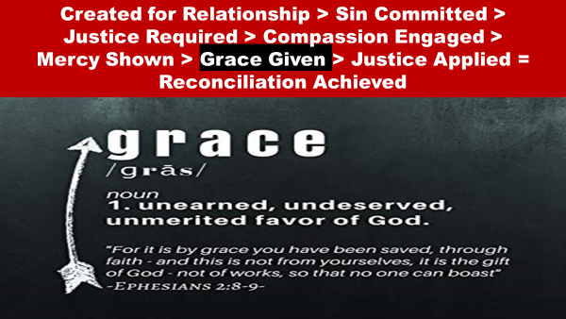

“An accurate, common definition describes grace as the unmerited favor of God toward man. In the Old Testament, the term that most often is translated "grace" is chen; The word chen occurs around sixty times in the Old Testament. There are examples of man's favor to man, but the theological concept of importance to us is the grace of God demonstrated toward man. The term occurs most often in the phrase favor "in your (i.e., God's) sight" or "in the eyes of the Lord." This assumes the notion of God as a watchful master or king, with the one who is finding favor, a servant, an employee, or perhaps a soldier.
The concept first occurs in Genesis 6:8. Noah finds "favor in the eyes of the Lord."
The context is Genesis 6:5…that the Lord was grieved at "how great man's wickedness on the earth had become" https://www.biblestudytools.com/dictionary/grace/

The New Testament uses the word ‘charis’ 156 times in NT
blessing 1, concession 1, credit 3, favor 11, gift 1, grace 122, gracious 2, gracious work 3, gratitude 1, thank 3, thankfulness 2, thanks 6

“Grace is a terribly misunderstood word. Defining it succinctly is notoriously difficult. Some of the most detailed theology textbooks do not offer any concise definition of the term. Someone has proposed an acronym: GRACE is God's Riches At Christ's Expense. That's not a bad way to characterize grace, but it is not a sufficient theological definition.
One of the best-known definitions of grace is only three words: God's unmerited favor. A. W. Tozer expanded on that: "Grace is the good pleasure of God that inclines him to bestow benefits on the undeserving." Berkhof is more to the point: grace is "the unmerited operation of God in the heart of man, effected through the agency of the Holy Spirit."
Grace is not merely unmerited favor; it is favor bestowed on sinners who deserve wrath. Showing kindness to a stranger is "unmerited favor"; doing good to one's enemies is more the spirit of grace. Grace is not a one-time event in the Christian experience. We stand in grace (Romans 5:2). The entire Christian life is driven and empowered by grace: "It is good for the heart to be strengthened by grace, not by foods" (Hebrews 13:9). Peter said we should "grow in the grace and knowledge of our Lord and Savior Jesus Christ" (2 Peter 3:18).
Thus we could properly define grace as the free and benevolent influence of a holy God operating sovereignly in the lives of undeserving sinners.https://www.oneplace.com/ministries/grace-to-you/read/articles/what-is-grace-10339.html

Why Do We Grace?
We need grace because of guilt
Our Accuser = Satan
Our Advocate = Jesus

Grace is a Key Step in the Reconciliation Process

Created for Relationship > Sin Committed > Justice Required > Compassion Engaged>
Mercy Shown> Grace Given > Justice Applied (based on faith response)=
Reconciliation Achieved

THE BENEFITS OF GRACE
We are...
Saved by grace Eph. 2:8-9
Forgiven by grace Isa. 43:25
Sustained by grace Phil. 2:13 (when tempted, when tired, when troubled)
Healed by grace Ps. 147:3
Liberated by grace Mt. 11:28-30
Given talents by grace Rom. 12:6
Minister and Serve by grace Eph. 3:7
Kept saved by grace Jude 1:24
Transformed by grace Rom. 12:2
Matured by grace 2 Peter 3:18

A Portrait of Grace
The Parable of the Prodigal/Lost Son

Luke 15:11-32…11 And Jesus said, “There was a man who had two sons. 12 And the younger of them said to his father, ‘Father, give me the share of property that is coming to me.’ And he divided his property between them. 13 Not many days later, the younger son gathered all he had and took a journey into a far country, and there he squandered his property in reckless living. 14 And when he had spent everything, a severe famine arose in that country, and he began to be in need. 15 So he went and hired himself out to one of the citizens of that country, who sent him into his fields to feed pigs. 16 And he was longing to be fed with the pods that the pigs ate, and no one gave him anything. 17 “But when he came to himself, he said, ‘How many of my father's hired servants have more than enough bread, but I perish here with hunger! 18 I will arise and go to my father, and I will say to him, “Father, I have sinned against heaven and before you. 19 I am no longer worthy to be called your son. Treat me as one of your hired servants.”’ 20 And he arose and came to his father. But while he was still a long way off, his father saw him and felt compassion, and ran and embraced him and kissed him. 21 And the son said to him, ‘Father, I have sinned against heaven and before you. I am no longer worthy to be called your son.’ 22 But the father said to his servants, ‘Bring quickly the best robe, and put it on him, and put a ring on his hand, and shoes on his feet. 23 And bring the fattened calf and kill it, and let us eat and celebrate. 24 For this my son was dead, and is alive again; he was lost, and is found.’ And they began to celebrate. 25 “Now his older son was in the field, and as he came and drew near to the house, he heard music and dancing. 26 And he called one of the servants and asked what these things meant. 27 And he said to him, ‘Your brother has come, and your father has killed the fattened calf, because he has received him back safe and sound.’ 28 But he was angry and refused to go in. His father came out and entreated him, 29 but he answered his father, ‘Look, these many years I have served you, and I never disobeyed your command, yet you never gave me a young goat, that I might celebrate with my friends. 30 But when this son of yours came, who has devoured your property with prostitutes, you killed the fattened calf for him!’ 31 And he said to him, ‘Son, you are always with me, and all that is mine is yours. 32 It was fitting to celebrate and be glad, for this your brother was dead, and is alive; he was lost, and is found.’”

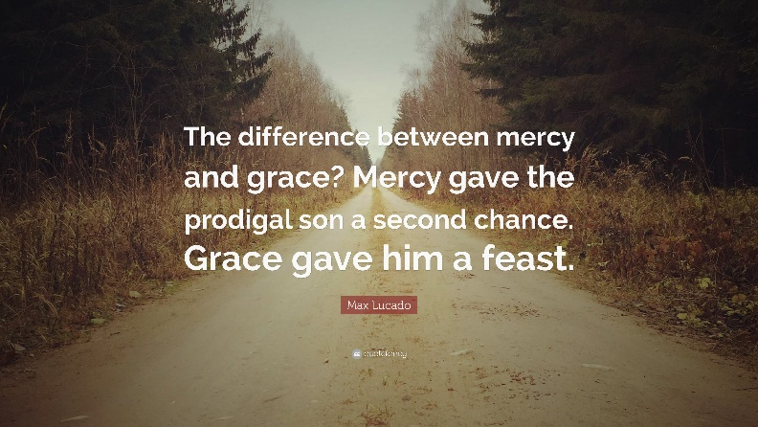

This parable is set in the teaching series along with the Parable of the Lost Sheep, and the Lost Coin.

The key point of these three parables is that Jesus cares about people, people who are lost and need to be found, reunited, or Reconciled back to God. Since God cares about the lost being reconciled back to Him, so should we!

- The Main Character in the Story is not the Prodigal, but the Father.
- God, Our Heavenly Father loves us dearly as His children
- We like the prodigal son, are self-centered and have walked away from God (sin)
- There are Consequences to our sinful actions (The grass is not greener on the other side)
- We must come to a realization that we have sinned and humbly turn to God
- God, Who is a God of Mercy, Grace and Forgiveness Seeks Genuine Reconciliation
- Some People Will Not See The Joy in the reconciliation of Others

