Sunday, May 12, 2204
Mother’s Day
Today we celebrate Mother’s in particular, but all women in general. Throughout the ages it has always been a challenge to be a woman, but even more in recent years with so many expectations. It can be tempting to become overwhelmed and discouraged when you try and meet all the expectations and responsibilities. My hope and aim today is to encourage, uplift, motivate as well as challenge women to rise and meet the call to be a Virtuous, Noble and Capable woman, as see in Proverbs 31.
So, take your bibles and turn to Proverbs 31 as we look into the classic passage concerning women. Before I read it, I want to remind all you ladies that this is not a mandatory checklist that you have to attain and match every characteristic. It is simply a beautiful guide to challenge and give a role model to emulate. This Proverb is probably over 3000 years old and seems to have been written by King Lemuel (some say a pen name for Solomon) based on the advice and guidance of his mother. So, ladies this is advice from a godly, virtuous woman who is seeking to guide her son in making a wise choice for a wife. But it is just as valid as a guide for all women to study and seek to emulate in order to be a Virtuous, Noble & Capable Woman for God.
Now, before I read the passage let me read this humorous poem by an anonymous lady who must have been struggling with the high and lofty ideals of Proverbs 31…
I Wish I Were A Bear
If you're a bear, you get to hibernate.
You do nothing but sleep for six months.
I could get used to that.
And another thing: before you hibernate,
You're supposed to eat and stuff yourself full .
That wouldn't bother me either.
If you're a mama bear, everyone knows you mean business; You swat anyone who bothers you or your cubs. If your cubs get out of line, you swat them, too.
Your husband expects you to growl when you wake up. He expects you to have hairy legs and excess body fat. He likes it! I wish I were a bear.

Well, you may sometimes feel overwhelmed as this lady did, but have no fear, with God’s help you can rise up to meet the challenge to be a Virtuous and Noble Woman…this generation and the ones to come desperately need the influence of godly women in order to have a bright and victorious future…

Proverbs 31:10-31…¹⁰ Who can find a capable woman? She is far more precious than jewels. ¹¹ The heart of her husband trusts in her, and he will not lack anything good. ¹² She rewards him with good, not evil, all the days of her life. ¹³ She selects wool and flax and works with willing hands. ¹⁴ She is like the merchant ships, bringing her food from far away. ¹⁵ She rises while it is still night and provides food for her household and portions for her female servants.
¹⁶ She evaluates a field and buys it; she plants a vineyard with her earnings. ¹⁷ She draws on her strength and reveals that her arms are strong. ¹⁸ She sees that her profits are good, and her lamp never goes out at night. ¹⁹ She extends her hands to the spinning staff, and her hands hold the spindle. ²⁰ Her hands reach^{[n]} out to the poor, and she extends her hands to the needy. ²¹ She is not afraid for her household when it snows, for all in her household are doubly clothed .²² She makes her own bed coverings; her clothing is fine linen and purple. ²³ Her husband is known at the city gates, where he sits among the elders of the land. ²⁴ She makes and sells linen garments; she delivers belts to the merchants. ²⁵ Strength and honor are her clothing, and she can laugh at the time to come. ²⁶ She opens her mouth with wisdom and loving instruction is on her tongue. ²⁷ She watches over the activities of her household and is never idle. ²⁸ Her children rise up and call her blessed. Her husband also praises her: ²⁹ “Many women are capable, but you surpass them all!” ³⁰ Charm is deceptive and beauty is fleeting, but a woman who fears the Lord will be praised. ³¹ Give her the reward of her labor, and let her works praise her at the city gates.
Before I address what Mother’s, Wives and women are encouraged to be and do, let’s make sure that we (all others who are not mothers) know how to show respect and to respond properly to the women in our lives. Let’s start at the end and then work our way back to the beginning:
Proverbs 31:30,31…³⁰ Charm is deceptive and beauty is fleeting, but a woman who fears the Lord will be praised. ³¹ Give her the reward of her labor, and let her works praise her at the city gates.
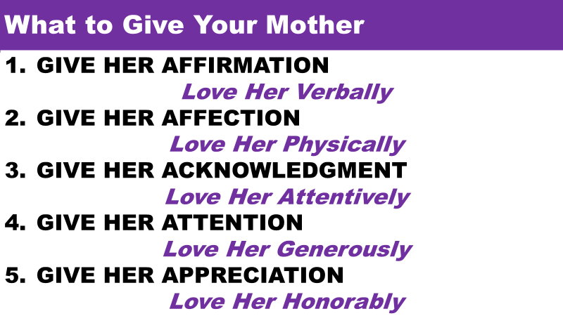
Now let us address the most precious things we can pass down to children (and our families & friends) That is our faith--the confident conviction that God is who He says and will do all He has promised. Here are ways to hand down a rich legacy to the next generation. (or to help them in Imagining a Bright Future)

- Model Godly Character through Lifestyle.
Our character should be a model to the people around us: virtuous, trustworthy, handles difficulty with grace,

Proverbs 31:10-12…¹⁰ Who can find a capable woman? She is far more precious than jewels. ¹¹ The heart of her husband trusts in her, and he will not lack anything good. ¹² She rewards him with good, not evil, all the days of her life.
Actions show that our faith is real (James 2:26).

- Provide and Care for Loved Ones & Strangers

¹⁵ She rises while it is still night and provides food for her household and portions for her female servants….²⁰ Her hands reach out to the poor, and she extends her hands to the needy. ²¹ She is not afraid for her household when it snows, for all in her household are doubly clothed…²⁸ Her children rise up and call her blessed. Her husband also praises her: ²⁹ “Many women are capable, but you surpass them all!”

We must be selfless, sacrificial, servant-hearted with fairness and equity to all.
- Teach Practical Biblical Principles.
²⁶ She opens her mouth with wisdom and loving instruction is on her tongue. ²⁷ She watches over the activities of her household and is never idle.
We need to know God's views on relationships, material wealth (Ps. 24:1), meeting needs (Phil. 4:19), and direction in life (Prov. 3:5-6). We must guide with gentleness and Godly wisdom.

- Bring Glory to God in All That You Do
³⁰ Charm is deceptive and beauty is fleeting, but a woman who fears (brings glory) the Lord will be praised.
If we do these four things we can help our children, our families, our friends, and a desperate world come to the point where they can not only ‘Imagine a Bright Future” but navigate and experience a bright future. Let’s all take a lesson from the Proverbs 31 woman and model our lives after this. Of course, it starts with placing your faith in God through the Lord Jesus Christ. If you are not sure of your salvation, today is the day for you to become an Authentic and Genuine Follower of Jesus Christ!
INVITATION

