The Most Important Question:

May I share…

…my story with you?

…what I’ve found to be true?

…what the Bible says about that?

If “Yes” - they’ve just invited you to share the Gospel

If “No” - Respect their wishes and wait
Let them decide and don’t push. Seeds have been planted for future conversations.

The 2-Verse Bridge Illustration
There’s a diagram that helps clarify the central message of the Bible. May I share it with you?
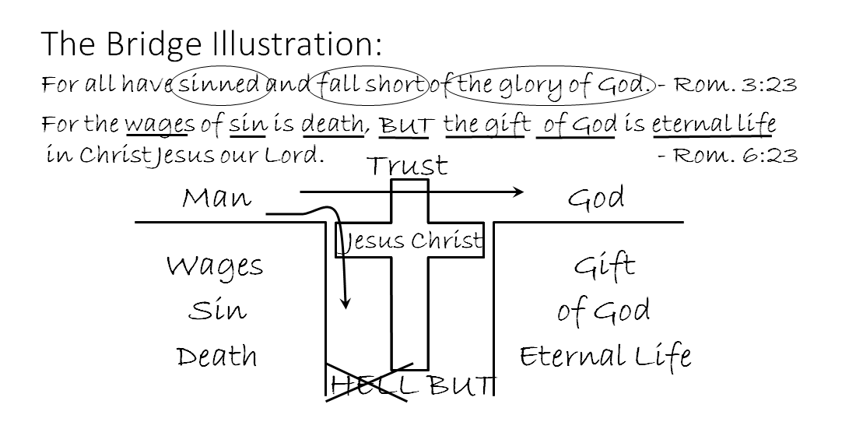
The Important Things to Share When Using the Bridge Illustration:
Write God on Right side of paper.
Say: The Bible teaches that there is a loving God who created mankind.
Write Man on Left side of paper
Say: But God is also righteous and holy and He created us free to either love Him in return or reject Him.
That rejection is the worst of what the Bible calls sin. Loving God with all your heart, mind, soul and strength is the greatest commandment in the Bible according to Jesus. And nobody does that...that’s why the Bible says:
Write Romans 3:23 at the top of the paper
Every single person has failed to meet God’s standards
Circle sinned
We’ve sinned because to one degree or another we have chosen to love and serve ourselves instead of loving and serving Him
Most people sense this and try to do things to please Him. But God’s standard is perfect love and obedience at all times - anything less is sin.
And the problem is: our sin separates us from God; draw lines for pit
circle fall short – draw arrow into pit
We fall short of God’s love and heaven – that’s the glory of God
circle the glory of God
Say: Because He is holy, just and righteous and He cannot tolerate sin.
So this is where everyone stands: separated from God and under His judgment because He is holy, just and righteous and His character demands that He punish sin.
Here is what the Bible says God’s response to our sin is:
Write Romans 6:23 (1st half) below Romans 3:23
Underline “wages” - write wages below man
Say: Wages are what’s owed, what we’ve earned and deserve
Underline “sin” - write sin below man
Say: Remember, the Bible says the worst sin is rejecting God
Underline “death” - write death below man
Say: Death in the Bible means separation: physically the soul from the body but spiritual death is separation from God and heaven for all eternity in a place of punishment called hell.
Write HELL at bottom of gap.
Say: If our sin problem is not dealt with before we die we will be eternally separated from God and every good thing in hell. That’s the Bad news, but…
Write “But” after “death” and at bottom of gap
“But” means a contrast, an alternative and the alternative comes because God is loving and doesn’t want people to go to hell.
Write remainder of Rom. 6:23
Underline “gift” - write gift below God
Say: a gift is something that cost someone in order to give it
Underline “of God” write “of God” below God
Say: “of God” means that this is a unique gift that only God can give
Underline “Eternal Life” - write “Eternal Life” below God
Say: Eternal life speaks of the restoration of a good relationship with God and the promise of heaven instead of hell. Cross out the word HELL.
Say: But, the Gift of God can only be obtained through Jesus Christ.
Underline “Christ Jesus” Draw a cross spanning the gap with “Jesus Christ” written inside
Say: Jesus was God Himself who became a man,
He lived a perfect sinless life
and died on the cross to pay the death penalty that all of us owed for our sin.
Jesus proved that He was God and had power to forgive sin by rising from the dead three days later.
We can stop falling short only by turning from trusting our own righteousness, and instead, we must trust Jesus’ death and resurrection as payment for our sins. We can cross over from death to life by trusting Him.
Draw arrow from man to God – write “trust” above the cross
Say: We can cross over by simply trusting Jesus and asking God to forgive us on the basis of the gift He has offered.
Ask: Where would you say you are on the diagram?
Ask: Would you like to cross over to the other side by trusting Jesus to give you the gift of eternal life?
If no, say: That’s OK. Most people need to think it over but remember: The worst insult and sin we can commit is to reject God and call Him a liar by saying the gift that He offers us wasn’t necessary - that we are somehow good enough on our own to merit heaven.

For Next Week
- Begin Memorizing John 1:12
- Continue to work on memory verses: John 1:14, 3:16; Rom. 3:23, 6:23: 1 Corinthians 15:3-4 - Goal is comfort like your address or phone number
- Keep reviewing Gospel Basics
- Practice Drawing and Sharing the Bridge Illustration
- Continue writing your Personal Testimony

