September 6, 2020
Faith Under Fire Pt 1 James 1:1-12

We live in a turbulent and challenging time when our faith seems to be challenged and “Under Fire” all around us. We must be courageous and stand firm and grow in maturity in our faith. True faith must be active, resilient, persevering and producing of fruit. A faith that withers under pressure or is weak in action, is without power and looks to the world as if it is dead. “The book of James speaks to believers who know suffering, who've faced trials, and who ultimately desire a deep relationship with God”.
(Adapted from Francis Chan. Right Now Medi. Sermon on James. Pt 1)

There are over 50 imperatives in the Book of James. This book is one that gives Christians the confident and assertive direction in order to become a mature disciple that carries out the work of our Lord Jesus Christ. Confidence to develop a rich and active FAITH UNDER FIRE

1 James, a bond-servant of God and of the Lord Jesus Christ, 2 Consider it all joy, my brethren, when you encounter various trials, 3 knowing that the testing of your faith produces perseverance. 4 And let perseverance have its perfect result, so that you may be perfect and complete, lacking in nothing. 5 But if any of you lacks wisdom, let him ask of God, who gives to all generously and without reproach, and it will be given to him. 6 But he must ask in faith without any doubting, for the one who doubts is like the surf of the sea, driven and tossed by the wind. 7 For that man ought not to expect that he will receive anything from the Lord, 8 being a double-minded man, unstable in all his ways. 9 But the brother of humble circumstances is to glory in his high position; 10 and the rich man is to glory in his humiliation, because like flowering grass he will pass away. 11 For the sun rises with a scorching wind and withers the grass; and its flower falls off and the beauty of its appearance is destroyed; so too the rich man in the midst of his pursuits will fade away. 12 Blessed is the one who perseveres under trial; for once they have stood the test, they will receive the crown of life which the Lord has promised to those who love Him.

“Twelve tribes” reflects language that points back to Israel, which originally had twelve tribes—each tracing their lineage back to one of the twelve sons of Jacob. The twelve tribes are used throughout Scripture to symbolize the fullness of God’s people. We see this picture carried on in the New Testament as Jesus chose twelve disciples—a clear reflection of the twelve tribes of Israel (See Matt. 19:28). In the book of Revelation the apostle John uses imagery of twelve tribes to denote the fullness of the people of God, now Jew and Gentile (Rev. 7:5–8; 21:12).
Through the centuries, many Jews had emigrated from their homeland in times of exile, war, famine, or economic hardship. This is known as the diaspora, which means “scattering.” The diaspora, or “Dispersion” as translated in the ESV, became a technical term for all places outside of Palestine where Jews lived. In Acts 8 we see the beginnings of a new Dispersion among Christ-followers. Persecution forced believers out of Jerusalem into Samaria, and eventually the far reaches of the Roman Empire.

So James is likely referring to Christ-followers, likely of Jewish decent, who had been scattered around the world as a result of persecution”. (Francis Chan)

2 Consider it all joy, my brethren, when you encounter various trials, 3 knowing that the testing of your faith produces endurance.

“The word for testing (dokimion) was often used in metallurgy. Precious metals would be smelted— tested—by putting them through extreme heat and removing impurities. Francis talked about the tested metal being so pure you could see your reflection in it. In his word-picture, it’s God testing us and seeing His reflection in us. As we go through the heat, we become more like Him. What God wants to do is not just to make you happy, He wants to make you holy. He wants you to be a reflection of Him and it’s the trials, the sufferings, that make us more like Christ. He says He wants us mature, complete, not lacking in anything. Have you ever thought about that as the goal of your life”? (Chan)

These “trials by fire” are designed to grow you and mature you in your faith. It is Refine Your Faith and Make You Pure.
Zechariah 13:9…And I will put this third into the fire, and refine them as one refines silver, and test them as gold is tested. They will call upon my name, and I will answer them. I will say, ‘They are my people’; and they will say, ‘The Lord is my God.’”
Malachi 3:3…He will sit as a refiner and purifier of silver, and he will purify the sons of Levi and refine them like gold and silver, and they will bring offerings in righteousness to the Lord.
Let’s take a look at some qualities of a Mature , Well Refined Faith

Outline adapted from: WHAT TO DO WHEN YOU FEEL LIKE GIVING UP.
Developing a Faith That Works – Part 1 Rick Warren. Permission Purchased
Also, from Warren W. Wiersbe. The Bible Exposition Commentary Vol. 2: James

WHAT MATURITY ISN'T:

* It's not: AGE * It's not: APPEARANCE

* It's not: ACHIEVEMENT * It's not: ACADEMICS

MARKS OF MATURITY

I. A MATURE PERSON IS POSITIVE UNDER PRESSURE

II. A MATURE PERSON PUTS HIS FAITH INTO ACTION

III. A MATURE PERSON HAS POWER OVER HIS TONGUE

IV. A MATURE PERSON IS A PEACEMAKER NOT A TROUBLEMAKER

V. A MATURE PERSON IS PATIENT AND PRAYERFUL

I. A MATURE PERSON IS POSITIVE UNDER PRESSURE

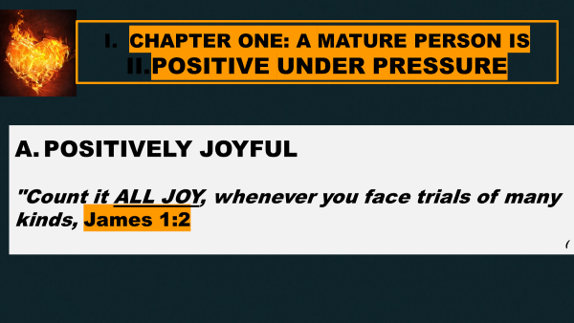

“The text is clear. We can respond to life’s trials with genuine joy if we know that the Lord has a purpose for why He would allow those difficult times of suffering and trials. In this passage, the purpose for trials was to produce patience or endurance (the ability to hold up under a trial) in our lives. Knowing that our loving Heavenly Father is doing something specific in our lives and that He is doing what is best for us helps us respond with genuine joy. Life’s trials are certainly not fun, but we can react to those painful situations with joy if we understand that God is demonstrating His love for us through those circumstances”. https://www.christianity.com/wiki/christian-terms/what-is-joy-in-christianity.html

“There’s a difference between joy and happiness. Happiness happens to us. Even though we may seek it, desire it, pursue it, etc., feeling happiness is not a choice we make.
Joy, on the other hand, is a choice purposefully made. Joy is an attitude of the heart and spirit, present inside of us as an untapped reservoir of potential.
It's possible to feel joy in difficult times. Joy doesn’t need a smile in order to exist, although it does feels better with one. Joy can share its space with other emotions – sadness, shame or anger.
Happiness can't. Happiness is not present in darkness and difficulty. Joy never leaves it. Joy undergirds our spirits; it brings to life peace and contentment.
Joy requires a connection. Often the connection is with other people, but it can also be with pets, creation, creativity, etc. Joy is present. In the moment. Happiness mostly just passes through”. https://www.compassion.com/sponsor_a_child/difference-between-joy-and-happiness.htm?referer=567731&gclid=Cj0KCQjwhb36BRCfARIsAKcXh6FsYurVn10284r0dv64AArYZR7aMyL07rwBIgCK2ZFrIakNDH_SVhMaAiMKEALw_wcB

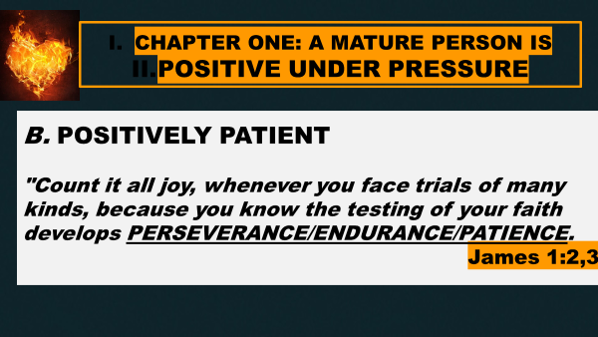

5281 u`pomonh, hupomone {hoop-om-on-ay'}
Meaning: 1) steadfastness, constancy, endurance 1a) in the NT the characteristic of a man who is not swerved from his deliberate purpose and his loyalty to faith and piety by even the greatest trials and sufferings 1b) patiently, and steadfastly 2) a patient, steadfast waiting for 3) a patient enduring, sustaining, perseverance
Origin: from 5278; TDNT - 4:581,581; n f
Usage: AV - patience 29, enduring 1, patient continuance 1, patient waiting 1; 32 (BibleWorks Software.)

