July 19, 2020 Courageous Living in Turbulent Times
Joining God in the Ministry of reconciliation

For the past several weeks we have been going through a series of messages under the title “Courageous Living in Turbulent Times”. We have dealt with the fact of adversity, the need for integrity, the courage to stand firm in your beliefs, courage to show God’s love in the midst of a fractured world, gave a call to be a Minister of Reconciliation, and then a call to live a courageous life free of fear because of our faith in Jesus Christ. Today I want to build off those messages and bring them to a clear point. To live courageously means that we accept our calling to be Ambassadors of Christ and to join Christ to be Ministers of Reconciliation.

The most important and impactful way to live a courageous life is to boldly join God in His Ministry of Reconciliation. We are to be fearless and compassionate in answering the call to reconciliation.

Let’s begin with seeking a clearer understanding of the pathway and the elements in reconciliation.

I want to share with you my understanding of the path to reconciliation,

Creation > Sin > Compassion > Mercy > Grace > Justice > Reconciliation

- Created In The Image Of God To Be In A Loving Relationship With Him And All People
- Mankind Sinned And Broke The Loving Relationship With God And People
- God’s Love For Mankind Leads Him To Be Compassionate To Us
- His Mercy Is The 1st Outcome Of His Compassionate Love For Us
- His Grace Is Then Shown To Us
- Justice Is Then Applied
- Reconciliation Is Made Possible

Our call is to take the pattern of God’s plan for reconciliation and put it into practice in today’s turbulent times.

It is to necessary to address the fact that you and I are not God! We are not perfect, we live in a sinful world, and we have a tendency to follow a selfish path. Thus, we must Intentionally, Deliberately, and Consistently rely on God’s Power to engage in this most important calling of Reconciliation.

The first step is to acknowledge were created in the Image of God for a loving and holy relationship. We then must admit that we have sinned and broken that relationship. Then we need to call out to a compassionate and loving God for mercy and grace in applying justice to our life. Once we have been reconciled to God through Christ we then can use that power to help us in our personal Ministry of Reconciliation.

Let’s begin with seeking a clearer understanding of Compassion…
Some of the following is adapted from
https://www.biblestudytools.com/dictionary/compassion/
https://www.compassion.com/child-development/meaning-of-compassion/

“The definition of compassion, according to the Merriam-Webster Dictionary, is the "sympathetic consciousness of others' distress together with a desire to alleviate it."
And the New Oxford American Dictionary defines compassion as "a sympathetic pity and concern for the sufferings or misfortunes of others."
“The Latin root for the word compassion is pati, which means to suffer, and the prefix com- means with. Compassion, originating from compati, literally means to suffer with. Compassion means someone else’s heartbreak becomes your heartbreak. Another’s suffering becomes your suffering. True compassion changes the way we live”. (compassion.com)

Compassion is something that both the saved person and a non-believer can experience. Though there is value in a non-believer’s expression of compassion, our goal here today, is to show the fuller, deeper and Biblical view of Compassion and the extreme need for it in today’s turbulent times.

Biblical Compassion …according to biblestudytools.com is… “That (human) disposition that fuels Acts of kindness and mercy. Compassion, a form of love, is aroused within us when we are confronted with those who suffer or are vulnerable. Compassion often produces action to alleviate the suffering, but sometimes geographical distances or lack of means prevent people from acting upon their compassionate feelings. Compassion is not a uniquely Christian response to suffering (cf. Exod 2:6 ; Luke 10:33 ), even though Christians have unique reasons for nurturing their compassionate dispositions.
The Hebrew (hamal , rachuwm Greek (splanchnisomai words sometimes translated as "compassion" also bear a broader meaning such as "to show pity, " "to love, " and "to show mercy." Other near synonyms for compassion in English are "to be loved by, " "to show concern for, " "to be tenderhearted, " and "to act kindly."

The meaning of compassion is to recognize the suffering of others and then take action to help. Compassion embodies a tangible expression of love for those who are suffering and it has the effect of seeking and providing justice for all people, especially those who are in discouraging or disparaging circumstances.

The spirit of the word compassion is synonymous with doing. Compassion is not concerned with material or physical things. It's concerned with the human spirit and soul. The spiritual definition of compassion involves acting to alleviate the suffering, of others.
What is the difference between mercy and compassion?
Mercy is the compassionate treatment of those in distress. Mercy is the fruit of compassion. It’s the gift given to the suffering by those living out their compassion. That will be our subject for Sunday August 9. But today let’s focus on Compassion and its motivation by Love. Let’s start with what the Bible says on the subject…always the best place to start?

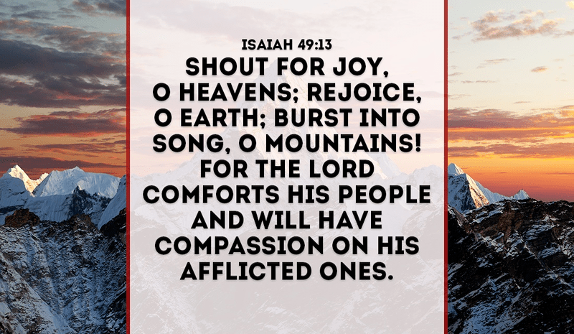 | 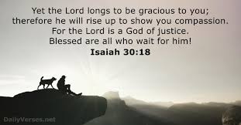 | 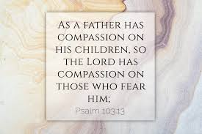

Matthew 9:36… When Jesus saw the crowds, He had compassion for them, because they were harassed and helpless, like sheep without a shepherd.

1 Peter 3:8… Finally, all of you, have unity of mind, sympathy, brotherly love, a tender heart, and a humble mind.

1 John 3:17… But if anyone has the world's goods and sees his brother in need, yet closes his heart against him, how does God's love abide in him?

- Compassion: Manifestation of Love
Adapted from Rick Warren — February 28, 2020. Devotional e-mail, Nothing Matters Without Love

John 13:34… A new commandment I give to you, that you love one another: just as I have loved you, you also are to love one another

Galatians 5:6…“If you are a follower of Christ Jesus . . . all that matters is your faith that makes you love others.” (CEV)

God says what matters in life is not your accomplishments or your achievements or your fame or your wealth. The only thing that matters is having a faith that causes you to love other people. If you miss that, you have missed the most important thing in life.

1 Corinthians 13

1. If you don’t live a life of love, then nothing you say will matter.
“If I could speak all the languages of earth and of angels, but didn’t love others, I would only be a noisy gong or a clanging cymbal” (1 Corinthians 13:1 NLT).
We’re really impressed by great speakers. We love eloquence and charisma. But God says, “I don’t care how good of a communicator you are. Are you living a life of love?” If you’re not, then nothing you say will matter. Words without love are just noise.
2. If you don’t live a life of love, nothing you know will matter.
“I may have the gift of prophecy. I may understand all the secret things of God and have all knowledge . . . But even with all these things, if I do not have love, then I am nothing” (1 Corinthians 13:2 NCV).
We live in a world where knowledge is exploding. We are smarter than we’ve ever been. But we still have the same problems: crime, abuse, prejudice, violence. Why? Because the world doesn’t need more knowledge. It needs more love. You may be a genius. But God says if you don’t have love in your life, all that you know is worthless.
3. If you don’t live a life of love, nothing you believe will matter.
The Bible says, “Even if I had the gift of faith so that I could speak to a mountain and make it move, I would still be worth nothing at all without love” (1 Corinthians 13:2 TLB).
There’s a myth that being a follower of Christ is just a matter of believing certain truths. Nothing can be further from the truth! Following Christ is about living a life of love. It takes more than belief to please God.
4. If you don’t live a life of love, nothing you give will matter.
The next verse says, “If I gave everything I have to the poor and even sacrificed my body, I could boast about it; but if I didn’t love others, I would have gained nothing” (1 Corinthians 13:3 NLT).
Love isn’t always the motivation for giving. Some people give just to get back or out of guilt or for control or prestige. You can give for a lot of wrong motives, but the Bible says if you’re not doing it out of love, none of your giving counts.
Galatians 5:6…“If you are a follower of Christ Jesus . . . all that matters is your faith that makes you love others.” (CEV)

