REGULAR CITY COUNCIL MEETING
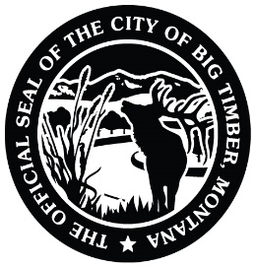
12/1/2025
7:00 PM
CARNEGIE LIBRARY MEETING ROOM
USE 4TH STREET ENTRANCE
314 MCLEOD ST
BIG TIMBER, MT

Meeting called by: Greg DeBoer Note Taker: Hope Mosness

*Please state your name and direct all comments to the Mayor. Citizens may address the Council regarding any item of City business that is NOT on this agenda during the public comment period. Each individual is limited to 3 minutes and NO action will be taken. If anyone would like to comment regarding an item that IS on the agenda, please wait until the agenda item has been presented to the Council by the Mayor and the public has been asked for comments.

*Please state your name and direct all comments to the Mayor*

6:55pm: PRAYER IN LOBBY OF MEETING ROOM COUNCILMEMBERS

---- AGENDA TOPICS ----

OPEN MEETING / PLEDGE OF ALLEGIANCE MAYOR DEBOER

APPROVE MINUTES FROM 11/17/25 PUBLIC HEARING AND REGULAR
CITY COUNCIL MEETING COUNCIL

SHERIFF’S REPORT SHERIFF RONNEBERG

PUBLIC WORKS REPORT KRIS NOVOTNY

ANIMAL CONTROL LOCATION – DISCUSSION COUNCILMAN FERGUSON

APPRAISAL FOR MARK NOREM BUILDING
(APPROVE/AMEND/REJECT) COUNCILWOMAN BAIRD

APPROVE CLAIMS, PAYROLL, AND OVERTIME FOR THE MONTH OF NOVEMBER COUNCIL

PUBLIC COMMENT PUBLIC

ADJOURN

