REGULAR CITY COUNCIL MEETING
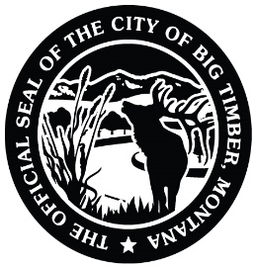
4/20/2026
7:00 PM
CARNEGIE LIBRARY MEETING ROOM
USE 4TH STREET ENTRANCE
314 MCLEOD ST
BIG TIMBER, MT

Meeting called by: Mayor Ferguson Note Taker: Hope Mosness

*Please state your name and direct all comments to the Mayor. Citizens may address the Council regarding any item of City business that is NOT on this agenda during the public comment period. Each individual is limited to 3 minutes and NO action will be taken. If anyone would like to comment regarding an item that IS on the agenda, please wait until the agenda item has been presented to the Council by the Mayor and the public has been asked for comments.

6:55pm – Prayer in lobby of the meeting room Councilmembers

---- AGENDA TOPICS ----

Open/Pledge of Allegiance Mayor Ferguson

Approve Minutes from 4/6/26 Regular City Council Meeting and 4/13/26
Special City Council Meeting Council

Big Timber Trail Network Update Kathy Morgan/Romey James

Encroachment Agreement – Goat Ranch Hospitality – 37 McLeod St
(Approve/Amend/Reject) Lana King

Montana Water Court Attorney and Information Request from
Crazy Mountain Ranch Jim Lippert

Letter of Support for Crazy Mountain Renewables
(Approve/Amend/Reject) Jim Lippert

Rankings from RFQ for Architectural/Engineering Services for City Hall Building City Hall Committee

Decision on Workers’ Compensation Program Withdrawal from MMIA
(Approve/Amend/Reject) Hope Mosness

Additional 2026 Lifeguards
(Approve/Amend/Reject) Hope Mosness

3rd Quarter Fiscal Year 2026 Budget Report Hope Mosness

Pledged Securities Report
(Approve/Amend/Reject) Hope Mosness

Approve Claims for 2nd Half of March 2026
(Approve/Amend/Reject) Council

Public Comment Public

Council Concerns Council

Adjourn

