Public Hearing and Regular City Council Meeting
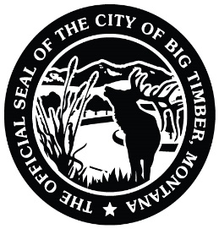
9/8/2026
7:00 PM
Carnegie Library Meeting Room
Use 4th Street Entrance
314 McLeod Street
Big Timber, MT

Meeting called by: Council President Kerri Baird Note Taker: Hope Mosness

*Please state your name and direct all comments to the Council President. Citizens may address the Council regarding any item of City business that is NOT on this agenda during the public comment period. Each individual is limited to 3 minutes and NO action will be taken. If anyone would like to comment regarding an item that IS on the agenda, please wait until the agenda item has been presented to the Council by the Mayor and the public has been asked for comments.

*Please state your name and direct all comments to the Council President*

6:55pm: PRAYER IN LOBBY OF MEETING ROOM Councilmembers

---- AGENDA TOPICS ----

Open Meeting/Pledge of Allegiance Mayor Ferguson

Approve Minutes from the 8/17/26 Regular City Council Meeting and the 8/31/26
Public Hearing and Special City Council Meeting Councilmembers

Sheriff’s Report Sheriff Ronneberg

Public Works Report Kris Novotny

Notice of Bid Acceptance - 2010 Ford Flex Animal Control Vehicle
(Approve/Amend/Reject) Kris Novotny

Request for Street Closures for October 3rd Fall Fest
(Approve/Amend/Reject) Aaron Freed

Request from SGHS Booster Club to use City Hall Lot for Homecoming Bonfire
(Approve/Amend/Reject) Kelsey Proue

Claims, Payroll, and Overtime for August 2026
(Approve/Amend/Reject) Councilmembers

Public Comment Public

Adjourn

