Week 4 Worksheets.

Identify Safety Symbols and Warnings

Instructions:
Review your tools and locate the following symbols:
- Warning Labels
- Electrical Hazard Symbols
- Personal Protective Equipment (PPE) icons
- Pinch point or moving part warnings
Match the symbol to its meaning using the chart below.
Safety Symbols Chart.

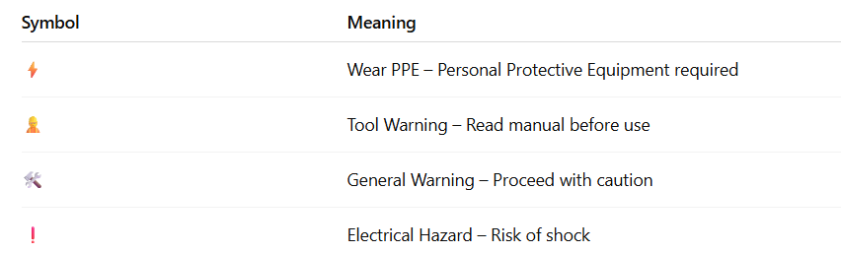

Safety checklist before plugging in a tool.

Use the checklist below before operating any power tool:
✅ Safety Step | Why It Matters
Inspect tool for damage | Cracks, frayed cords = danger
Ensure power switch is OFF | Prevent surprise start-up
Check plug and cord | Look for wear or exposed wires
Confirm proper PPE is worn | Safety goggles, gloves, etc.
Ensure dry environment | Avoid electrical hazards
Use grounded outlet | Prevent electric shock

3. Quick Activity: Safety Quiz
Instructions:
Answer the following questions based on today’s safety lesson:
1. What symbol warns you about electrical shock?
2. Why should you check that the tool is off before plugging it in?
3. What PPE should you wear when using a circular saw?
4. What does a red triangle warning label mean?
5. What should you do if a cord is frayed?

🔑 Answer Key
1. The ⚡ symbol indicates electrical hazard or shock risk.
2. To avoid accidental start-up, this could lead to injury.
3. Safety goggles, hearing protection, gloves depending on the tool.
4. A warning label indicating high risk or danger – check the manual.

4. Self-guided lesson: Power Grinder.

This self-led session is designed to take approximately one hour.
Part 1: What Is a Power Grinder?
A power grinder is a handheld tool used for grinding, cutting, or polishing metal, wood, and other materials. Most commonly, you'll encounter an angle grinder in the workshop.
Part 2: Vocabulary Match
Match the word to its correct definition.
Term | Definition Letter
1. Guard | ___
2. Disc/Wheel | ___
3. Trigger/Switch | ___
4. Flange Nut | ___
5. Spindle Lock | ___

Definitions:
A. The rotating part that holds the grinding disc in place
B. Covers part of the disc to protect from sparks and debris
C. The part that starts/stops the tool
D. Used to secure the disc tightly
E. The attachment used for grinding, cutting, or sanding

Part 3: Grinder Safety First
Circle YES or NO for each safety rule.
- Always wear safety goggles when using a grinder. YES / NO
- Use a grinder without the guard if it gets in your way. YES / NO
- Let the grinder reach full speed before applying pressure. YES / NO
- It’s okay to touch the spinning disc with your fingers. YES / NO
- Always unplug the tool before changing discs. YES / NO
Part 4: Label the parts.

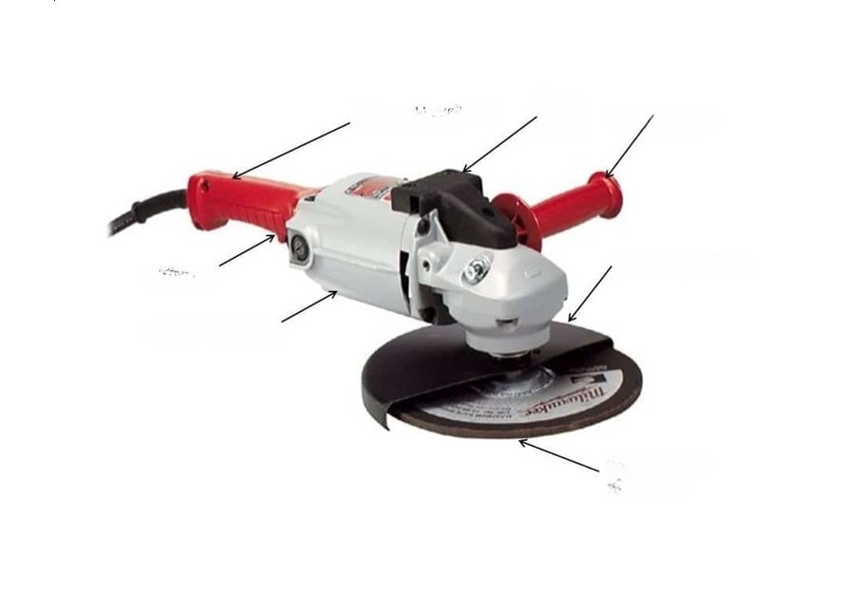
- Trigger Handle
- Tool Reset
- Idle Handle
- Safety Guard
- Trigger
- Motor Housing
- Grinding Wheel
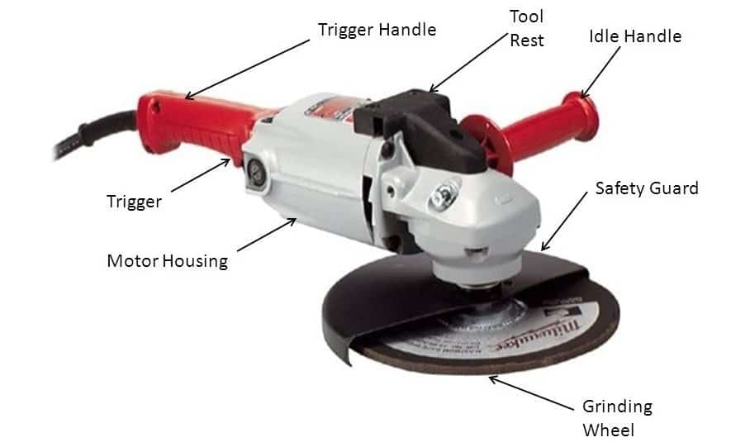

Power Grinder Safety Rules

✅ Before Use

Inspect the grinder and disc

Check for cracks, warping, or wear on the disc.

Ensure the grinder is clean, dry, and undamaged.

Wear proper PPE

Safety goggles or a full face shield (eye protection is essential).

Hearing protection (grinders are loud).

Gloves (anti-vibration recommended).

Long sleeves and pants (to protect against sparks/debris).

Check the tool rating

Match the disc speed rating with the grinder's RPM.

Never exceed disc limitations.

Ensure guard is in place

Never remove or bypass the protective guard.

⚠️ While Using

Hold with both hands

Use side handle and main grip for stability and control.

Keep firm footing

Work on a clean, dry, and non-slip surface.

Avoid grinding near flammables

Sparks can ignite flammable materials, vapors, or liquids.

Don’t force the tool

Let the grinder do the work. Too much pressure can cause kickback.

Maintain correct angle

Typically 15°–30° for grinding, flat for sanding.

🔌 After Use

Turn off and unplug

Always disconnect power before changing discs or cleaning.

Let disc come to a complete stop. Never set the grinder down while the disc is still spinning.

Store safely. Place in a dry, secure area away from dust and moisture.

📝 Power Grinder Safety Quiz
1. What is the purpose of the guard on a grinder?
2. Name two pieces of personal protective equipment (PPE) you should wear when using a grinder.
3. What should you do before plugging in the grinder?
4. How should you hold the grinder when in use?
5. What should you check about the grinding disc before using it?

Answers.

- To protect the user from sparks, debris, and disc fragments.
- Safety glasses (or face shield) and hearing protection.
- Inspect tool/disc, ensure guard is in place, switch is OFF.
- With both hands, firm grip, steady at correct angle.
- Check that disc is correct, secure, not cracked or damaged.

Part 5: Practice Activity (Teacher/Parent Supervised)
Activity: Metal Edge Smooth-Out
Objective: Learn how to use a grinder to smooth the edge of a small metal plate (or simulate with soft material like wood if working with teens at home).
Instructions:
- Inspect your tool and safety gear.
- Clamp down your workpiece.
- Put on gloves, eye protection, and hearing protection.
- Power on the grinder and gently apply the disc to the edge.
- Observe how the material is removed.

✅ Checklist:
☐ Wore full safety gear
☐ Let the disc reach full speed
☐ Applied light, even pressure
☐ Kept both hands on the tool
☐ Turned off and unplugged the tool before setting it down

5. Using an Orbital Sander.

Objective
Students will learn the purpose, safety protocols, and basic use of an orbital sander through guided content and a hands-on sanding task.

Lesson Structure

Part 1: Introduction Reading

An orbital sander is a handheld power tool used to smooth surfaces using a rapidly rotating sanding pad that moves in small, circular motions. It’s commonly used in woodworking to smooth wood surfaces, remove old paint or finishes, and prepare material for staining or sealing. Choosing the right grit sandpaper is essential—coarse grits (60–80) are best for heavy removal, while finer grits (120–220) are used for finishing. Proper personal protective equipment (PPE) is important when operating an orbital sander, including safety goggles to protect your eyes, a dust mask to avoid inhaling fine particles, and ear protection to guard against prolonged noise exposure. Always prioritize safety: keep hands away from the sanding pad during operation, use clamps or a vice to secure your workpiece, and always unplug the sander before changing discs or making adjustments.

Part 2: Tool Walkthrough

Activity:
- Examine an orbital sander
- Identify the parts.

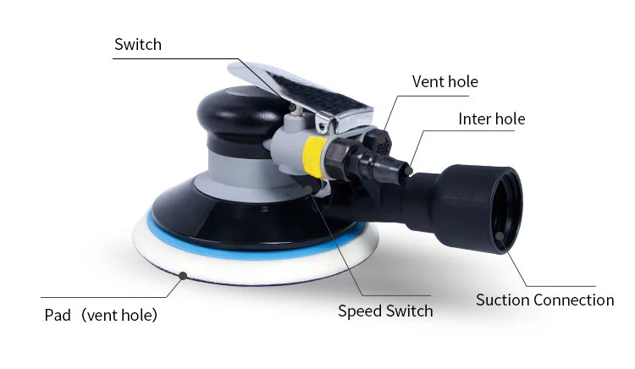

Part 3: Safety Checklist & Practice Setup

Activity:
- Complete a Safety Checklist before sanding:
- PPE on
- Disc attached securely
- Wood clamped
- Area clean and ventilated
- Cords out of path

Part 4: Hands-On Practice
Task:
- Sand a small board (e.g., 6" x 12")
- Start with coarse grit (80), finish with fine grit (150-220)
- Keep sander flat, move in slow circular motions
- Do not press down—let the sander do the work
Goal: Achieve a smooth, even surface without swirls.

Part 5: Reflection
Activity:
- Write in your notebook:
- What went well?
- What was difficult?
- One tip they’d share with a peer

Printable Safety Checklist

☐ PPE on (goggles, dust mask, ear protection)
☐ Sanding disc securely attached
☐ Workpiece clamped or secured
☐ Area clean and ventilated
☐ Cords clear and untangled
☐ Tool inspected for damage
☐ Understanding of the ON/OFF switch
☐ Dust bag or vacuum attached (if available)
☐ Practiced grip and stance

6. Using a Power Drill.

Objective
Students will understand the parts, safety procedures, and practical use of a power drill through guided content, bit identification, and a hands-on drilling activity.

Part 1: Introduction Reading

A power drill is a handheld electric tool used to drill holes or drive screws into wood, metal, plastic, or other materials. It typically includes key parts such as the chuck (which holds the bit), the trigger, the forward/reverse switch, the clutch for torque control, and the handle. Drills can be corded or cordless.
Common drill bits include twist bits for general drilling, spade bits for wider holes in wood, and driver bits for fastening screws.
To use a drill safely, always wear safety goggles to protect your eyes from debris, use hearing protection in extended use, and ensure the bit is securely fastened in the chuck. Clamp your workpiece when possible, and always remove the battery or unplug the drill before changing bits or making adjustments. Let the tool do the work—don't force it.

Part 2: Drill Bit Identification

Activity:
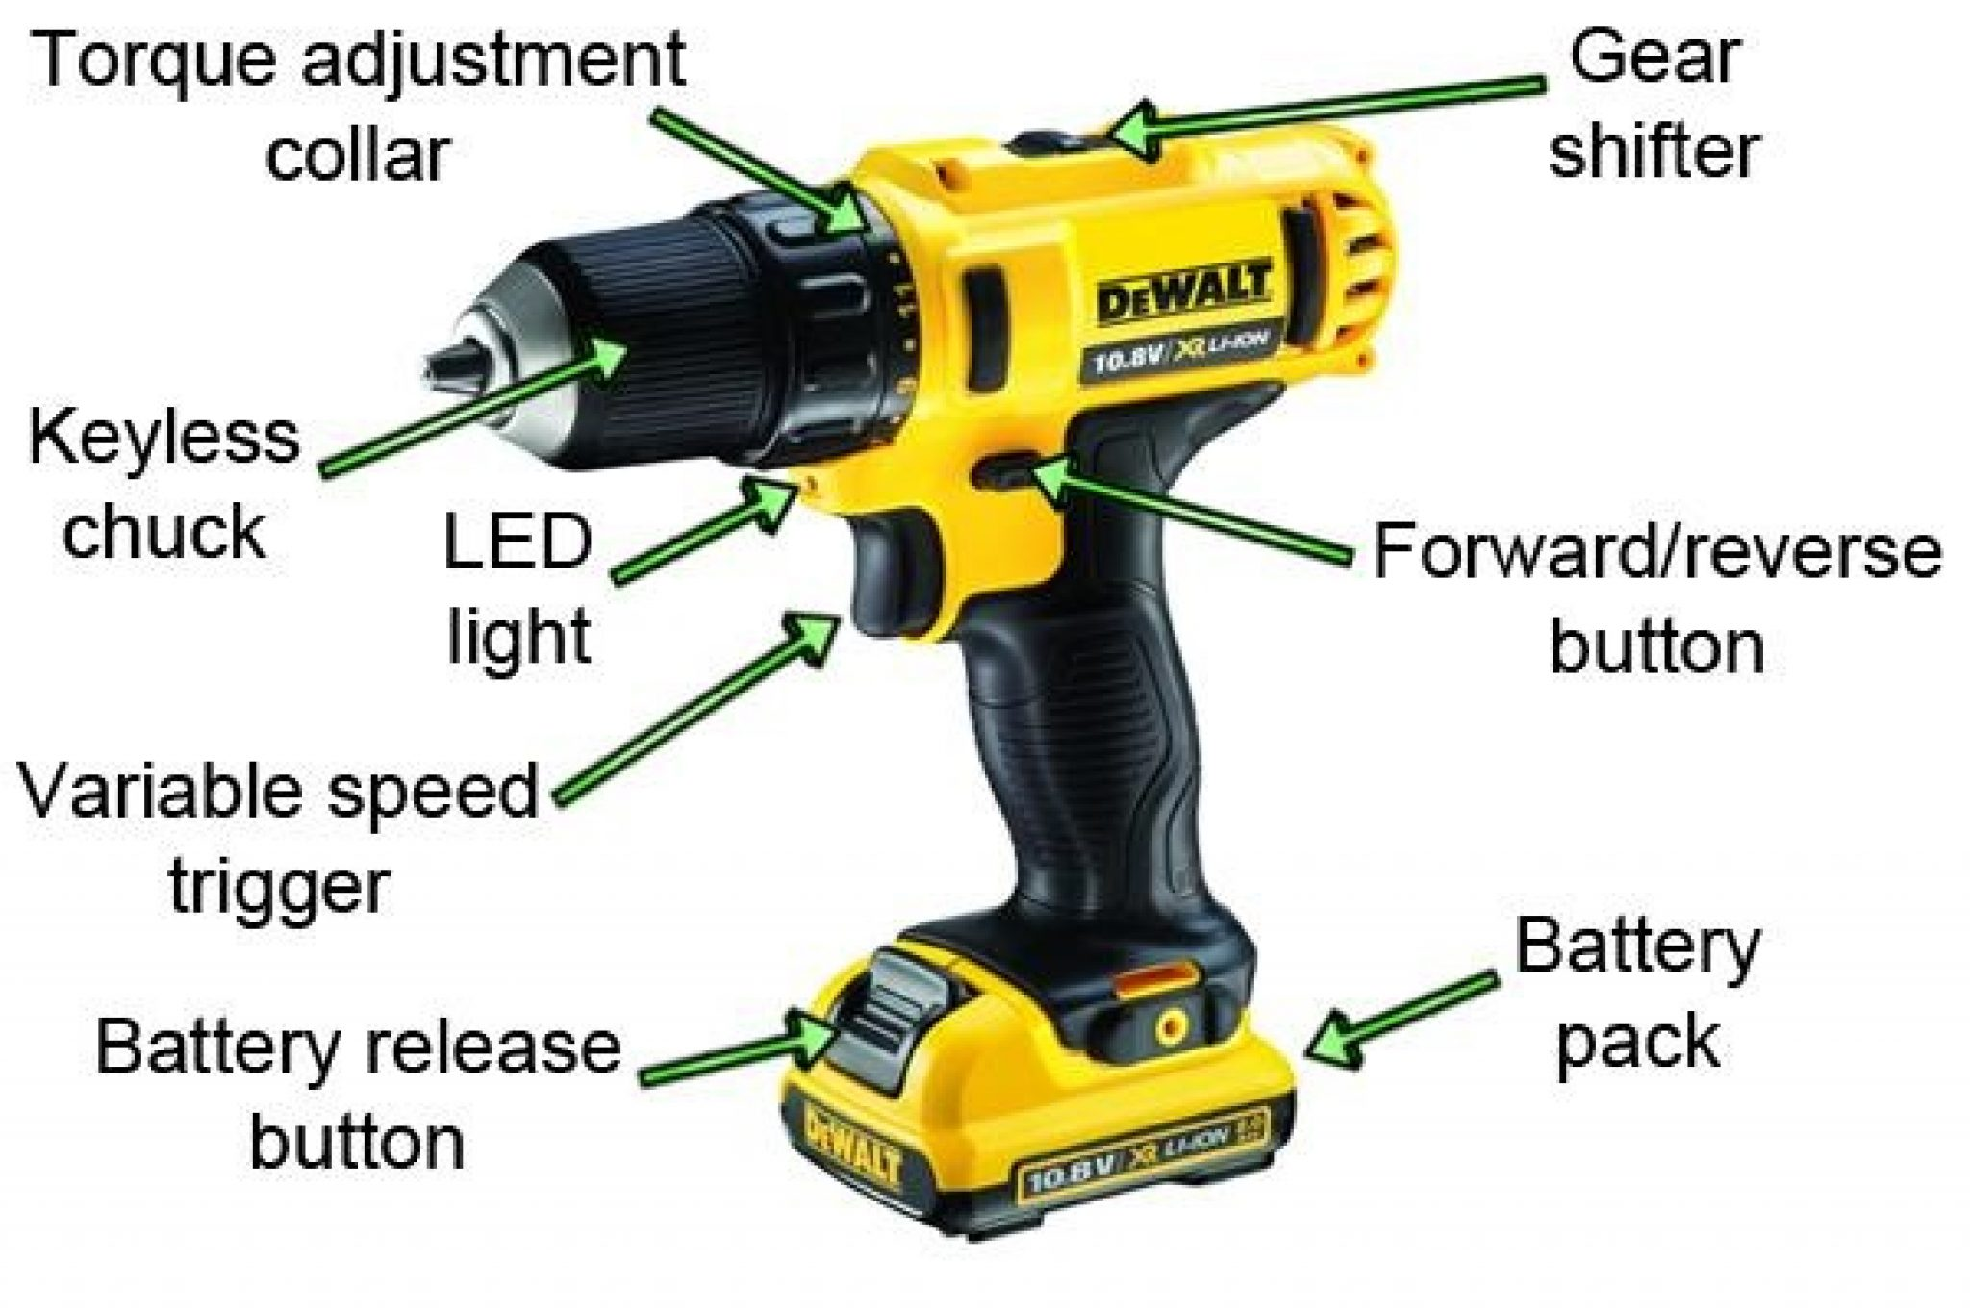

Part 3: Safety Checklist & Setup
Activity:
- Complete a Safety Checklist before drilling:
- PPE on (goggles, ear protection)
- Bit securely inserted in chuck
- Wood or material clamped
- Drill set to correct direction (forward or reverse)
- Battery charged or cord safe and untangled

Part 4: Hands-On Practice
Task:
- Drill 3–5 pilot holes in a 2×4 using a twist bit.
- Practice changing bits and adjusting the clutch.
- Try driving a screw with a driver bit.
Goal: Use the correct drill bit and maintain control while achieving clean holes or screw placement.

Part 5: Reflection
Activity:
- Write in your notebook:
- What went well?
- What was difficult?
- One safety rule you found most important

Printable Safety Checklist
☐ PPE on (goggles, ear protection)
☐ Drill bit securely fastened in chuck
☐ Workpiece clamped or secured
☐ Correct drill direction set (forward/reverse)
☐ Cord/battery safe and out of the way
☐ Hands clear of drilling area
☐ Trigger sensitivity tested
☐ Understanding of clutch and speed setting
☐ Tool inspected for damage


7. Project Builds.

You will create both builds.
Bird Feeder.
Tools Needed: Saw or jigsaw, sander, Drill and Screws OR Nails and Hammer
Materials:
- 1” x 4” x 8 foot piece of cedar or pressure treated wood for outside durability
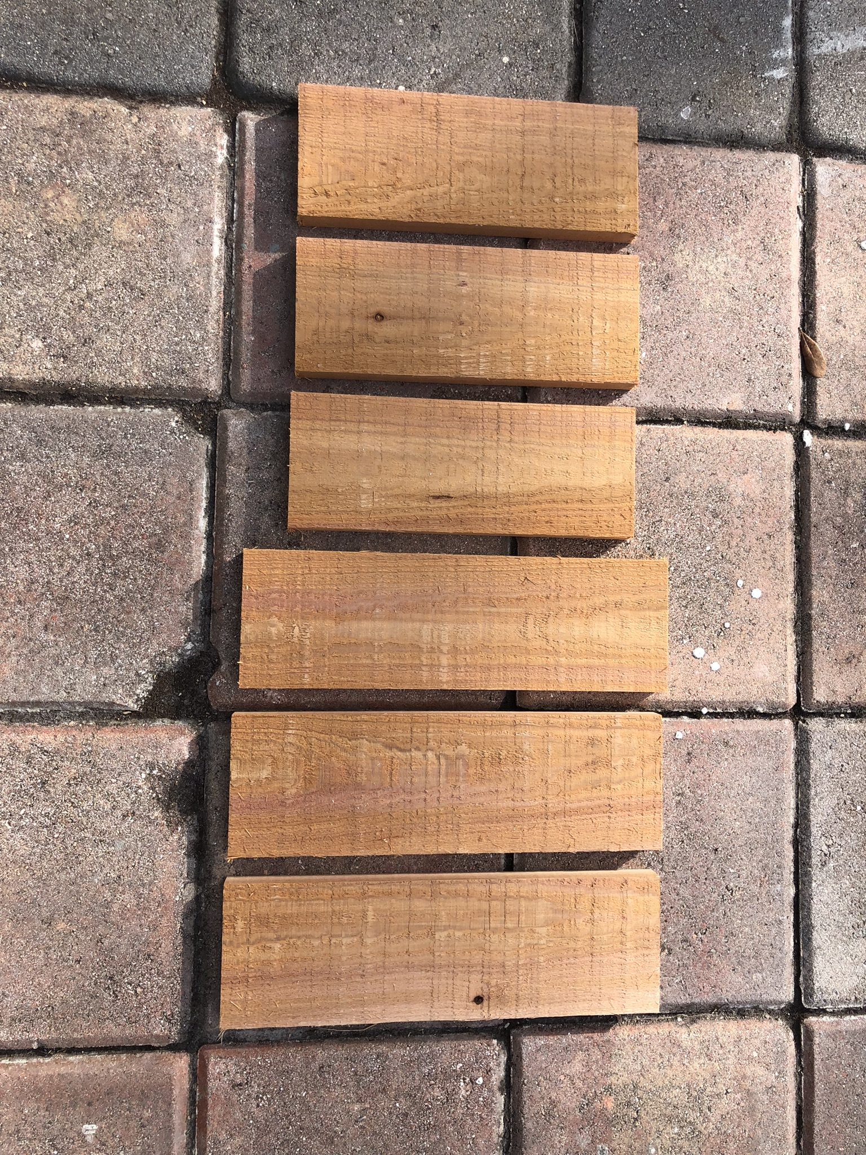
- Nails/screws
- Wood glue
- Screw-in cup hook
- Paint/stain (optional)

Step-by-Step Build:
- Cut 3 pieces to 11” and 3 pieces to 9”.
- Take 2 of the 9” pieces and cut it to make a peak at the top.
- Cut one of the 11” pieces in half long ways.

- Cut 2 of the 11’ pieces at 45 degrees on length of one side.
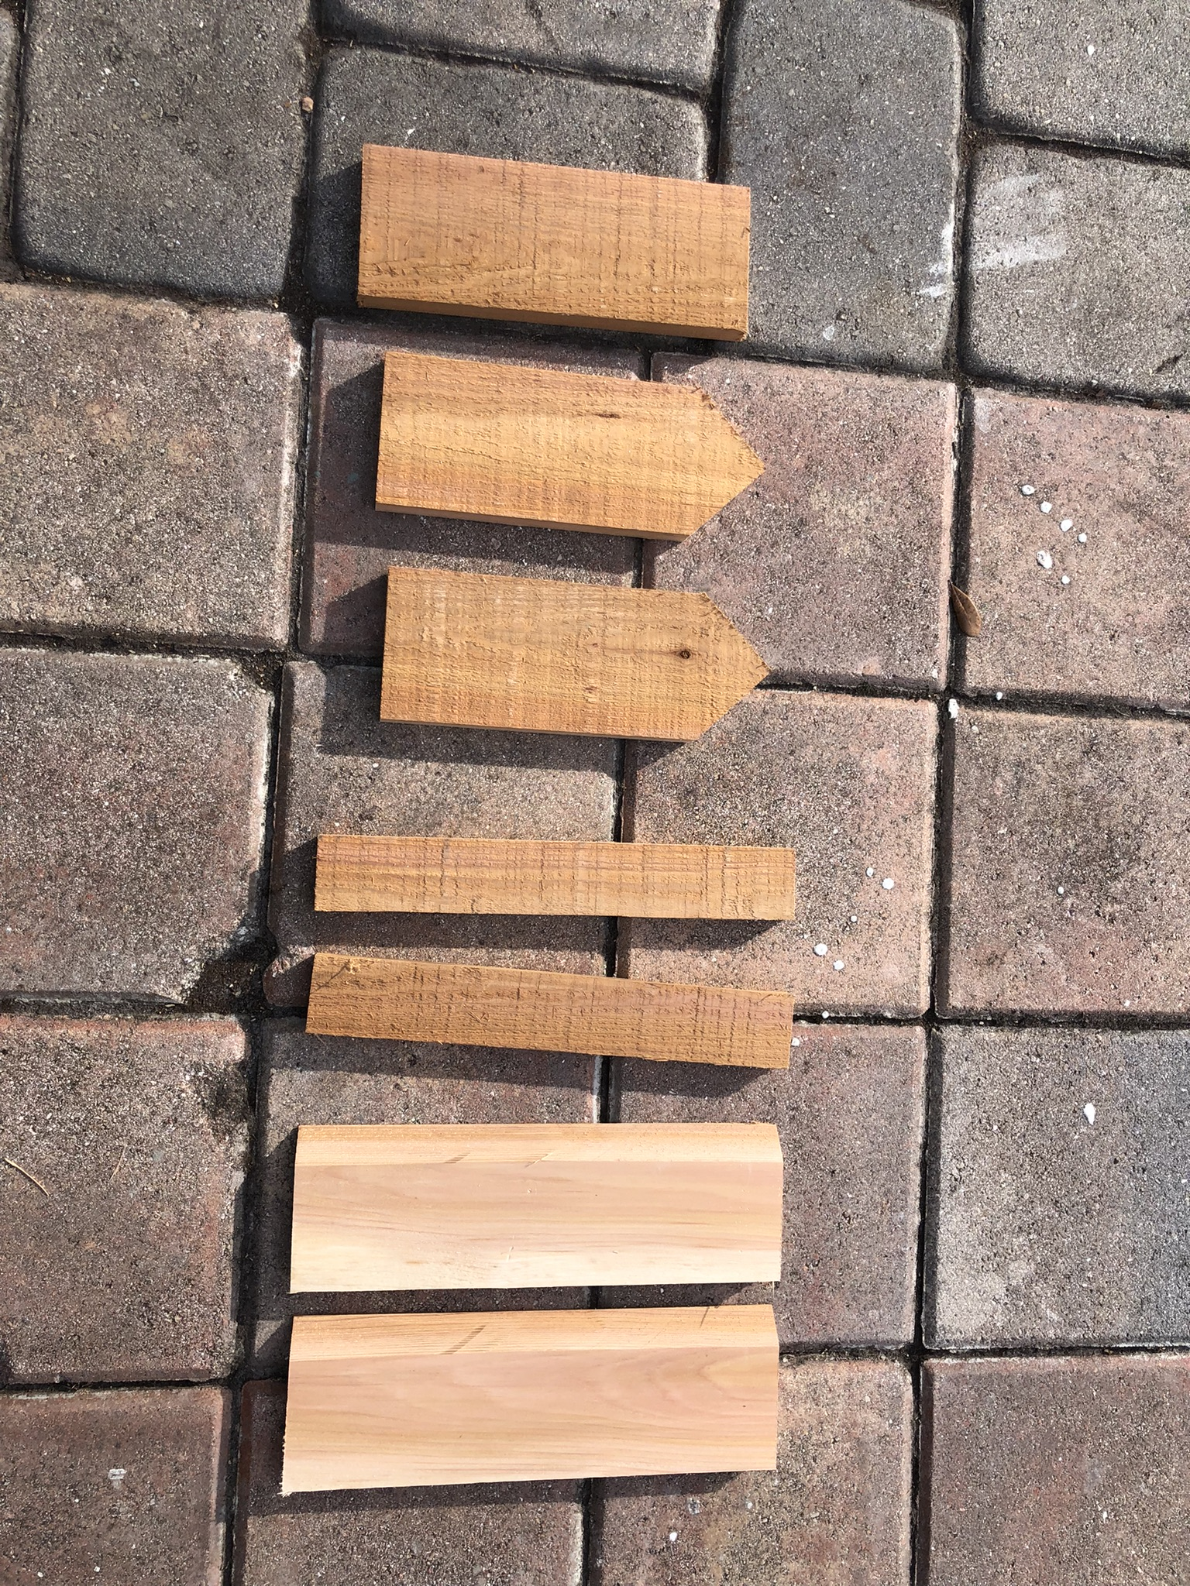

- Note: If you are using screws you need to drill a pilot hole first so the wood doesn’t split.

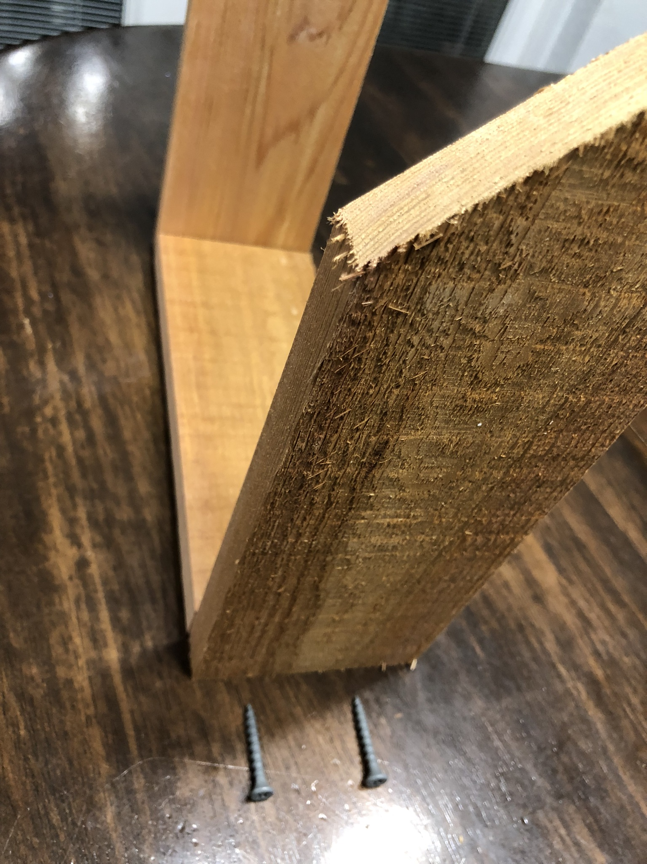
- Install the 9’ bottom to the sides.

- Install the roof pieces.
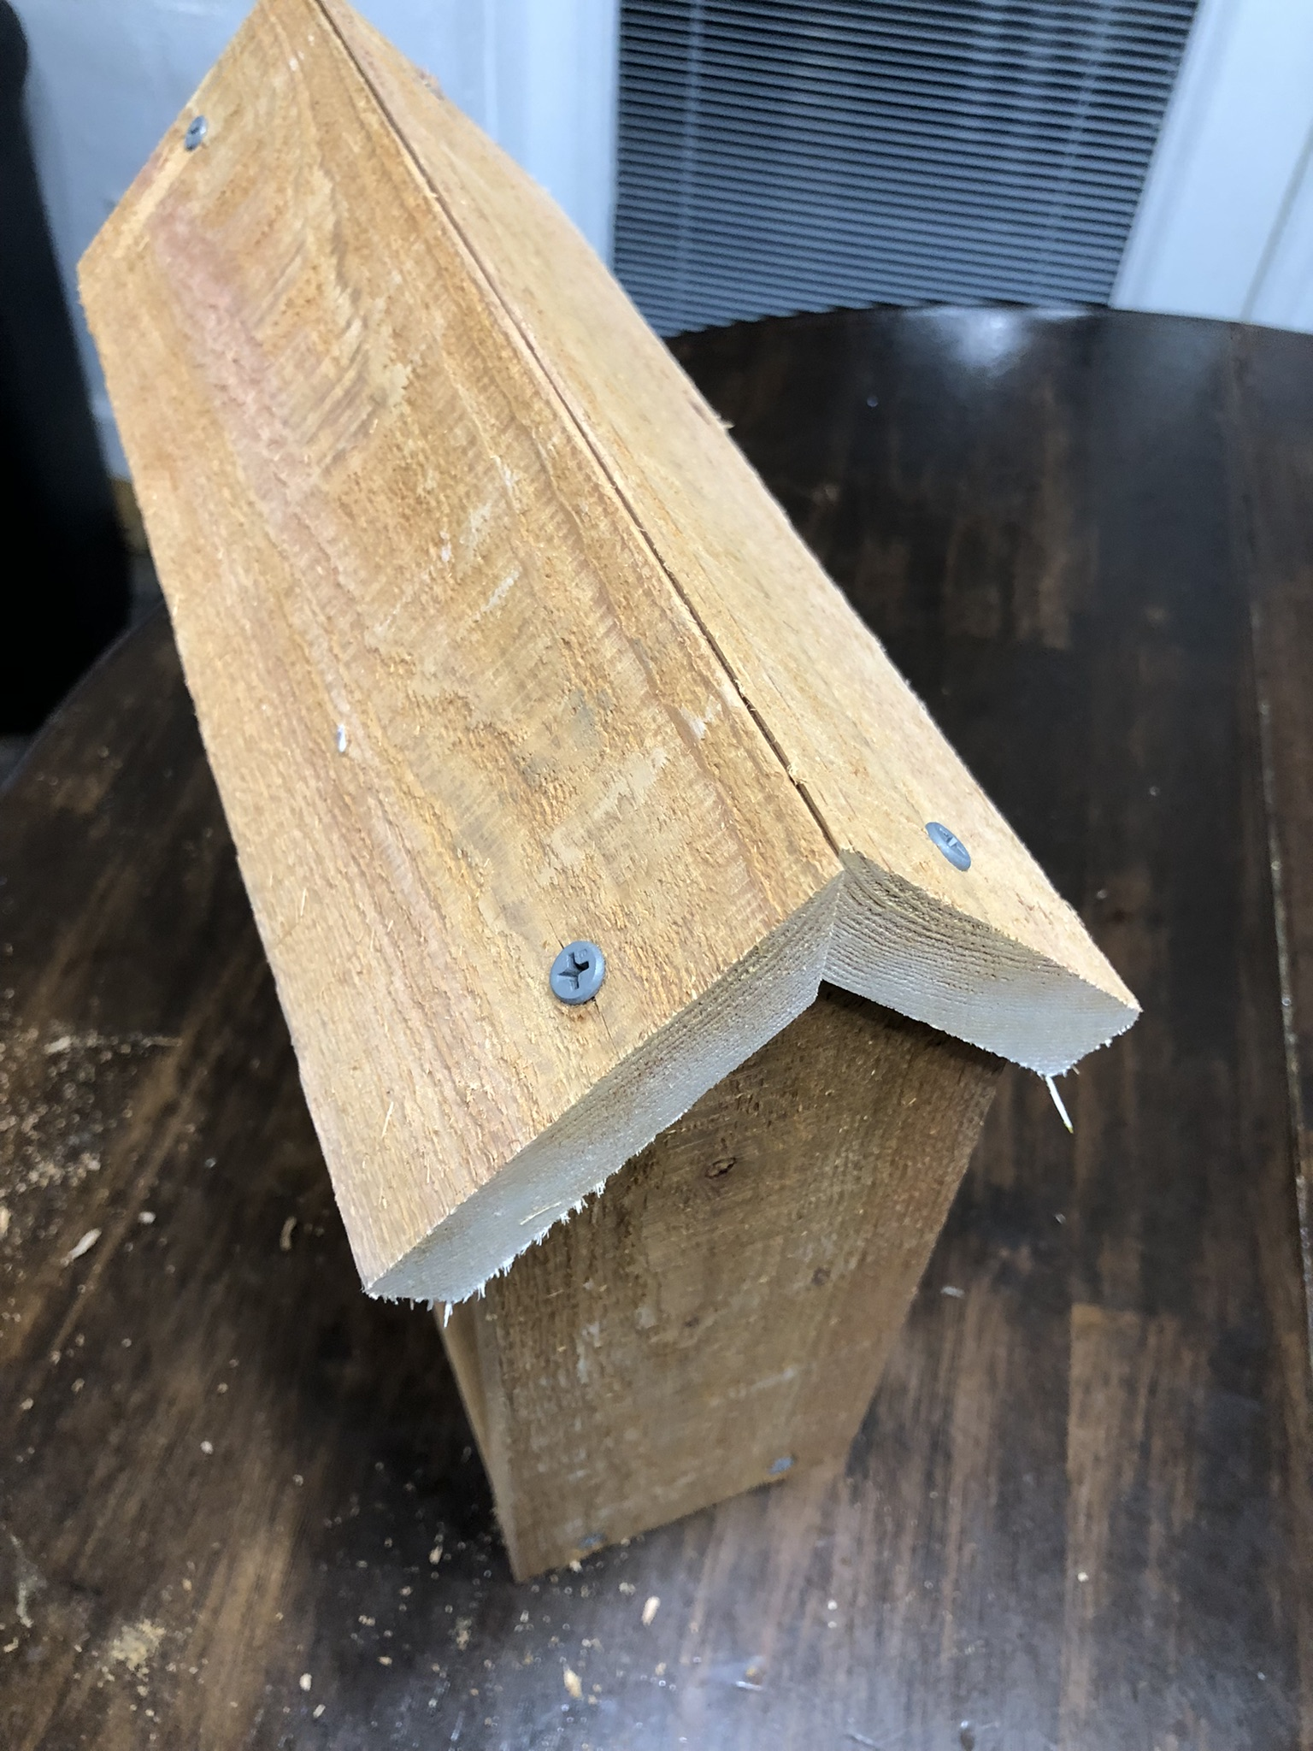

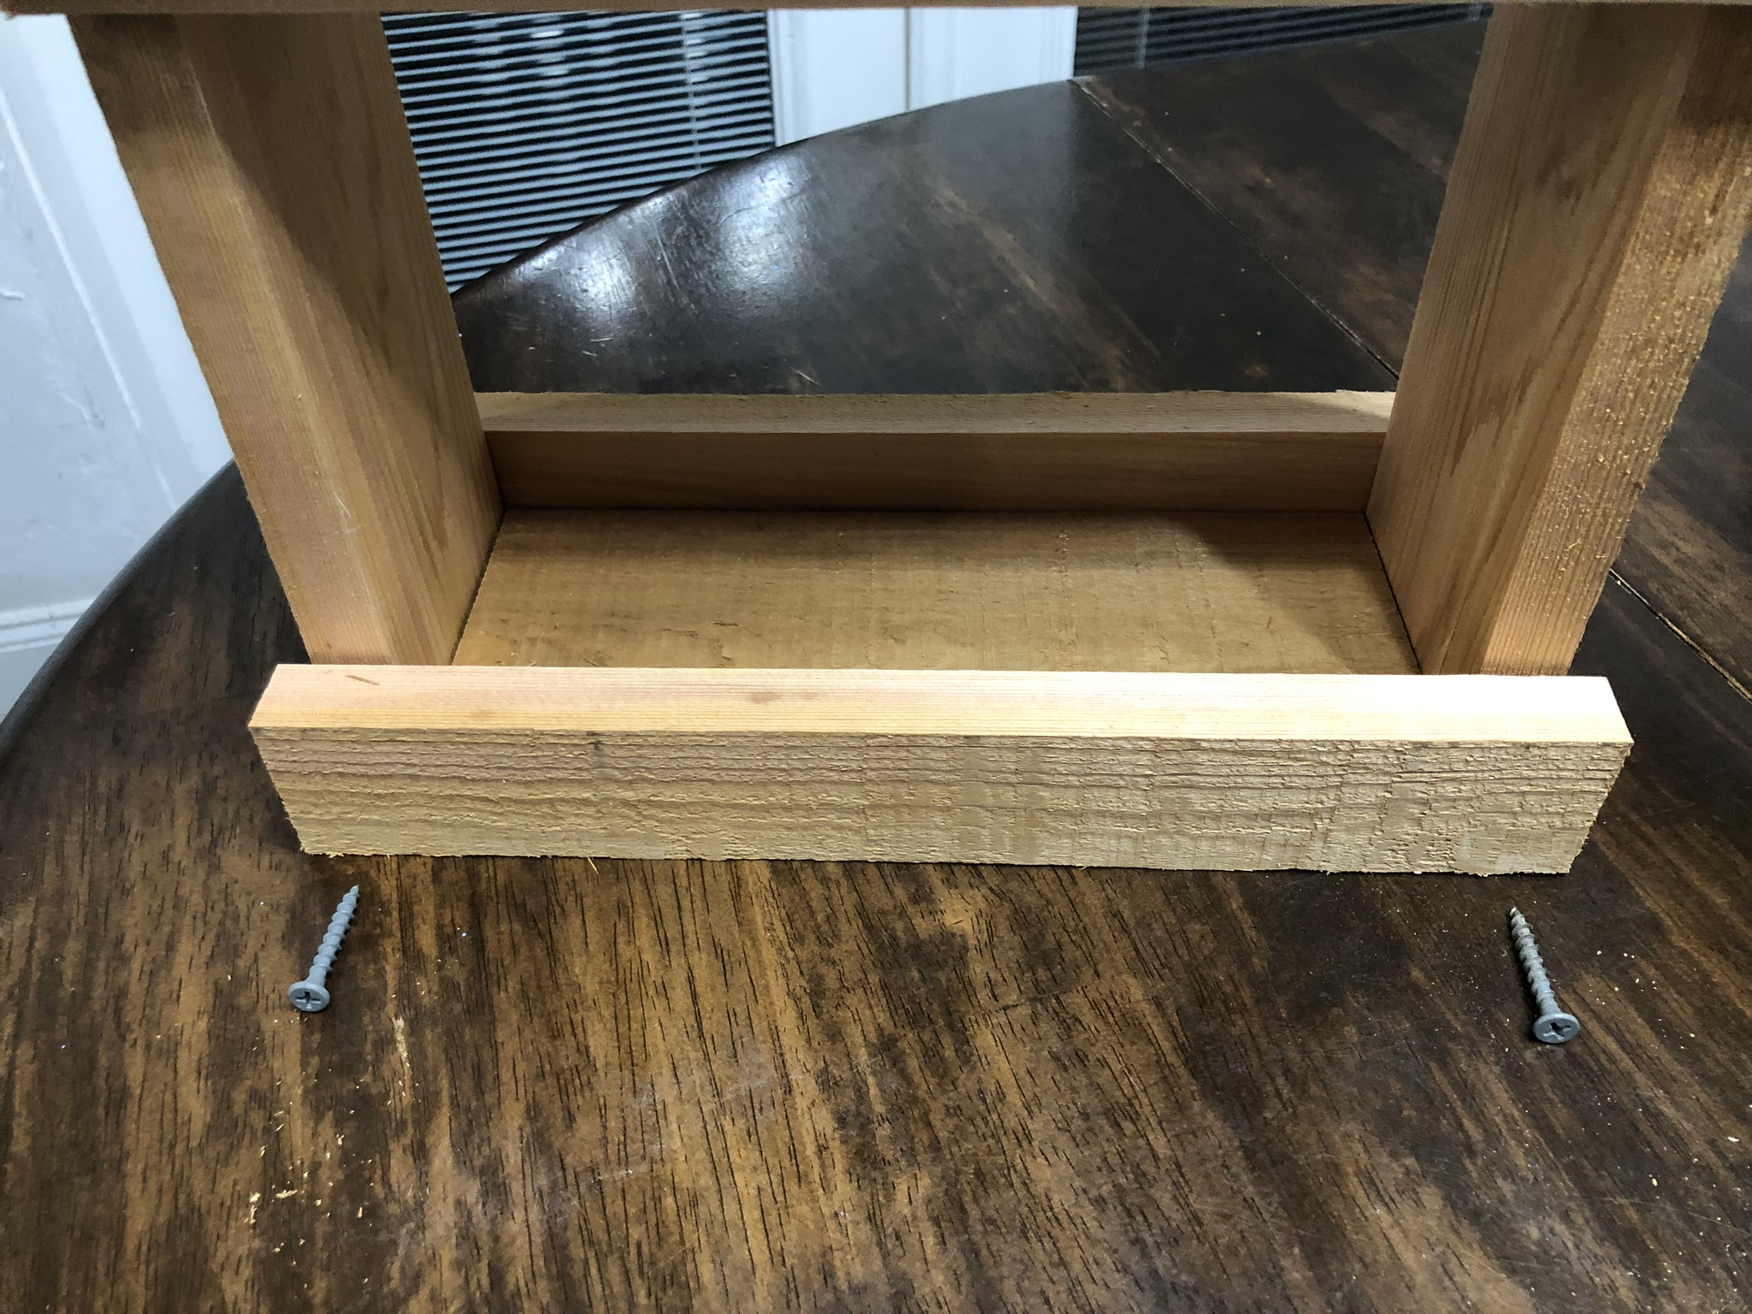
- Install the bottom sides.

- Sand, paint and stain if desired.
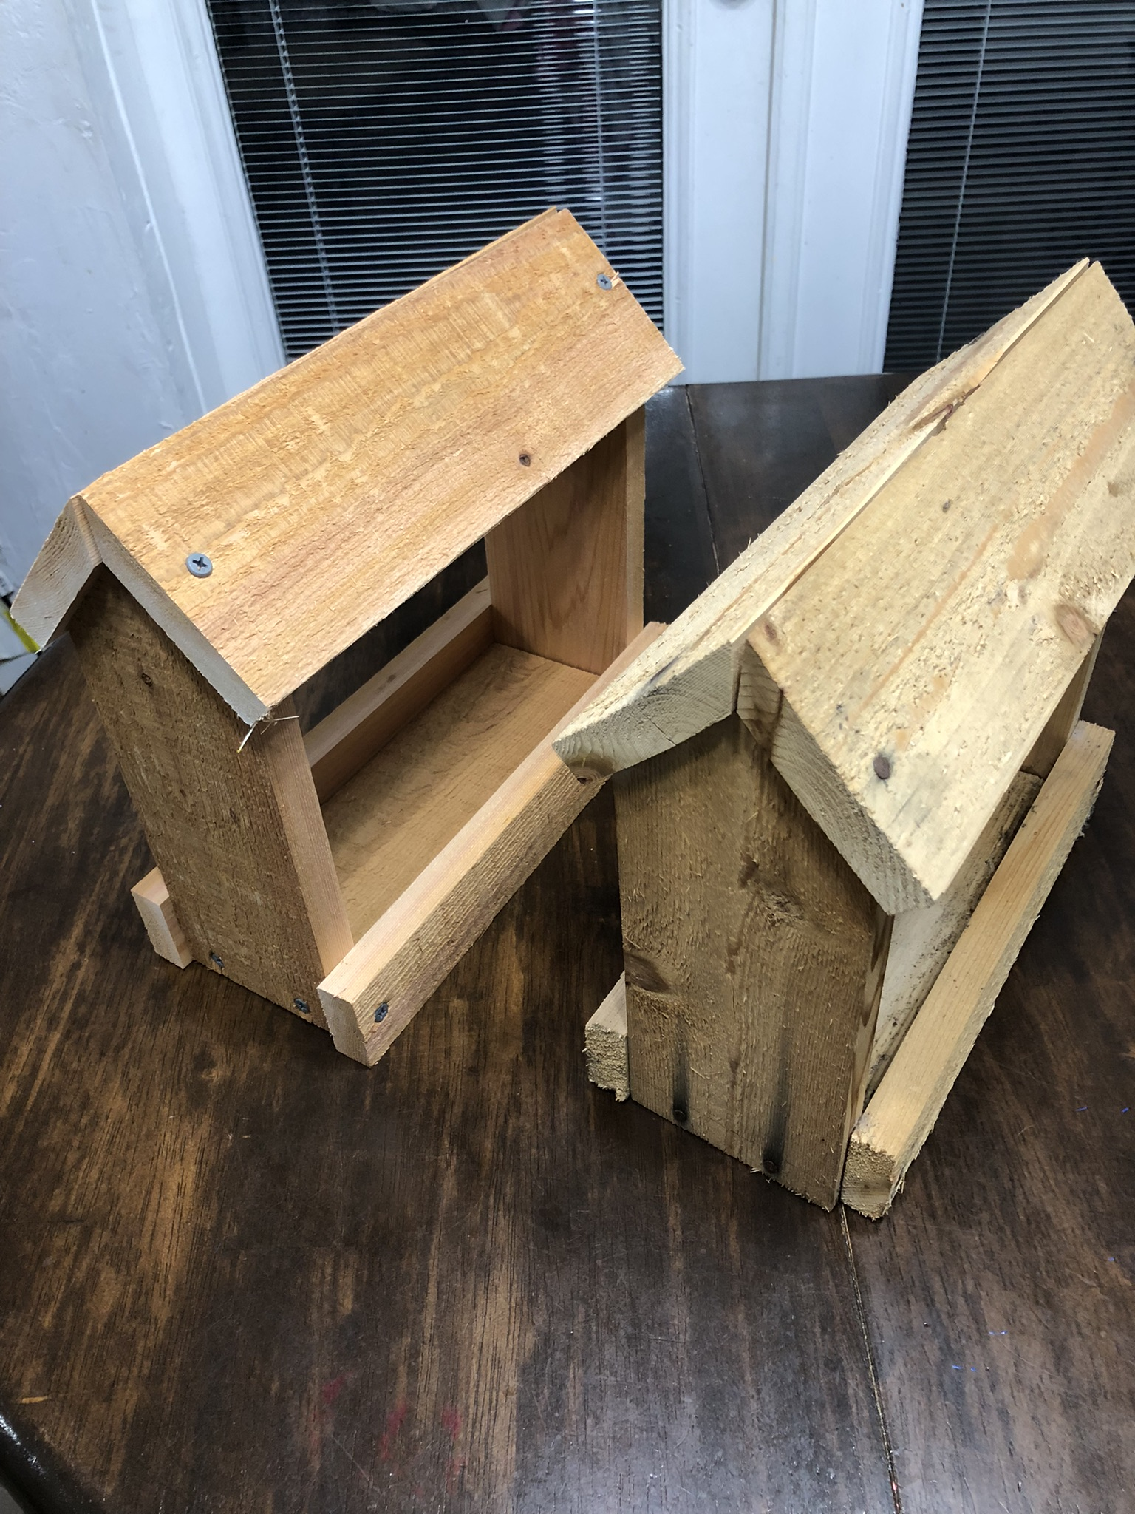

- Install the screw hook and hang.


Birdhouse Build Project Rubric (20 Points Total)

Criteria | Excellent (4 pts) | Good (3 pts) | Fair (2 pts) | Needs Work (1 pt)
Measurement Accuracy | All measurements precise within 1/16” | Most measurements accurate within 1/8” | Several cuts off by more than 1/8” | Measurements inconsistent, affecting assembly
Cut Quality | Clean, square cuts with no tear-out | Minor rough edges, mostly square | Multiple rough or uneven cuts | Cuts crooked, splintered, or unsafe
Assembly & Joinery | Pieces fit tightly with secure joints | Minor gaps but overall secure | Gaps visible, joints somewhat loose | Loose or unstable construction
Finish & Sanding | Smooth surfaces, edges rounded, no splinters | Mostly smooth, minimal roughness | Some rough areas or splinters | Rough surfaces, splinters present
Safety Practices | Consistently used PPE and safe tool handling | Minor lapses in safety practices | Multiple lapses in safety awareness | Unsafe tool use or missing PPE

Score /20

Shelf Build Plan.
Tools Needed: Saw (hand or circular), Level, Drill and Screws OR Hammer and nails.
Materials:
- ½” x 6” x 8 foot
- Nails/screws
- Wood glue (optional)
- Paint/stain (optional)

Step-by-Step Build:
- Cut 1 piece to 24” or 2 feet.
- Cut 1 piece 22.5”.
- Cut the 22.5” piece in half lengthwise.
- Cut a square 5.5” x 5.5”
- Cut it in half diagonally to make 2 triangles.

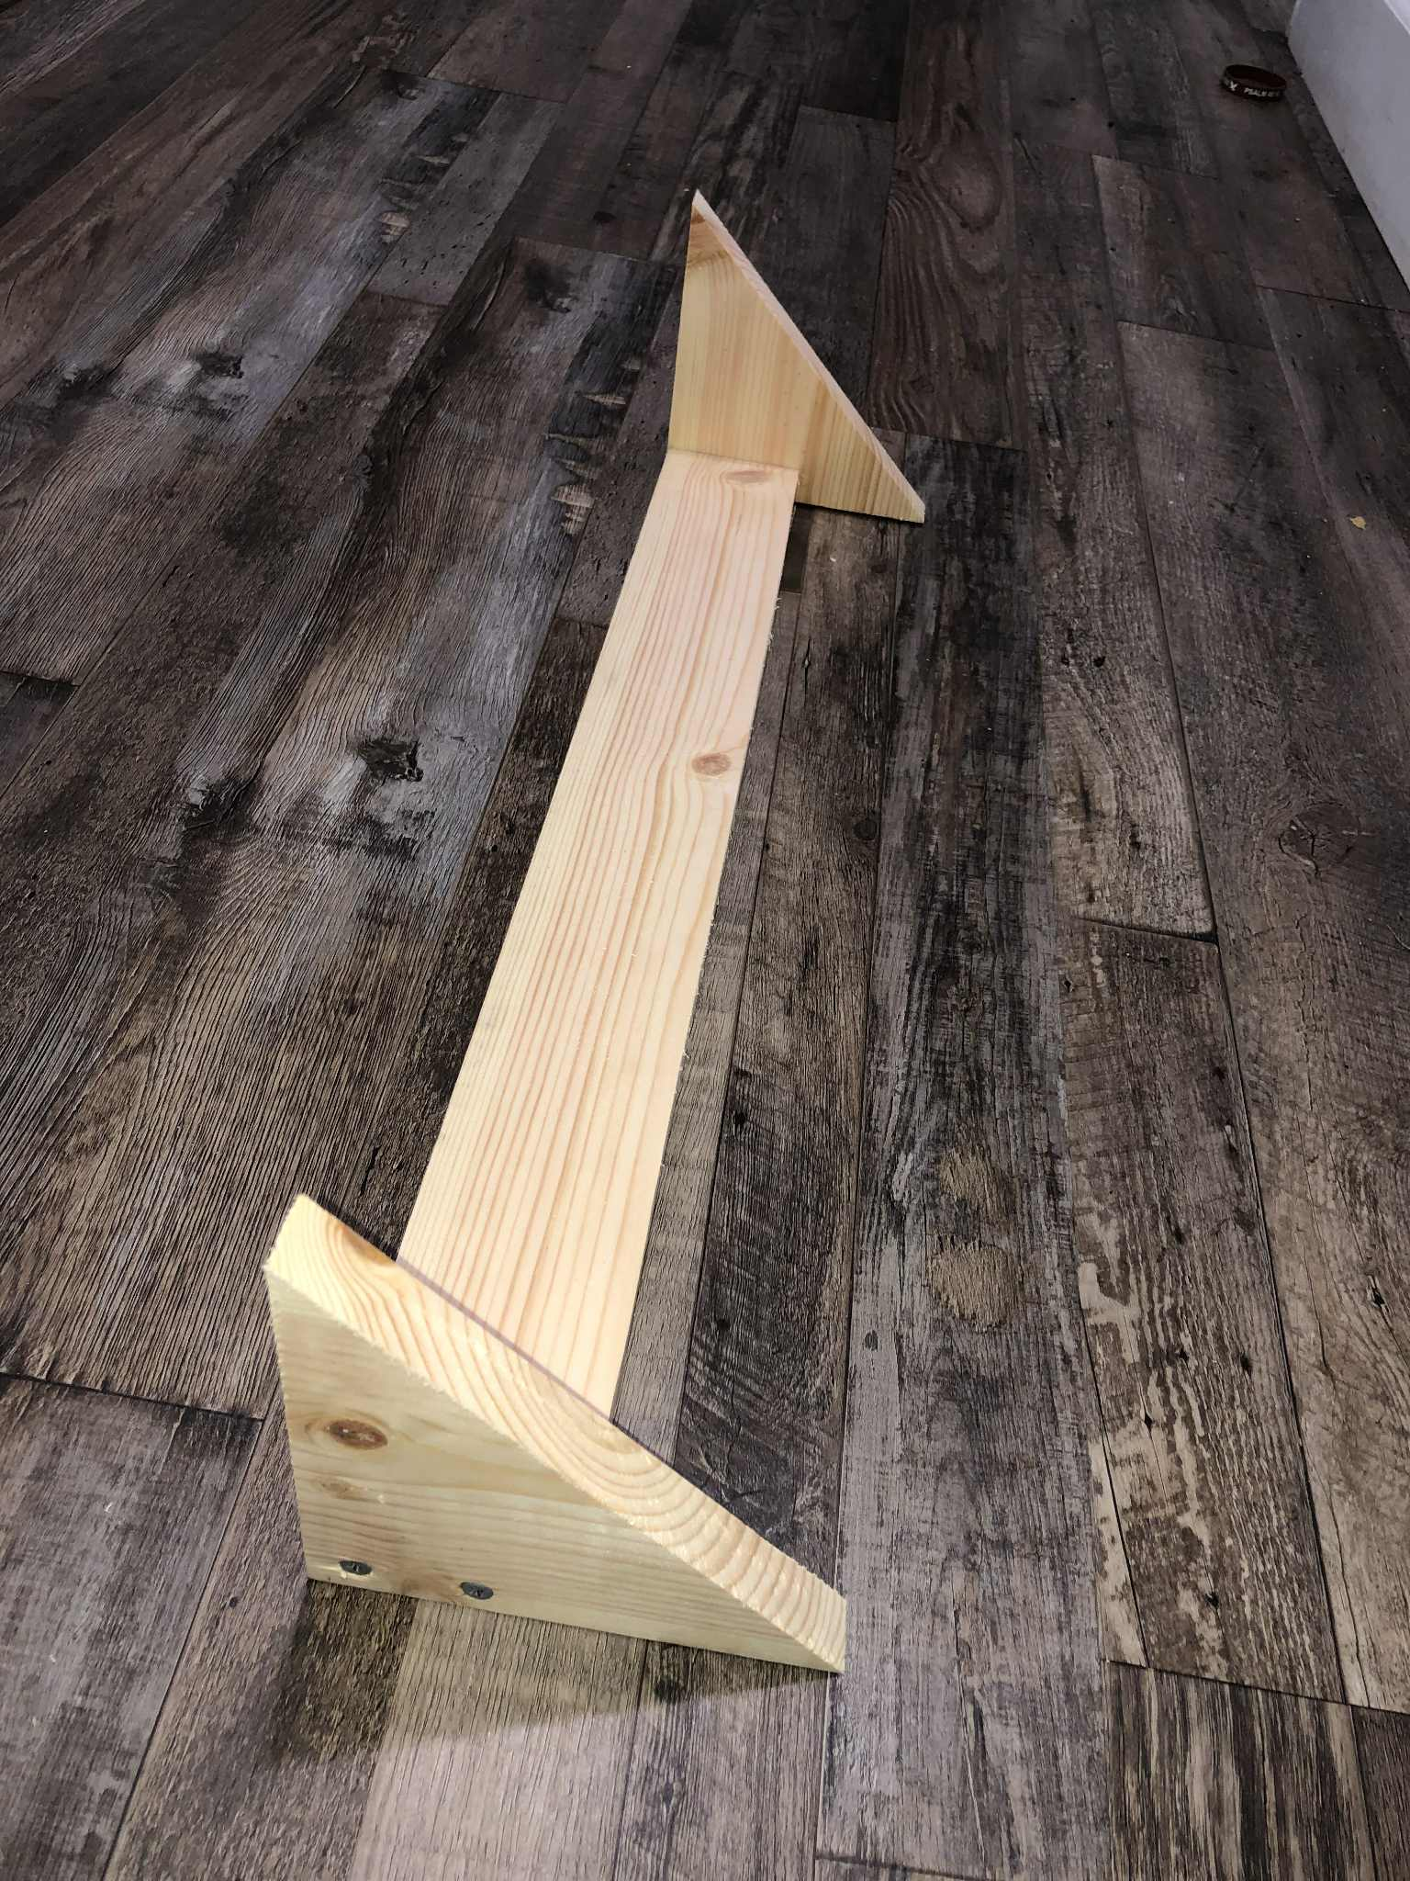
6. Sand all the edges.
7. NOTE: When using screws make pilot holes so the wood doesn’t split.
8. Attach the 2 triangles to the 22.5” piece. TIP: Use a flat surface.

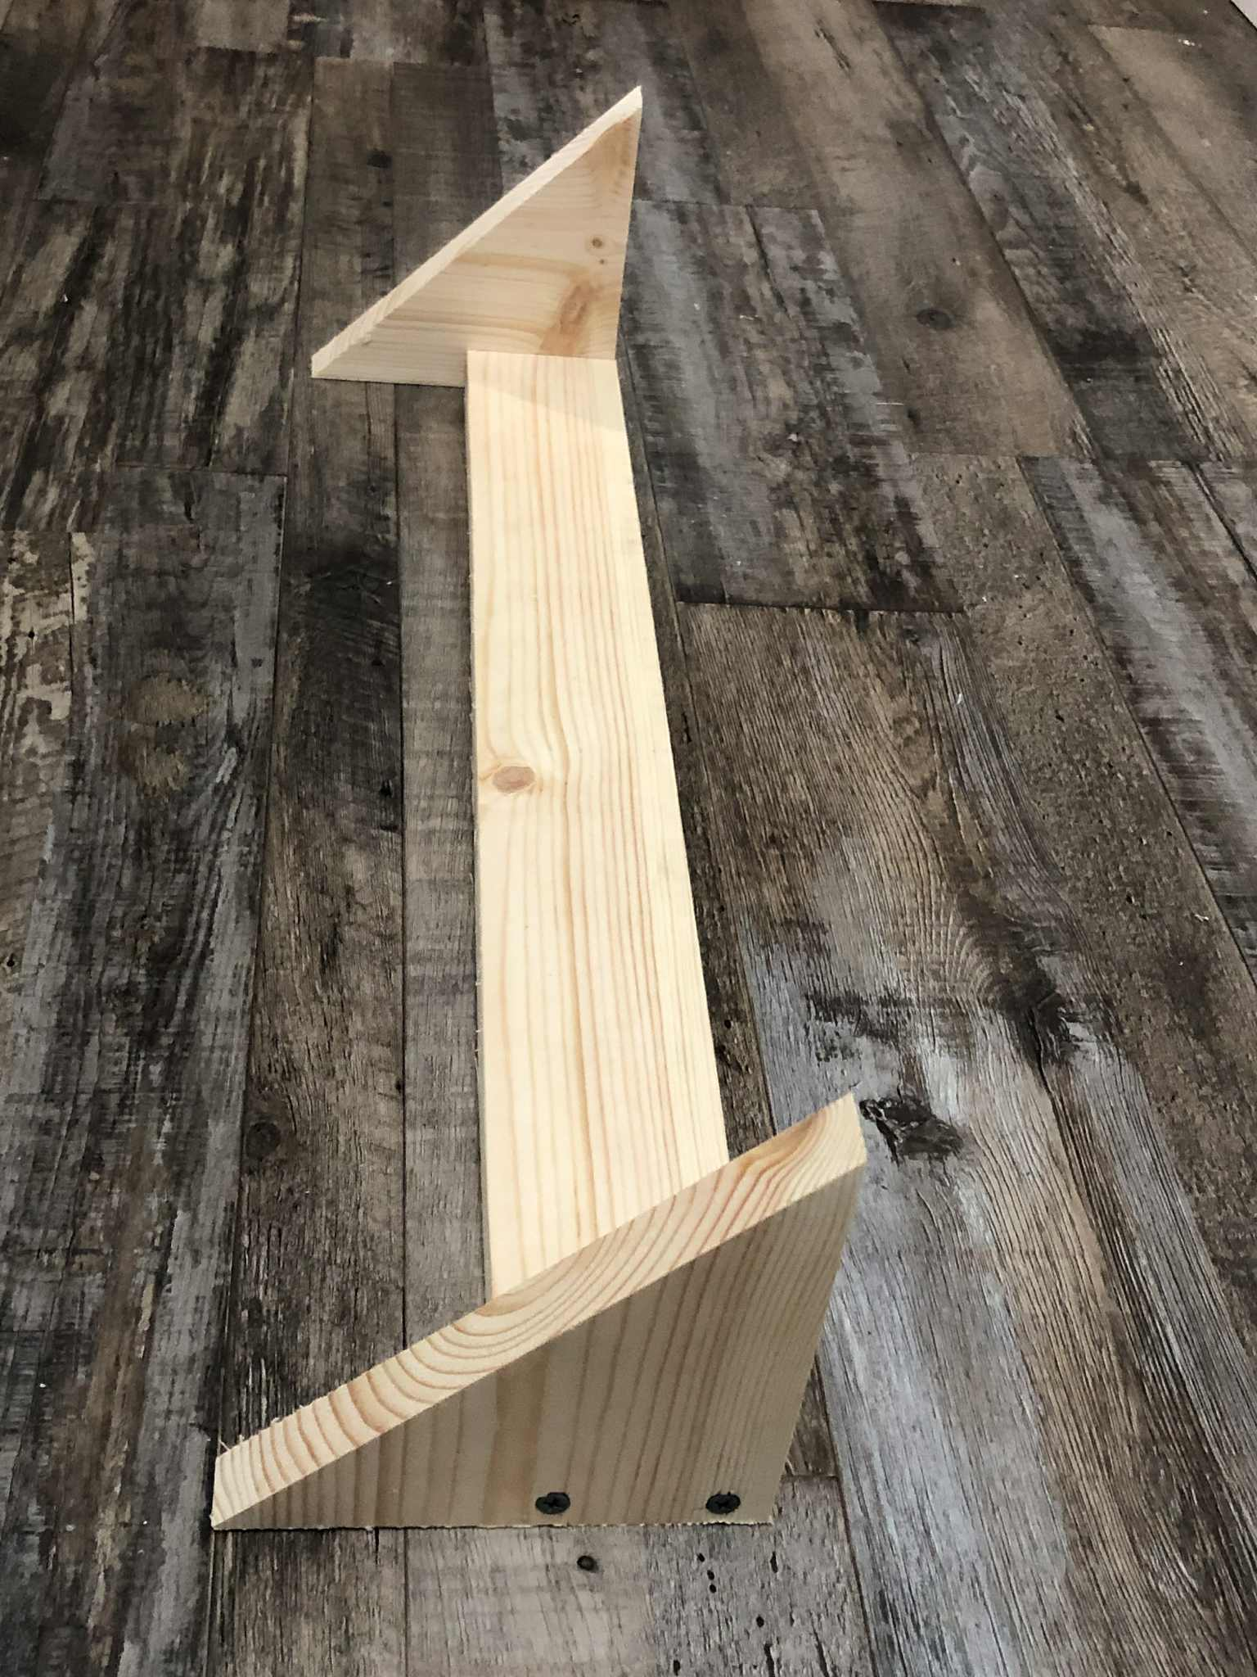
- Attach the top shelf part.

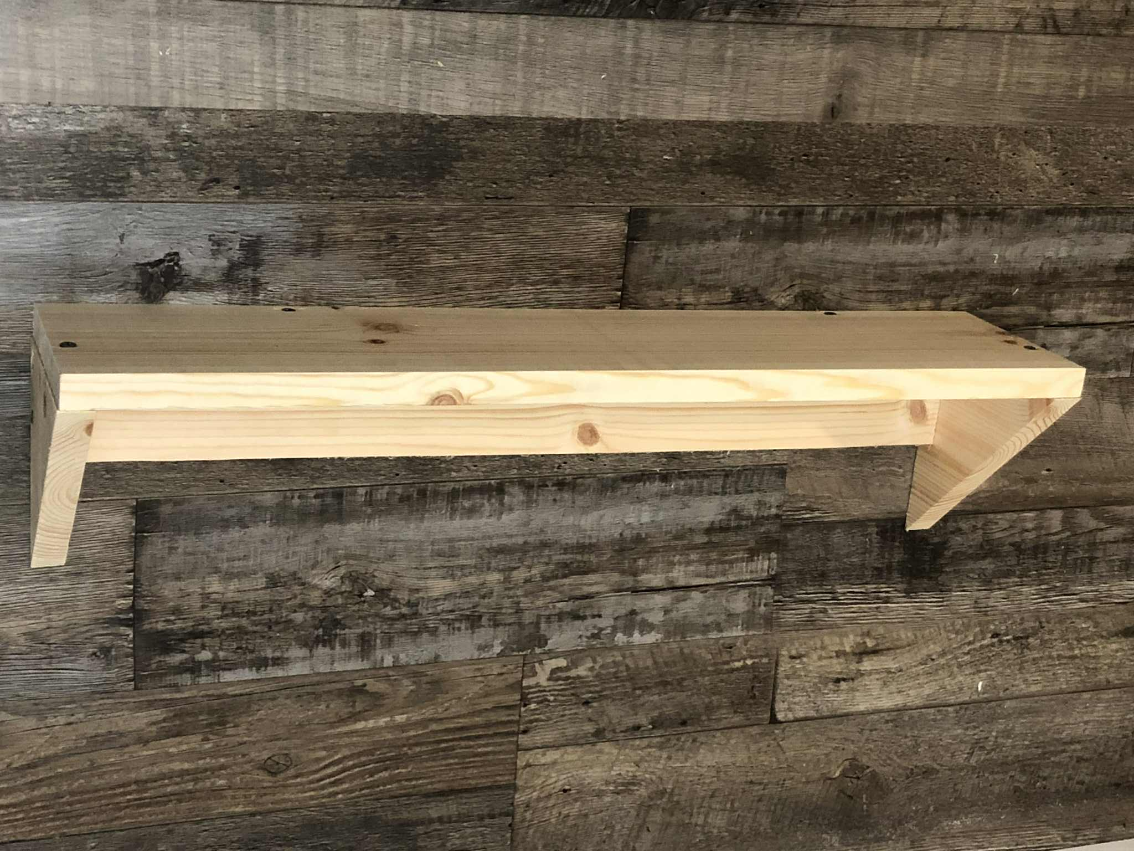
- Sand and caulk if needed.
- Paint or stain if desired.
- Attach to the wall. Locate stud for best results.

Shelf Project Rubric (20 Points Total)

Criteria | Excellent (4 pts) | Good (3 pts) | Fair (2 pts) | Needs Work (1 pt)
Measurement Accuracy | All measurements precise within 1/16” | Most measurements accurate within 1/8” | Several cuts off by more than 1/8” | Measurements inconsistent, affecting assembly
Cut Quality | Clean, square cuts with no tear-out | Minor rough edges, mostly square | Multiple rough or uneven cuts | Cuts crooked, splintered, or unsafe
Assembly and Joinery | Pieces fit tightly with secure joints | Minor gaps but overall secure | Gaps visible, joints somewhat loose | Loose or unstable construction
Finish and Sanding | Smooth surfaces, edges rounded, no splinters | Mostly smooth, minimal roughness | Some rough areas or splinters | Rough surfaces, splinters present
Safety Practices | Consistently used PPE and safe tool handling | Minor lapses in safety practices | Multiple lapses in safety awareness | Unsafe tool use or missing PPE

Score /20

- Reflect and review.
Pick a project and complete it.
1. Power Tool Safety Poster
Objective: Design a safety poster for a specific power tool.
Instructions:
- Pick one tool: Drill, Jigsaw, or Sander
- Make a half-page poster
- Include: Tool Name, One Safety Rule, and an Image or Drawing
- Bonus: Add a catchy safety slogan and decorate it!
2. Fix the Mistake - Safety Scenarios
Objective: Read the scenario and find the safety mistake.
Instructions: Write or explain what is wrong and how to fix it.
Example Scenarios:
1. Eli uses a jigsaw with one hand while holding the wood with the other. What’s wrong?
2. Maya drilled without safety glasses because it was a quick job. What’s the risk?
3. Jordan sanded wood without checking if the sander’s pad was damaged.
4. Alex plugs in the drill with wet hands.
5. Sam walks around swinging a plugged-in power tool.
3. Tool Talk: Interview a Power Tool
Objective: Pretend you’re interviewing a power tool.
Instructions: Pick one tool and answer the questions below as if the tool is speaking.
Tool Name: ______________________
1. What’s your name and what do you do?
2. What materials do you work best on?
3. What’s your biggest safety risk?
4. What should humans NEVER do when using you?

9. Safety Quiz

1. What should you always wear when using a power tool?
A) Sandals
B) Gloves only
C) Safety goggles
D) A backpack

2. What should you do before changing the blade on a jigsaw?
A) Test the blade first
B) Leave the tool plugged in
C) Unplug the tool
D) Turn the speed to high

3. What does a symbol with glasses mean?
A) Get a new pair of glasses
B) Wear safety goggles
C) No sunglasses allowed
D) Wear gloves

4. Why is it important to drill a pilot hole before using a screw?
A) It makes the tool louder
B) It helps the screw go in straight and prevents wood from splitting
C) It wastes time
D) You don’t need to

5. What should you check before using any power tool?
A) If it looks cool
B) If your friends are watching
C) That it’s clean, undamaged, and safe
D) If it has a sticker

6. What is the best place to set a power tool down?
A) On the floor
B) On top of another tool
C) Somewhere stable and clean
D) In your lap

7. Which tool is best for cutting curves in wood?
A) Orbital sander
B) Drill
C) Hammer
D) Jigsaw

8. What should you do if a tool sounds or feels strange?
A) Keep going
B) Hit it
C) Tell the instructor and stop using it
D) Use it faster

9. What is the purpose of an orbital sander?
A) To drill holes
B) To smooth wood surfaces
C) To cut angles
D) To measure wood

10. Why should you never wear loose clothing or jewelry while using tools?
A) It looks bad
B) It might get caught and cause injury
C) You’ll get sweaty
D) Tools are allergic

✅ Answer Key
1. C
2. C
3. B
4. B
5. C
6. C
7. D
8. C
9. B
10. B

