Week 10 - Final Carpentry Project: Build a Small Bench with Shelf

Project Duration:
6 hours

Skills Learned:
- Measuring and layout using a speed square and tape
- Cutting wood to length
- Drilling and fastening with screws
- Using wood glue for joints
- Sanding, edge finishing
- Installing trim or decorative edges

Materials Needed:
Per your design.

Project Steps:
During this final week it is your job to create a small bench with a shelf from scratch. You will be designing it, assembling it, sanding it, and adding finishing touches. At the end your teacher or parent will assess your work.

Hour 1: Design and Layout
- Design your bench.
- Review plans and measurements.
- Mark and cut all boards for top, shelf, legs, and supports.

Hour 2–3: Assembly
- Attach legs to the bench top using glue and screws.
- Add shelf between the legs at desired height.
- Install support braces underneath or behind for strength.

Hour 4: Sanding & Edge Work
- Round over edges with sandpaper or router.
- Fill screw holes, gaps with wood filler if needed.

Hour 5: Finishing Touches
- Apply stain or paint.
- Add trim or decorative touches.

Hour 6: Presentation & Clean Up
- Students present their bench and describe their process.
- Clean tools and workspace.

Optional Extensions:
• Carve or stencil student initials.
• Add small hooks or basket storage.

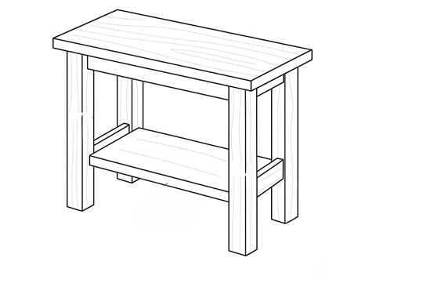
Here is an example of the project. Yours is not supposed to be an exact replica, instead we want you to use your imagination and come up with something that shows off all your new woodworking skills!

Project Rubric
Criteria | Excellent (4) | Good (3) | Fair (2) | Needs Work (1)
Accurate measurements and layout | All measurements and layout are precise. | Minor measurement errors; layout mostly aligned | Several measurement errors; layout somewhat uneven | Major errors in measurements and layout; does not follow plan
Assembly | All joints tight and square; structure is solid and stable | Slight gaps or minor misalignment; still stable | Noticeable gaps or uneven joints; stability somewhat compromised | Loose, unstable, or obviously crooked assembly
Clean sanding and finish work | All surfaces smooth; finish applied evenly and neatly | Minor rough spots or slight unevenness in finish | Several rough spots; finish uneven or blotchy | Rough surfaces throughout; finish poorly applied or missing
Creative design or add-ons | Unique, well-executed design features or functional enhancements | Some creative elements or small enhancements | Minimal creativity; mostly follows basic design | No creative features; plain and unmodified
Presentation | Clear, confident explanation with detailed steps and reasoning | Clear explanation with most steps described | Basic explanation with some missing details | Unclear or incomplete explanation of process

Score /20

