Worksheets for Week 1: Welcome to Carpentry.

1. Worksheet: 5 Things Carpenters Do
Instructions: Based on what you learned in the video, list five things that carpenters do in their jobs.
1.

2.

3.

4.

5.

2. Writing Prompt: Why I Want to Learn Carpentry
Instructions: In 4–6 sentences (or more), explain why you want to learn carpentry and what you hope to build or achieve.

3. Workshop Safety Contract

Student Name: ___________________________
As a student in the Intro to Carpentry for Teens course, I understand that safety is the top priority in the workshop. I agree to follow all safety rules, listen carefully to instructions, and use tools responsibly.

🔒 I promise to:
- Wear safety gear when required (goggles, gloves, etc.)
- Keep my workspace clean and tools organized.
- Follow all safety instructions from my instructor.
- Never run, horseplay, or use tools in an unsafe way.
- Ask for help if I am unsure about a tool or task.
I understand that unsafe behavior may result in being removed from an activity or the workshop.
Student Signature: _________________________
Date: ___________

Parent/Guardian Agreement
I understand the safety expectations for this course and agree to support my student in learning and using safe practices in carpentry.
Parent/Guardian Signature: _________________________
Date: ___________

4. Safety Quiz: Safe or Unsafe?

Instructions: Circle "Safe" or "Unsafe" for each scenario below.
1. A student wears safety goggles while using a saw. — Safe / Unsafe
2. Someone leaves a hammer on the floor in a walkway. — Safe / Unsafe
3. Wearing gloves when handling sharp wood. — Safe / Unsafe
4. Running in the workshop. — Safe / Unsafe
5. Unplugging a tool before changing blades. — Safe / Unsafe

5. Safety Poster.
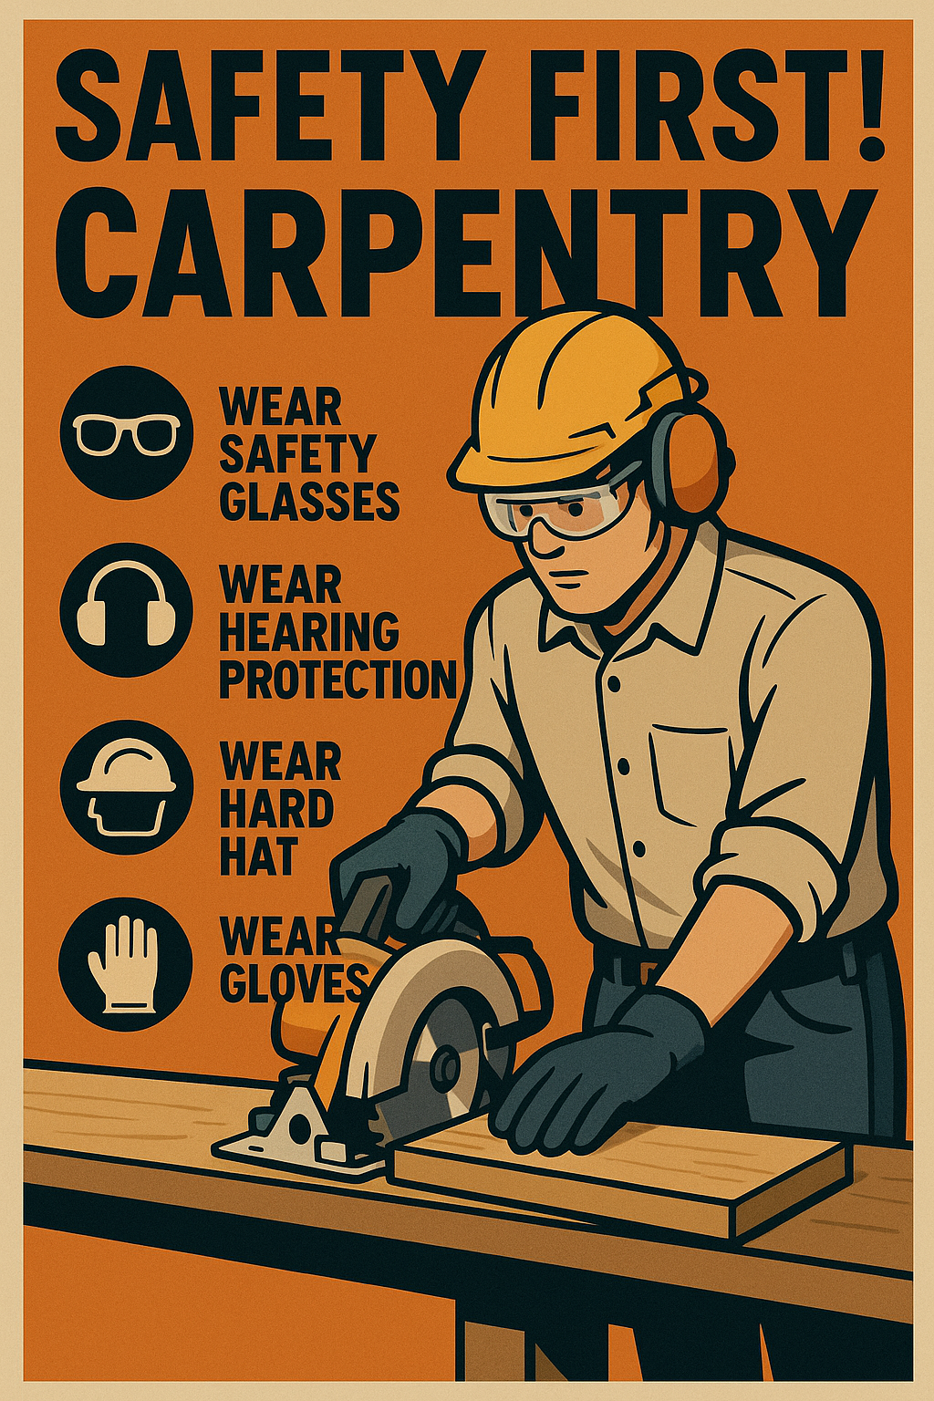

6. Tool ID Chart.

Tool Name | What It Looks Like | What It Is Used For
Allen Wrench | L-shaped hex key | Tightening or loosening hex screws (often in furniture)
Drill | Handheld tool with rotating bit | Making holes or driving screws into materials
Hammer | Long handle, flat metal head | Driving nails, removing nails, light demolition
Handsaw | Long blade with teeth and handle | Cutting wood or soft materials manually
Level | Flat tool with bubble tubes inside | Checking if something is straight or even
Pliers | Scissor-like with gripping jaws | Gripping, twisting, or pulling small objects or wires
Screwdriver | Handle with a straight or cross tip | Tightening or loosening screws (flathead or Phillips)
Tape Measure | Retractable metal measuring strip | Measuring length, width, or height of materials
Utility Knife | Small knife with retractable blade | Cutting cardboard, plastic, or light materials
Wrench | Metal tool with open or closed ends | Turning bolts or nuts to tighten or loosen

7. Tool ID.
Instructions: Match each tool to its correct name and use. Complete the table.

Tool Image | Tool Name | What It's Used For
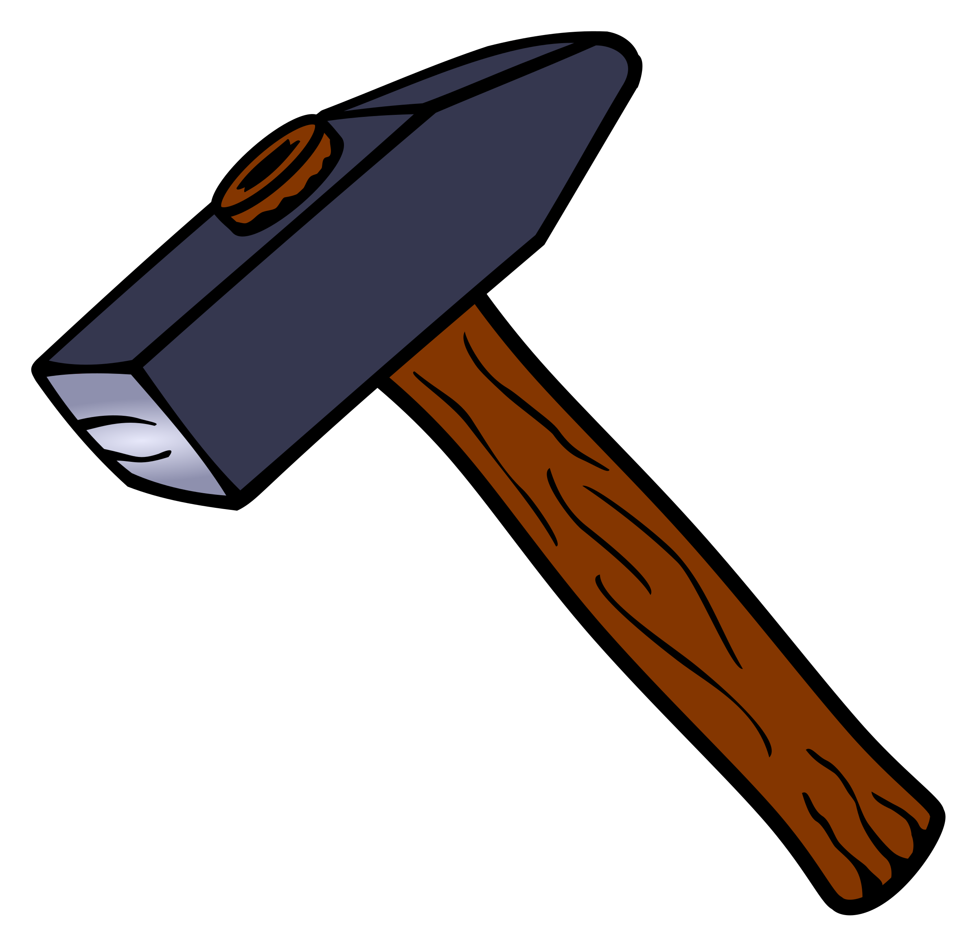
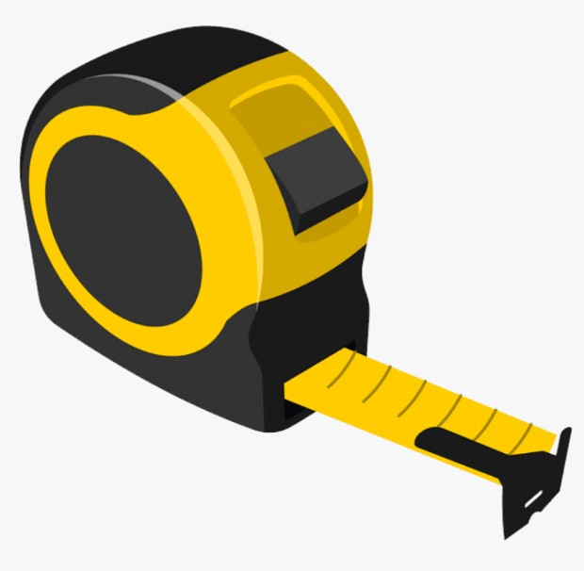
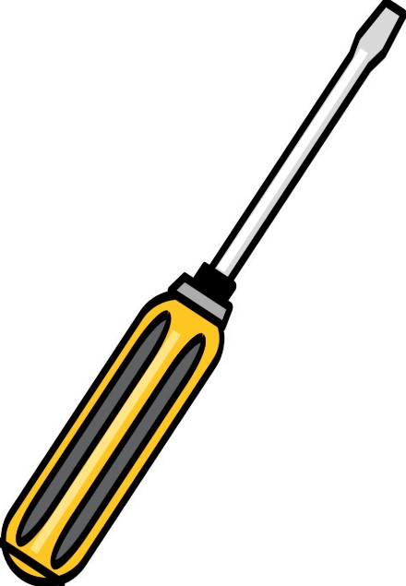
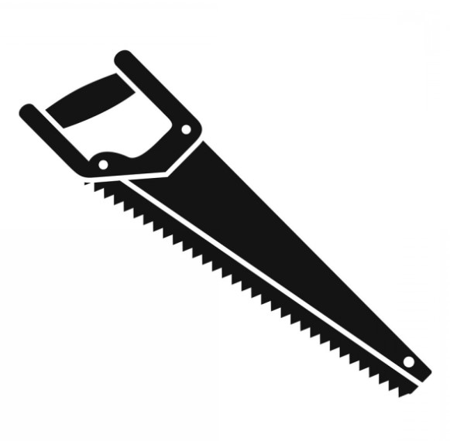
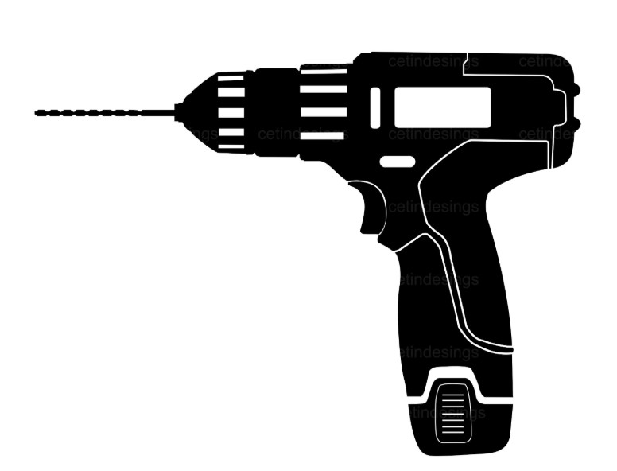
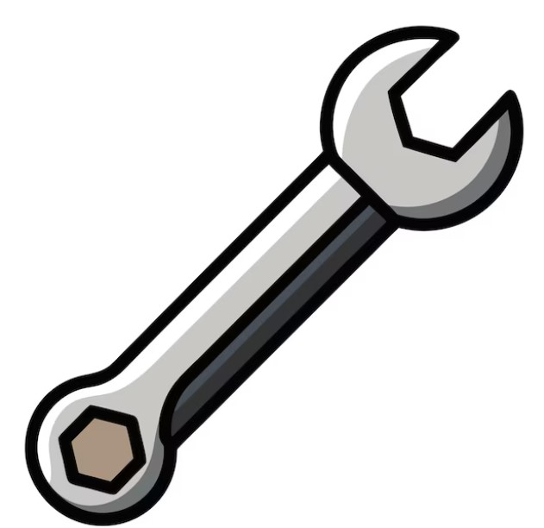
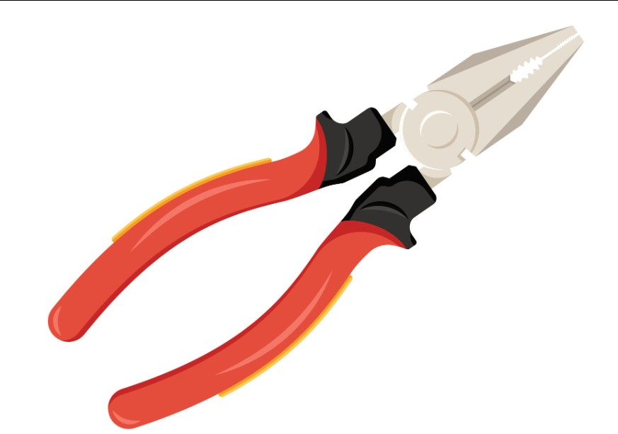
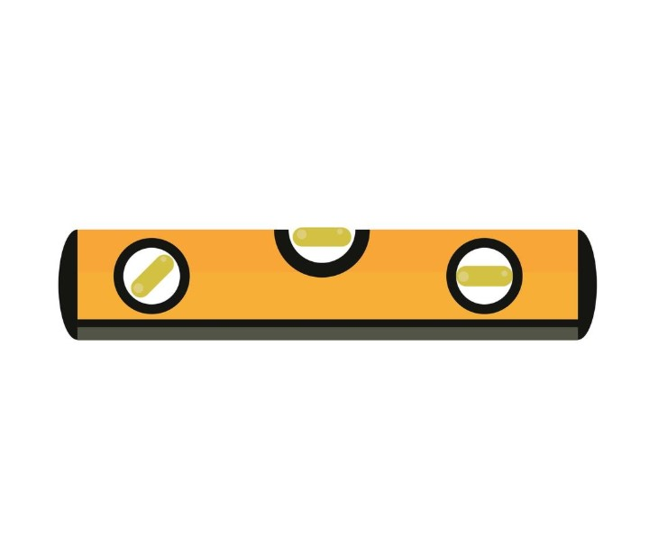
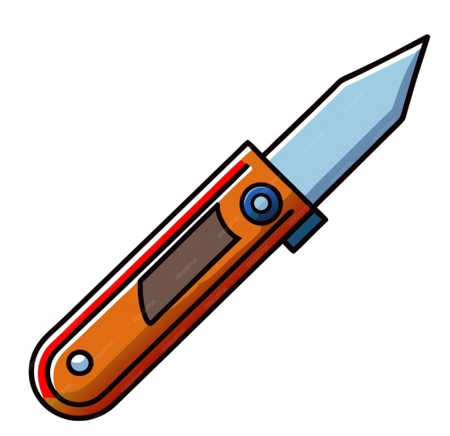
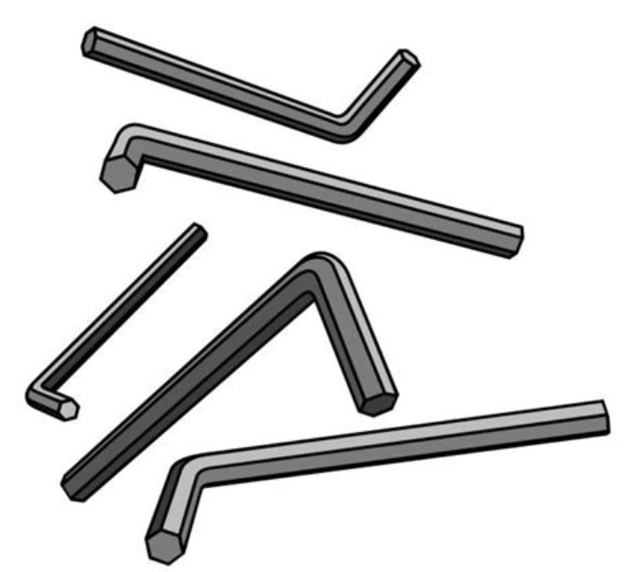

8. Introduction to Measurement Units: Inches, Feet, and Fractions

1. What Is an Inch?
An inch (in) is a small unit of length. It's commonly used to measure short distances like the width of a board or the length of a screw. There are 12 inches in one foot.
Most tape measures break inches down into fractions (like 1/2", 1/4", 1/8", 1/16") to allow for very precise measurements.

2. What Is a Foot?
A foot (ft or ′) is a bigger unit of measurement. One foot equals 12 inches. For example, a standard 2x4 board might be 8 feet long, or 8′ = 96 inches.
Feet are often used when measuring walls, floors, or other larger objects.

3. Understanding Fractions on a Tape Measure
Fractions help you measure parts of an inch. Here's a quick breakdown:
Fraction | Decimal | Description
1/2″ | 0.5 | Half of an inch
1/4″ | 0.25 | Quarter of an inch
1/8″ | 0.125 | One-eighth of an inch
1/16″ | 0.0625 | One-sixteenth of an inch

Quick Tips
- 1 foot = 12 inches
- Always start measuring from the zero mark on the tape, not the metal tab end.
- Learn to recognize fractions visually—this helps speed up your work.
Practice Questions
1. How many inches are in 3 feet?
2. What is half of 1 inch written as a fraction?
3. On a tape measure, what fraction comes after 1/4″?
4. Convert 2 feet into inches.
5. You measure a piece of wood and it is 1 foot and 6 inches long. How many total inches is that?
6. Label the following fractions from smallest to largest: 1/8″, 1/2″, 1/4″, 1/16″
7. Circle the correct answer: 12 inches = (a) 1 foot (b) 2 feet (c) 6 inches
8. A board is 36 inches long. How many feet is that?
9. If you cut a 1-foot board in half, how many inches is each piece?
10. What is the smallest fraction typically found on a standard tape measure?

Answer Key
1. 36 inches
2. 1/2″
3. 3/8″
4. 24 inches
5. 18 inches
6. 1/16″, 1/8″, 1/4″, 1/2″
7. (a) 1 foot
8. 3 feet
9. 6 inches
10. 1/16″

9. Creative Reflection: Draw Your Dream Tool or Workshop
Instructions: In the space below, draw your own dream tool or the workshop you’d love to build. Add labels or notes.

10. Build Your Carpenter’s Identity Board

Objective
Students will create a visual “identity board” that represents their introduction to carpentry, including their goals, favorite tools, safety reminders, and basic terminology they’ve learned so far.

Materials Needed
- Poster board or construction paper (11"x17")
- Glue sticks or tape
- Magazines (trades, DIY, construction)
- Printed images of tools, job sites, safety gear (optional)
- Scissors and markers
- Handout: List of basic carpentry terms and safety rules (for reference)

Instructions
- Title Section: Write your name and the title 'My Carpentry Journey Begins'.
- Career Corner: Add images or words that represent carpentry jobs you’re interested in.
- Tool Zone: Choose 5 basic tools, draw or paste them, and label each.
- Safety Reminder: Write or illustrate one important safety rule you’ll always remember.
- Vocabulary Zone: Include at least 3 new carpentry terms and definitions you’ve learned.
- Goal Box: Write one personal goal for the course.

Outcomes
- Students deepen understanding of course material.
- Encourages personal reflection and motivation.

