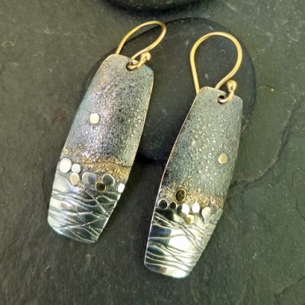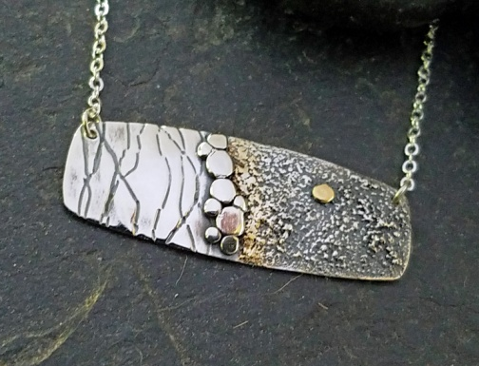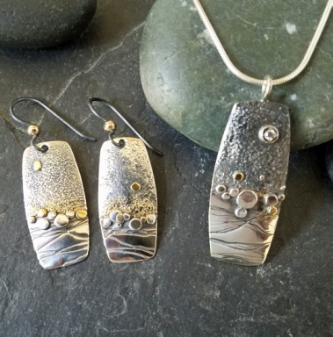
Starry Starry Night ONLINE by April Bower
fused dust and pebbles pendant & earrings in Argentium silver and 18K gold.
Intermediate level, you must be comfortable with a torch
Create coordinating earrings and pendant in Argentium Silver, known for its wonderful fusing properties with 18k yellow gold accents. Learn how to create and successfully fuse the metal dust for texture and dimension, contrasting with rolled texture and fused "pebbles" in both silver and gold. Fusing, forming, finishing, burnishing and patination will be addressed
Minimum amount of metal for creating these projects
(ARSS= Argentium Sterling Silver (or AS)
24g ARSS sheet Rio# 108224 3"x1.5" *for forms and dust filed off edge. 24g is good for earrings or even pendant. A ring top would need 18g or close. (You will probably have to order 1”X6” or 1.5”x6” as it is sold in 6” width)
16g round ARSS wire for pebbles 12"length * these could be instead made of Argentium scraps in various sizes
.925 earwires w/ GF. bead 1 pair/ student * or make your own
18g 3mm sterling or AS jump rings 2 per horizontal pendant * if desired OR
18g ARSS round wire 6” for bail options
18K Yellow Gold sizing stock 1mmx3mm Rio# 604521 1/2" minimum for dust and moons * 22k is even better, but do not choose casting grain as it has additives (zinc) that make fusing less successful.

YOU WILL ALSO NEED:

3 cans or small lidded containers for dust and granules
oil can type flux dispenser for Yellow or Purple Flux *You could paint it on with a small artists brush
Yellow Aqua Flux , Batterns, MyT flux or Rondas Purple Flux will all do. Not white paste flux
Wax spatula or small scoop for dust
parchment paper sheet to collect dust particles
1 yard of 26 g steel binding wire and an index card for texturing use whatever you have
burnisher, 1.5" curved prefered
side cutters for granule making
forming block in wood like Whammer or swage block * sand bag and cork or hammer handle will make do
brass scratch brush
6”x6” clean solderite board or newish (flat) charcoal block for fusing surface
Charcoal block for granule making surface.

Starry Starry Night online workshop by April Bower

Studio supplies needed to complete the project

Hand tools
- bench pin
- bench block
- side cutters to cut wire for granules
- metal shears
- vise grip pliers, any size will do
- Jewelry flat or half round file and sanding sticks to smooth edges
- fine tweezers
- burnisher, curved tip preferred
- sharpie, fine tip
- hole punch pliers (1mm) or # 55 drill ( or close) for ear wire hole
- Coarse flat 6" or larger flat file with handle. Flat Bastard or wood file (see About Files handout)
- sand bag or wood forming block
- scratch brush
- Planishing hammer for flattening granules & mallets for forming
- Bar keepers friend or pumice for cleaning metal and a liquid cleaner; dish soap or Mr. Clean type
- rubber gloves, kitchen type works well
- fine sand sponge or green scratch cloth to preclean the metal
- an extra large Foil Lasagna type pan or a metal cookie sheet with Parchment paper sheet liner to catch filings
- a clean dry paint brush to sweep up filings and a business card or index card to use as dust scoop.
- A small soft artists paintbrush to clean up dust/ flux application ( inexpensive)
- clean shop rag or paper towels
- Masking tape
- safety glasses

Studio Tools
Torch. I use Eurotool Handy Flame butane for fusing, but use what you have. Larger bushier flame is better than small pinpoint flame. Your acetylene and air torch should work well with a medium/ small tip (#1). A Smith “little” will do, use a large tip with a softer flame. (See Torch video)
Solder station: Heat safe area with cookie sheet or Fire brick or annealing tray & solder pick and tweezers. A clean flat solderite board (preferred for fusing) & charcoal block to melt granules on. * they now recommend charcoal block for fusing the new 940 Argentium rather than solderite board
Pickle and rinse water. and a simple dish of water for washing and rinsing metal if no sink.
flux: like Batterns, Rio My T flux, Aquaflux. (the clear yellow or purple or orange stuff, not white paste flux)
patina: Your favorite blackener: Liver of Sulfur, Goshiba, Jax, Black Max
Rolling mill; flat or combo. *You could replace the rolled texture with a stamped or hammered if no rolling mill.
Polishing lathe or flex shaft for clean up and polishing * steel wool and pro polish pad will do as a minimum.

