Week 6 Worksheets.

Fasteners.

What Are Fasteners?
Fasteners are hardware devices used to mechanically join or secure two or more objects together. They’re essential in carpentry, construction, and furniture building.

Common Types of Fasteners

Fastener | Description | Common Uses
Nails | Thin metal shafts with a flat head; driven with a hammer or nail gun | Framing, trim work, sheathing
Screws | Have threads for gripping wood or other materials; driven with screwdriver/drill | Cabinets, furniture, decking
Nuts and bolts | Bolts go through material and are secured with nuts on the opposite side | Structural joints, heavy-duty builds
Lag Screws | Heavy-duty screws with hex heads, used with pilot holes | Decks, beams, outdoor framing
Brads | Small, thin nails with small heads | Finish work, trim, delicate assemblies
Staples | U-shaped fasteners used with staple guns | Upholstery, paneling, lightweight materials
Wood Dowels | Cylindrical wooden rods used in joinery | Cabinetry, furniture joints
Pocket Screws | Angled screws used in pre-drilled pocket holes | Hidden joints in furniture and cabinetry

Fastener Material Types.
- Steel (most common) – strong and economical
- Galvanized – zinc-coated for rust resistance (great for outdoor use)
- Stainless Steel – rust-proof and durable, but more expensive
- Brass/Copper – decorative and corrosion-resistant

Tips for Choosing the Right Fastener.
- Match fastener length to the material thickness
- Use coated or galvanized fasteners for outdoor use
- Pre-drill pilot holes for hard woods or long screws to prevent splitting
- Use washers with bolts for better load distribution
- Choose appropriate head types (flat, pan, hex, etc.) for appearance and tool access

Fasteners Quick Quiz

Instructions: Match each fastener description to its correct name.
A. Nail
B. Screw
C. Bolt
D. Wood Glue
E. Dowel
1. _____ Used with a nut to hold pieces tightly together; often used in furniture.
2. _____ Thin metal shaft with a flat or pointed tip, driven by hammer.
3. _____ Adhesive used to join two surfaces of wood permanently.
4. _____ Cylindrical wooden rod used in joinery for hidden connections.
5. _____ Twisted metal fastener that holds tight when driven with a driver tool.
⭐ Bonus: Which fastener would you use to attach two wooden boards for a shelf and why?

Creative Joinery Sketch Challenge.

Design a simple wooden item using at least TWO types of joints. Label each joint and explain why you chose it.
Sketch Area:

Explain your design:

- Build Sample Joints.
Objective
Build and evaluate at least two types of basic wood joints from home, and reflect on the process and strength of each.
Instructions
Follow these steps. Use the checklist below to track your progress.
✅ Student Checklist
☐ Watch the short video demo on wood joints
☐ Gather your materials: 3–4 small wood pieces, glue or screws, dowels (optional), tools (clamp, screwdriver, etc.).
☐ Build 2 sample joints (choose from: Butt, Lap, or Dowel).
☐ Label each joint with its name and fastening method.
☐ Take a picture of each joint.
☐ Complete the reflection questions.

Reflection Questions
1. Which joint felt strongest during your build? Why?

2. Which joint was easiest to make? Why?

3. Where do you think each joint could be used in real life?

Glue Strength Test

Objective
Conduct a glue strength challenge at home and determine when glue alone is sufficient compared to nails or screws.

Instructions
Follow the instructions below to complete your glue strength test. Use the checklist to keep track of your progress.

✅ Student Checklist
☐ Watch the instructional video on how to apply wood glue and prepare test joints (link provided by instructor).
☐ Gather materials: 2 small wood pieces, wood glue, clamps (or heavy books), and a way to test strength (weights, books, or hand pull).
☐ Apply glue to join two pieces of wood. Clamp and allow to dry for at least 30 minutes.
☐ Test the strength of the joint using weights or by carefully pulling the pieces apart.
☐ Take a photo or video of your test.
☐ Complete the reflection questions and upload your results to the class folder.

How to Apply Wood Glue
Follow these steps to apply wood glue properly and create strong joints:
1. Dry Fit First – Assemble the pieces without glue to check fit and alignment.
2. Surface Prep – Ensure surfaces are clean, dry, and smooth. Sand if necessary.
3. Apply the Glue – Apply a thin, even bead of glue and spread it across the surface.
4. Clamp the Joint – Use clamps with moderate pressure; clean off excess glue with a damp cloth.
5. Wait for Curing – Clamp for at least 30 minutes (longer for strong bonds). Full cure: up to 24 hours.

Preparing Test Joints
Use test joints to practice gluing techniques or check glue strength before final assembly.
Common Test Joint Types:
- Edge-to-Edge Joint: Glue long edges together to create a wider panel.
- Butt Joint: One board glued flat to another’s face or edge.
- Miter Joint: Two angled cuts (e.g., 45°) joined together.
- Lap Joint: One piece overlaps another partially to increase surface contact.
Steps to Prepare Test Joints:
1. Cut small wood samples (4–6 inches) for each type of joint.
2. Apply glue and clamp each joint as described above.
3. Label each joint type clearly.
4. After curing, test strength by gently pulling or applying pressure.

Reflection Questions

1. How well did your glued joint hold up during testing?

2. Did it break easily or hold strong under pressure?

3. In what situations do you think glue alone is enough?

4. When would you recommend adding screws or nails?

Project Rubric: Wood Glue and Joint Preparation
Use this rubric to assess student understanding and execution of glued wood joints.
Criteria | Excellent (4) | Good (3) | Needs Improvement (1–2)
Joint Accuracy | All joints correctly named and match their descriptions. | Most joints named correctly; minor confusion. | Few or no joints labeled correctly or unclear answers.
Gluing Technique | Glue applied evenly with proper clamp pressure; no excess. | Minor glue inconsistencies; mostly well clamped. | Messy or uneven glue; poor clamping technique.
Construction Effort | Neat cuts and clean assembly; clear attention to detail. | Some rough edges or misalignment but functional. | Sloppy construction; lacks care or completion.
Safety Practices | Followed all safety rules; wore proper PPE; cleaned up. | Minor safety reminders needed. | Disregarded safety expectations or cleanup.
Reflection Quality | Thoughtful and complete answers to all reflection questions. | Most questions answered with basic understanding. | Incomplete or vague reflection responses.
Total Score: ____ / 20
Comments:

Project Plan: Build a Small Stool or Crate

Objective
Apply your skills in measuring, cutting, joining, and finishing to build a small stool or crate.

Materials Needed
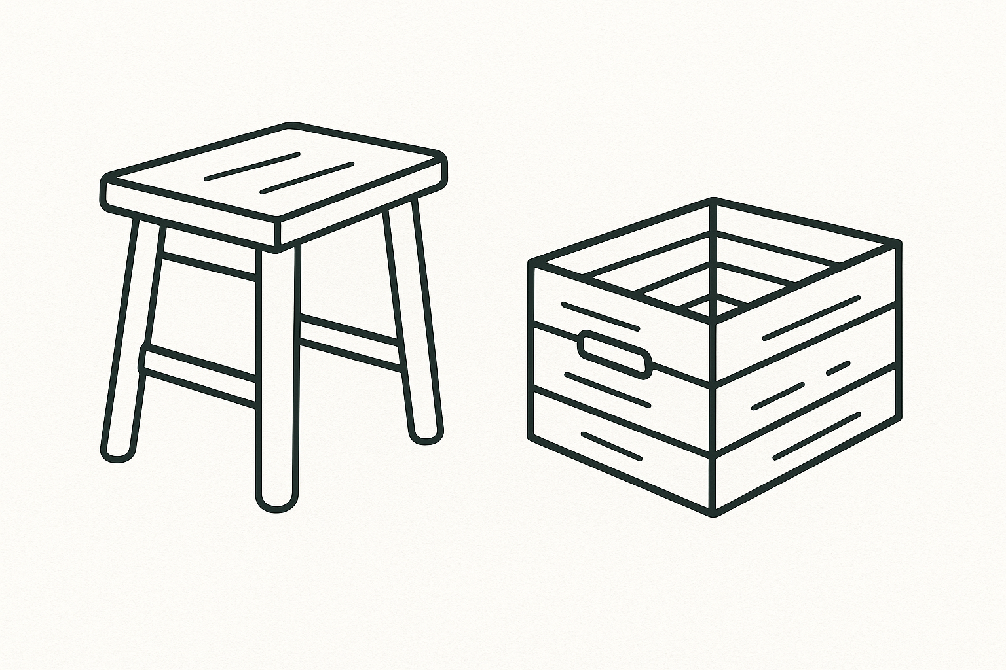
• Wood pieces (based on your design)
• Screws or nails
• Wood glue
• Drill or screwdriver
• Measuring tape or ruler
• Saw (hand saw or circular saw)
• Clamps (optional)
• Sandpaper
• Wood finish or paint (optional)

✅ Project Steps & Checklist
☐ Sketch your design and take measurements.
☐ Create a cut list based on your design.
☐ Measure and mark your wood pieces.
☐ Cut the wood using a handsaw or circular saw.
☐ Assemble the pieces using appropriate joinery (butt joints, glue, screws).
☐ Clamp and let glue dry, if used.
☐ Sand all surfaces for a smooth finish.
☐ Apply paint or wood finish (optional).

Reflection Questions
1. What part of the project was the most challenging?

2. What did you enjoy most about the build?

3. If you could do it again, what would you change or improve?

Rubric: Small Stool or Crate Project
This rubric evaluates performance in design, construction, and craftsmanship.
Criteria | Excellent (4) | Good (3) | Needs Improvement (1–2)
Planning and Measurements | Detailed and accurate measurements; thoughtful design and layout. | Mostly accurate measurements; design is functional. | Measurement errors; unclear or incomplete planning.
Cutting Accuracy | Cuts are clean, precise, and square. | Minor imperfections; generally clean cuts. | Rough, uneven, or misaligned cuts.
Joinery and Assembly | Joints are secure, well-aligned, and show strong construction. | Some joints slightly misaligned but overall stable. | Loose, weak, or misaligned joints; poor construction.
Finishing | Smooth sanding and clean finish; no visible glue or defects. | Minor flaws in sanding or finish; mostly clean work. | Finish is rough or incomplete; visible glue or defects.
Work Habits and Safety | Worked independently, followed all safety rules, and maintained clean area. | Followed most safety guidelines; few reminders needed. | Unsafe behavior or poor workspace maintenance.
Total Score: ____ / 20
Comments:

