Week 2 Worksheets.

1.Journal Prompt
Why does precision matter in carpentry?

2. Worksheet: Label the Parts of a Tape Measure
Instructions: Use the word bank to label each part of the tape measure in the image below.
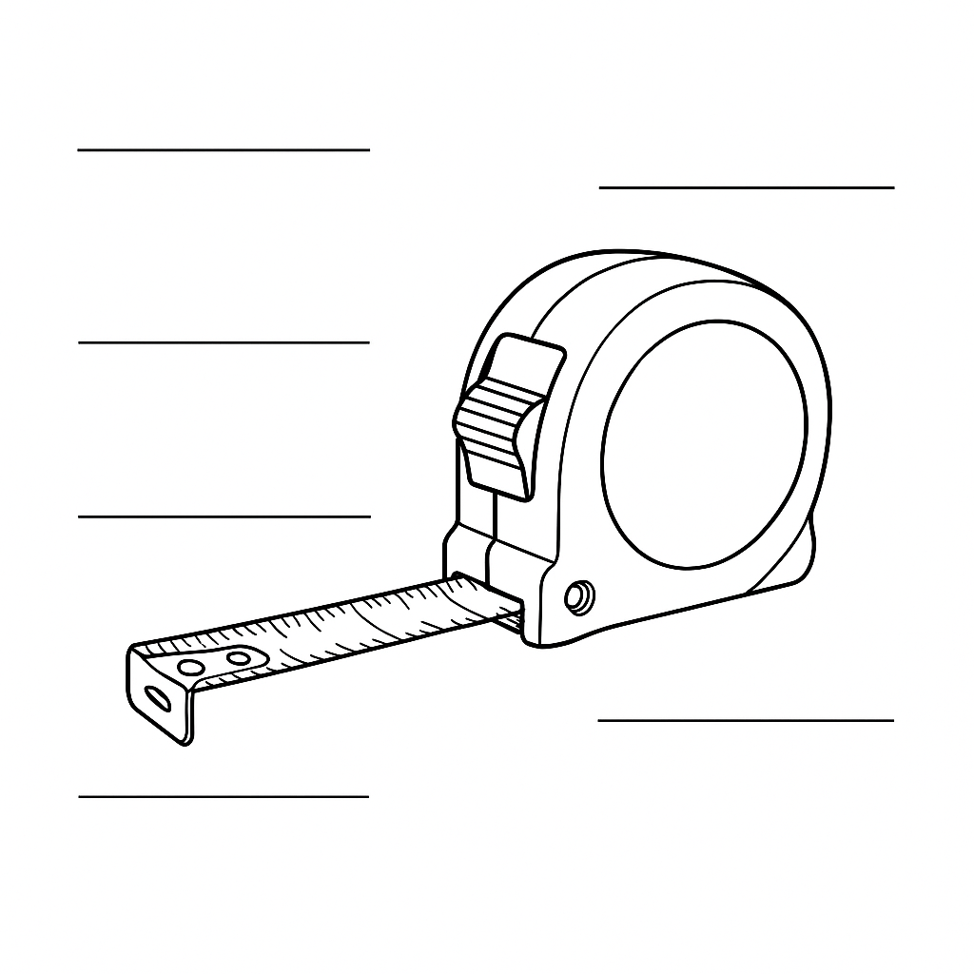

Word Bank: Hook, Lock, Blade, Housing, Belt Clip, Measurement Markings

3. Practice Activity

Students: Practice measuring different objects around the room using a tape measure. Record your measurements below.
1. Object: ______________________ | Length: ______________________
2. Object: ______________________ | Length: ______________________
3. Object: ______________________ | Length: ______________________
4. Object: ______________________ | Length: ______________________
5. Object: ______________________ | Length: ______________________

4. Name That Square
Instructions: Look at each square tool below. Write the correct name and describe its purpose.

. 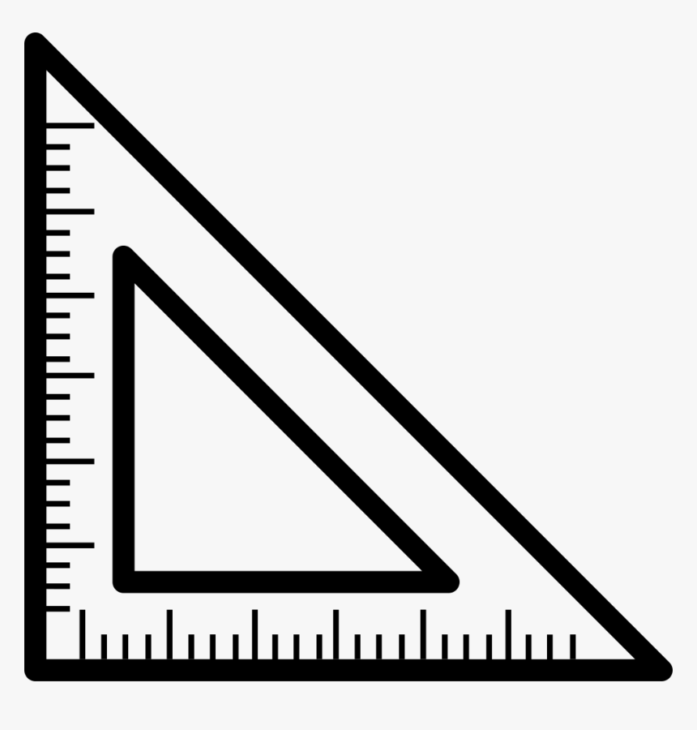
Name: ___________________________
What it’s used for: __________________________________________________

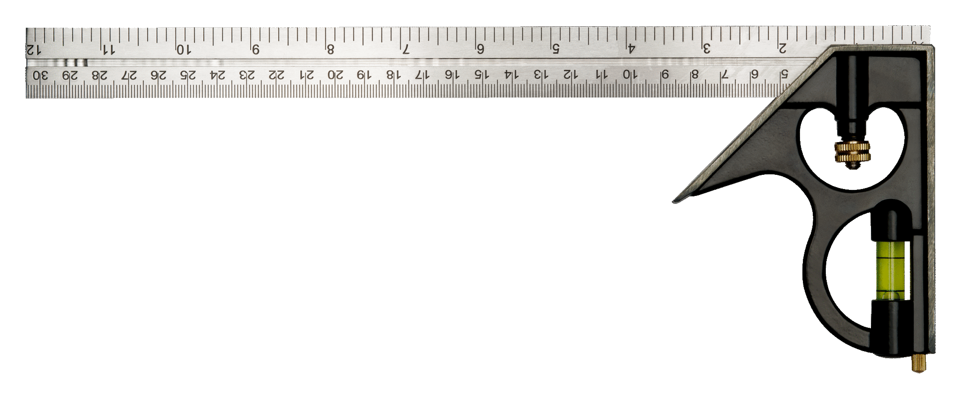
Name: ___________________________
What it’s used for: __________________________________________________

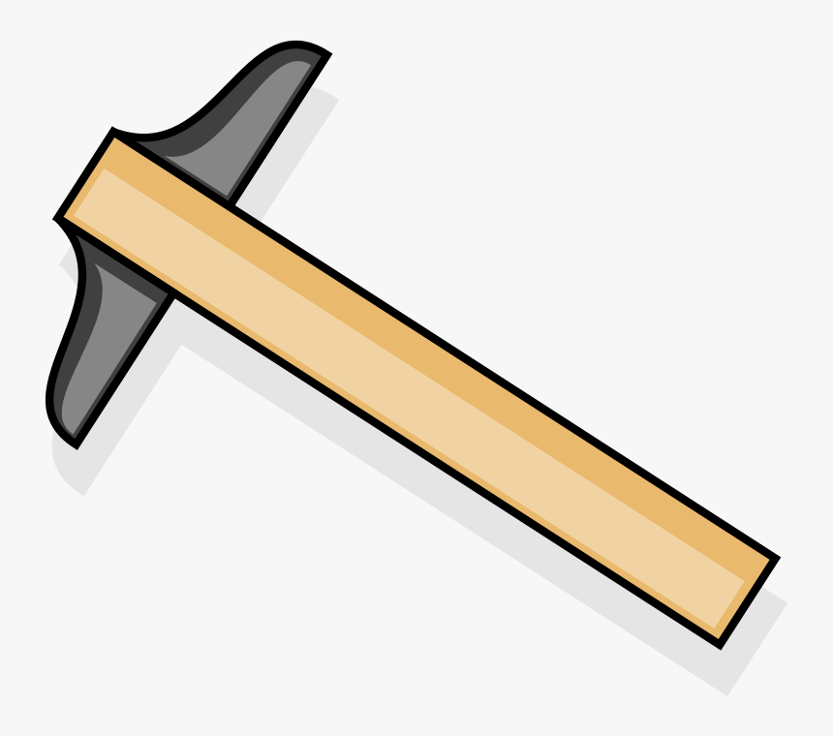
Name: ___________________________
What it’s used for: __________________________________________________

5. Practice Marking 90° Lines

Objective:
Students will use a square tool (such as a speed square or combination square) to draw precise 90° lines—essential in almost all woodworking projects.

Materials Needed:
• Pencil
• Ruler or measuring tape
• Speed square or combination square
• Paper or small pieces of wood
• Flat work surface

Instructions:
1. Start with a straight edge (the side of your paper or a wood scrap).
2. Place the square tool against the edge so one arm sits flush.
3. Use a pencil to draw a line along the other arm of the square—this creates a 90° angle.
4. Repeat at different points and on different surfaces to build confidence.

Skills Reinforced:
• Understanding right angles
• Tool positioning and handling
• Accuracy in layout work
• Preparing for real project cuts

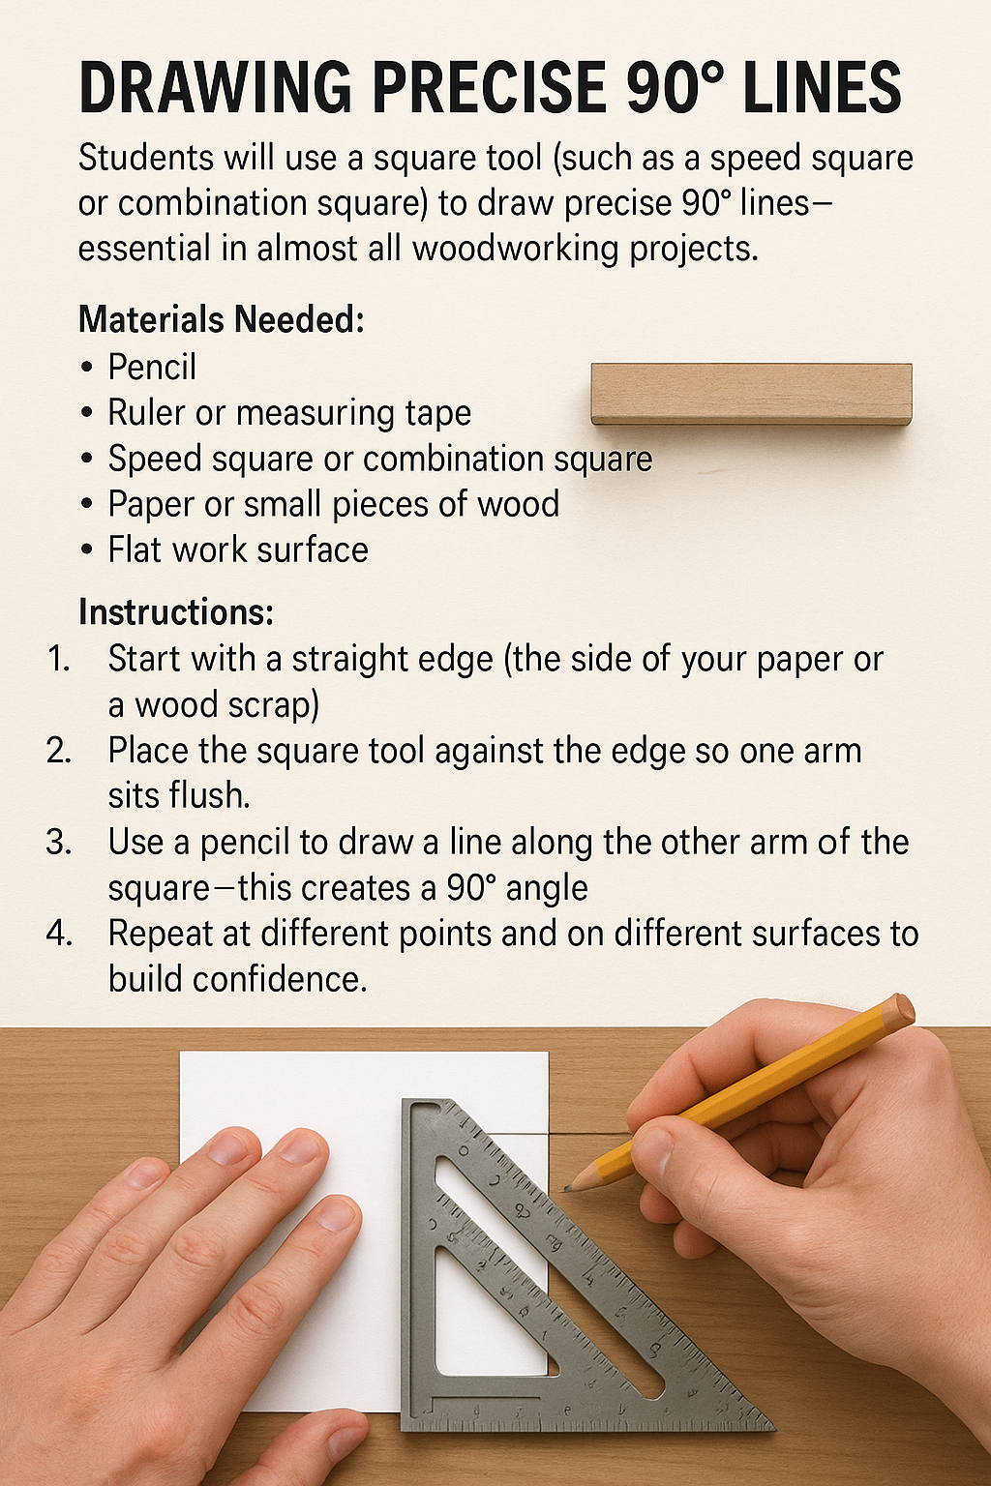
✏️ Student Practice Area
Use this space to draw several 90° angles using your square tool.

6. Using a Speed Square and Tape Measure for Layout.

Objective
Practice using a speed square and tape measure to perform common carpentry layout tasks. This activity builds hands-on skills in marking straight lines, angles, and stud spacing.

Materials Needed
- Speed square (or printed paper version)
- Tape measure (or printed tape measure strip)
- Pencil or pen
- 2'x2' wood panel, cardboard, or foam board

Instructions
- Measure and mark three vertical lines spaced 16 inches apart across your board.
- Use the speed square to ensure each line is square (90°) to the bottom edge.
- From the top right corner, use the speed square to mark a 45° diagonal line.
- Label your lines: A, B, C (the 16" OC lines) and D (the 45° angle).
- Take a photo of your board showing all layout marks.
- Write 2–3 sentences explaining how you used the speed square and tape measure.

📸 Submission
Share the photo with your instructor/parent for review.

Evaluation Rubric
Criteria | Excellent (5) | Good (3) | Needs Improvement (1)
Accuracy of Layout | All lines are measured and marked precisely with correct spacing and angles. | Most lines are measured and marked correctly with minor mistakes. | Several layout errors; spacing or angles incorrect.
Use of Tools | Correct and safe use of both tape measure and speed square. | Mostly correct use with minor tool handling issues. | Tools used incorrectly or unsafely.
Clarity of Markings | All markings are clearly labeled and easy to read. | Most markings are legible and labeled. | Markings are faint, unclear, or not labeled.
Photo and Explanation | Photo is clear and explanation is thoughtful and complete. | Photo is adequate and explanation is basic. | Photo missing or explanation incomplete.
/20

Speed Square Labeling Activity
Instructions: Look at the diagram of the speed square below. Use the word bank to label each part. Write the correct term next to each line or use numbers to match.

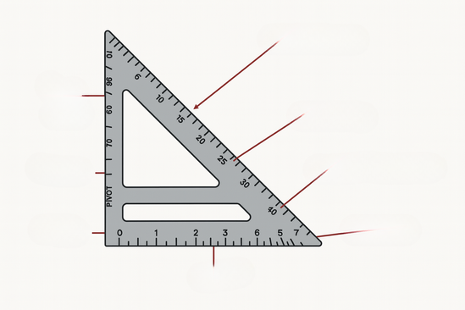

Word Bank
• Pivot
• Ruler
• Fence x 2
• Hypotenuse
• 90° Scale x 2
• Scribe Notches

Answer Key.

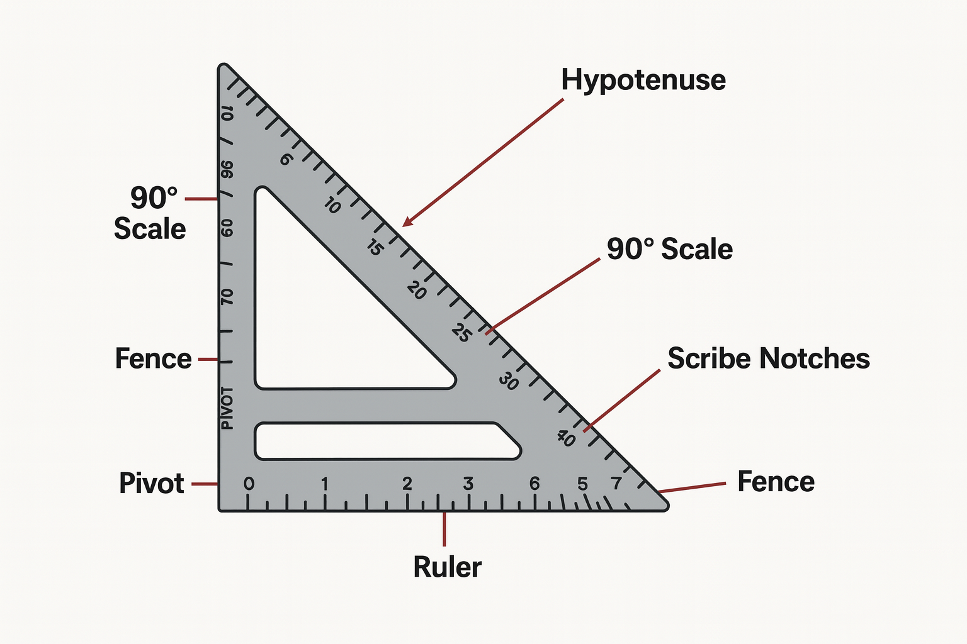

Scribe Lines Challenge: Using a Speed Square.

Objective:
Students will demonstrate how to use the scribe notches on a speed square to mark consistent, parallel layout lines on a board.

Materials Needed:
- 1x6 or 1x8 board (at least 24" long)
- Pencil
- Speed square
- Tape measure
- Ruler or straightedge
- Safety gear (glasses, gloves optional)

Instructions:
- Mark a baseline – Use the speed square to draw a straight baseline across one edge of the board, 1" from the edge.
- Measure and plan – Measure out and plan for 5 parallel layout lines at ½" increments.
- Use scribe notches – Insert a pencil into the scribe notch at ½", hold the square flush to the edge of the board, and slide it along while keeping the pencil in place to draw your line.
- Repeat – Repeat the process using 1", 1½", 2", and 2½" notches.
- Check accuracy – Use a tape measure or ruler to confirm the distance between each line.
- Label – Lightly label each line (½", 1", etc.) for review.
- Submit – Turn in your marked board for assessment.

Rubric: Scribe Lines Challenge (10 Points)

Criteria | Excellent (2 pts) | Good (1 pt) | Needs Work (0 pts)
Baseline is straight and accurate | ✅ | ⚠️ | ❌
Lines are parallel | ✅ | ⚠️ | ❌
Correct spacing used | ✅ | ⚠️ | ❌
Proper use of scribe notches | ✅ | ⚠️ | ❌
Work is neat and labeled | ✅ | ⚠️ | ❌
Total: ____ / 10

- Mini Project – Custom Name Plate.
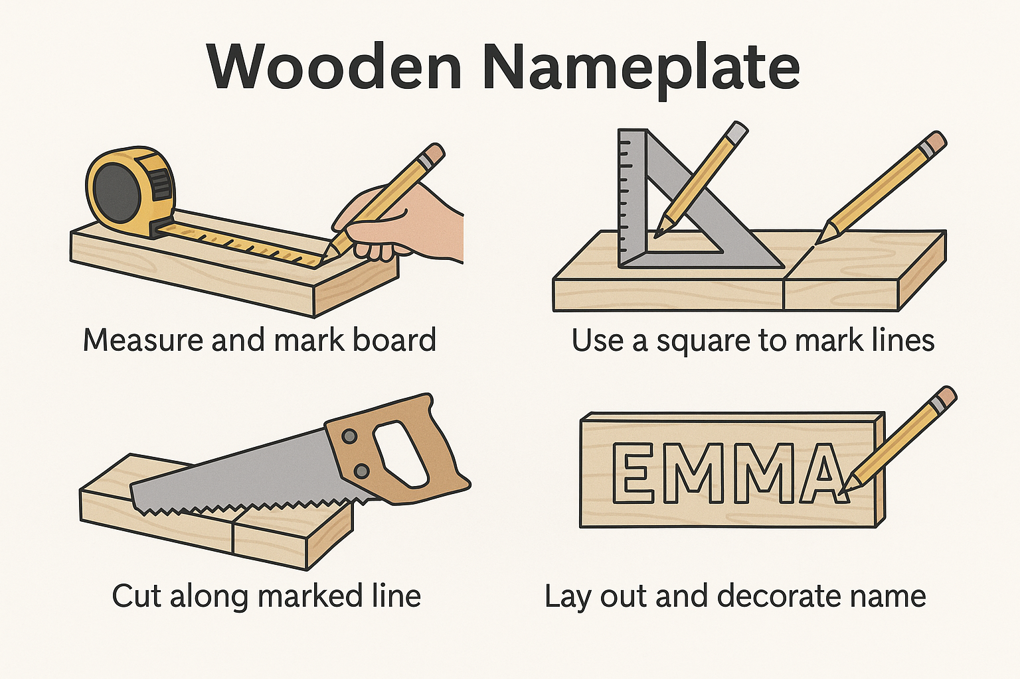

Overview
In this 2-hour lesson, students will apply measurement and layout skills to create a personalized wooden name plate. This hands-on project reinforces accuracy in measuring, marking, and basic tool handling.

Objectives
- Apply measurement and layout skills accurately on wood.
- Use a speed square and tape measure to lay out project dimensions.
- Practice marking consistent letter spacing.
- Create a customized wood name plate.

Materials Needed
- 1x6 board (cut to 12” length)
- Tape measure
- Speed square
- Pencil
- Lettering stencils or printed name template
- Sandpaper
- Wood stain or paint (optional)
- Safety gear

Instructions
1. Begin by sanding your wood board to smooth all edges and surfaces.
2. Use a tape measure to find and mark the center of the board lengthwise and widthwise.
3. Use a speed square to draw a straight centerline horizontally across the board.
4. Decide where your name will go. Measure the full length of your name using stencils or a printed template.
5. Center the name horizontally by dividing the remaining space on each side equally.
6. Use the tape measure and speed square to evenly space out each letter and lightly mark guide lines with a pencil.
7. Carefully trace your name onto the board using stencils or the printed template.
8. Optional: Outline the letters using a carving tool, wood burner, or marker. You can also paint or stain your board.
9. Let any paint or finish dry before handling.
10. Clean your work area and prepare to share your finished project with the group.

Assessment Criteria
- Accurate measurement and layout of letters
- Proper tool handling and safety awareness
- Neatness and visual balance of the final product
- Participation in cleanup and reflection

Rubric: Custom Name Plate Project (10 Points)

Criteria | Excellent (2 pts) | Good (1 pt) | Needs Work (0 pts)
Accurate and centered layout | ✅ | ⚠️ | ❌
Proper and safe use of tools | ✅ | ⚠️ | ❌
Neatness of letter markings/design | ✅ | ⚠️ | ❌
Creativity and effort in customization | ✅ | ⚠️ | ❌
Participation in cleanup and reflection | ✅ | ⚠️ | ❌
Total: ____ / 10

