Week 8 Worksheets.
- Introduction to Framing Concepts.
Framing is the structural backbone of any building. It gives the walls, floors, and roof their shape and support. Understanding the parts of a wall frame is essential for anyone learning construction or carpentry.
Studs
Studs are vertical pieces of lumber that form the main structure of a wall. They’re usually spaced evenly, most commonly 16 inches apart, to provide strong and stable support. Studs are what the drywall or wall sheathing attaches to.
Plates
At the top and bottom of the wall frame are long horizontal boards called plates. The top plate supports ceiling joists or roof trusses, while the bottom plate anchors the wall to the floor. Together, plates connect all the studs and form the basic frame.
Headers
When a window or door is installed, the studs that would normally go there are cut. A header is a strong, horizontal beam placed above the opening to carry the load that the missing studs would have supported.
Trimmer Studs (Jack Studs)
To support headers, trimmer studs are installed underneath them on each side of the opening. They’re shorter than regular studs and work with king studs to frame around windows and doors.
Other Key Terms
- King Stud: A full-length stud that runs from the bottom plate to the top plate and helps support the trimmer stud.
- Sill Plate: The bottom piece of a window frame that supports the window itself and sits between the trimmers.
Framing must be done carefully, as it determines the strength, layout, and accuracy of everything built on top of it.

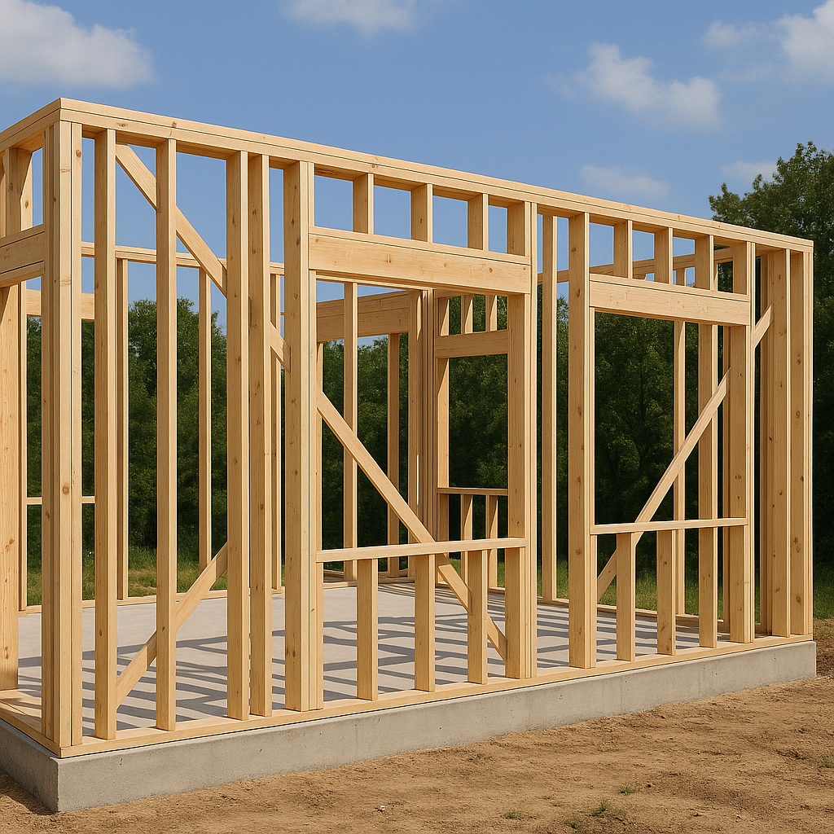

Framing Basics Quiz.
Instructions: Choose the best answer or complete the task as directed.
1. What is the purpose of a stud in a wall frame?
A. Supports the roof
B. Provides vertical support for walls
C. Acts as insulation
D. Creates a space for doors

2. What is the standard spacing for wall studs in residential framing?
A. 10 inches
B. 12 inches
C. 16 inches
D. 36 inches

3. What component sits at the top and bottom of a wall frame, connecting all studs?
A. Header
B. Beam
C. Plate
D. Joist

4. What is the purpose of a trimmer stud?
A. Decorative trim on a wall
B. Shorter stud that supports a header
C. Vertical support in a roof frame
D. Temporary construction aid

5. Which part of the frame distributes the load over a window or door opening?
A. Trimmer
B. King stud
C. Header
D. Sill plate

Short Answer.
6. Describe the difference between a king stud and a trimmer stud.

7. Why is it important to space studs evenly in a wall frame?

Answer Key.
1. B – Provides vertical support for walls
2. C – 16 inches
3. C – Plate
4. B – Shorter stud that supports a header
5. C – Header
6. The king stud runs full height of the wall and supports the trimmer. The trimmer stud is shorter and supports the header over an opening.
7. Even spacing ensures structural integrity, supports drywall or sheathing properly, and complies with building codes.

Create a Frame.
Sketch your own simple wall frame on the paper labeling studs, plates, headers, and window openings.

Label the frame.
Instructions: Use the word bank to label the frame.
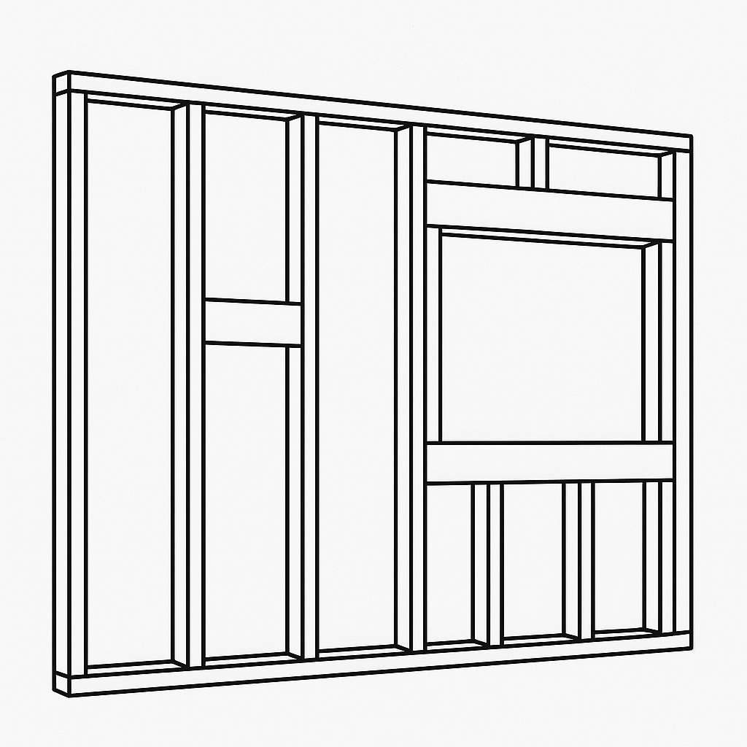
Word Bank: Top Plate, Stud, Blocking, Header, Trimmer, Cripple, Rough Sill, Sole Plate

Answer Key.
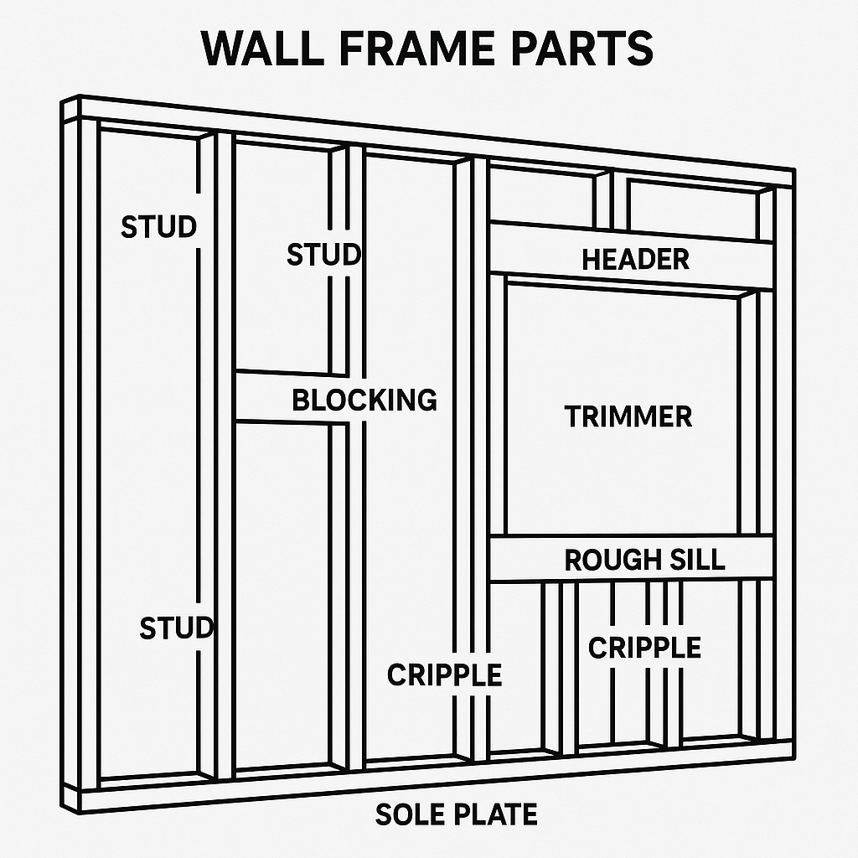

- Build a Mini Wall Frame Model.

Objective
Students will create a scale model of a wall frame using cardboard strips or popsicle sticks. This activity reinforces understanding of wall framing components, stud spacing, and structural layout.

Materials Needed
- Popsicle sticks or strips of cardboard (approx. ¼ inch wide)
- Ruler
- Scissors or craft knife
- White glue or hot glue
- Pencil and paper

Instructions
- Review scale.
- Plan & Layout.
  - On a piece of paper or cardboard backing, draw a rectangle that represents a wall frame (e.g., 6" wide × 4" tall)
  - Mark vertical stud locations every 1.5 inches across the bottom edge
- Cut & Assemble
  - Cut "studs" and "plates" from popsicle sticks or cardboard
  - Glue top and bottom plates horizontally
  - Add vertical studs evenly spaced every 1.5 inches
- Wrap-Up & Share
  - Label the parts of the frame on paper or attach a small key

Assessment

Score /12

Criteria | Excellent (3) | Good (2) | Needs Work (1)
Accurate Stud Spacing | All studs 1.5" apart | Most correct | Few correct
Correct Parts Included | Plates, studs, header | Most parts | Few parts
Craftsmanship | Neat, aligned, clean glue | Fair effort | Messy/incomplete
Understanding of Framing | Can label and explain parts | Basic explanation | Lacks clarity

Mini Wall Frame with Window.

Project Overview
In this project, you will build a miniature model of a framed wall section with a window opening. You will apply your understanding of wall framing components and practice basic measurement and building skills.

Materials Needed
- 1" x 2" or 1" x 3" wood strips (to simulate 2x4s, cut to scale)
- Wood glue or small nails
- Measuring tape or ruler
- Saw (hand or miter)
- Sandpaper
- Safety gear (goggles, gloves)
- Pencil
- Clamp (optional)

Steps
1. Measure and cut all framing parts to scale (18" x 12" overall frame, 3" stud spacing).
2. Lay out the bottom and top plates and mark stud locations.
3. Assemble the outer frame first using glue or nails.
4. Insert vertical studs with proper spacing.
5. Construct the window frame: add header, trimmers, rough sill, and cripples.
6. Ensure structure is square and secure all joints.
7. Optional: label parts or paint for presentation.
8. Take photos of your final model.

Framing Project Rubric Score /16
Criteria | Excellent (4) | Good (3) | Needs Improvement (1-2)
Accuracy of Framing | Correctly placed all framing parts to scale. | Minor errors in spacing or placement. | Several major errors in layout or missing parts.
Craftsmanship | Neatly cut and assembled with secure joints. | Mostly clean, few gaps or uneven cuts. | Sloppy cuts or poorly assembled.
Safety and Tool Use | Used all tools safely and properly. | Minor safety issues or unsure tool handling. | Unsafe use or did not use tools correctly.
Completion and Effort | Project completed with strong effort. | Completed but rushed or lacked effort. | Incomplete or minimal effort.

Framing Terms & Concepts Quiz

Circle the correct answer.
1. What is the vertical framing member in a wall called?
A) Beam B) Stud C) Joist D) Plate

2. Which part of the wall frame runs horizontally at the very bottom of the wall?
A) Top Plate B) Bottom Stud C) Sole Plate D) Header

3. What is the purpose of a header in a wall frame?
A) To support the roof B) To divide the room C) To transfer weight around an opening D) To cover the top of the wall

4. Which tool is most commonly used to check 90° angles in framing?
A) Level B) Tape Measure C) Speed Square D) Chalk Line

5. What is the typical spacing between wall studs in residential construction (in inches)?
A) 24" B) 10" C) 8" D) 12"

Match the term to its definition.
Write the letter of the correct definition next to each term.
6. Stud
7. Top Plate
8. Header
9. Cripple Stud
10. Trimmer
Definitions:
A) Horizontal board at top of wall frame
B) Beam over window or door opening
C) Vertical wall framing member
D) Short stud below or above an opening
E) Stud that supports a header

Short Answer
11. Explain why accurate stud spacing is important in framing.

12. What is the difference between a joist and a rafter?

Framing Quiz Answer Key
1. B) Stud
2. C) Sole Plate
3. C) To transfer weight around an opening
4. C) Speed Square
5. A) 24"

6. C) Vertical wall framing member
7. A) Horizontal board at top of wall frame
8. B) Beam over window or door opening
9. D) Short stud below or above an opening
10. E) Stud that supports a header

11. Accurate stud spacing ensures that walls are structurally sound, supports drywall or sheathing evenly, and meets building code requirements.

12. A joist is a horizontal framing member that supports floors or ceilings, while a rafter is a sloped framing member that supports a roof.

- Framing Basics Challenge – Real-World Stud Spacing Investigation

Duration: 1 Hour
Lesson Type: Self-Guided / At-Home
Objective: Students will apply their understanding of stud spacing by investigating the walls in a real structure and comparing them to standard framing practices.

Materials Needed:
- Tape measure
- Stud finder (or tap-and-nail method)
- Pencil and notebook
- Ruler or straightedge
- Optional: phone or tablet for photo or diagram

Instructions:
Step 1: Find a Wall to Study
- Choose a wall in your home, garage, or shed (interior or exterior).
- Make sure you have access to measure across the wall surface.

Step 2: Locate the Studs
- Use a stud finder OR gently tap along the wall and use a small nail or pushpin to check for studs.
- Start at one edge and move across the wall.

Step 3: Measure and Record Spacing
- Measure the distance between the centers of each stud (center-to-center).
- Write down each measurement and number the studs in order.

Step 4: Analyze the Pattern
- Compare your findings to the standard 16 inches on center spacing.
- Are the measurements consistent?
- Note if any spacing is off or if you found extra studs around windows or doors.

Step 5: Report or Diagram
Choose one of the following:
- Option A: Draw a top-down diagram of the wall showing stud placement and spacing (label dimensions).

- Option B: Write a short report explaining:
  - What you measured
  - What you discovered about stud spacing
  - How it compares to what you’ve learned

- Mini Header Strength Test

Objective: Students will test and compare the strength of different materials used for headers, demonstrating how construction material choices affect structural load-bearing.

Materials Needed:
- Cardboard strips (cut to ~6" long, 1" wide)
- Popsicle sticks (or wooden coffee stirrers)
- Glue (wood glue or hot glue)
- 2 small blocks or stacks of books (as wall supports)
- Weights: Pennies, coins, washers, or small nuts
- Ruler or measuring tape
- Notebook or worksheet for observations

Instructions:

Step 1: Build Two Mini Headers

- Header A (Weaker Material):
Glue 2–3 layers of cardboard together flat, forming a “beam.”
- Header B (Stronger Material):
Glue 2–3 popsicle sticks together side-by-side and reinforce with one across the bottom like an "I-beam".
Let glue dry before testing.

Step 2: Set Up the Test Rig

- Place your two books or blocks about 5" apart to act as “walls.”
- Lay Header A across the top like a bridge.
- Ensure both ends are well-supported and level.

Step 3: Load the Header

- Begin stacking coins or weights on top of the center of the header, one at a time.
- Stop when the header visibly bends or collapses.
- Record how many coins it held before bending.
Repeat for Header B.

Step 4: Compare Results
- Record in a table:

Mini Header Test Results
Header Type | Material Used | # of Coins Held | Notes
Header A | Cardboard
Header B | Popsicle Sticks

- Which held more weight?

- What material properties made a difference?

Step 5: Reflect

Write 2–3 sentences answering:
- Why do real headers need to be made from strong materials?

- What surprised you about your results?

