Week 9 Worksheets.

Overview: What Is Finish Carpentry and Why It Matters.

Finish carpentry is the final stage of woodwork in construction, focused on visible elements that add both beauty and functionality. It comes into play after the structure is built and systems like electrical and drywall are in place. This phase refines a space and makes it livable and elegant.

Key Aspects of Finish Carpentry
Aspect | Details
Purpose | Adds aesthetic detail and usability—think trim, molding, cabinetry, and doors—making spaces polished and functional.
Common Tasks | Installing baseboards, crown molding, window and door casings, built-in shelving, wainscoting, and hardwood floors.
Materials Used | High-quality and visually appealing materials like hardwoods (oak, maple, cherry), MDF for moldings, veneers, and decorative panels.
Tools & Skills | Requires precision—using miter saws, brad/nail guns, chisels, sanding tools, and meticulous measurement to achieve a flawless finish.
Project Timing | Performed after rough carpentry, plumbing, electrical, and drywall—when the project is structurally complete and ready for finishing touches.

Why Finish Carpentry Is Essential.
- Completes the Visual Design.
Finish carpentry brings the architectural style to life. Without trim, casings, and cleanly fitted elements, even well-framed spaces look incomplete.
- Improves Function and Durability.
Properly installed doors, windows, and trim protect against wear and improve usability by ensuring smooth operation and sealing edges.
- Adds Value and Craftsmanship.
High-quality finish work enhances a building’s feel, adds resale appeal, and showcases skilled craftsmanship.
- Defines the Final Quality
A structure’s underlying frame may be sound, but the polish of finish carpentry is what gives a space distinction and a sense of completeness


Identify trim.

Objective
Students will visually identify and label different finish carpentry materials and trim types commonly found in interior spaces.

Materials Needed
- Pens/pencils

Instructions
- Walk around the classroom, school hallway, or your home.
- Make a list of all finish carpentry components you observe.
- Sketch one section (e.g., a door casing or baseboard transition) and label the parts.

1. Trim Type Identified: _______________________________

Description/Location: _______________________________

2. Trim Type Identified: _______________________________

Description/Location: _______________________________

3. Trim Type Identified: _______________________________

Description/Location: _______________________________

4. Trim Type Identified: _______________________________

Description/Location: _______________________________

3. Sketch Area.

Sketch a section of trim you observed (e.g., door casing or baseboard) and label its parts below:

4. Using a Speed Square and Tape Measure for Layout.

Lesson Overview

In this lesson, students will learn how to accurately measure and mark dimensions using a tape measure and speed square. They will practice marking standard construction layouts and angles on wood to prepare for framing and finish carpentry tasks.

There are two essential layout tools in carpentry: the tape measure and the speed square.

Reading a tape measure accurately is a foundational carpentry skill. Most tape measures in the U.S. use imperial units—inches and feet. Each large numbered line on the tape represents 1 inch, with the foot marks (e.g., 1F, 2F) often highlighted in red or bold. Between each inch are fractional lines. The longest line between inches is ½ inch, the next longest is ¼ inch, then ⅛ inch, and finally 1⁄16 inch, which is the smallest common division. Each of these marks represents a smaller portion of the inch and helps carpenters make precise cuts and layouts.

It's also important to understand the hook tab at the end of the tape. This metal piece is designed to move slightly—it compensates for its own thickness when taking inside versus outside measurements. For highly precise work, carpenters sometimes “burn an inch” by starting at the 1" mark to avoid any potential error from the hook. Reading a tape measure confidently means understanding the numbering system, recognizing fractional divisions, and knowing when to adjust for accuracy.

A speed square is one of the most versatile and essential tools in carpentry, often used for measuring, marking, and checking angles. It’s shaped like a right triangle and combines the functions of a try square, miter square, protractor, and saw guide all in one. The fence (or lip) allows you to snug the tool against the edge of a board for quick 90° (square) and 45° markings. This makes it easy to draw perpendicular lines for cutting or layout work.

The speed square is also equipped with a degree scale, which lets you measure or mark angles for rafters, stairs, or angled cuts. The pivot point is the corner where the fence meets the triangle—this is where you rotate the square to find a specific angle. Along the edge are scribe notches, which let you quickly mark parallel lines by inserting a pencil and sliding the square along the wood. Whether you're framing, cutting, or laying out a project, the speed square helps ensure clean, accurate measurements with minimal tools.

Materials Needed
- 2 ft piece of 2x4 or scrap board
- Speed square
- Tape measure
- Carpenter’s pencil
- Safety glasses

Instructions
- Measure and mark a 90° line – From one end of the board, measure 6 inches along the edge and make a small mark. Place the lip of the speed square against the board’s edge and draw a straight 90° line across the board.
- Measure and mark a 45° line – From the opposite end, measure 4 inches along the edge and make a mark. Place the speed square’s lip against the board and pivot until your pencil is in the 45° slot, then draw the line.
- Create parallel layout lines – From one reference edge, measure 1½ inches at both ends of the board. Use the speed square to connect these marks for a long, parallel line.
- Mark a center point – Measure the full length of the board, divide by two, and mark the center point. Draw a cross mark at the center using the speed square.
- Check your work – Verify your 90° lines are square, 45° lines are accurate, and parallel lines are evenly spaced.

Completion Checklist
- Correctly measured and marked a 90° line
- Correctly measured and marked a 45° line
- Drew parallel lines at consistent spacing
- Located and marked the center point accurately
All lines are straight, clean, and labeled

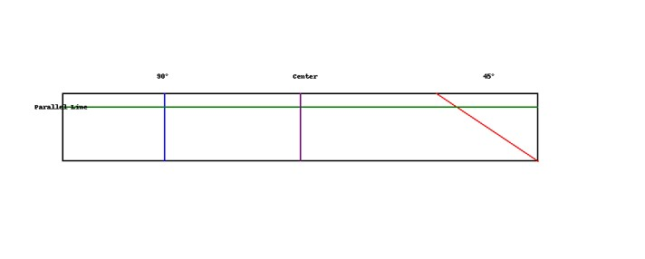

- Scribe Lines Challenge: Use Speed Square Notches for Layout

Objective
Use the notches (scribe lines) on a speed square to draw consistent, parallel lines from the edge of a board. This builds layout accuracy and confidence in using hand tools.

Materials Needed
- Speed square with scribe notches
- Pencil or carpenter’s pencil
- 2x4 or flat board (at least 24" long)
- Optional: Ruler or tape measure for verification

Instructions
1. Place the fence of the speed square snug against the long edge of the board.
2. Insert the pencil into one of the scribe notches (e.g., 1" mark).
3. Slide the square along the edge while holding the pencil steady.
4. This creates a parallel line exactly 1" from the board's edge.
5. Repeat for at least two more distances (e.g., 3/4", 1-1/4").
6. Check if your lines are straight and evenly spaced.

Challenge Goal
Draw at least 3 straight, evenly spaced lines along the entire board using different scribe notch distances.

Assessment Rubric

Criteria | Points
Lines are parallel to edge | 5
Correct use of scribe notches | 5
Pencil control and technique | 5
Neatness and line consistency | 5

Score /20

Optional Extension
- Time Challenge: How many accurate lines can you draw in 5 minutes?

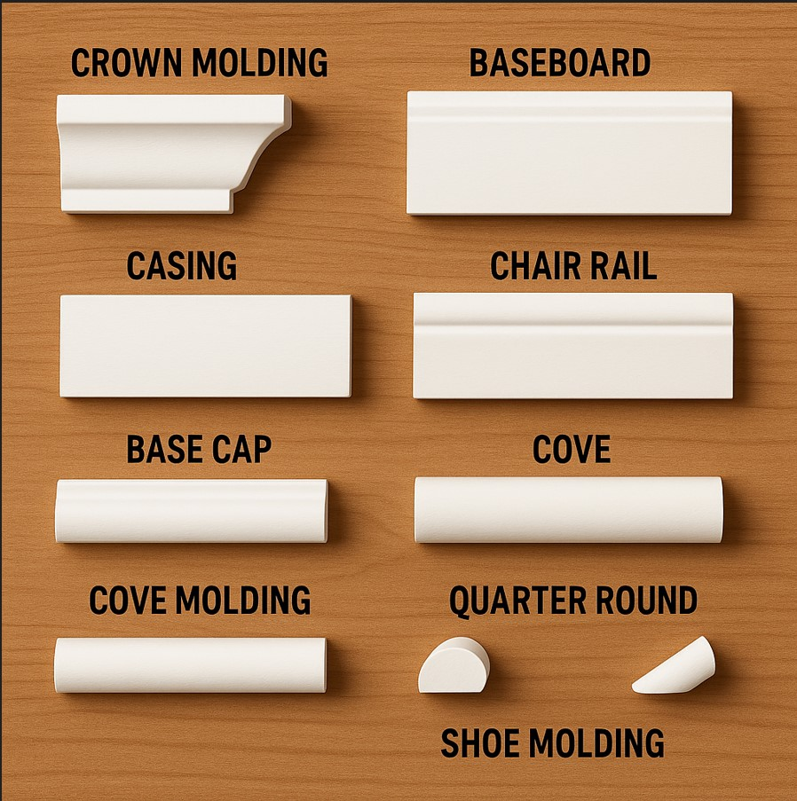

6. Create a Trim Style Board

Objective:
Students will explore finish carpentry by identifying and displaying three different trim profiles on a visual board.

Materials Needed:
• Foam board or cardboard backing (approx. 11"x17")
• Ruler or measuring tape
• Pencil and marker
• Glue or double-sided tape
• Labels or sticky notes

Instructions.

- Use the internet to select 3 trim profiles:
Choose three distinct trim styles (e.g., Colonial, Modern, Craftsman, or baseboard, casing, crown).

- Cut and Arrange:
Arrange your trim pieces vertically or horizontally on the board with even spacing.

- Label Each Profile:
Use labels to name each trim type. Include:
- Name of the trim style
- Where it's commonly used (e.g., baseboard, window casing)
- Aesthetic features (e.g., curved, flat, layered)

- Decorate Your Board (Optional):
Add a title: “Trim Style Board” and any visuals or colors to enhance presentation.

5. Present Your Board:
Share your board with your family.

- Draw.
Draw your own trim profile ideas inspired by traditional styles and explain where they would be used.

- Install Baseboard and Casing Pieces on Project Panel.

Objective
Students will accurately measure, cut, and install baseboard and casing pieces on a mock project panel to simulate interior finish carpentry installation.

Materials Needed
- Pre-cut or scrap lengths of baseboard and casing trim
- Mock panel or plywood board (approx. 24" x 24")
- Miter saw or hand saw
- Wood glue or finish nails
- Tape measure, pencil, speed square
- Optional: caulk, filler, and sandpaper for finishing

Instructions
1. Measure the length of the bottom edge of the panel for your baseboard.
2. Cut the baseboard piece to fit using a straight 90° cut.
3. Measure and mark for casing pieces to simulate a window or door trim set on the panel.
4. Cut casing pieces using 45° angles at the corners.
5. Attach all trim pieces securely to the panel using glue and/or finish nails.
6. (Optional) Fill nail holes and seams, then sand for a smooth finish.
7. Label your panel with your name on the back for evaluation.

Assessment Rubric (20 points)
Criteria | Excellent (4) | Good (3) | Needs Improvement (2) | Incomplete (1)
Measurements and Layout | All measurements are accurate. | Most measurements are correct. | Multiple measurement errors. | Measurements missing or highly inaccurate.
Cuts and Angles | All cuts are clean and precise. | Cuts are mostly accurate. | Cuts are rough or poorly angled. | Cuts are incorrect or not attempted.
Installation Fit and Finish | Pieces fit tightly with no gaps; joints are seamless. | Good overall fit; small gaps or visible joints. | Loose or uneven fit; visible gaps or misaligned pieces. | Pieces not secured properly or not installed.
Use of Tools and Safety | Used tools correctly and safely. | Minor errors in tool handling. | Frequent tool misuse. | Unsafe use of tools or no tool use demonstrated.
Overall Presentation | Panel is clean, aligned, and professionally presented. | Good appearance with minor imperfections. | Sloppy or rushed appearance; poor alignment. | Project incomplete or unusable.
Total Score: /20
- Install Crown Molding on a Mock-Up Corner

Objective:
Students will learn how to measure, cut, and install crown molding on a 90° mock-up corner using miter and coping techniques.

Materials Needed:
• Crown molding (wood or MDF), enough for two inside corner pieces
• 2'x2' or 2'x4' mock-up corner frame (2 walls joined at 90°)
• Miter saw (or miter box and hand saw)
• Tape measure and pencil
• Wood glue
• Finish nails or brad nails and nailer
• Sandpaper
• Caulk and putty (optional)
• Paint or finish (optional)

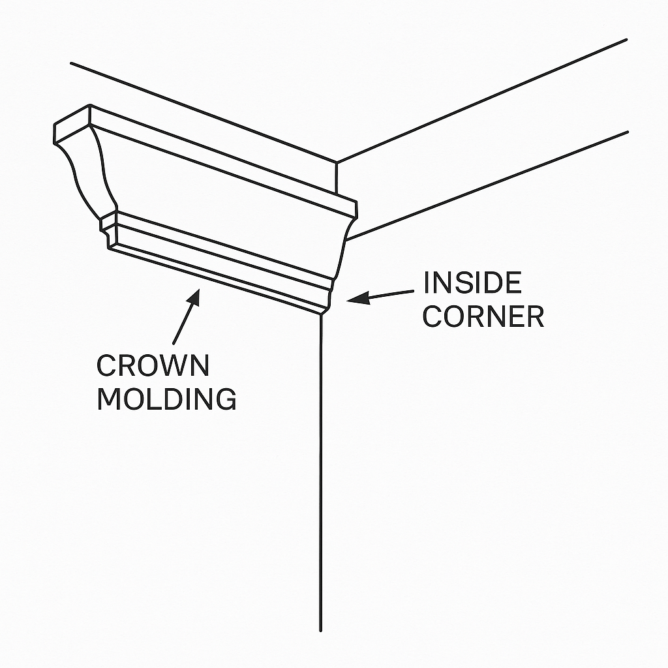

Instructions.

- Prep the Mock-Up Frame:
Use two 2'x2' boards or panels joined at a 90° angle to simulate an inside corner.

- Measure for Crown Molding:
Measure the top of each wall and mark crown molding length on the back side (the wall side).

- Cut the Molding:
Use a miter saw set to 45° to cut inside corners. Optionally, use a coping saw to cope one end of the molding for a tighter joint.

- Test Fit:
Dry fit both pieces against the mock-up wall to check for proper fit and clean joints.

- Attach Molding:
Apply wood glue along contact surfaces. Nail the crown into place along the top and bottom edges.

- Finishing:
Fill any gaps or nail holes with wood putty or caulk. Sand smooth, then paint or stain as desired.

- Present and Reflect:
Show your completed corner and explain your process and how you ensured clean cuts and joints.

Reflection Questions:
- • What made aligning and cutting the crown molding challenging?
- • Did you use a mitered or coped joint? Why?
- • How can you ensure tight-fitting joints in future projects?

Project Rubric:

Criteria | Excellent (4) | Good (3) | Fair (2) | Needs Work (1)
Accurate measuring and layout
Clean 45° or coped joints
Proper installation and fit

Neat finishing (caulk/paint)
Safety and tool handling

Score /20

