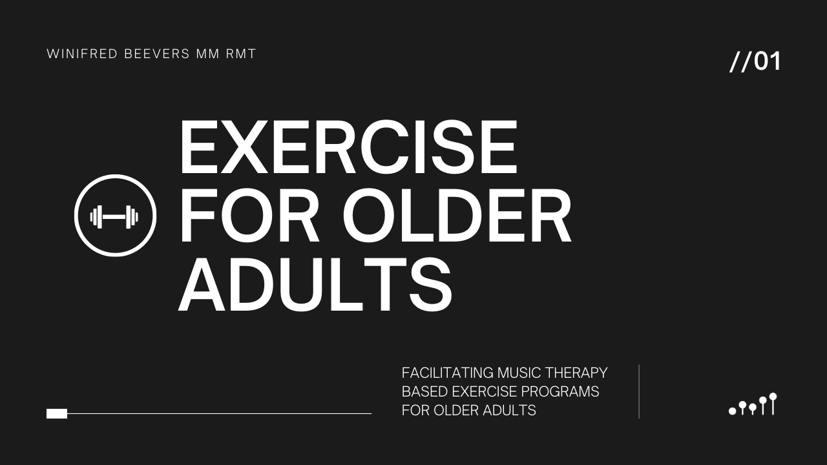
TUTORIAL WORKBOOK
This workbook is to accompany the Music Therapy Online tutorial ‘Exercise for older adults: Facilitating music therapy based exercise programs for older adults’ by Winifred Beevers.
Follow along with this workbook as you listen to the tutorial. You can pause the tutorial and complete the activities as you go or complete the workbook exercises afterwards.

INSTRUCTIONS
- Complete the workbook questions as you watch the tutorial or shortly afterwards.

- Send your completed workbook to jacinta@musictherapyonline.org to receive your certificate of completion.

Workbook Questions

What would you like to learn from today’s tutorial? Why is this topic important to you?

Make a list of what you would like to know about your clients before they join your exercise group.

Make a list of 5 exercises and choose the music to match each exercise. Note down the age and diagnosis of your client too.

Choose an appropriate song to match the following movements.
- Stamping feet
- Kicking legs
- Turning head side to side

Choose one of the songs from your list and play it through while incorporating:
- Clear downbeat
- Accent bass
- Tempo matching movement
- Slight staccato
- Musical cue to finish

Choose one of the songs from your list and practice a:
- Long ending (using decelerando and a cadence)
- Short musical cue to indicate you are ending the song

Make a list of 5 songs that you think would be suitable to end an exercise group with (and would encourage everyone to sing along).

What equipment do you already have that you could incorporate into an exercise session? How would you use it?

What equipment would you LIKE to incorporate into an exercise program? How would you use it?

Congratulations! You’re done!
See the TUTORIAL SUMMARY & SUBMISSION INFO doc for details on how you can claim your CMTE/CPD credits.

Thank you for joining us for this tutorial today!
You can find more fabulous tutorials at www.musictherapyonline.org

