Week 3 Worksheets.

Tool Identification.
Instructions: Look at each tool image below. In the space provided, write the correct name of the tool. After writing, handle the real tool and check the box.

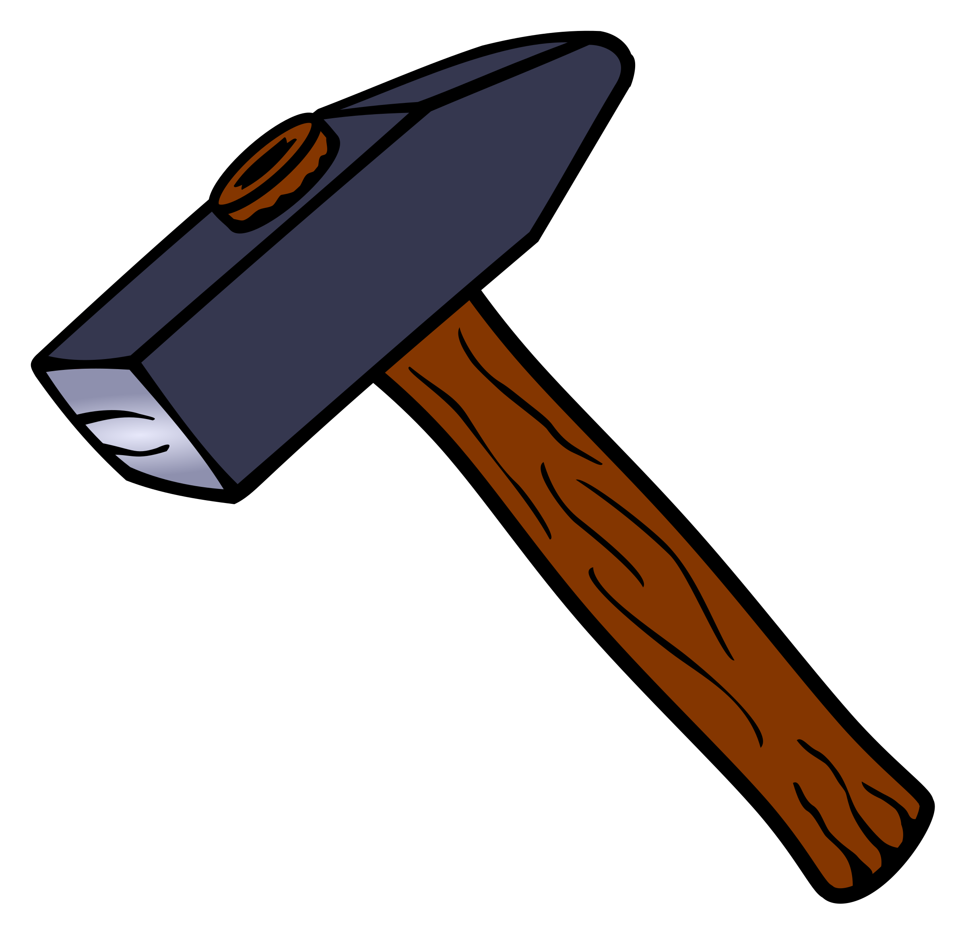
Tool Name: __________________________________________
Check if Handled: ☐

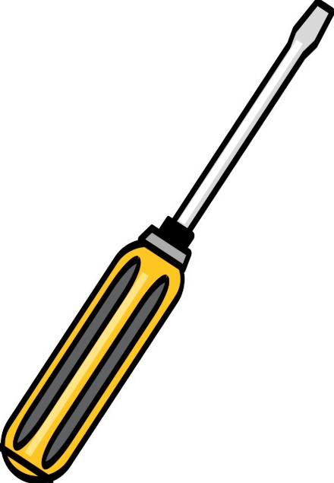
Tool Name: __________________________________________
Check if Handled: ☐

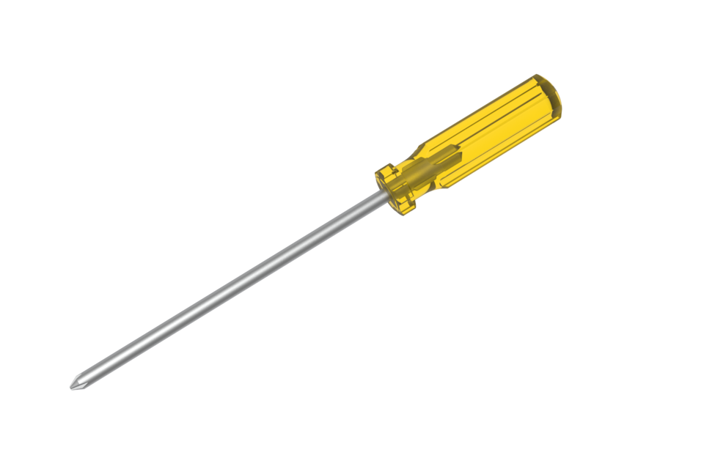
Tool Name: __________________________________________
Check if Handled: ☐

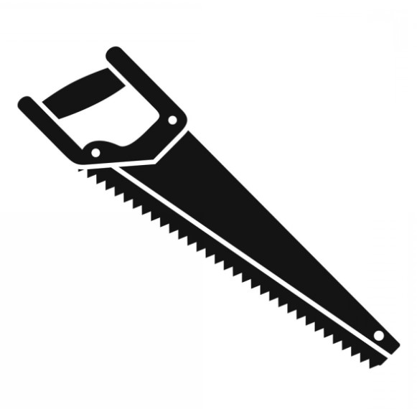
Tool Name: __________________________________________
Check if Handled: ☐

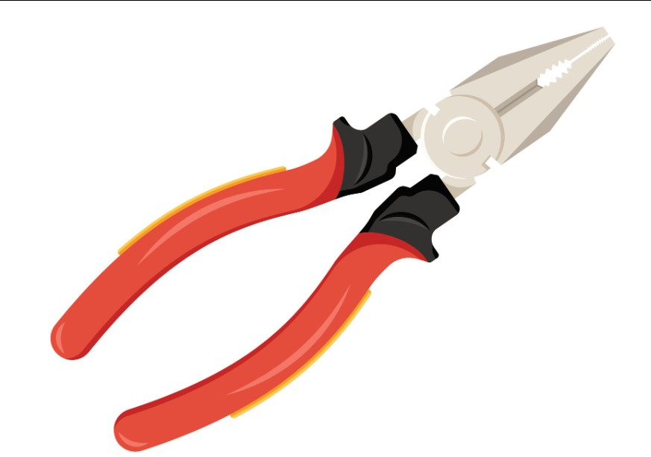
Tool Name: __________________________________________
Check if Handled: ☐

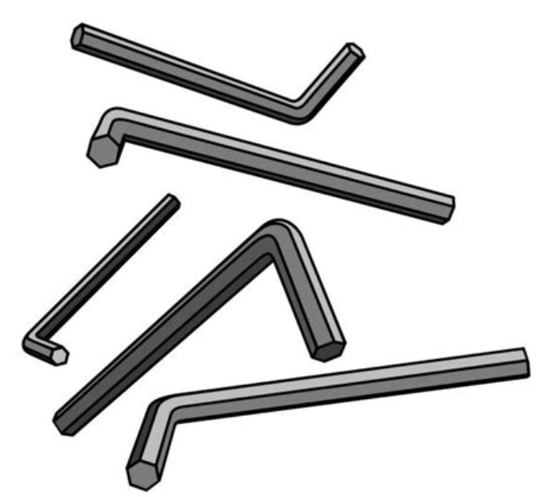
Tool Name: __________________________________________
Check if Handled: ☐

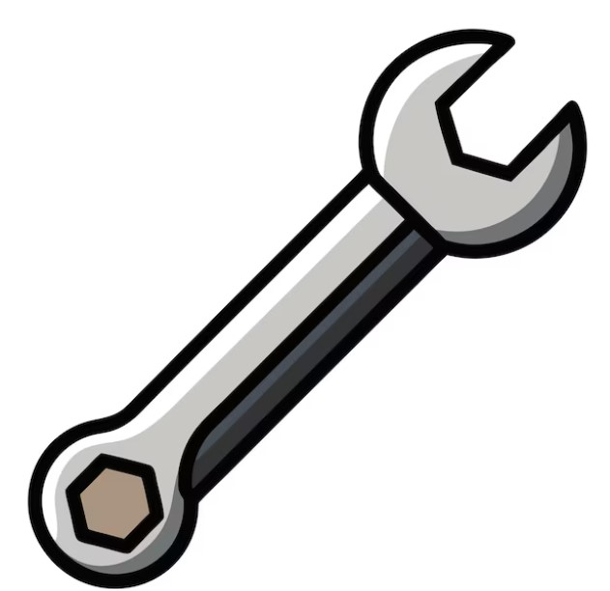
Tool Name: __________________________________________
Check if Handled: ☐

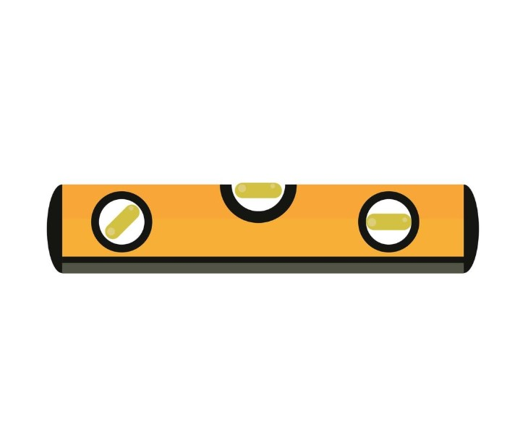
Tool Name: __________________________________________
Check if Handled: ☐

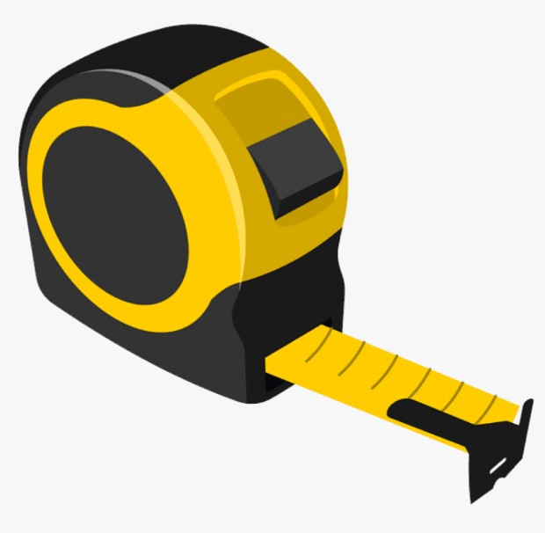
Tool Name: __________________________________________
Check if Handled: ☐

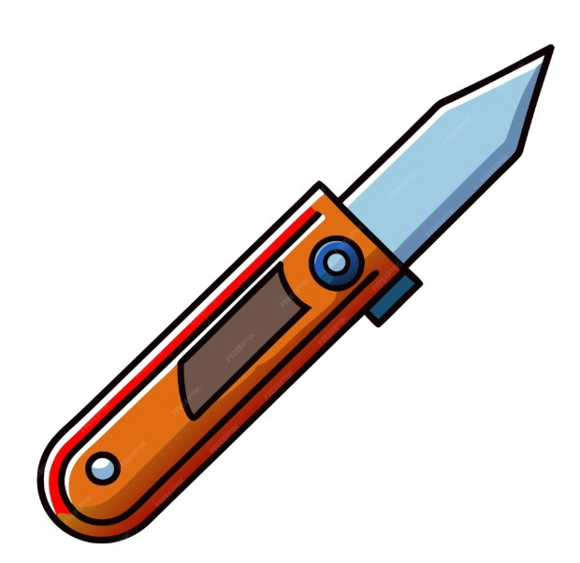
Tool Name: __________________________________________
Check if Handled: ☐

2. Quick Quiz: Hand Tool Know-How.
- What’s the safest way to remove a nail?
- When do you use a Phillips head vs. a flat-head screwdriver?
- What does a level measure?
- What direction should your saw strokes go?
- Name three types of clamps.

📝 Answer Key:
- Use the claw end of the hammer and pull steadily.
- Phillips = cross pattern, Flat-head = single slot
- Whether a surface is horizontally or vertically straight
- Forward stroke does most of the cutting
- C-clamp, bar clamp, quick-grip clamp

- Review Safety Guidelines.
- Always wear safety glasses when using tools.
- Keep your work area clean and organized.
- Use the right tool for the job.
- Keep your hands behind cutting edges.
- Don’t force tools—let them do the work.
- Store tools properly after use.
- Check tools for damage before using.
- Never use a dull blade or a broken handle

Introduction to Handsaws.

Learning Objectives
- Identify the three main types of handsaws
- Understand basic safety rules for handsaw use
- Practice using a handsaw correctly
- Choose the right saw for the job

What Is a Handsaw?
Read the descriptions below and match them to the correct saw in the worksheet later.
1. Crosscut Saw – Designed to cut across the wood grain. Teeth are angled for smooth slicing action.
2. Rip Saw – Cuts along the wood grain. Teeth act like tiny chisels.
3. Back Saw – Used for precise cuts, usually in a miter box. It has a reinforced back edge for stability.
Think about: Why might carpenters need different types of handsaws?
Watch: https://www.youtube.com/watch?v=Ezd0rfgbQK8

Handsaw Safety Rules
Read and remember these safety tips before using any saw:
- Always wear safety goggles
- Clamp your wood firmly to a stable surface
- Keep fingers far from the cutting path
- Start with a slow pull stroke to guide the blade
- Let the saw do the work—don’t force it

Handsaw Practice Activity – “Saw the Line”
Instructions:
1. Find a safe workspace like a table or workbench.
2. Clamp a piece of scrap wood (a 1x4 or 1x6 board is ideal).
3. Draw a straight line across the wood using a square.
4. Use a crosscut saw to cut along the line.
5. Observe your cut: Was it straight? Did the saw bind or skip?
Optional: Take a photo of your finished cut and add to your binder.

Reflection
Answer in your journal or course discussion board:
- What was the most difficult part of using a handsaw?
- How will you improve your sawing skills next time?

- Hammering Techniques.

Learning Objectives
- Understand the difference between nails and screws and their uses
- Practice driving fasteners in straight, evenly spaced rows
- Learn to set nails and screws flush and secure

Part 1: Video Introduction
Watch this: https://www.youtube.com/watch?v=5-PlR8tf84c
While Watching, Ask Yourself:
- Why would I choose a screw instead of a nail?
- How do pros ensure fasteners are flush and straight?

Part 2: Build a Nail & Screw Practice Board

Materials Needed:

- 1 piece of 1x6 or 1x8 scrap wood (≈ 12" long)
- 10+ nails (finishing or common)
- 10+ wood screws (1½–2½ inch)
- Hammer
- Screwdriver or drill-drive
- Ruler or tape measure
- Pencil
- Safety goggles

Instructions:
- Draw two parallel lines across the board (one for nails, one for screws).
- Mark dots every 1 inch to space fasteners evenly.
- Hammer nails along one line—each should be straight, flush, and secure.
- Drive screws along the second line—ensure they are flush and don’t split the wood.
Optional Upload: Take a photo of your finished board to submit.

Part 3: Reflection & Self-Evaluation

Answer in your carpentry journal or course platform:
1. What was harder—hammering nails or driving screws? Why?
2. Which fastener do you think gives a stronger hold?
3. What did you learn about spacing, depth, or alignment from this activity?

Review.
- Print a photo of your Nail & Screw Practice Board and add to your binder.
Criteria | 5 Points (Excellent) | 3 Points (Satisfactory) | 1 Point (Needs Improvement)
Layout and Spacing | Rows are evenly spaced and clearly marked. | Mostly even, a few irregular gaps. | Random or uneven layout.
Nail Placement | All nails are straight, flush, and secure. | Minor bending or depth issues. | Many nails crooked or overdriven.
Screw Placement | Screws are straight, flush, and secure. | Slight angle or inconsistent depth. | Loose, crooked, or overdriven screws.
Safety and Cleanliness | Work area clean, PPE used. | One minor safety concern. | Multiple safety issues or no PPE.
Reflection Completion | All questions answered thoughtfully. | Some answers incomplete. | Minimal or no effort.
 |  |  | Total out of 25. /25

Leveling Work pieces and Securing with Clamps.

Why Leveling and Clamping Matters.

In woodworking, leveling ensures that surfaces are even, balanced, and aligned before fastening. If a work piece is not level, you may end up with gaps in joints, crooked assemblies, or unstable furniture.
Clamps hold pieces in place while glue dries, fasteners are installed, or adjustments are made. They prevent movement that could cause misalignment. Different clamp types are designed for different jobs:
- C-Clamp: Provides strong, concentrated pressure for small to medium workpieces.
- Quick-Grip Clamp: Easy one-handed operation, ideal for quick setups.
- Bar / F-Clamp: Long reach for larger assemblies.
- Spring Clamp: Lightweight, fast, and portable for temporary holds.
Pro Tip: Always check your work piece for level before and after clamping. Tightening clamps can shift alignment.

Tool Identification.
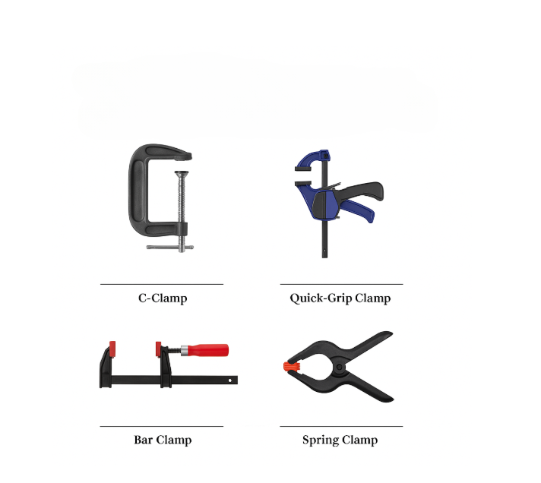

Safety Review: Using Clamps Safely.

Clamps are powerful tools that help hold materials in place while you work, but if used improperly, they can cause damage to your project—or even injury. Understanding how to use clamps safely is an essential part of woodworking.

1. Watch Out for Pinch Points
Many clamps, especially C-clamps and quick-grip clamps, have moving parts that can pinch your fingers if you’re not careful. Always keep your hands clear of the tightening mechanism when adjusting or releasing a clamp.

2. Avoid Over-Tightening
Applying too much pressure can damage wood by leaving dents or even causing cracks. Tighten clamps just enough to hold the work piece securely—no more.

3. Use Protective Pads
Place a small piece of scrap wood, cardboard, or clamp pads between the clamp and your work piece. This prevents clamp jaws from marring or scratching the surface.

4. Check Stability Before Working
Once your clamps are in place, gently try moving the workpiece to ensure it is held securely. If it shifts, readjust and recheck the clamping.

Questions
Why is it important to avoid placing your fingers near clamp tightening mechanisms?
What can happen if you tighten a clamp too much?
Name one material you can use to protect the surface of your work from clamp damage.
What should you do after clamping a work piece to make sure it’s secure?
List two safety tips for using clamps:
1.
2.

Leveling Practice

Scenario: You are joining two boards to make a tabletop.
1. Place the boards side by side on a flat surface.
2. Use a bubble level to check if they are even.
3. Insert shims or adjust position until level.
4. Select an appropriate clamp for the width of your boards.
5. Clamp the boards together.
6. Re-check level and adjust if needed.

Mixed Clamp Challenge
Instructions:
- Join three pieces of wood into a 'T' shape.
- Use at least two different clamp types.
- Check level at every stage.
Reflection Questions:
1. Which clamp was easier to use? ___________________
2. Which clamp held more securely? ___________________
3. What was the most challenging part of keeping the work pieces level? ___________________

- Hand Tool Practice.

Tool 1 – Utility Knife.

Materials Needed.
Utility knife
Cardboard

Directions.
- Draw 3 squares on cardboard with a ruler.
Use the utility knife to cut them out.
- Don’t forget safety.

Tool 2 – Pliers

Materials needed
Pliers
Hammer
Nails

Directions
- Drive some nails into a piece of wood but not all the way.
- Use pliers to pull them out.

Tool 3 – Level
Materials Needed
Level

Directions
- Go around every picture frame in your home and check for levels. Is it level?

