Week 7 Worksheets.

Identify Symbols on a Sample Blueprint
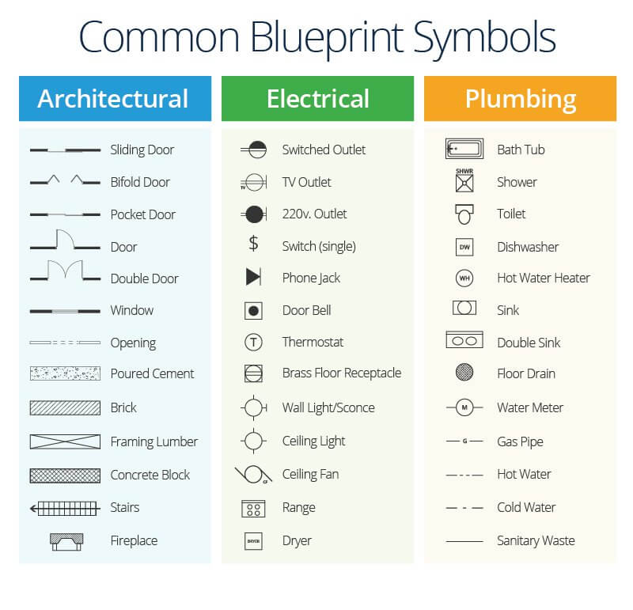

Blueprint Symbols Quiz

Instructions: Circle the correct answer for each question.

1. Which symbol represents a standard door?
A) ──|──
B) ⊗
C) ┌─┐
D) ⟶

2. What does this symbol represent? |__|
A) Window
B) Double Door
C) Shower
D) Sliding Door

3. Which of the following is a symbol for a Switch (single)?
A) ●
B) $
C) ⊖
D) ◯

4. The symbol ⊙ represents which electrical item?
A) Ceiling Fan
B) Phone Jack
C) 220v. Outlet
D) TV Outlet

5. Which symbol represents a bathtub?
A) □
B) 🛁
C) An oval with two lines
D) A rectangle with a faucet symbol

6. What symbol is used for poured cement in blueprints?
A) Hatched lines
B) Crosshatch pattern
C) Light speckle texture
D) Dotted outline

7. This symbol ┌┐ appears under which category?
A) Plumbing
B) Electrical
C) Architectural
D) HVAC

8. The circle with the letter 'H' inside it indicates:
A) Water Heater
B) Hot Water Line
C) Handrail
D) High Voltage

9. Which of these is the correct symbol for a wall light/sconce?
A) ⊖
B) ◐
C) ⊕
D) 🌕

10. A line with dashes and dots (– · – · –) indicates:
A) Cold water
B) Gas pipe
C) Hot water
D) Sanitary waste

✅ Answer Key

A

A

B

C

D

C

C

A

C

C

Challenge.

On this page or a separate sheet, draw your own mini-room sketch (like a kitchen or bathroom) and add 3 symbols you just identified. Label them clearly.

Blueprint Review Activity

Instructions:
Study the sample blueprints provided. Use the questions below to help you identify key components such as scale, dimensions, and labels.

Practice Questions:
1. What is the scale of the blueprint you are reviewing?

2. Identify two labeled items on the plan. What do they represent?

3. Find a measurement on the blueprint. What is the real-life size it represents?

4. Are there any elevation or side views? If yes, what do they show?

5. Does the blueprint include a materials list or notes section? What does it say?

6. What room or object is this blueprint for? How can you tell?

7. What do you think this blueprint is missing, if anything?

Online Lesson Plan: Introduction to Scaled Drawing.

Lesson Overview
In this lesson, students will learn the basics of drawing a simple project plan using scale and graph paper. They will understand how scaled drawings help in visualizing and planning carpentry projects accurately.

Learning Objectives
By the end of this lesson, students will be able to:
• Understand how and why scaled drawings are used.
• Identify graph paper scale and apply it in a drawing.
• Create a basic shape (e.g., a table top or shelf) with accurate dimensions.

Materials Needed
• Graph paper
• Ruler
• Pencil

Activities
- Watch: https://www.youtube.com/watch?v=zGnUK_ITJLo
- Watch: https://www.youtube.com/watch?v=L5ah8kj3NiQ

When reading or drawing blueprints, it's important to understand the scale being used. A scale tells you how the measurements on the drawing relate to the actual size of the real object or structure. Since buildings and rooms are too large to draw at full size, we shrink them down using a scale.

🔹 What is a Scale?
A scale is a ratio that compares the measurement on the drawing to the real-world size. For example:
- 1 square = 1 inch means that each square on the grid paper represents 1 actual inch of the real object.
- 1/4" = 1'-0" (read: “one-quarter inch equals one foot”) means that every ¼ inch on the drawing equals 1 foot in real life.

Common Scales Used in Carpentry & Drafting.

Scale | Meaning | Used For
1 square = 1 inch | 1 grid square = 1 inch in real life | Small projects, furniture
1/2" = 1'-0" | ½ inch = 1 foot | Interior layouts, cabinetry
1/4" = 1'-0" | ¼ inch = 1 foot | House floor plans
1/8" = 1'-0" | ⅛ inch = 1 foot | Larger buildings or site plans
1" = 10' | 1 inch = 10 feet | Site drawings, landscape plans

🔹 Why is Scale Important?

- It helps builders and carpenters accurately measure and construct from a drawing.
- Ensures materials are cut to the right size.
- Allows large structures to fit neatly on a sheet of paper.

Activity: Draw Your Bedroom to Scale
Scale: 1 square = 1 foot
Instructions:
Draw a top-down view of your bedroom. Include major items like your bed, dresser, desk, and door.
Label each item clearly and write its real-life measurements next to the scale drawing.

Scaled Drawings.
Instructions: Put into practice what you’ve learned by sketching these items.

1. Bookshelf (2- or 3-Shelf Unit)
Instructions:
• Sketch a front view showing the total height and shelf spacing.
• Sketch a top view to show depth and width.
• Label all major parts (shelves, sides, back).

Sketch Area:

2. Step Stool
Instructions:
• Draw a side view showing both steps and the overall height.
• Indicate step heights and width of the base.
• Label parts like ‘step 1’, ‘step 2’, and ‘base’.

Sketch Area:

3. Tool Caddy or Carrying Tray
Instructions:
• Sketch a top view with compartments clearly marked.
• Draw a side view to show depth and handle placement.
• Label the handle, compartments, and sides.
Sketch Area:

4. Birdhouse
Instructions:
• Draw a front view with the entry hole placement and size.
• Include a side view showing roof overhang.
• Label the front, roof, and base.

Sketch Area:

Practice Prompt: Design Your Dream Treehouse
Scale: 1 square = 6 inches
Instructions:
Draw a top-down view of a treehouse platform. Include any walls, windows, furniture, a ladder, or other features.
Be creative, but make sure to stick to the scale!
Sketch Box:

Practice Prompt: Plan a Mini Garden Bed
Scale: 1 square = 1 foot
Instructions:
Create a garden layout that’s 4 feet by 6 feet. Choose and place 3–5 types of plants.
Use symbols or labels for each plant and keep spacing realistic.
Sketch Box:

Practice Prompt: Draw a Bird’s-Eye View of a Park
Scale: 1 square = 2 feet
Instructions:
Sketch a mini park including a swing set, sandbox, benches, a path, and grassy areas.
Feel free to add extras like trees or fountains—as long as you follow the scale!
Sketch Box:

