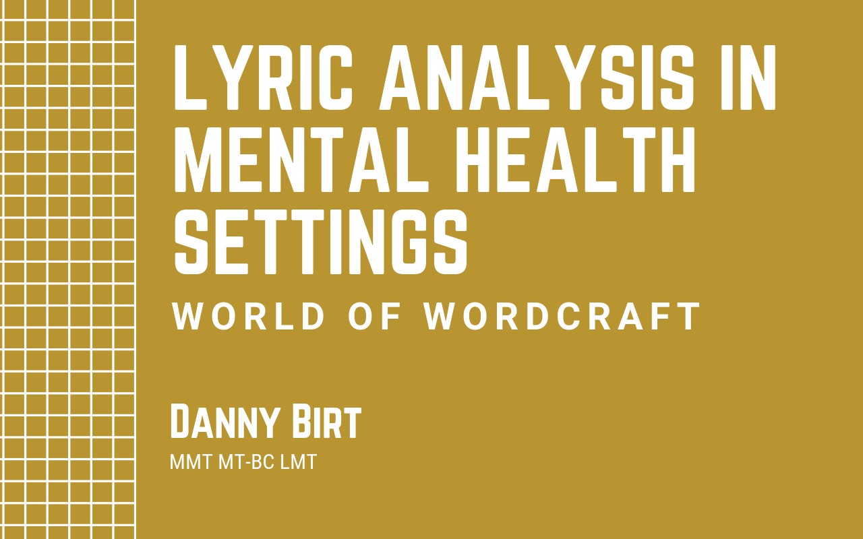
TUTORIAL WORKBOOK

This workbook is to accompany the Music Therapy Online tutorial ‘Lyric analysis in mental health settings’ by Danny Birt. Follow along with this workbook as you listen to the tutorial. You can pause the tutorial and complete the questions as you go.

Tutorial outline
Overview
- Introduction, overview and learning outcomes
- Needing a song for lyric analysis
- Finding songs
- Evaluating your song choices
- Preparing your song
- Presenting your song
- Analysing your song with your clients
- Alternate lyric analysis
- Summary & bonus content activities

Learning Objectives
- Set lyric analysis goals for a variety of clients in behavioural health
- Explore a range of ways to find the best song to fit those goals
- Evaluate lyrics’ impact from the standpoint of the individual word through the gestalt
- Choose different musical styles to accompany lyrics with which to have different effects
- Learn how to present lyrics to visual, auditory, and kinesthetic learners
- Widen your own perspective on analysis

Workbook Questions
What would you like to learn from today’s tutorial?

Come up with 3 different goal-oriented lyric search phrases connected to a therapy goal you could use with your clients.
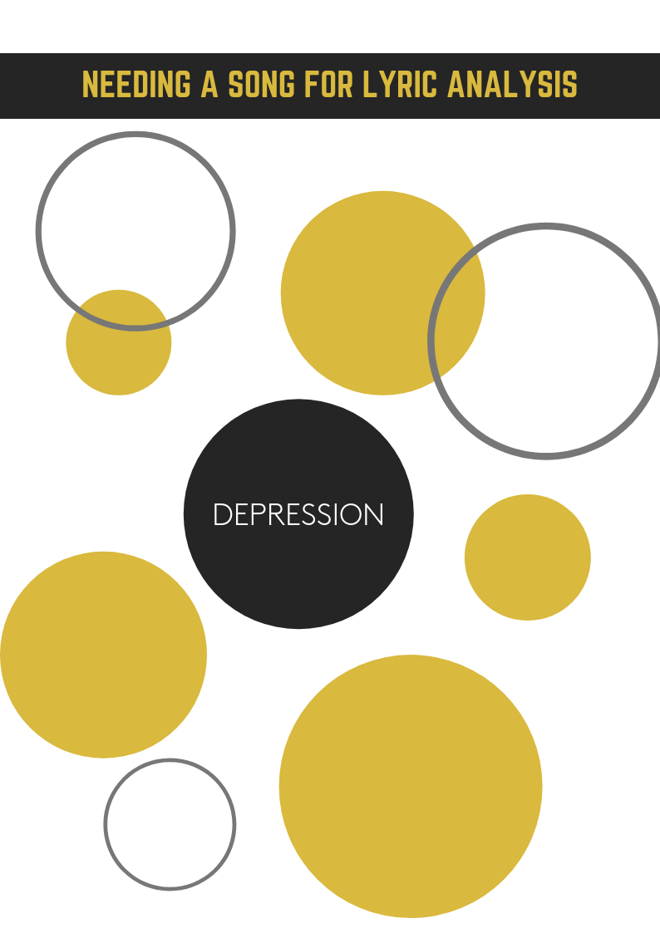
Use your 3 search phrases from your bubble chart to search for songs. List at least one song which shows up in all 3 searches and one song which is unique to each search. You should come up with a minimum of 4 songs.

Search Phrase 1 __________________________________________________________
Song –
Performer –

Search Phrase 2 __________________________________________________________
Song –
Performer –

Search Phrase 3 __________________________________________________________
Song –
Performer –

Common song across all phrases
Song –
Performer –

Narrow down the song list you made on the last page until you have one song that works. It should be non-blatant, open to interpretation, rich in verbiage, have at least something universal to human experience, be non-repetitive, and the whole should be greater than the sum of its parts. If you need to, go back and search again until you find an appropriate song.
Song –
Performer –

After listening to the two versions of ‘Shout’ answer the following:
- With which populations would you use each version of that song?
- What reactions are you looking for with each version of that song?
- Which version would be used in an anger management group? Why?

After listening to the two versions of ‘Mad World’ answer the following:
- With which populations would you use each version of that song?
- What reactions are you looking for with each version of that song?

After listening to the two versions of ‘Everybody wants to rule the world’ answer the following:
- With which populations would you use each version of that song?
- What reactions are you looking for with each version of that song

Compare and contrast YOUR chosen song with at least 2 other cover versions. If you can't find 2 other versions then create them in your own mind. How would/do they sound? What effects would/do they have?

Write down how you will present your song. Sketch out a rough draft of how you would visually present it, directions you want to give beforehand and any other facilitation information.

What did you find the most useful about today’s tutorial? Don’t forget you can pass on any positive feedback to Danny via the feedback sections.

Congratulations! You’re done!

If your local music therapy association has an ongoing education/registration program then this bonus credit activity is eligible for CPD/CMTE credits.
See the TUTORIAL SUMMARY & SUBMISSION INFO doc for details on how you can claim your CMTE/CPD credits.

Thank you for joining us for this tutorial today!
You can find more fabulous tutorials at www.musictherapyonline.org

