NOTICE: FOR LAW ENFORCEMENT USE ONLY!

This information is confidential and intended solely for the use of the individual or entity to which they are addressed. This information message contains confidential and proprietary information and is intended only for the individual(s) and /or law enforcement agencies specifically named. If you are not the named addressee you should not disseminate, distribute or copy this information. If you are not the intended recipient you are notified that disclosing, copying, distributing or taking any action in reliance on the contents of this information is strictly prohibited and may result in legal action, including prosecution.

Greetings!

Thank you for participating in the online certification program. All information necessary to successfully complete the online certification exam is included in this study guide. A minimum score of 90% is required to pass the online certification exam.

There is no time limit to take the exam, and you have up to five (5) attempts to successfully complete the exam and obtain the minimum passing score.

There are three sections contained in this study guide.

Section I: Legal Information & Company History

Section II: Test Information

Section III: - Practice Test & Answer Key

Please don’t hesitate to contact us if you have any questions or if we can be of any additional assistance.

Please direct any questions, comments, concerns or feedback to:

Ian Scott
Director of Operations
Scott Company Drug Testing
(877) METH-KIT / (877) 638-4548
ian@scottcompany.com

Legal Information & Company History

Chemical Colormetric Drug Testing Kits are a nationally recognized and accepted method of establishing the probable cause required to affect an arrest for possession of an illegal drug or a controlled substance.

In medical and forensic science, a presumptive test is an analysis of a sample, which establishes either:

A) The sample is definitely not a certain substance, or
B) The sample probably is the substance.

The presence of a substance, even presence at a trace level, can often be detected by a presumptive test.

All reagents used by Scott Company to determine the presence of illegal drugs or controlled substances are listed in the National Institute of Justice Color Test Reagents/Kits for Preliminary Identification of Drugs of Abuse: NIJ Standard–0604.01 (Dept of Justice)

These tests, and others like them, are presumptive tests, and can generally be used to establish the probable cause necessary to affect an arrest for the possession of an illegal drug or other controlled substance.

Forensic laboratory analysis is usually done following the presumptive field tests to positively identify the substance. .

Presumptive field test kits are engineered to detect one (or more) specific substances and display a specific reaction appropriate to that particular substance. While presumptive testing is extremely reliable, faster, and less expensive than other methods of testing, it is possible (though unlikely) to receive a false positive result under certain conditions, when certain substances are introduced into the presumptive test.

No drug field test is 100% foolproof. We strongly advise the individual officer and appropriate agencies to use common sense and evaluate the totality of the circumstances before making an arrest.

If your agency requires it, you should (in compliance with any necessary incident documentation as per your agency's standard operating procedures) include a detailed description of the results you observe(d) (whether positive or inconclusive) when using any Scott Company Drug Testing product used to establish the probable cause necessary to effect the arrest.

Please note: the colors shown during any presumptive field test are not permanent, and will materially degrade over time because by design the chemical reactions appropriate to each test are not stable enough to maintain their positive result coloration for long periods. This should be taken into consideration if requires that the test is stored as evidence. Always make sure that the evidence chain of custody is well documented.

A positive result on any drug field test kit may not always be enough to bring formal charges against a suspect – it is extremely important to know your agency’s appropriate legal procedure in accordance with local, county, state, or federal laws and ordinances.

Your should contact your supervisory officer, local district attorney, or prosecutors office if you have any questions regarding the legality of colormetric field tests for the presumptive identification of narcotics, illegal drugs and /or controlled substances in your jurisdiction.

Because of this, Scott Company recommends that, in an effort both to aid the prosecution and to protect the legal and constitutional rights of the accused, in the absence of a written confession, signed by the suspect, the arresting agency should (where and when appropriate in accordance with local, county, state, or federal laws and ordinances) obtain a confirmation of the composition of any substance tested using a confirmatory testing method (such as a gas chromatography/mass spectrometry (GC/MS)) to obtain a confirmed analytical result before final charges are filed against an individual suspected of the sale, delivery, manufacture or possession of the suspected illegal drug or other controlled substance.

Please note: tasting substances suspected of being illegal drugs and/or controlled substances is a highly unreliable and extremely dangerous method of identification that should be avoided at all costs.

If you have any questions, please don't hesitate to contact us, your local prosecutor or district attorney's office, or legal counsel.

Scott Company Drug testing was founded in 1990 by forensic chemist and retired DEA Agent L.J. Scott, the inventor of the Scott Reagent.

Updated for 2017!
Pursuant to the 2005 the National Institute of Justice Color Test Reagents/Kits for Preliminary Identification of Drugs of Abuse: NIJ Standard–0604.01 (Dept of Justice), the following information has been added to the packaging for ALL Scott Company products.

IMPORTANT!
READ BEFORE USING!

- This test is intended to be used for presumptive identification purposes only, and that all substances tested should be subjected to more definitive examination by qualified scientists in a properly equipped crime laboratory.

- Users of this test should receive appropriate training in its use and understand that the reagents can give false-positive as well as false-negative results.

- Reagent and/or sample contamination can cause misleading results.

- Tests can be best be stored out of direct sunlight and in climate controlled environments where possible.

- Though presumptive testing is extremely reliable, faster, and less expensive than other methods of testing, it is possible to receive a false positive result under certain conditions, when certain substances are introduced into the presumptive test. We strongly advise the individual officer and appropriate agencies to use common sense and evaluate the totality of the circumstances before making an arrest.

- Scott Company recommends that, in an effort both to aid the prosecution and to protect the legal and constitutional rights of the accused, the arresting agency obtain confirmation of the composition of any substance tested using a confirmatory testing method such as a gas chromatography/mass spectrometry (GC/MS) to obtain a confirmed analytical result before final charges are filed against an individual suspected of the sale, delivery, manufacture or possession of the suspected illegal drug or other controlled substance.

Free product training (including study guide, exam and certification) is available on our website. Visit scottcompany.com to enroll.

Section II: Test Information

Scott Cocaine Test

- Reagent: Scott Reagent (simplified)
- Application: used to detect the presence of cocaine HCL and/or cocaine base (crack)
- Positive test reaction: rapidly developing blue color

Scott Cocaine Residue Swab

- Reagent: Scott Reagent (simplified)
- Application: used to detect the presence of cocaine HCL and/or cocaine base (crack) residue
- Positive test reaction: rapidly developing blue color

Methamphetamine Test

- Reagent: Simon’s Reagent
- Application: used to detect the presence of methamphetamine
- Positive test reaction: blue/purple color within 10 seconds

Methamphetamine Residue Swab

- Reagent: Simon’s Reagent
- Application used to detect the presence of methamphetamine residue
- Positive test reaction: blue/purple color within 10 seconds

Marquis (Heroin) Test

- Reagent: Marquis Reagent (NOTE: This test contains strong acid – use caution when handling!)
- Application: used to detect the presence of diacetyl morphine (heroin), amphetamines (including methamphetamines) and Oxycodone
- Positive test reaction: rapidly developing purple color (heroin); rapidly developing orange-turning-brown color (amphetamines/methamphetamines); rapidly developing gray color (OxyCodone)

Heroin Residue Test

- Reagent: Marquis Reagent (NOTE: This test contains strong acid – use caution when handling!)
- Application: used to detect the presence of diacetyl morphine (heroin) residue
- Positive test reaction: rapidly developing purple color

MDMA (Ecstasy) Test

- Reagent: Sulphuric Acid (NOTE: This test contains strong acid – use caution when handling!)
- Application: used to detect the presence of MDMA (3,4-methylenedioxy-methamphetamine)
- Positive test reaction: rapidly developing purple-turning-black color

Duquenois Marijuana Test

- Reagent: Duquenois Reagent (NOTE: This test contains strong acid – use caution when handling!)
- Application: used to detect the presence of THC (delta-9-tetrahydrocannabinol) in suspected marijuana, hashish, hash oil, and/or “wax”
- Positive test reaction: purple color AFTER a 60-second wait

Ehrlich’s LSD Test

- Reagent: Ehlich’s Reagent (NOTE: This test contains strong acid – use caution when handling!)
- Application: used to detect the presence of LSD (d-lysergic acid diethylamide)
- Positive test reaction: purple color

GHB Test

- Reagent: Ferric Chloride-Hydrated Reagent

Application: used to detect the presence of gamma-hydroxybutyric acid (GHB)
- Positive test reaction: brown color

Mecke’s Test

- Reagent: Mecke’s Reagent (NOTE: This test contains strong acid – use caution when handling!)
- Application: used to detect the presence of opiates
- Positive test reaction: bluish-green color

Mandelin Test

- Reagent: Mandelin Reagent (NOTE: This test contains strong acid – use caution when handling!)
- Application: used to detect the presence of MDMA (3,4-methylenedioxy-methamphetamine), amphetamines (including methamphetamines) and Ketamine
- Positive test reaction: dark blue color (MDMA); green (amphetamines/methamphetamines); orange-turning-brown (Ketamine)

MDPV / Mephedrone Test (Bath Salts)

- Reagent: Mandelin Reagent (NOTE: This test contains strong acid – use caution when handling!)
- Application: used to detect the presence of MDPV (3,4-methylenedioxypyrovalerone) or Mephedrone (4-methylmethcathinone)
- Positive test reaction: orange color (Mephedrone); green color (MDPV)

Ephedrine / Pseudoephedrine Test

- Reagent: Ephedrine Reagent
- Application: used to detect the presence of ephedrine and/or pseudoephedrine
- Positive test reaction: lavender color

Section III: - Practice Test & Answer Key

1.Scott Company Drug Testing was founded by:

- L.J. Scott, a forensic chemist and DEA agent
- Mark Cuban, billionaire entrepreneur and owner of the Dallas Mavericks
- Sheriff Joe Arpaio of Maricopa County, Arizona
- Ernesto Miranda

2.Chemical Colormetric Drug Testing Kits are a nationally recognized and accepted method of establishing the probable cause required to effect an arrest for possession of an illegal drug or a controlled substance.

- true
- false

3.When using a Scott Company Cocaine Test and/or a Cocaine Residue Swab, a positive result will be indicated by the rapid development of a ________ color presence.

- Green
- Purple
- Yellow
- Bright Blue

4.The presence of a substance, even presence at a trace level, ______ detected by a presumptive test.

- can be
- can NOT be

5.The Duquenois Marijuana test requires a ____ wait time before observing any color change.

- 15 second
- 30 seconds
- 45 second
- 60 second

6.All Drug Field Tests Kits are 100% foolproof and can never, ever indicate a false positive reading.

- True - there is no possible way any drug test kit can be fooled.
- False - no drug test kit suitable for field use is 100% immune from false positive readings

7.Scott Company Drug testing was founded in _________

- 1946
- 1990
- 2002
- 2014

8.All reagents used by Scott Company to determine the presence of illegal drugs or controlled substances are listed in the National Institute of Justice Color Test Reagents/Kits for Preliminary Identification of Drugs of Abuse: NIJ Standard–0604.01, published by ___________

- The Dept of Justice
- The FBI
- ICE
- Dept of Homeland Security

9.These tests, and others like them, are presumptive tests, and can generally be used to establish the probable cause necessary to effect an arrest for the possession of an illegal drug or other controlled substance.

- true
- false
- Arresting and filing formal charges are the exact same thing

10.The Marquis Reagent is completely inert (harmless) and no precautions whatsoever should be taken when handling any test utilizing this reagent system.

- True
- False - this test contains a strong acid
- There is no way to know the answer to this question without knowing the exact chemical properties of the reagent components.

11.The Scott Company Heroin Test and Heroin Residue Swab utilize the following reagent system:

- Marquis Reagent
- Sodium Nitroprusside Reagent
- Ehrlich’s Reagent
- Duquenois-Levine Reagent

12.Tasting substances suspected of being illegal drugs and/or controlled substances is a highly reliable and legally accepted method of identification.

- True
- Sometimes
- False - is it rarely, if ever, a good idea to ingest something that you believe may be a narcotic, controlled substance, or illegal drug.

13.Scott Company tests can be used on "Bath Salts" to see if they contain:

- Mephedrone and/or MDPV
- Table Salt and Mild Detergent
- Trioxin

14.An additional confirmatory test can be used after the presumptive test report is positive for the substance to confirm the substances identity or to measure the percentage purity or other quantitative analysis.

- true
- false

15.Ephedrine and/or Pseudoephedrine can be a precursor to which of the following drugs?

- Tylenol
- Heroin
- Methamphetamine
- Lysergic Acid Diethelymide

16.GCMS is a generally understood to refer to a:

- Gas Chromatographer / Mass Spectrometer
- Garden Colored / Multifunction Sphere
- Golf Charlie / Mike Sierra
- Gas Charged / Mass State

17.The Mandelin Test can be used to detect the presence of:

- Ketamine
- Cocaine
- Marijuana / THC
- LSD

18.Your should contact your supervisory officer, local district attorney, or prosecutors office if you have any questions regarding the legality of colormetric field tests for the presumptive identification of narcotics, illegal drugs and /or controlled substances in your jurisdiction.

- true
- false

19.When using a Scott Company Heroin Test and/or a Heroin Residue Swab, a positive result will be indicated by the rapid development of a ________ color presence.

- Blue
- Purple
- Bright Yellow-Green
- Brown

20.The Scott Company Cocaine Test and Cocaine Residue Swab utilize the following reagent system:

- Scott Cocaine Reagent (simplified)
- Scott Cocaine Reagent (modified)
- Duquenois-Levine Reagent
- Marquis Reagent

21.When using a Scott Company Methamphetamine Test and/or a Meth Residue Swab, a positive result will be indicated by the development of a ________ color presence within 10 seconds.

- Blue-Purple
- Red
- Bright Fluorescent Blue
- Yellow-Green

22.In medical and forensic science, a presumptive test is an analysis of a sample, which establishes either:

- That the sample is definitely not a certain substance
- The sample probably is the substance.
- Both A and B
- Neither A nor B

23. The colors shown during any presumptive field test are not permanent, and will materially degrade over time.

- true
- false

24.If your agency requires it, you should always make sure that the test is properly marked and stored as evidence, and make sure that the evidence chain of custody is well documented.

- true
- false

25. Depending on the jurisdiction, a positive result on any drug field test kit may not always be enough to bring formal charges against a suspect.

- True - in some cases, it may generally be best to await the results from the crime lab before filing formal charges.

- False - a positive result is ALWAYS enough to file formal charges in every single court, every single time.

26. This test is intended to be used for presumptive identification purposes only, and that all substances tested should be subjected to more definitive examination by qualified scientists in a properly equipped crime laboratory.

- true
- false

27. Reagent and/or sample contamination can cause misleading results

- true
- false

28. Tests can be best be stored out of direct sunlight and in climate controlled environments where possible.

- true
- false

29. Though presumptive testing is extremely reliable, faster, and less expensive than other methods of testing, it is possible to receive a false positive result under certain conditions, when certain substances are introduced into the presumptive test.

- true
- false

30. Individual officers and appropriate agencies should always use common sense and evaluate the totality of the circumstances before making an arrest.

- true
- false

31. Scott Company recommends that, in an effort both to aid the prosecution and to protect the legal and constitutional rights of the accused, the arresting agency obtain confirmation of the composition of any substance tested using a confirmatory testing method such as a gas chromatography/mass spectrometry (GC/MS) to obtain a confirmed analytical result before final charges are filed against an individual suspected of the sale, delivery, manufacture or possession of the suspected illegal drug or other controlled substance.

- true
- false

32. A Duquenois Marijuana / THC Test will indicate a positive result by turning a ___________________ color after a 60 second wait.

- Red
- Green
- Yellow
- Blue/Purple
- Orange turning Brown
Answer Key:

1. A
2. A
3. D
4. A
5. D
6. B
7. B
8. A
9. A
10. B
11. A
12. C
13. A
14. A
15. C
16. A
17. A
18. A
19. B
20. A
21. A
22. C
23. A
24. A
25. A
26. A
27. A
28. A
29. A
30. A
31. A
32. D

III – Addendum: Positive Results

Below are images of positive results.
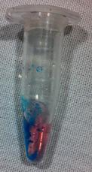
Positive Result; Cocaine HCL

Image courtesy of Wisconsin Narcotics Officer's Association 2015

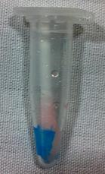

Positive Result; Cocaine Residue

Image courtesy of Wisconsin Narcotics Officer's Association 2015

Positive Result; Heroin (diacetylmorphine) - Marquis Test

Image courtesy of Wisconsin Narcotics Officer's Association 2015

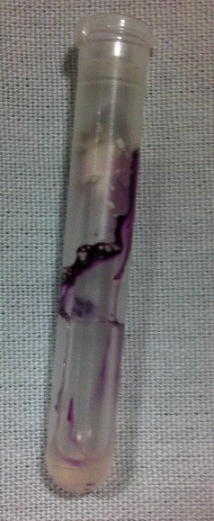

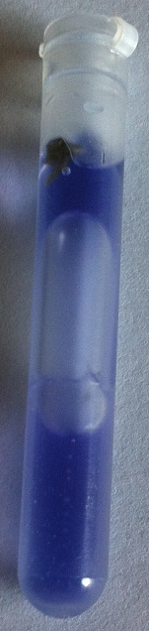

Positive Result; THC (in marijuana leaf)

Image courtesy of Wisconsin Narcotics Officer's Association 2015

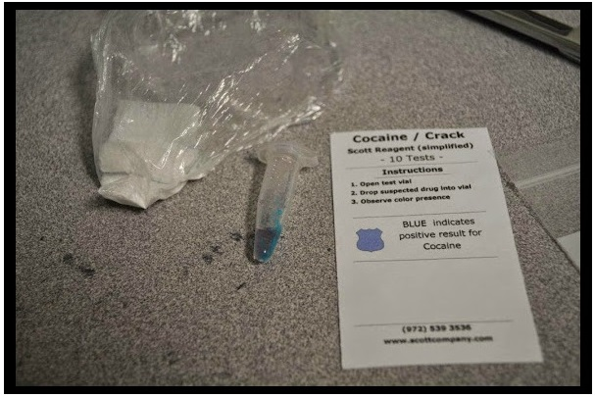
Positive Result: Cocaine HCL

Image courtesy of New Hanover County Sheriff's Office
(Vice/Narcotics Division)

Positive Result: Cocaine HCL

Image courtesy of New Hanover County Sheriff's Office
(Vice/Narcotics Division)

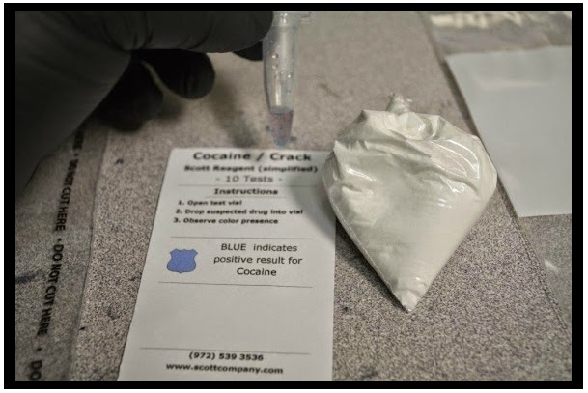

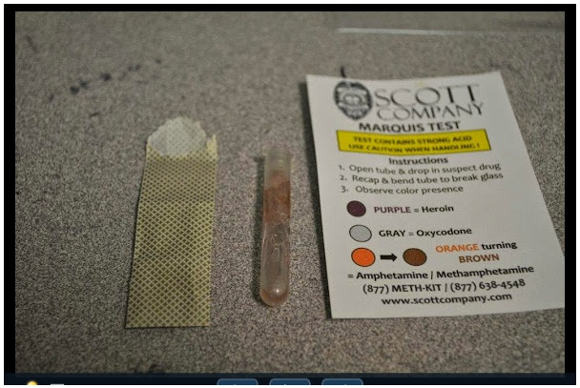

Positive Result: Methamphetamine
(Marquis Test)

Image courtesy of New Hanover County Sheriff's Office (Vice/Narcotics Division)

