Abstract Template
Sampling and Quality Assurance 2026

ABSTRACT

Sampling with Drones

Thomas McLoughlin
Drone and Marine Vessel Coordinator, Sydney Water

Email: thomas.mcloughlin@sydneywater.com.au

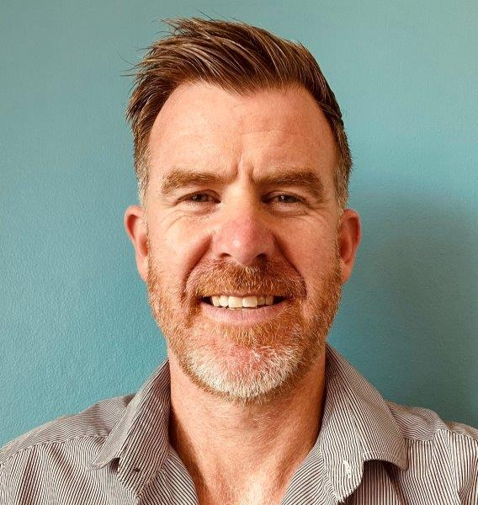

Drones are rapidly transforming environmental monitoring, offering organisations unprecedented capability, safety, and operational efficiency. Sydney Water is actively expanding its drone program to integrate these emerging technologies into core operational, regulatory, and scientific workflows.

Sydney Water Aquatic Monitoring (SWAM) program is endorsed by the EPA, with the overarching aim:

“To monitor the performance of Sydney Water’s water resource recovery facility (WRRF) discharges and quantify the impacts—positive or negative—of these discharges, sewer overflows, and leakage on the aquatic environment.”

The SWAM Nearshore intertidal drone pilot (volume 4) demonstrates how aerial platforms can deliver high resolution data from locations that were previously inaccessible or unsafe to survey. During spring, drones were deployed to collect water quality samples and conduct intertidal rock platform algal and quadrat surveys across three impact sites (Warriewood, Shellharbour, Bombo) and eight reference sites. Sites such as Bombo, once effectively unreachable using traditional field methods, can now be routinely accessed via drone, significantly reducing risk while improving data quality and sampling consistency.

This pilot highlights the expanding capability of drone technology—enhanced sensor payloads, precision navigation, and advanced sampling tools—to support innovative monitoring solutions. As drone systems continue to evolve, they provide Sydney Water with new avenues to enhance environmental compliance, improve operational efficiency, and strengthen our understanding of coastal ecosystem dynamics.

