

FALL WEEK 10 | November 15-16, 2025

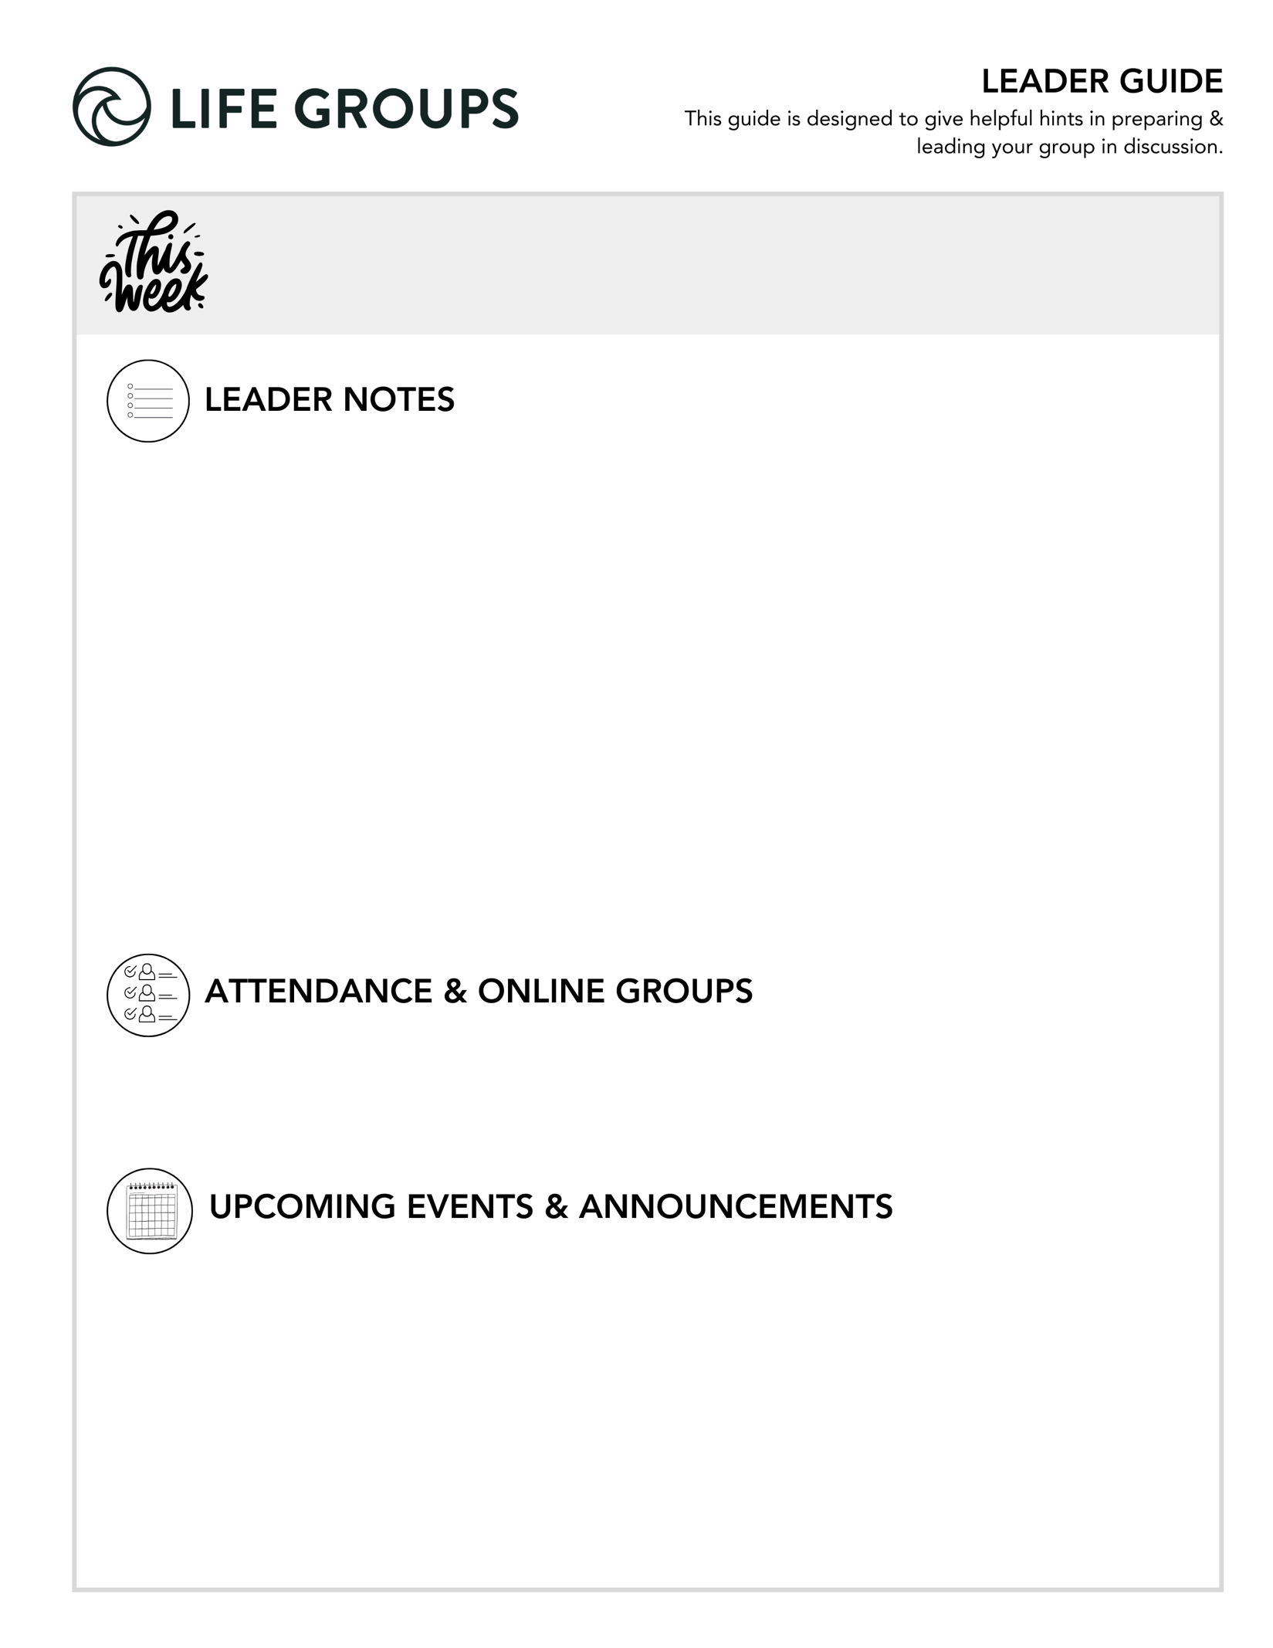
- Roster Confirmations and Feedback forms. Ask your group about their plans for the winter quarter and let us know when you turn in your roster confirmation. Also take some time and ask your group to fill out the feedback form! This is a huge help for us and our ministry. Thanks for being a part of it!
- Communion This Week. Make sure you get your supplies ready.
- Christmas Party or Friendsgiving. Though not required, feel free to do a Friendsgiving or Christmas Party with your group sometime in December. A white elephant gift exchange or Christmas games can be a fun
way for an extra connection as you move into the Christmas season.
- Winter Quarter Dates. Sign-ups Jan 3-11. Winter Quarter Jan 11- Mar 14.

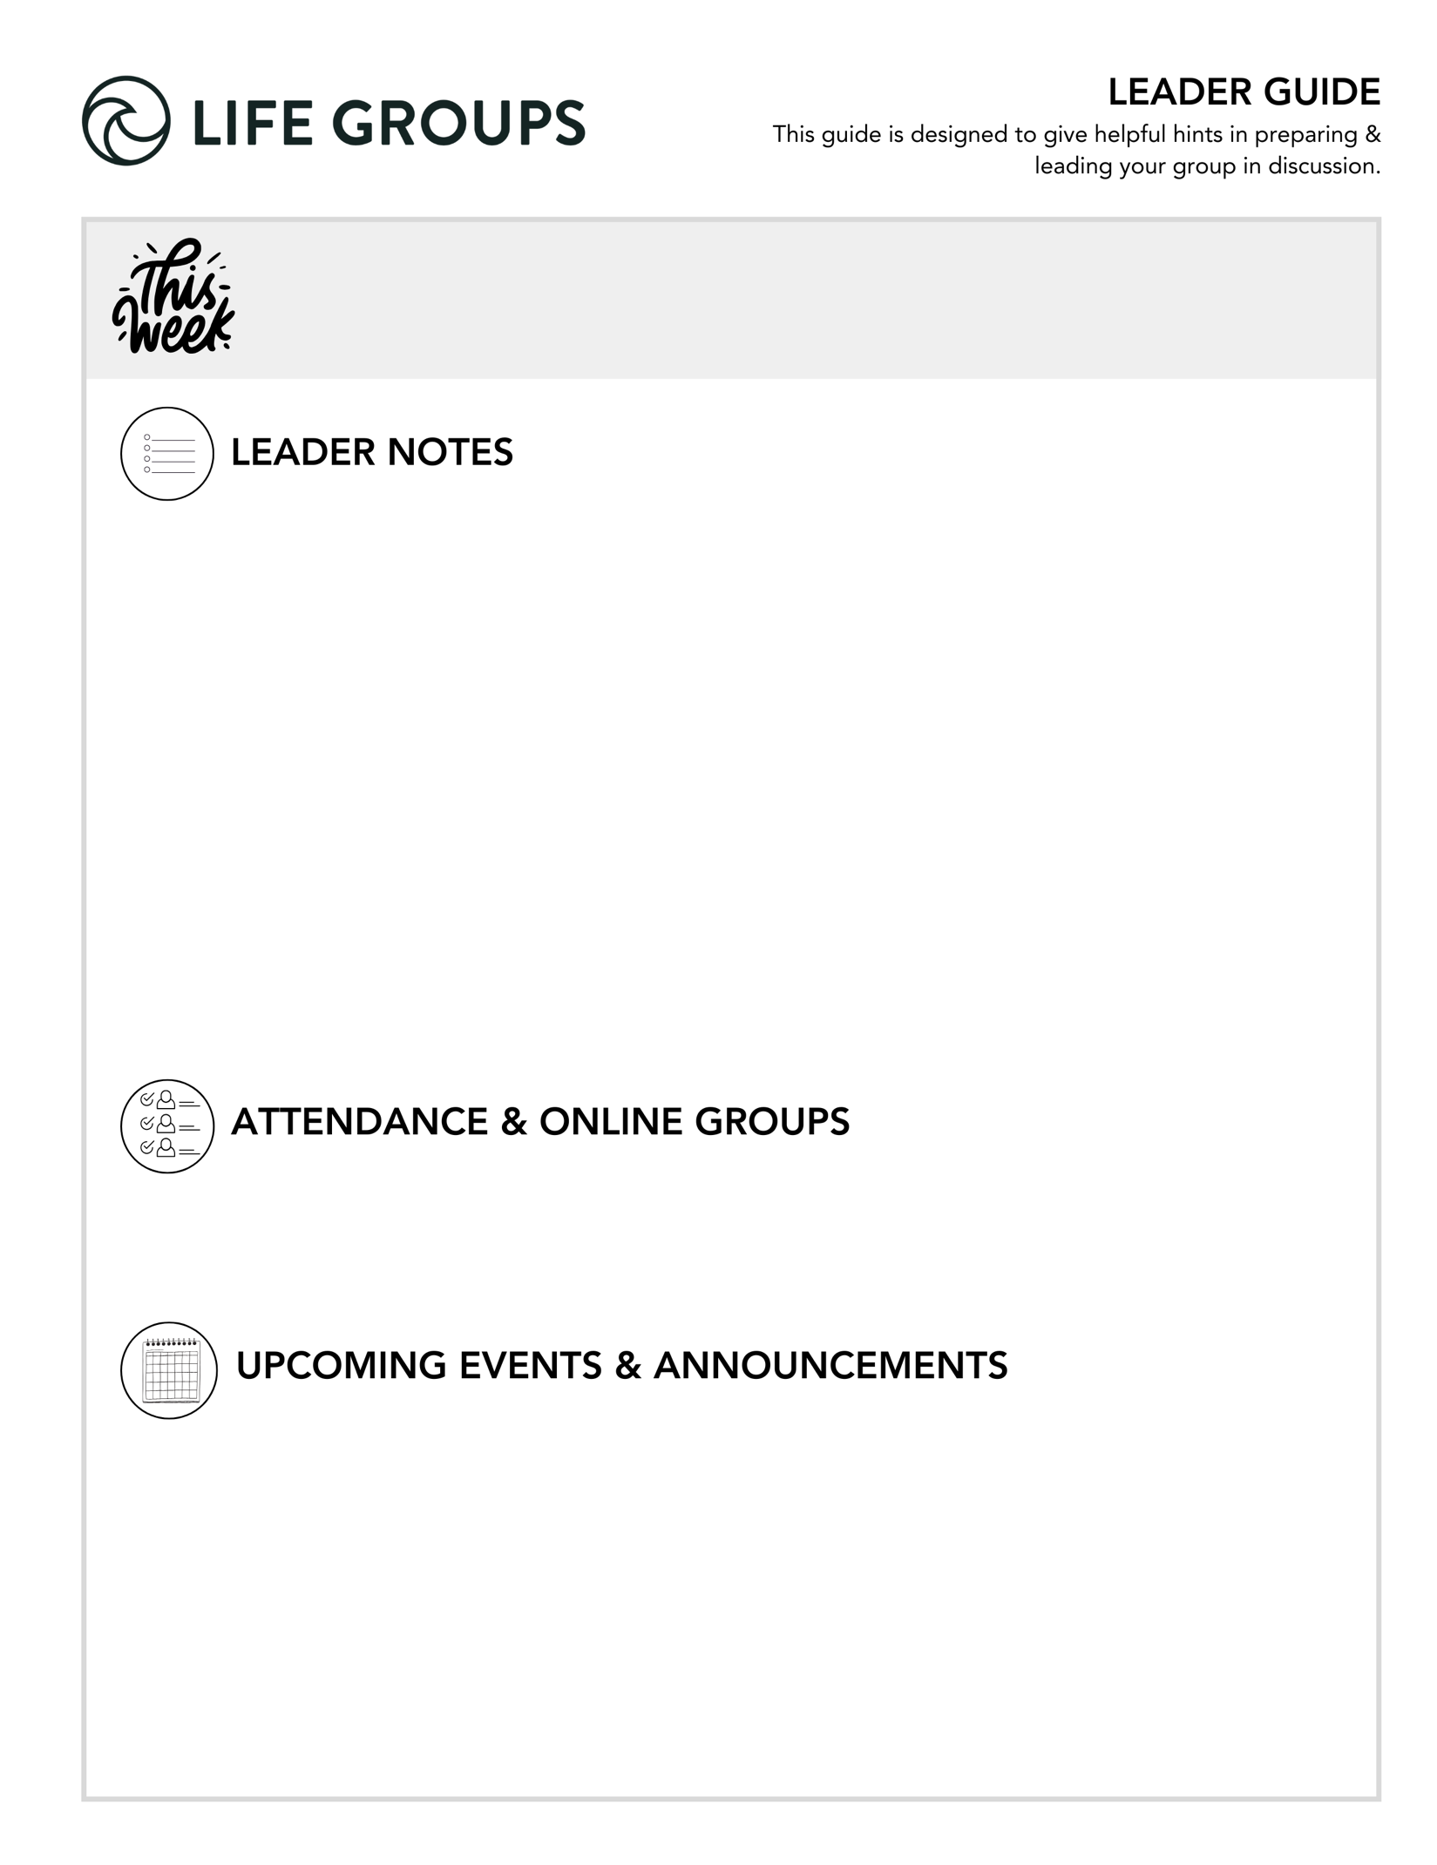

- Submit attendance: Post attendance Let us know of any changes for the Winter Quarter that you know of in the notes section!
- Online Groups: Get tips and tutorials!

- Thanksgiving Day Turkey Trot 5K - OPEN TO EVERYONE! North Coast’s annual Turkey Trot 5K takes place at the Vista Campus on November 27. This is a great way to start Thanksgiving Day and support the Military Connection Ministry!
  - Link to register: https://www.northcoastchurch.com/calendar/turkey-trot/

- Military Connection Thanksgiving Dinner - FOR ALL ACTIVE DUTY, VETERAN, OR RETIRED MILITARY – AND THEIR IMMEDIATE FAMILIES. The Military Connection ministry offers a full Thanksgiving dinner, football on the large screen, activities for kids, contest, raffles, and more!
  - Link to register: https://my.northcoastchurch.com/Event/thanksgiving2025


LEADER DISCUSSION GUIDE
_____________________________

WARM UP

1. This week, Life Groups wrap up before the holiday break. As you reflect on this quarter together in your Life Group, what is something you are thankful for or will remember from this season?

Additional Thought: Gratitude is one of the simplest ways to refocus our hearts on God’s faithfulness. This question helps the group close the quarter in celebration.
Additional Scripture: 1 Thessalonians 5:18 – “Give thanks in all circumstances; for this is the will of God in Christ Jesus for you.”
Additional Question: What’s one way you’ve seen God answer prayer or show up unexpectedly in your group this quarter?

2. This weekend, we talked about the rest Jesus gives our souls, not just our bodies. What would be your ideal way to relax or rest after a stressful day or demanding season?

Additional Thought: This fun question reveals how differently people recharge through activity, others stillness.
Additional Scripture: Psalm 62:1 – “For God alone my soul waits in silence; from him comes my salvation.”
Additional Question: How does your current version of “rest” compare to what Jesus describes as rest for the soul?

3. What part of the message or verses did you most need to hear this week?

Additional Thought: This question centers the conversation in Scripture and allows the Spirit to personalize what hit home for each person.
Additional Question: How do you sense God inviting you to respond to what stood out?


KNOW IT

Re-read Matthew 11:28-30.

1. We heard an explanation of a “yoke.” Can you think of a modern-day object or analogy that embodies this concept and how does it relate to Jesus’ invitation?

Additional Thought: A yoke symbolizes partnership and direction—Jesus invites us to join Him, not work for Him alone. Modern analogies might include training wheels, GPS, or noise canceling head phones…all you hear is Him!
Additional Scripture: Galatians 5:1 – “For freedom Christ has set us free… do not submit again to a yoke of slavery.”
Additional Question: What might it look like in your life to move from pulling your own load to walking in step with Jesus?
Conversation Caution: Some may view the word “yoke” as burdensome, clarify that this is about shared strength, not added weight.

2. Jesus calls Himself gentle and humble in verse 29. Out of all the adjectives that define Jesus, what do you think is the significance of Him using those two in this context?

Additional Thought: Jesus could have chosen power or authority, but He chose character traits that bring safety and accessibility to the weary.
Additional Scripture: Philippians 2:5–8 – Jesus humbled Himself by becoming obedient to death on a cross.
Additional Question: How does knowing Jesus is gentle and humble reshape how you come to Him when you’re exhausted or ashamed?

3. Another excellent reminder of the rest God gives is found in Psalm 23. Read it and pay attention to the kind of shepherd He is. Notice that the psalmist is walking through the darkest valley, not around it, but he still finds comfort in God’s presence. How does that connect to Jesus saying, “My yoke is easy, and my burden is light?”

Additional Thought: Real rest doesn’t come from escape, but from God’s nearness in the middle of difficulty. Both Psalm 23 and Matthew 11 emphasize presence over circumstance.
Additional Scripture: Isaiah 26:3 – “You keep him in perfect peace whose mind is stayed on you, because he trusts in you.”
Additional Question: When have you felt God’s peace even though your situation didn’t change?
Group Dynamic Tip: Consider reading Psalm 23 aloud slowly as a group exercise in resting together before discussion.


SHARE IT

1. This weekend, we talked about how our souls can find rest even if our burdens don’t actually change because true soul rest comes from Jesus. Have you met Christians who seemed to be going through hell, but they still displayed Heaven? What did you notice about them?

Additional Thought: These stories inspire faith by showing that peace is possible even in pain. This can help the group visualize “soul rest” in real life.
Additional Scripture: Philippians 4:11–13 – “I have learned in whatever situation I am to be content…”
Additional Question: What did those people know or practice that you might want to imitate?
Group Dynamic Tip: Invite a few brief stories rather than one long one to keep everyone engaged.

2. Chris talked about how the people wanted miracles, but Jesus wanted their repentance and a relationship with them. He pointed out that we often want the “presents” of God, not the presence of God. What’s one area where you’ve wanted God to fix your circumstances more than form your character?

Additional Thought: This question invites gentle self-awareness.
Additional Scripture: James 1:2–4 “The testing of your faith produces steadfastness…”
Additional Question: What helps you shift from asking for relief to asking for growth?


LIVE IT

1. We are about to head into a Christmas season that reminds us of Jesus’ presence with us, and yet it can be easy to feel unrested around this time. Take a moment and examine—how rested is your soul right now? Where in your life might you need to slow down, and walk through the four steps given to us this weekend in order to surrender and reconnect with Jesus?

Additional Thought: The holidays often magnify both joy and exhaustion. This is a chance to practice the very rest Jesus offers before the rush begins.
Additional Scripture: Matthew 6:33 “Seek first the kingdom of God…”
Additional Question: What would it look like to intentionally build soul rest into your holiday schedule?
Conversation Caution: Resist the temptation to make this about time management; focus on spiritual connection.

2. Communion reminds us that Jesus carried the heaviest burden for us. As you prepare to take Communion as a group, what is one way you want to “yoke yourself to Jesus” this week? Also, understanding repentance better, is there anything you want to repent of before we participate in this act of Communion?

COMMUNION IDEAS: You may want to involve others by asking them to read Scriptures. The bread and juice can also be set on a table in the middle of the room, and people can take Communion after you read the Scripture and pray, or while the group sings or listens to a worship song.
PURPOSE: Introduce Communion by sharing that it’s about being intentional in remembering the great love God has for us by sending His son Jesus to suffer and die that we might have live.
- READ (and share option): You can have others read it or you as a leader.
Read Romans 5:7-8
Read John 15:12-17
Question option - “What are you grateful for in light of these verses as to who God is and how he has worked in their life this past year.” Looking back during this quarter with your Life Group, what stands out as a small or significant growth point in your journey with Jesus?
Read I Corinthians 11:24-26 and have everyone take a Communion.
“This is my body, which is for you; do this in remembrance of me.” 25 In the same way, after supper he took the cup, saying, “This cup is the new covenant in my blood; do this, whenever you drink it, in remembrance of me.” 26 For whenever you eat this bread and drink this cup, you proclaim the Lord’s death until he comes.
- Music / Worship Option – Play In Christ Alone while your group takes Communion - You can play it while you pass out the Communion
- Video Option – If you would like, you can use this video to lead your group in Communion. A pastor will take you through communion and it will then transition to a worship song. But please feel to lead it yourself if you desire to. northcoastchurch.com/communion
DISTRIBUTE: As a leader/host team, you may want to serve each person as a symbol of Christ’s love and service to us. Pass the bread, thank the Lord for it and eat together. Pass the cup, thank the Lord for it and drink together.
PRAY: Move into prayer time, thanking Jesus for His commitment to love us and how He is working in our lives. Close your time in prayers of praise.


Pastor Chris Brown
November 15-16, 2025
Message #29/ Matthew 11:20-30
northcoastchurch.com/sermons

Why We Get Disappointed Or Angry With God

We are simply on a different page:
Matthew 11:20-24, John 21:25

We want MIRACLES, God wants REPENTANCE.

We want the TEMPORARY fixed when God is working on the ETERNAL.

Repentance: a change of MIND that leads to a change of ACTION.

How to get back on the same page:
Matthew 11:25-30, 1 Samuel 4:1-11, Psalm 23

Jesus’ greatest desire is to be KNOWN by us, not USED by us.

We need to learn how to:

MEET with Him

SHARE with Him

LEARN from Him

RECEIVE from Him

NOTE: God does not promise to change our EXTERNAL PROBLEMS, but promises to change our INTERNAL POSITION.

