

FALL WEEK 7 | October 25-26, 2025

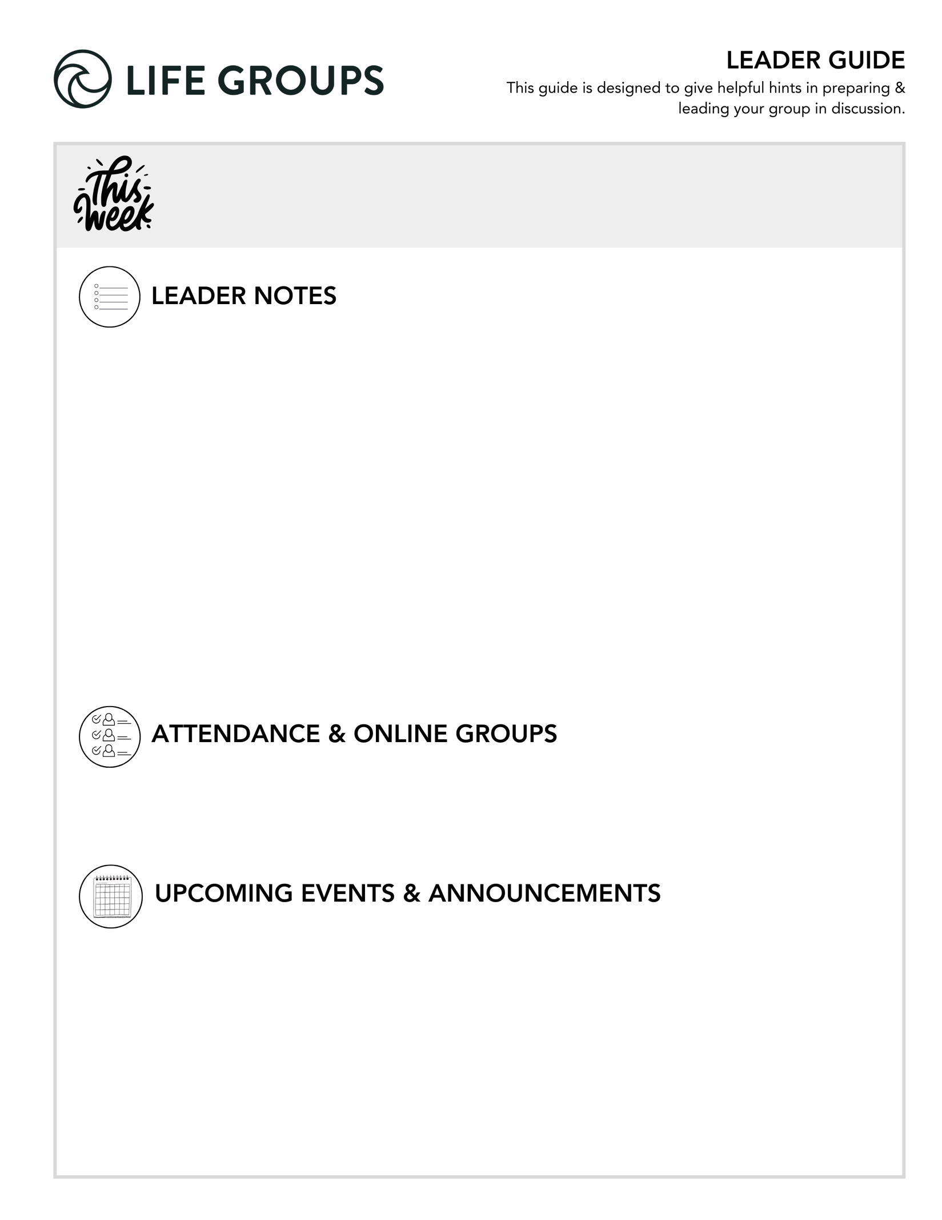

- Need help? Reach out to your Life Group Pastor any time!
- You don’t have to answer every question. Pick the ones that fit your group best.
- Encourage everyone to share. Set time limits if needed.
- Use the audio guide for more insights: Leader Tools
- Finalizing social and service projects? Check out:
  - Service project ideas
  - Social ideas
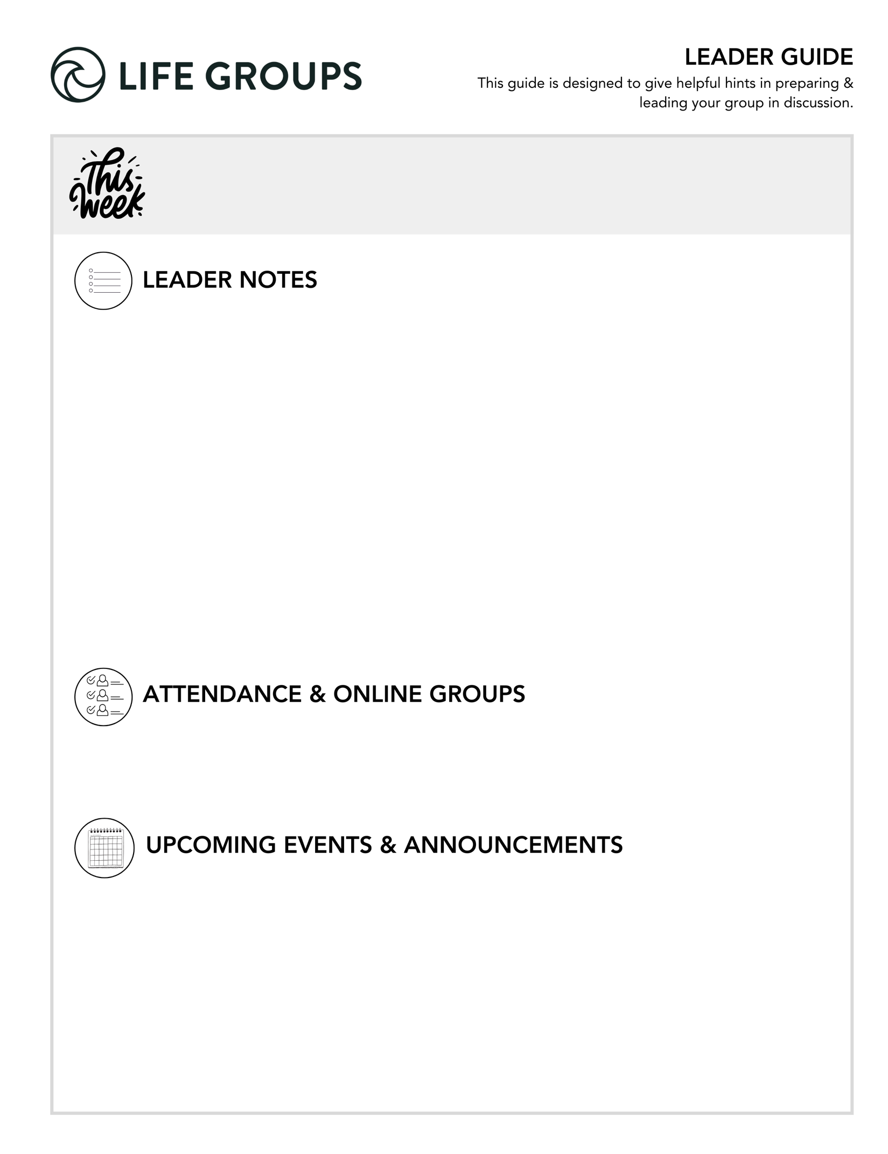

- Submit attendance: Post attendance
- Online Groups: Get tips and tutorials!


LEADER DISCUSSION GUIDE
_____________________________

WARM UP

1. This weekend, we were challenged to consider how the reality of death should shape the way we live. How often do you think about death, or your life in terms of the end?

Additional Thought: This can be a surprisingly vulnerable question. Some may think about death often due to loss, health, or philosophy—others rarely. There’s no wrong answer.
Additional Scripture: Psalm 90:12 – “So teach us to number our days that we may get a heart of wisdom.”
Additional Question: Does thinking about the end help you focus more or feel overwhelmed?
Conversation Caution: Be prepared for some to share about recent grief or loss. Offer empathy and gently steer back to the theme of intentional living.
Group Dynamic Tip: Create a calm, safe tone. Acknowledge that this is a big question to start with and let people pass if they prefer.

2. James talked about celebrating joyfully as a form of worship, like the invitation in Ecclesiastes to eat, drink, and be merry. What is your favorite way to celebrate what God has done in your life?

Additional Thought: Joy and celebration are key spiritual practices often overlooked. This question lets people share in gratitude.
Additional Scripture: Ecclesiastes 3:13 – “...everyone should eat and drink and take pleasure in all his toil—this is God’s gift to man.”
Additional Question: What’s one celebration you’ve had in the last year that felt sacred or memorable?
Conversation Caution: Some may feel like they haven’t had a reason to celebrate. Affirm that celebration can happen even in small things.

3. The message this weekend carried both good news and sobering realities. How did it sit with you, and what has lingered with you since?

Additional Thought: This question brings the conversation into real reflection. People may mention urgency, eternal perspective, or conviction.
Additional Scripture: John 10:10 – “I came that they may have life and have it abundantly.”
Additional Question: What’s something you feel challenged or inspired to act on from the message?
Conversation Caution: Avoid allowing the group to stay in vague responses. Encourage naming what stuck and why.


KNOW IT

This weekend, we were reminded that life isn’t a dress rehearsal - you’ve got one shot to live for what matters most. In Matthew 25:14-30, Jesus tells a story that shows what that looks like in action. Read the parable and discuss:

1. What does “faithful with little” look like in your everyday life?

Additional Thought: Jesus honors small, unseen acts. Faithfulness isn’t always dramatic.
Additional Scripture: Luke 16:10 – “One who is faithful in a very little is also faithful in much…”
Conversation Caution: Some may feel their life is too “small” to matter. Remind them that God sees and rewards even quiet faithfulness.

2. When you think about hearing “well done, good and faithful servant,” what kind of life would you hope to look back on?

Additional Thought: Think about the spiritual impact we leave behind and the kind of person we’re becoming.
Additional Scripture: 2 Timothy 4:7 – “I have fought the good fight, I have finished the race, I have kept the faith.”
Additional Question: What values or habits do you hope define your life?

3. What do you think leads someone to “bury” what God has given them instead of putting it to use?

Additional Thought: Fear, comparison, self-doubt, or feeling unnoticed can lead people to “play it safe” instead of living boldly.
Additional Scripture: 1 Peter 4:10 – “As each has received a gift, use it to serve one another…”
Additional Question: What “talent” might you be tempted to bury rather than use?


SHARE IT

1. We heard that obedience to God can put you at odds with the world, and people might hate you. Where are you tempted to live for people’s approval instead of God’s? What difference does it make when you remember that God’s opinion matters most?

Additional Thought: Approval-seeking can show up in subtle ways, overcommitting, people-pleasing, hiding convictions.
Additional Scripture: Galatians 1:10 – “...If I were still trying to please man, I would not be a servant of Christ.”
Additional Question: What’s one area where you need courage to live for God's applause alone?
Conversation Caution: Be gentle with this one; some people may not realize how deeply they’re influenced by others’ opinions.

2. James said we have two options for how to live - hellishly or hopefully. Has there been a time in your life when you were living more like one than the other? What did that look like for you?

Additional Thought: This question opens the door to real testimony. We all drift at times; this helps us reflect on how grace pulled us back.
Additional Scripture: Romans 12:2 – “Do not be conformed to this world, but be transformed by the renewal of your mind…”
Additional Question: How did God meet you in that season and begin to reorient your direction?
Conversation Caution: Be ready for heavier stories. Listen well and offer prayer if needed.


LIVE IT

1. James reminded us of the importance of loving deeply because people are the only thing we take with us into eternity. Is there someone who comes to mind that you want to invest in or deepen your relationship with?

Additional Thought: People are eternal; relationships are our greatest investment. This could be a child, coworker, spouse, friend, or someone hard to love.
Additional Scripture: John 13:35 – “By this all people will know that you are my disciples, if you have love for one another.”
Additional Question: What’s one action step you could take to deepen that relationship this week?
Conversation Caution: Be cautious around estranged or painful relationships. Let people name who they feel led toward, no pressure.
Group Dynamic Tip: Invite each person to write a name on a sticky note or card and keep it as a reminder this week.

2. This weekend’s message gave us a lot of reminders and challenges when it comes to living like we’re dying. What’s the most important one for you to remember or live out this week?

• Additional Scripture: James 1:22 – “Be doers of the word, and not hearers only…”
• Additional Question: How can we support you or pray for you in that?
• Conversation Caution: Don’t let it end in theory, encourage people to name one concrete thing.
• Group Dynamic Tip: Close by going around and letting each person share one “I will” statement (e.g., “I will text __,” “I will pray for __,” “I will write __”).

 |  | Pastor James Griffin  October 25-26, 2025  Ecclesiastes 9:1-10
 |  | northcoastchurch.com/sermons

Live Like You’re Dying

