

FALL WEEK 8 | November 1-2, 2025

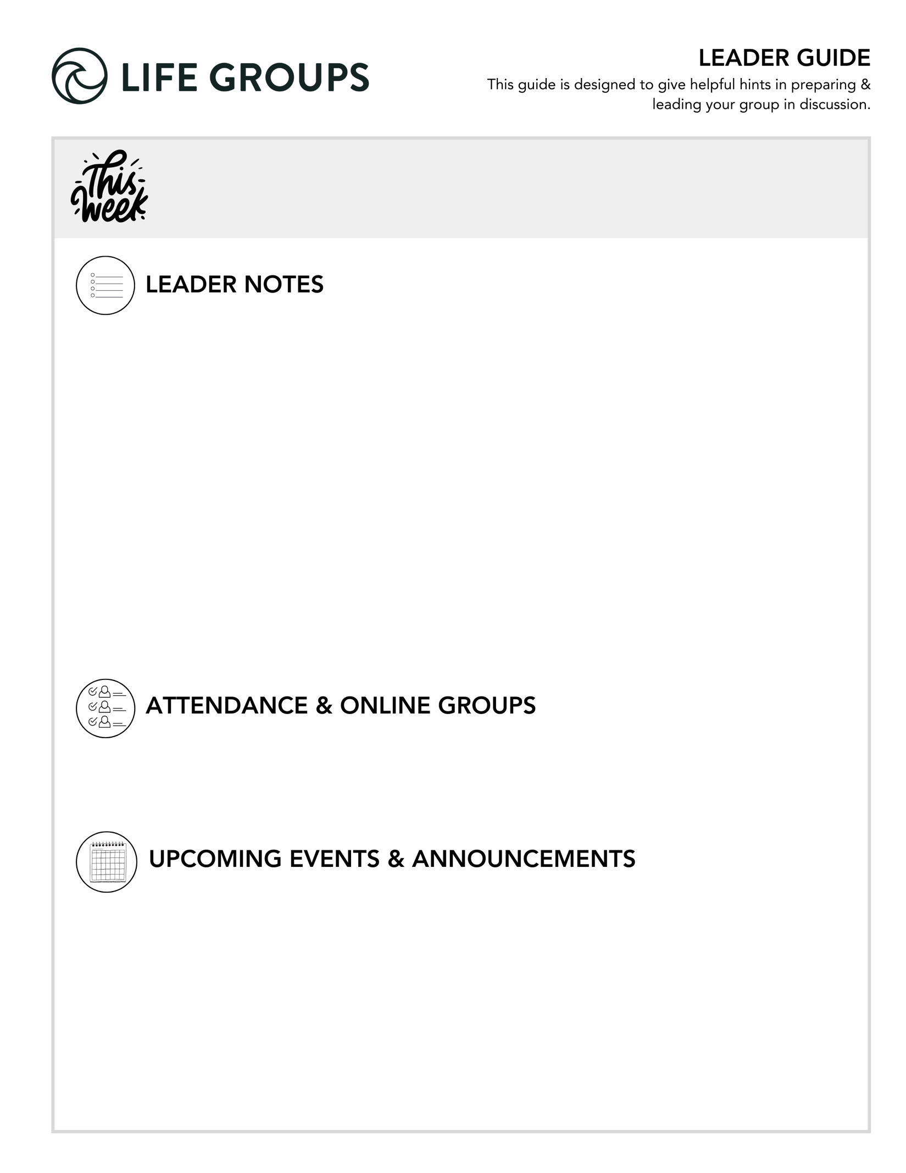

- Need help? Reach out to your Life Group Pastor any time!
- You don’t have to answer every question. Pick the ones that fit your group best.
- Encourage everyone to share. Set time limits if needed.
- Use the audio guide for more insights: Leader Tools
- Finalizing social and service projects? Check out:
  - Service project ideas
  - Social ideas
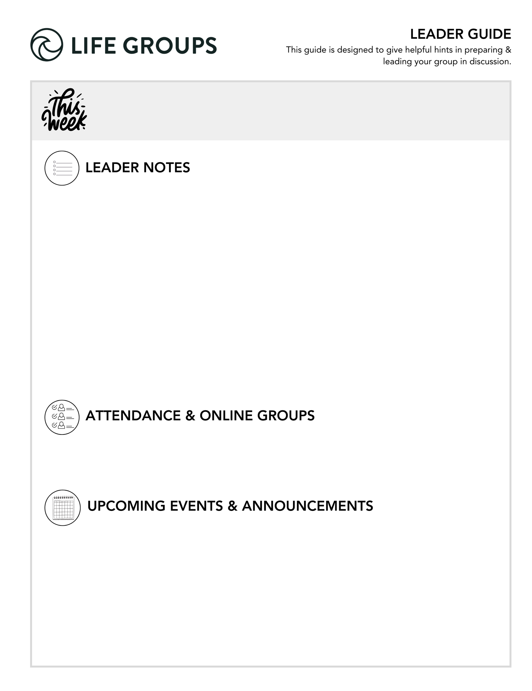

- Submit attendance: Post attendance
- Online Groups: Get tips and tutorials!

- Thanksgiving Day Turkey Trot 5K - OPEN TO EVERYONE! North Coast’s annual Turkey Trot 5K takes place at the Vista Campus on November 27. This is a great way to start Thanksgiving Day and support the Military Connection Ministry!
  - Link to register: https://www.northcoastchurch.com/calendar/turkey-trot/
- Military Connection Thanksgiving Dinner - FOR ALL ACTIVE DUTY, VETERAN, OR RETIRED MILITARY – AND THEIR IMMEDIATE FAMILIES. The Military Connection ministry offers a full Thanksgiving dinner, football on the large screen, activities for kids, contest, raffles, and more!
  - Link to register: https://my.northcoastchurch.com/Event/thanksgiving2025


LEADER DISCUSSION GUIDE
_____________________________

WARM UP

1. Chris pointed out November kicks off the holiday season (aka “family crisis” season). Are you eager or dreading the upcoming holidays, or both? Why?
Additional Thought: The holidays can surface both joy and tension—this question helps surface how people are really doing before heavier topics.
Additional Scripture: Romans 12:18 – “If it is possible, as far as it depends on you, live at peace with everyone.”
Additional Question: What usually helps you stay centered and focused on Jesus through the holidays?
Conversation Caution: Family dynamics can be painful or complicated; avoid offering quick fixes. Listen with empathy.
Group Dynamic Tip: Keep the tone lighthearted to start, but be ready for meaningful reflection if people go deeper.

2. This weekend we heard about the cost of being a Christian. What comes to mind when you think of the cost of being a Christian today?
Additional Thought: Cost looks different across cultures—ours may involve comfort, reputation, or convenience more than physical persecution.
Additional Scripture: Luke 9:23 – “If anyone would come after me, let him deny himself and take up his cross daily and follow me.”
Additional Question: How does the “cost” vary across different cultures? Ours versus another country, etc.?
Conversation Caution: Be careful not to let the discussion drift into political or cultural debates. Keep the focus on personal discipleship and what it means to follow Jesus faithfully in everyday life.
Group Dynamic Tip: Encourage honesty—there’s value in naming both big and small ways discipleship costs us something.

3. What is one new thing you learned from the sermon or hadn’t thought about before?

Additional Thought: This helps anchor the conversation in the weekend message—draw out specific insights or shifts in perspective.
Additional Question: If not something new you hadn’t thought about before, what was just a good reminder?
Conversation Caution: Challenge members to expand on why that note stood out to them or how it changed their perspective.
Group Dynamic Tip: If several people share, jot key themes on a whiteboard or note to tie back later in discussion.


KNOW IT

Jesus and the apostle Paul both give guidance on how disciples should live, even if it produces opposition. Read Romans 12:9-21 and Matthew 5:1-12.

1. How are these two passages of Scripture similar? What are their main messages?

Additional Thought: Both call believers to radical love, humility, and endurance in the face of opposition.
Additional Scripture: 1 Peter 3:9 – “Do not repay evil with evil or insult with insult, but with blessing...”
Additional Question: How does living this way reflect Jesus’ character to the world?
Conversation Caution: These passages overlap in spirit—no need to get bogged down in details or differences. Help the group reflect on the overall posture Jesus calls us to.
Group Dynamic Tip: Split the group to read each passage, then share observations before combining insights.
2. Why does following Jesus sometimes lead to persecution or opposition?

Additional Thought: In Matthew 10:21-42, Jesus is preparing His disciples for the spiritual reality of opposition, not instructing them to interpret every discomfort as persecution. The Gospel itself provokes resistance because Jesus’ message calls people to surrender.
Additional Scripture: John 15:18–19 – “If the world hates you, keep in mind that it hated me first.”
Additional Question: What about Jesus’ message tends to provoke resistance or rejection?
Conversation Caution: It’s easy for this question to drift toward cultural commentary or political frustrations. Encourage the group to stay centered on the Gospel message itself, the spiritual reasons Jesus said we’d face opposition, and on how to respond with grace and love.

3. What instructions in these passages stand out to you as especially challenging or encouraging for how to live as a follower of Jesus today?
Additional Thought: Some may highlight loving enemies, blessing persecutors, or rejoicing in suffering—each reveals growth areas.
Additional Scripture: Philippians 2:3–4 – “Do nothing out of selfish ambition... value others above yourselves.”
Additional Question: What’s one instruction from these passages you want to practice more intentionally this week?
Conversation Caution: People may mention cultural examples or current events. Acknowledge those connections briefly, but guide discussion back to Scripture and personal application rather than societal critique.
Group Dynamic Tip: Have everyone pick one verse from either passage to memorize or meditate on this week.


SHARE IT

1. Chris reminded us that the level of tension and opposition we face might not be the best indicator of our discipleship, but fruit is. How would you give an answer to the question of whether or not there’s fruit in your life?

Additional Thought: Fruit often grows quietly—patience, love, forgiveness, and generosity count as much as bold witness. “Fruit” in this context also means: are people coming to know Jesus because of how you’re living?
Additional Scripture: Galatians 5:22–23 – “But the fruit of the Spirit is love, joy, peace…”
Additional Question: Which fruit of the Spirit do you see God growing most in you right now?
Conversation Caution: Some may bring up moral or political “issues” as examples of standing for truth. Affirm their conviction but remind the group that spiritual fruit is measured by love, joy, peace, and Christlike character.
Group Dynamic Tip: Encourage others to affirm the fruit they see in each other’s lives.

2. Jesus made it clear that we’re not always going to be in a place where sharing the Gospel is welcome or wanted, and sometimes speaking out in those times can do more harm than good. Is there a time in your life where you know you shared Jesus in your actions even if you didn’t say anything?

Additional Thought: Our lives often speak louder than words—kindness, integrity, and grace are powerful witnesses.
Additional Scripture: 1 Peter 2:12 – “Live such good lives among the pagans that... they may see your good deeds and glorify God.”
Additional Question: What opportunities do you have right now to represent Jesus without words?
Conversation Caution: Keep stories authentic—avoid making this about “being perfect” in front of others.
Group Dynamic Tip: Encourage storytelling here—it helps normalize quiet, faithful witness in everyday life.


LIVE IT

1. There can be an inward struggle over whether to talk about Jesus or remain silent to avoid trouble. The disciples are both commanded to teach the kingdom and flee persecution. How do you decide when it is time to do one or the other?

Additional Thought: Wisdom often comes through prayer and discernment; the Spirit guides both courage and restraint.
Additional Scripture: Colossians 4:5–6 – “Be wise in the way you act toward outsiders… let your conversation be always full of grace.”
Additional Question: How do you sense God prompting you to speak—or to hold back—in difficult moments?
Conversation Caution: Discussions about “speaking up” can easily veer into political or social commentary. Keep the focus on how the Holy Spirit leads us to share Jesus wisely and lovingly, not on defending positions or arguments.
Group Dynamic Tip: Role-play a gentle example of how to respond when faith conversations come up naturally.

2. Who do you feel God has put in your life that you need to share the kingdom with? What do you think the risk and reward really is in having that conversation?

Additional Thought: Sharing the Gospel isn’t about pressure—it’s an act of love that trusts God with the outcome.
Additional Scripture: Romans 1:16 – “For I am not ashamed of the gospel, because it is the power of God that brings salvation…”
Additional Question: What might be a first step toward opening that door with them?
Conversation Caution: Some may feel intimidated—affirm that God works through both words and actions.
Group Dynamic Tip: End with prayer for boldness and specific people mentioned—keep it hopeful, not heavy.

f |  | Pastor Chris Brown  November 1-2, 2025  Message #27 / Matthew 10:21-42
f |  |   northcoastchurch.com/sermons

Do We Know The Cost Of Being A Christian?

Six things Jesus wanted us to know before following Him:
Matthew 10:21-42, 3:2, 4:17

Know the CALLING:
Matthew 9:36-10:7

Know the COST:
Matthew 10:21-23

Know the CARE:
Matthew 10:26-31

Know the CONSEQUENCES:
Matthew 10:32-33

Know the CROSS:
Matthew 10:34-39

Know the CHURCH:
Matthew 10:40-42

