

FALL WEEK 9 | November 8-9, 2025

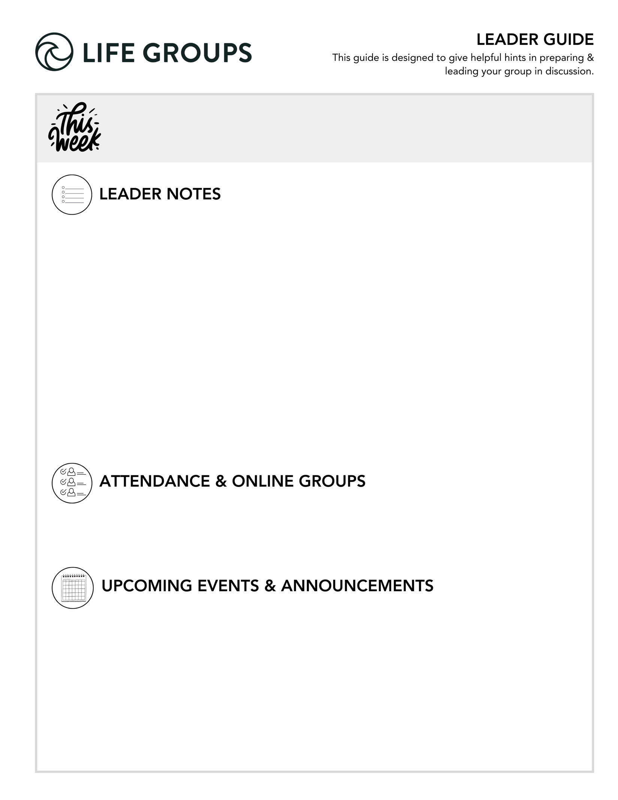
- Roster Confirmations and Feedback forms. Ask your group about their plans for the winter quarter and let us know when you turn in your roster confirmation. Also take some time and ask your group to fill out the feedback form! This is a huge help for us and our ministry. Thanks for being a part of it!
- Communion Next Week.
- Christmas Party or Friendsgiving. Though not required, feel free to do a Friendsgiving or Christmas Party with your group sometime in December. A white elephant gift exchange or Christmas games can be a fun
way for an extra connection as you move into the Christmas season.
- Winter Quarter Dates. Sign-ups Jan 3-11. Winter Quarter Jan 11- Mar 14.

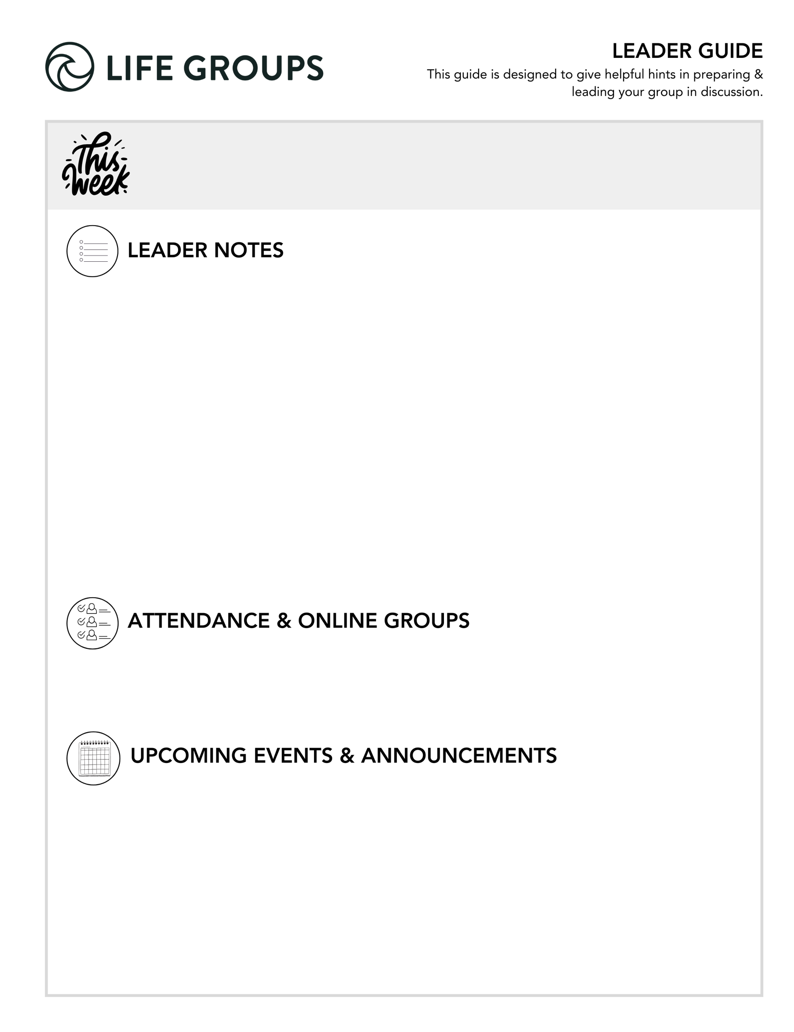

- Submit attendance: Post attendance Let us know of any changes for the Winter Quarter that you know of in the notes section!
- Online Groups: Get tips and tutorials!

- Thanksgiving Day Turkey Trot 5K - OPEN TO EVERYONE! North Coast’s annual Turkey Trot 5K takes place at the Vista Campus on November 27. This is a great way to start Thanksgiving Day and support the Military Connection Ministry!
  - Link to register: https://www.northcoastchurch.com/calendar/turkey-trot/

- Military Connection Thanksgiving Dinner - FOR ALL ACTIVE DUTY, VETERAN, OR RETIRED MILITARY – AND THEIR IMMEDIATE FAMILIES. The Military Connection ministry offers a full Thanksgiving dinner, football on the large screen, activities for kids, contest, raffles, and more!
  - Link to register: https://my.northcoastchurch.com/Event/thanksgiving2025


LEADER DISCUSSION GUIDE
_____________________________

WARM UP

1. Larry recognized that sometimes the Christian life can feel like we’re a five-year-old kid waiting for Christmas. Think back to Christmas morning as a kid — what were you like? Did you wake your parents early? Try to peek at presents?
Additional Thought: This question is a fun, nostalgic way to surface personality types in the group before diving into deeper discussion about waiting and expectations.
Additional Question: How do you typically handle waiting for something now with patience or restlessness?

2. This weekend’s message focused a lot on expectations. When facing new situations, do you tend to expect the best or brace for the worst?

Additional Thought: This question helps uncover how group members approach faith either with hope or caution
Additional Scripture: Philippians 4:6–7 – “Do not be anxious about anything... and the peace of God... will guard your hearts and minds.”
Additional Question: How does your default mindset affected your relationship with God?

3. Was there anything that stood out to you that was especially encouraging in this week’s message?


KNOW IT

1. Jesus didn’t fit the expectations of most people in His day, including John the Baptist. Read Isaiah 11:1-10. What stands out to you about the kind of King or Savior this passage describes? How might that have shaped what the Jewish people were expecting?

Additional Thought: This passage highlights both the gentleness and justice of the Messiah a ruler of peace, not political power. It’s easy to see why and how people longed for a conqueror.
Additional Scripture: Zechariah 9:9 – “Behold, your king is coming to you... humble and mounted on a donkey.”
Additional Question: What parts of Isaiah’s description surprise you or feel different from what culture values in a leader?
Conversation Caution: Some may veer into political commentary; keep focus on character qualities of Jesus, not modern leadership.
Group Dynamic Tip: Consider reading the passage twice, once silently, once aloud to let the imagery sink in.

2. Re-read Matthew 11:1-15 from this weekend (and optionally Mark 1:1–11 for context). Why do you think even someone like John the Baptist struggled to recognize Jesus for who He was?

Additional Thought: Even faithful believers can struggle when God doesn’t meet our expectations. John’s doubt shows faith and confusion can coexist.
Additional Scripture: Isaiah 55:8–9 “For my thoughts are not your thoughts…”
Additional Question: How do you relate to John’s struggle? When have you wondered if God was doing what you expected?
Conversation Caution: Don’t frame doubt as failure. Affirm that wrestling with God’s timing or methods is part of a mature faith.


SHARE IT

1. Larry called Jesus a “wild man.” What are three of the most surprising or “wild” things about Jesus to you?
Additional Thought: Jesus’ compassion, boldness, and unpredictability all break our molds of religious neatness, this helps the group rediscover wonder.
Additional Scripture: Mark 2:15–17 Jesus eats with tax collectors and sinners.
Additional Question: How does Jesus’ “wildness” challenge your comfort zones?
Conversation Caution: Keep this from turning into frustration about “organized religion” redirect back to who Jesus is.
Group Dynamic Tip: Invite everyone to write down their top three words or phrases about Jesus’ surprising qualities before sharing aloud.

2. We learned five things we can expect when God is at work. Which one tends to be the hardest for you to trust or accept, and why? Share an example when this felt true or challenging for you.

Additional Thought: People grow when they name where trust is hard. Encourage honesty about disappointment or confusion with God.
Additional Scripture: Proverbs 3:5–6 – “Trust in the Lord with all your heart…”
Additional Question: How have you seen God work good from unmet expectations in your life?
Group Dynamic Tip: Allow enough time here; this question could spark deep vulnerability. Consider closing in prayer after it.


LIVE IT

1. When it feels like God is confusing, slow, or going off the script you think He should follow, what helps you trust Him?

Additional Thought: Waiting exposes what we believe about God’s character. Encourage recalling specific times when His faithfulness became clear later.
Additional Scripture: Psalm 27:13–14 – “Wait for the Lord; be strong, and let your heart take courage…”
Group Dynamic Tip: Invite members to share one personal “anchor verse” or truth they cling to during uncertainty.

2. This message was about our expectations of God, and this series is about the “art of surrender.” What’s one area of your life where you need to trade your expectations for trust or surrender this week?

Additional Thought: Surrender in our conext is not giving up it’s releasing control to the One who knows better.
Additional Scripture: Romans 12:1–2 – “Present your bodies as a living sacrifice…”
Additional Question: What might it look like to actively surrender that area this week, practically, not just mentally?
Conversation Caution: Don’t pressure anyone to share specifics if it’s personal. Create space for reflection or silent prayer.
Group Dynamic Tip: End with prayer pairs or small circles, asking God to help each person release expectations and embrace trust.

Dr. Larry Osborne
November 8-9, 2025
Message #28 / Matthew 11:1-19
northcoastchurch.com/sermons

Not The Jesus Anyone Expected

The Passage:
Matthew 11:1-19/ Isaiah 35:5-6; 29:18-19; 61:1/ Malachi 3:1

Why we call audibles:

1. The Fear of LOSS.

2. The Fear of MISSING OUT.

What to expect when God is at work:

1. Expect to be CONFUSED.
Isaiah 55:8-9/ John 11:1-45/ 2 Corinthians 1:8-9/ Job 1-2

2. Expect to WAIT.
2 Peter 3:8/ Hebrews 11:8-13/ Genesis 16:1-4; 21:8-14

3. Expect God to use the WRONG PEOPLE.
Mark 9:38-40/ Philippians 1:15-18/ 1 Samuel 16:6-13

4. Expect God to keep inviting the WRONG PEOPLE to the PARTY.
Luke 5:27-32/ Luke 14:15-24/ Matthew 22:1-14/ Romans 5:8/ 1 Corinthians 6:9-11/ 1 Timothy 1:15-16

5. Expect God to use YOU.
Philippians 1:6/ Mark 5:19

