

FALL WEEK 1 | September 19-20
rch 1, 2026

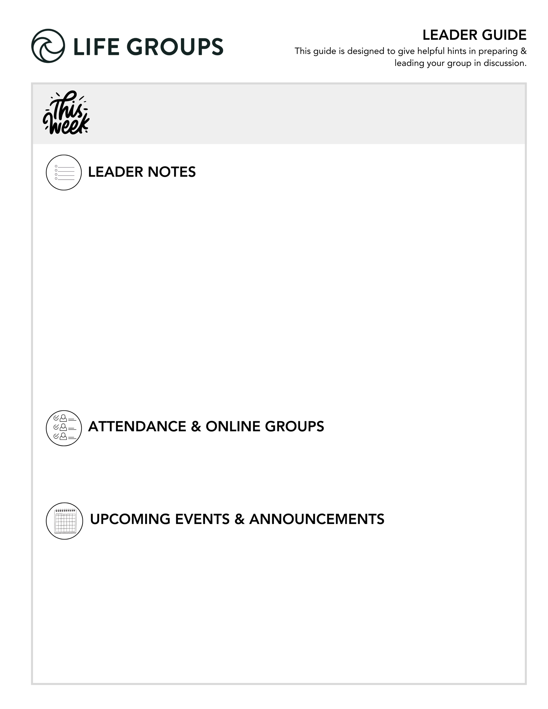
GETTING READY FOR YOUR FIRST MEETING
Here’s a quick overview of a typical first meeting for a new Life Group quarter:
- Welcome & Eat – Potluck is a great option. Online groups can try a virtual dinner option.
- Group Sharing – Because you will spend extra time getting to know each other or reconnecting, make sure you have enough time to spend on the Purpose of Life Groups and Life Group Commitment.
- KNOW, SHARE, LIVE IT Sections (optional – only if you have time)
- Review the Life Group Commitment Form – This is a tool to help your group set clear expectations and create shared ownership for the health of the group.
- Close in prayer.
- Mingle afterward.

Looking for more insight on your first meeting? You can find the “First Night Agenda” on how to make your first night great on the Leader Tools page of our website.

It’s a successful night when you hear from everyone at every meeting and keep God’s Word at the center.

- Women’s Gathering – Join women from all campuses on Tuesday, October 13, 6-9pm for biblical encouragement, practical leadership tools, and a meaningful time of refreshment. Originally created as a pre-conference event for the North Coast Leadership Conference, the Women’s Gathering has grown into a favorite annual evening open to all women of North Coast Church. In a world where discouragement, fear, and isolation can quietly creep into every area of life, come be reminded that you are not alone. Whether you’re leading in ministry, the marketplace, your home, or somewhere in between, you’ll leave encouraged in your faith, equipped with practical takeaways, and connected with women pursuing Jesus together. Bring a friend and enjoy an evening of inspiring teaching, shopping, delicious desserts and beverages, plus food available for purchase from food trucks. For more info or to register, check out the North Coast Church app.

LEADER DISCUSSION GUIDE
_____________________________

WARM UP

Your first meeting is designed for getting acquainted, connecting, enjoying a meal together, and discussing how to make your Life Group meetings great! The questions have been shortened this week to allow ample time for this.

Each week, “Warm Up” questions help us break the ice, get to know each other, get the conversation started, and/or share our initial impressions from the weekend’s message.

1. Fall has officially arrived! Describe your perfect fall day from start to finish.

2. When you picture a great Life Group quarter, what do you hope is a part of it?


KNOW IT

Each week, “Know It” questions help us understand or further unpack the Scripture from the message.

In Matthew 24:1-35, Jesus warns us not to be deceived or let our hearts grow cold. As you read through the Purpose of Life Groups (on back), which part do you think could help us most with that, and why? What is it about being known by and connected to other Christians that can help us stay grounded in truth?

- Additional Question: Why do we need other Christians to help us faithfully follow Jesus?
- Additional Thought: Avoid making Life Groups sound like the solution instead of Jesus. Community helps keep us grounded because people continually point one another back to Christ, Scripture, prayer, and obedience. The group itself isn't the source of truth.
- Conversational Caution: Be sensitive to people who haven't yet experienced deep connection in the group. A newer member may hear others describing years of relationships and wonder whether they belong. This is an opportunity to reinforce that connection develops over time.
- Additional Verse: Hebrews 3:12–13 See to it, brothers and sisters, that none of you has a sinful, unbelieving heart that turns away from the living God. But encourage one another daily, as long as it is called “Today,” so that none of you may be hardened by sin’s deceitfulness.


SHARE IT

Each week, “Share It” questions help us reflect and share our personal life experiences about the topic at hand, considering how it works or has worked out in our lives.

Jesus warned that the love of many will grow cold. What tends to pull your heart away from God or make your faith feel more like a routine? What helps fuel your love for God and others and keep your faith alive?

- Conversational Caution: Watch for the “Sunday school answer.” People may quickly respond with prayer, Bible reading, church, or Life Group. Those are good answers, but you can help people dig a little deeper with a follow-up question like this: What is it about those practices that actually reconnects your heart to God?
- Additional Thought: Keep the two halves of the Share It questions connected. Don't spend the entire discussion diagnosing what makes faith cold. The second half—what fuels your love?—moves the conversation toward hope and practical discipleship.
- Essentials Training Tip: If someone says, “Busyness pulls me away,” you do not need to fix their schedule. A simple follow-up or “piggyback” question such as “What do you think busyness does to your relationship with God?” could take the conversation deeper.


LIVE IT

Each week, “Live It” questions help us think through how we can apply the topic or put it into action in our lives.

Life Group should be more than a place we attend, but a place where we help one another know the truth and live out our calling. What do you hope this group helps bring out in you, and what do you hope to bring to this group?

- Conversational Caution: Avoid making this feel like a volunteer recruitment question. “What do you hope to bring?” isn't primarily asking people to take on a job. Contribution can look like listening, encouragement, prayer, honesty, hospitality, consistency, asking good questions, sharing wisdom, or simply being present.
- Additional Thought: Don't let people underestimate what they bring. Some members may immediately think, “I don't really have anything to offer.” This is a good opportunity to broaden the definition of contribution. A person doesn't need to be the most knowledgeable, spiritual, outgoing, or experienced member to have something meaningful to offer.
- Additional Question: Where would you like this group to challenge you—not just encourage you?
- Additional Verse: 1 Thessalonians 5:11 Therefore encourage one another and build each other up, just as in fact you are doing.

Pastor Chris Brown
September 19-20, 2026
Message #68 / Matthew 24:1-35

northcoastchurch.com/sermons

Signs That The World Is Ending…Now What?

Making the main thing the main thing:
Matthew 24:1-35, Daniel 7,9,12, Isaiah 13, Joel 2, 1 Thessalonians 4:15-17, Revelation 6

Jesus’ response about the end of the age is

PASTORAL, not PREDICTIVE.

To produce CAUTION, not a CALENDAR.

We need to focus on what is CLEAR, not CONFUSING.

So what is our main thing?
Matthew 24:1-35, 5:13-16, 22:37-40, John 13:34-35, Galatians 5:22, 1 Corinthians 13:1-13, Philippians 2:1-1

If we are going to be followers of Jesus and His teachings,

Don’t let the TEMPORARY rob us of the ETERNAL.

Then we have to put our CALLING ahead of our CAREER.

We cannot let the headlines of our CULTURE kill our CALLING.

