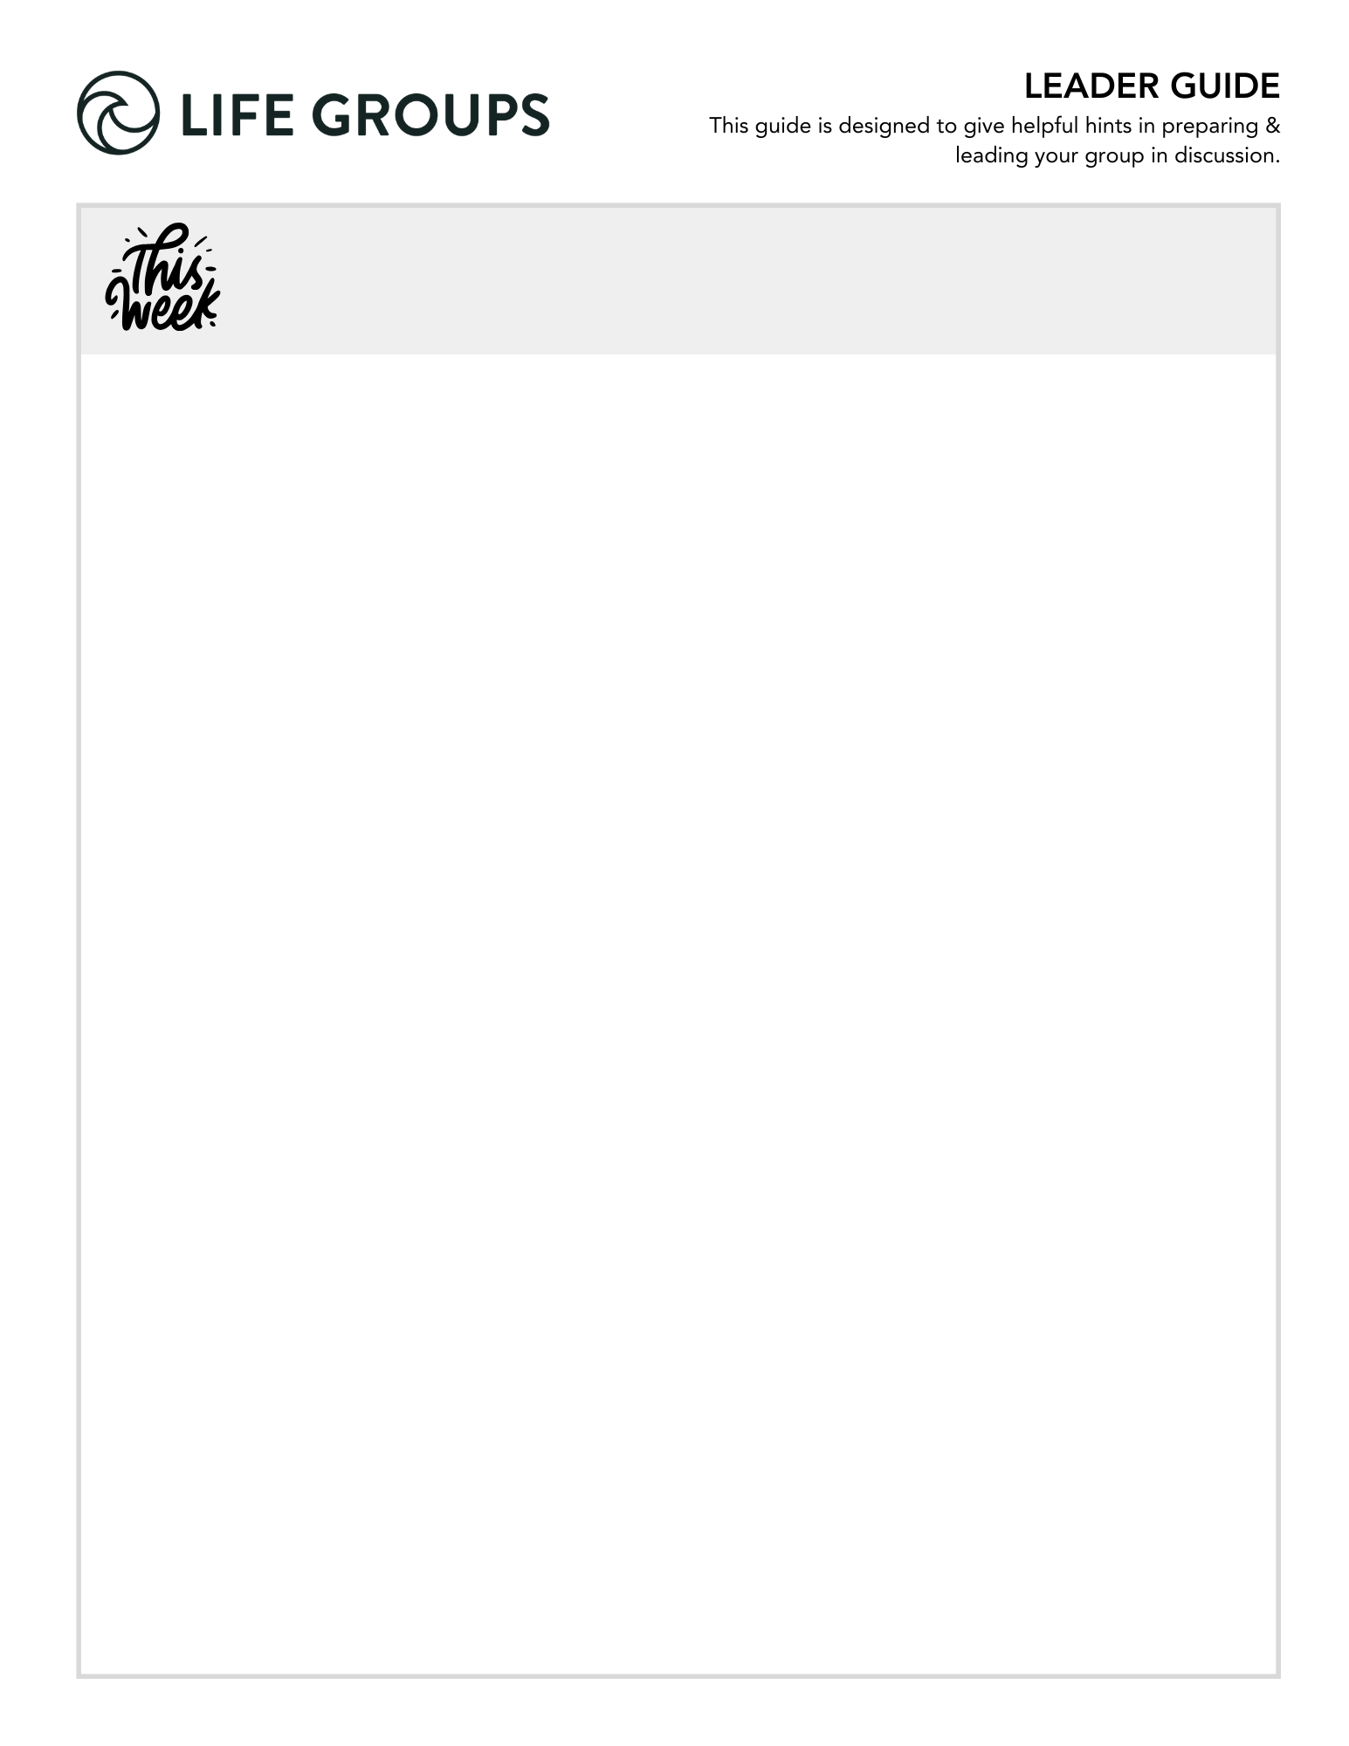

FALL WEEK 2 | September 26-27,2026
rch 1, 2026

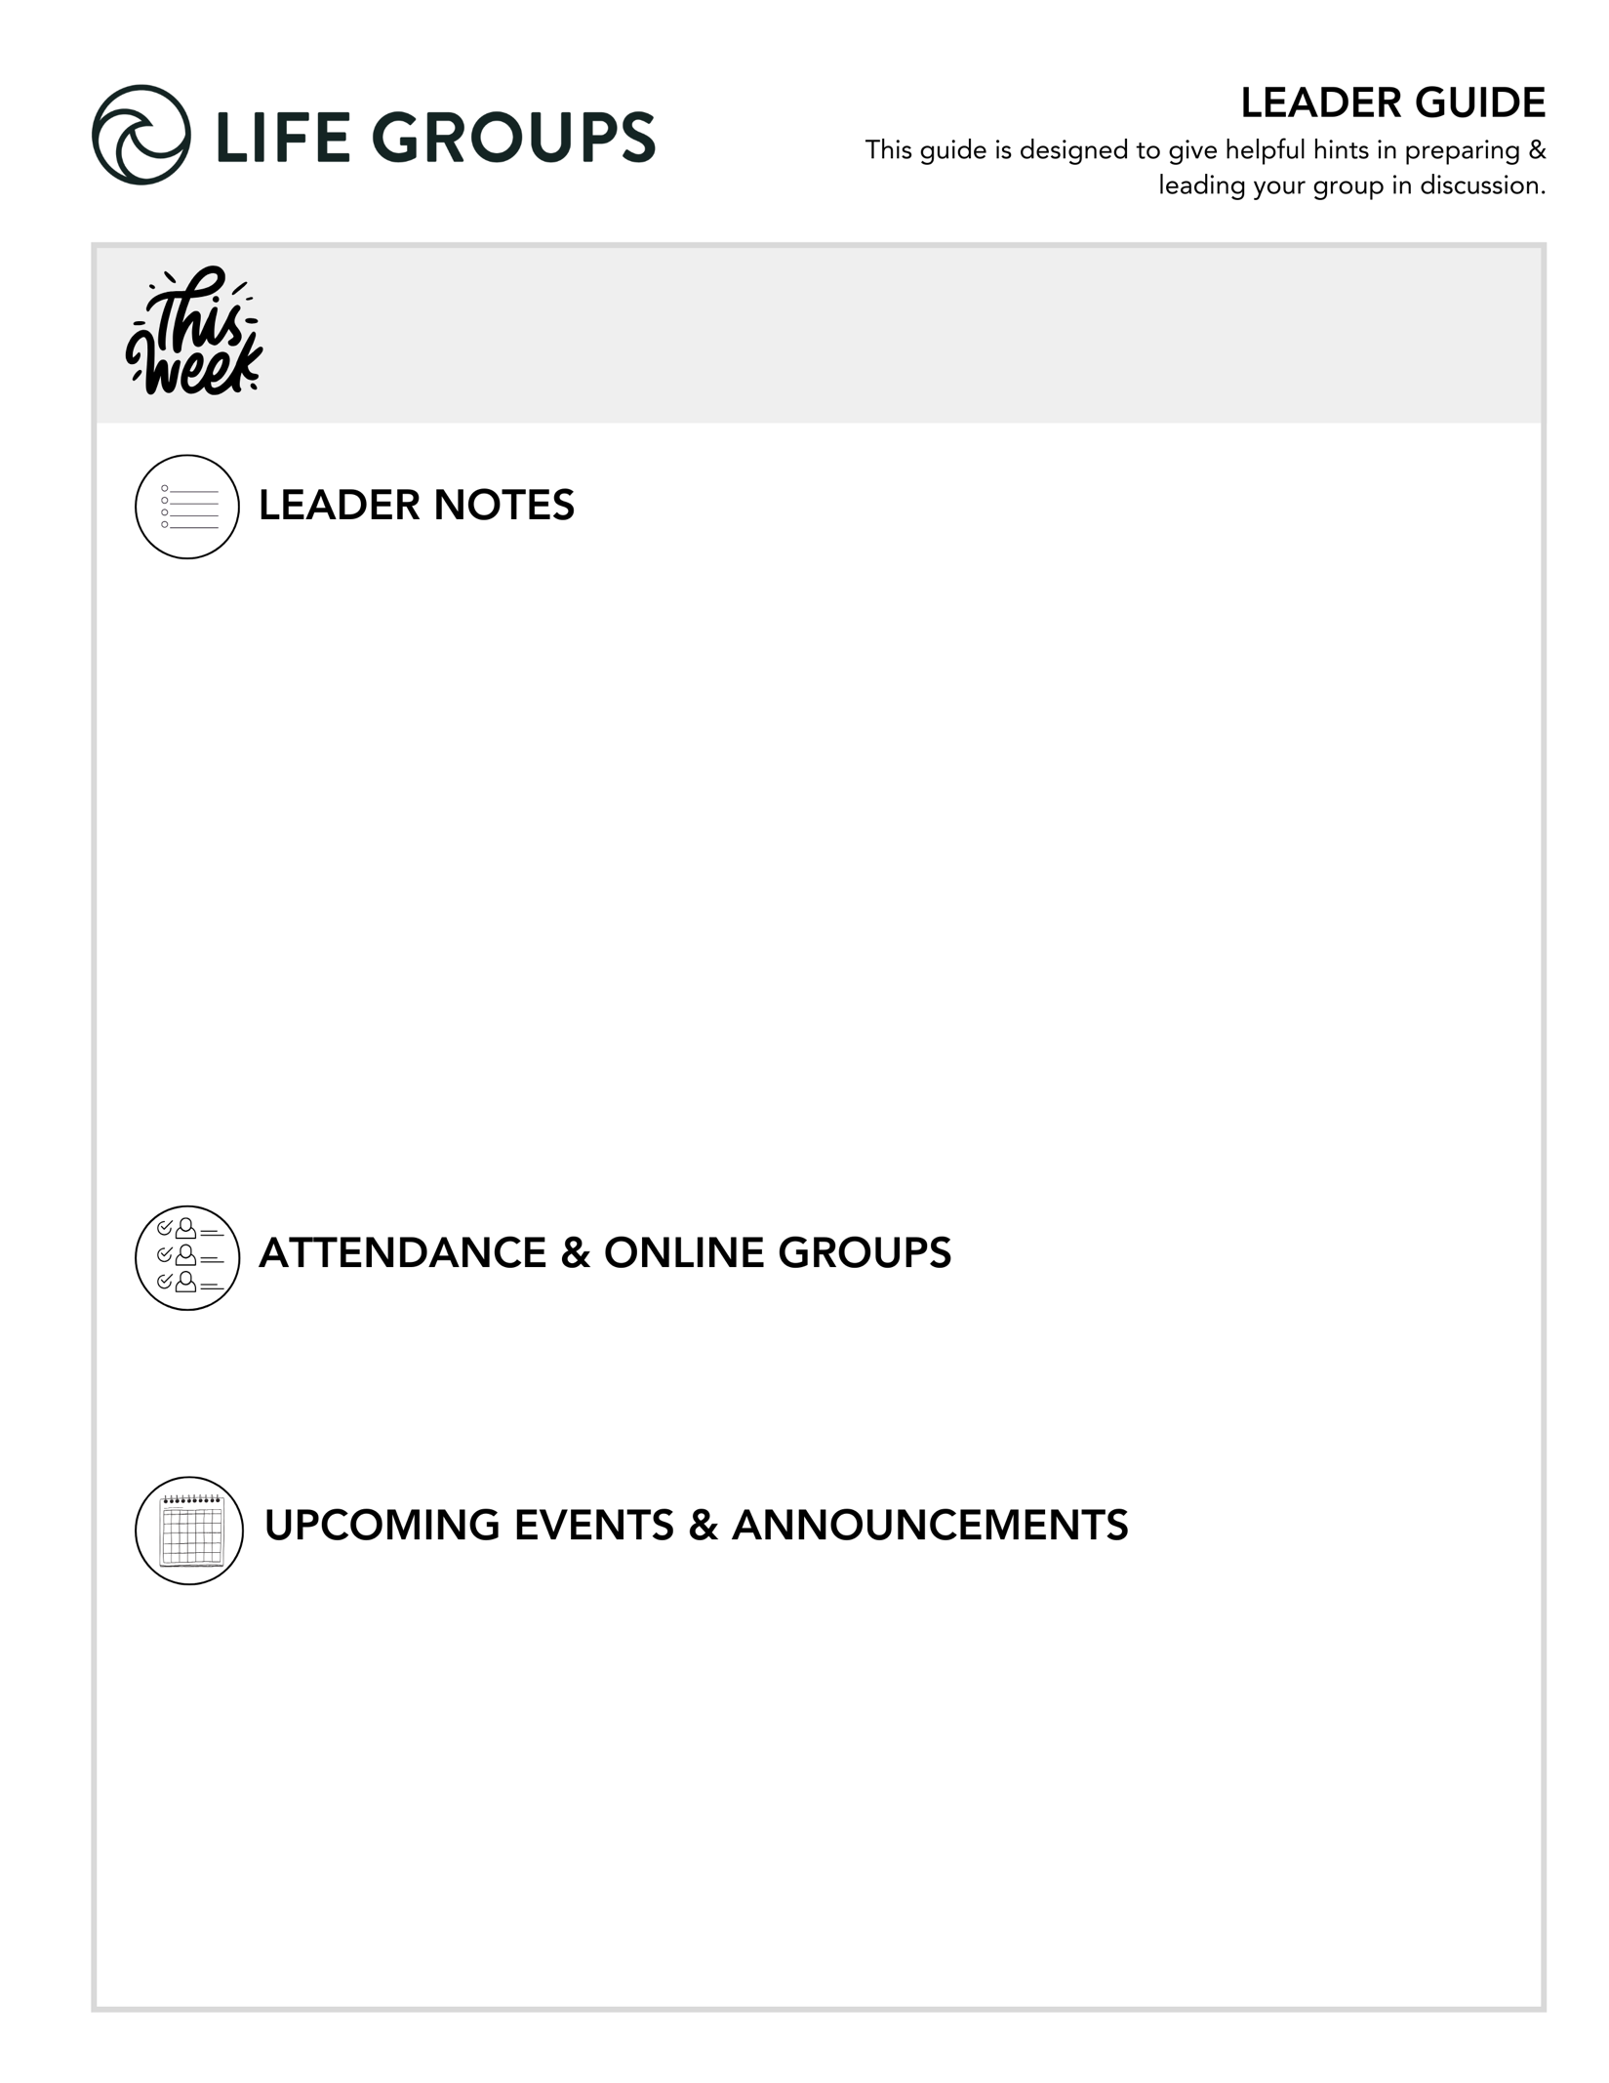

Life Group Commitment Sheet. If you didn’t go over this last week, make sure you take time to go over the Commitment Form this week or review what you talked about with anyone who missed the first week.

Start planning your social! Check out: Life Group social ideas

Don’t forget about your Impact project! Check out: Impact Projects

LEADER INSIGHTS

Remember, your role is not to lead people to "right" answers, but to:
- create safety
- guide reflection
- point people to Jesus

Success this week is:
Hearing from everyone at every meeting and keeping God's Word at the center.

- Women’s Gathering – Join women from all campuses on Tuesday, October 13, 6-9pm for biblical encouragement, practical leadership tools, and a meaningful time of refreshment. Originally created as a pre-conference event for the North Coast Leadership Conference, the Women’s Gathering has grown into a favorite annual evening open to all women of North Coast Church. In a world where discouragement, fear, and isolation can quietly creep into every area of life, come be reminded that you are not alone. Whether you’re leading in ministry, the marketplace, your home, or somewhere in between, you’ll leave encouraged in your faith, equipped with practical takeaways, and connected with women pursuing Jesus together. Bring a friend and enjoy an evening of inspiring teaching, shopping, delicious desserts and beverages, and food trucks available for purchase. For more info or to register, check out the North Coast Church app.

LEADER DISCUSSION GUIDE
_____________________________

WARM UP

Each week, “Warm Up” questions help us break the ice, get to know each other, get the conversation started, and/or share our initial impressions from the weekend’s message.

1. This weekend was all about what it means to be ready. Are you more of a “plan everything ahead” person or a “figure it out when we get there” person?

2. Jeff shared his recurring nightmare about being unprepared for a pop quiz. What class would you have been most terrified of getting a surprise pop quiz in?

3. What is something from this weekend’s message that challenged you, encouraged you, or made you think differently?

KNOW IT

Each week, “Know It” questions help us understand or further unpack the Scripture from the message.

1. In Matthew 24:36-51, Jesus compares His return to the days of Noah, when people were going about the ordinary rhythms of life without realizing what was coming. What’s the difference between living a normal life and becoming so absorbed in everyday life that we’re no longer spiritually ready?
- Conversational Cautions:
- Avoid turning “being ready” into anxiety about Christ's return. The passage calls disciples toward watchfulness and faithfulness, not panic.
- Matthew 24 can easily send a group into timelines, signs, world events, or debates over interpretations.
- Be careful with the busyness answer. “I'm too busy” will probably surface quickly. Go underneath it.
- Additional verse: Colossians 3:1–2 Since, then, you have been raised with Christ, set your hearts on things above, where Christ is, seated at the right hand of God. 2 Set your minds on things above, not on earthly things.

2. Read 1 Thessalonians 5:1-28 and notice the similarities between Paul’s instructions here and Jesus’ words in Matthew 24. What practical pictures of readiness stand out to you?
- Additional Question: What surprises you about Paul's description of someone who is spiritually ready?
- ESSENTIALS TRAINING CONNECTION: This is a good opportunity to use the Small-to-Large Group Principle. Start with something everyone can answer, “Which instruction stands out?” Then move toward the larger, more personal question, “What does this reveal about how God wants us to live?”

3. In verses 12-22, Paul gets really practical about what faithful living looks like. If these verses were a “readiness checklist,” what’s one or two things you’d like to be more intentional about?

- Additional Thought: There is an important difference between intention and application. “I want to be more patient” is an intention. “When my coworker frustrates me this week, I want to slow down before responding and ask God to help me respond graciously” is application.
- ESSENTIALS TRAINING CONNECTION: Since everyone is choosing from the same passage, this is a natural go-around-the-circle question. Give everyone a minute to reread verses 12–22 and choose one or two instructions.
- Additional verse: James 1:22 — Do not merely listen to the word, and so deceive yourselves. Do what it says.


SHARE IT

Each week, “Share It” questions help us reflect and share our personal life experiences about the topic at hand, considering how it works or has worked out in our lives.

1. Think of someone you know who seems to live ready for Jesus’ return—not fearful or frantic but faithfully following Him. What does their everyday life look like, and what stands out to you about the way they follow Jesus?

- Conversational Caution: Watch the comparison trap. Keep the conversation inspirational rather than comparative. The goal is not to rank spiritual maturity.
- Additional Question: What is it about that person's life that makes their faith seem genuine to you?
- Group Dynamic Tip: This question has the potential to generate stories, so don't rush through the examples.

2. Jeff reminded us that we don’t become faithful on our own—the Holy Spirit is at work in us as we follow Jesus. Looking back, where can you see that growth in your own life? How are you more spiritually “ready” today than you were when you first met Jesus?

- Additional Thought: This question asks people to look backward before looking forward. Rather than focusing primarily on where they still fall short, it invites them to notice evidence of the Holy Spirit's work over time.
- Conversational Caution: Make room for the person who can't see growth right now. Someone may honestly say, “I don't know.” Don't rush to correct them. A difficult season can make growth hard to recognize.
- Additional Question: What has God used most to produce that growth?


LIVE IT

Each week, “Live It” questions help us think through how we can apply the topic or put it into action in our lives.

1. Just like you can’t prepare for a test by cramming at the last minute, faithfulness is built over time. What’s one small thing you could do consistently that would help you live more “ready”?

- Additional Thought: Keep dependence on the Holy Spirit in view. This connects directly to the previous question. Spiritual practices don't transform us through sheer willpower; they create rhythms in which we intentionally remain responsive to God's work in us.

2. Jesus gave us a picture of one person being taken and another left in the field, reminding us that there will come a time when our opportunity to share Jesus with the people we care about is gone. Think about the people you regularly do life with. Who comes to mind who doesn’t know Jesus yet? How are you currently praying for or sharing Jesus with them?

- Additional Question: Instead of thinking about everything you could do, what's one next step you could take with that person?

Pastor Jeff Whye
September 26-27, 2026
Message #69 / Matthew 24:36-51

northcoastchurch.com/sermons

Stay Ready

POINT #1: READ THE SYLLABUS
Matthew 26:36, 42-44

His words are LIFE and give LIFE.

There is a difference between BELIEVING something and allowing what you believe to CHANGE how you live.

POINT #2: REMEMBER THE FLOOD
Matthew 24:37-39

The greatest threat to our readiness isn't always REBELLION, sometimes it's just DISTRACTION.

Sometimes ordinary life gets so LOUD that eternity gets really QUIET.

POINT #3: BE FAITHFUL TO THE ASSIGNMENT
Matthew 24:45-47

We serve the MASTER by serving the people at His TABLE.

POINT #4: THERE IS HELP WITH THE ASSIGNMENT
John 14:16–17, 26; Acts 1:8

God didn't leave us to do the assignment ALONE. He gives us His SPIRIT.

POINT #5: KNOW YOUR ASSIGNMENT
Matthew 24:40–41; Matthew 28:19–20

Maybe PROXIMITY isn't an accident. It's probably the ASSIGNMENT.

