

SPRING WEEK 1 | March 28-29, 2026
rch 1, 2026

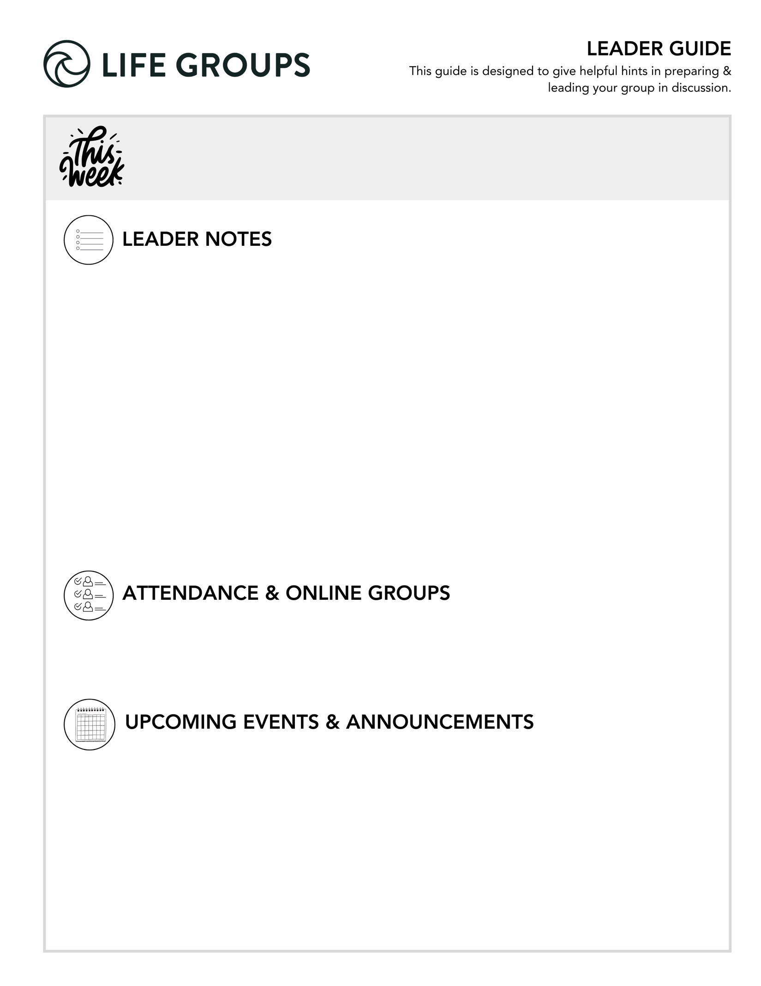

GETTING READY FOR YOUR FIRST MEETING
Here’s a quick overview of a typical first meeting of new Life Group quarter:
- Welcome & Eat – Potluck is a great option. Online groups can try a virtual dinner option.
- Group Sharing – Because you will spend extra time getting to know each other or reconnecting, make sure you have enough time to spend on the Purpose of Life Groups and Life Group Commitment
- KNOW, SHARE, LIVE IT Sections (optional – only if you have time)
- Review the Life Group Commitment Form – This is a tool to help your group is set clear expectations and create shared ownership for the health of the group.
- Close in prayer
- Mingle afterward

Looking for more insight on your first meeting? You can find the “First Night Agenda” on how to make your first night great on the Leader Tools page of our website.

Reminder - We measure success each week: Hearing from everyone at every meeting and keeping God’s Word at the center.

- Ready to Make an Impact? – Each Life Group quarter we invite all of our Life Groups to make an impact through serving together with one of our Local Impact partners. Has your Life Group picked an Impact Project yet? From packing toiletry kits and sack lunches to hosting bingo nights at the senior center, building beautification, meal delivery and so much more, the North Coast Impact website has hundreds of service opportunities in your area! Learn more in the North Coast Church app or at northcoastchurch.com

LEADER DISCUSSION GUIDE
_____________________________

WARM UP

Your first meeting is designed for getting acquainted, connecting, enjoying a meal together, and discussing how to make your Life Group meetings great! The questions have been shortened this week to allow ample time for this.

Each week, “Warm Up” questions help us break the ice, get to know each other, get the conversation started, and/or share our initial impressions from the weekend’s message.

Before we discuss this week’s message, a couple weeks ago, Chris invited us to share the story of when Jesus became real to us, when He became more than just a name. We also heard the stories of several pastors in the daily videos in the app. Take two minutes each to share your story in your group—when did Jesus become real to you?
- Note: If there is only one question you can go over with your Life Group due to time, please make it this one.

KNOW IT

Each week, “Know It” questions help us understand or further unpack the Scripture from the message.

1. This weekend, we saw Jesus warn His disciples about becoming like the Pharisees and Sadducees. Re-read Matthew 16:1-12 and share anything that stood out to you from the passage or Larry’s message.

- Additional Thought: This could be a good question to ease back into Life Group discussion.

2. The Pharisees added to Scripture and the Sadducees subtracted from it, and Jesus warns His disciples against both. What are some possible dangers of adding to or subtracting from Scripture? Which do you think is more common for Christians today?
- Additional verse: Deuteronomy 4:2 - Do not add to what I command you and do not subtract from it, but keep the commands of the Lord your God that I give you.


SHARE IT

Each week, “Share It” questions help us reflect and share our personal life experiences about the topic at hand, considering how it works or has worked out in our lives.

Larry gave several warnings from the teaching of the Pharisees and Sadducees that he said to avoid like the plague. Which of these do you think you’re most prone to drift toward if you’re not careful?


LIVE IT

Each week, “Live It” questions help us think through how we can apply the topic or put it into action in our lives.

Larry said to avoid becoming an accidental Pharisee or Sadducee, we keep our eyes on Jesus, not others. What is one area in your life this week you can take your eyes off others and put them back on Jesus?

Dr. Larry Osborne
March 28-29, 2026
Message #43 / Matthew 16:1-12

northcoastchurch.com/sermons

The Accidental Pharisee

The key players:
Pharisees:
ADDED to Scripture
Radical SEPARATION

Sadducees:
SUBTRACTED from Scripture
Radical COMPROMISE

The passage:
Matthew 16:1-12

Two life lessons:

1. Hard hearts aren’t going to be CONVINCED by more EVIDENCE.
John 11:47-53 / Matthew 16:4

2. If we aren’t genuinely seeking the TRUTH, we won’t find the TRUTH.
John 20:24-29/ Luke 24:13-35/ Proverbs 16:5

How to avoid becoming an accidental Pharisee (or Sadducee):

1. Keep your eyes on JESUS, not OTHERS.
Proverbs 6:16-19/ James 1:22-25

2. Avoid these things like the PLAGUE:

The teaching of the Sadducees
1. When truth OFFENDS, BURY it.

2. Wealth, influence, and success are worth COMPROMISING for.

The teaching of the Pharisees
1. God is honored by extra RULES, RITUALS, and TRADITIONS.
Proverbs 30:5-6/ Colossians 2:20-23

2. It’s more important to be RIGHT than LOVING.
1 Corinthians 13:1-8/ Revelation 2:1-7

3. Those who love God AVOID and DESPISE His enemies.
Luke 5:32 & Mark 2:17/ Luke 6:35/ 2 Timothy 2:24-26

