

SPRING WEEK 2 | April 3-5, 2026
rch 1, 2026

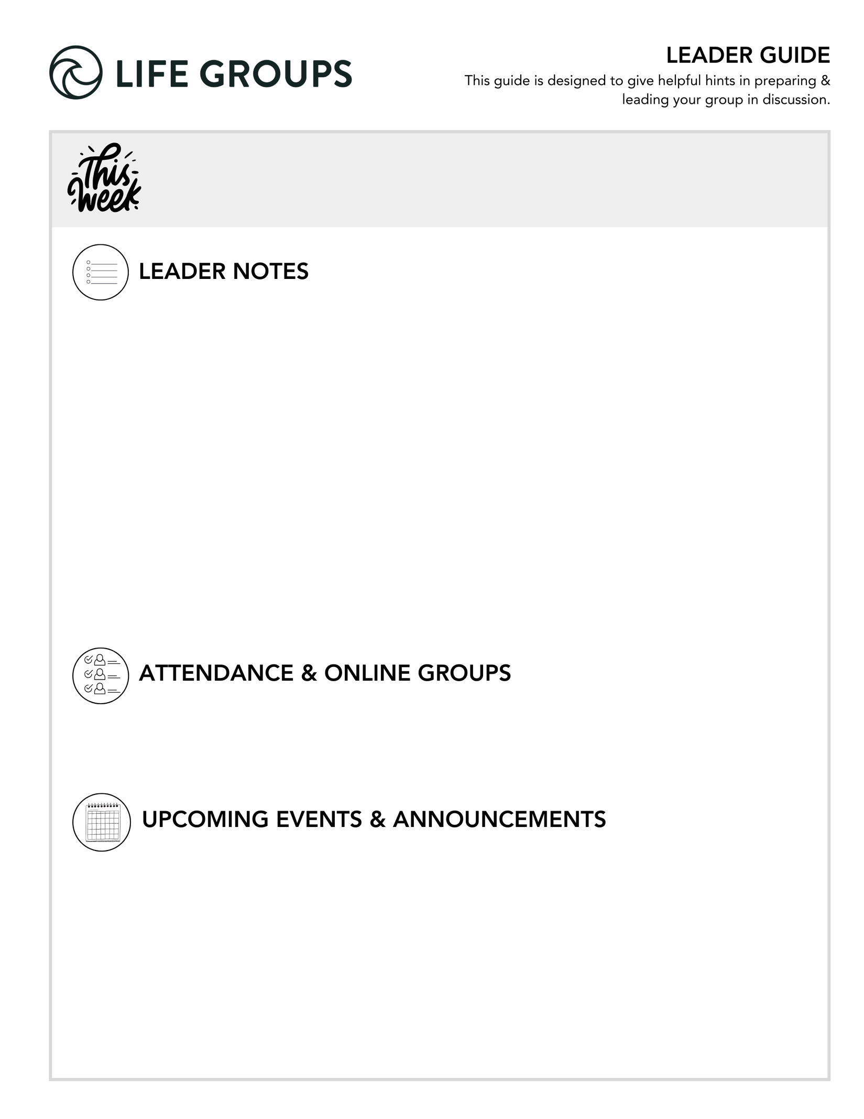

Leader Insight:
The thread through this discussion guide of following Jesus is not about getting everything right—it’s about ongoing surrender, growth, and trust.

Remember, your role is not to lead people to “right” answers, but to:
• create safety
• guide reflection
• point people to Jesus

Success this week is:
Hearing from everyone at every meeting and keeping God’s Word at the center.

- Ready to Make an Impact? – Each Life Group quarter we invite all of our Life Groups to make an impact through serving together with one of our Local Impact partners. Has your Life Group picked an Impact Project yet? From packing toiletry kits and sack lunches to hosting bingo nights at the senior center, building beautification, meal delivery and so much more, the North Coast Impact website has hundreds of service opportunities in your area! Learn more in the North Coast Church app or at northcoastchurch.com

LEADER DISCUSSION GUIDE
_____________________________

April 5, 2026

WARM UP

1. We just celebrated Easter. What is a memorable Easter for you, and why does it stand out?

2. In this weekend's passage, Jesus gives Simon a new name – Peter. Did you have a nickname growing up or one that friends still use today? What's the story behind it?

3. What was something new, memorable, or surprising from this weekend's message?

- Conversation Caution: Avoid turning this into a recap of the entire message. Stir the conversation towards focusing on personal takeaways.


KNOW IT

In the passage this weekend, Jesus asks His disciples who people think He is, and then asks them, “What about you?” Re-read Matthew 16:13-28.

1. Jesus draws a distinction between what people say about Him and what His disciples personally believe. How would you personally describe what it looks like to truly know Jesus and follow Him daily, not just in words, but in how you live?
- Additional Thought: Knowing Jesus is not just intellectual agreement—it’s relational trust that shapes daily decisions, priorities, and identity.
- Conversation Caution: Some may default to “church answers.” Gently guide toward real-life examples rather than generalities.

2. Even after walking closely with Jesus, Peter still misunderstood parts of who He was and what He came to do. How do people today tend to get Jesus right in some areas, but wrong in others? What are areas you feel like you still need to get right or work on?
- Additional Question: What has helped you grow in your understanding of who Jesus really is?
- Conversation Caution: Avoid this turning into a theological debate. Keep the focus on personal growth and understanding.


SHARE IT

1. Peter went from getting it right to getting it wrong in a matter of moments. Jesus actually called him, “Satan,” yet continued to work in his life. Can you think of a time you acted more like Satan than Christ? What did you learn about God’s grace from that experience?
- Additional Thought: Peter’s story reminds us that failure does not disqualify us—God continues to work in us even when we get it wrong.
- Additional Scripture: Romans 5:8 – While we were still sinners, Christ died for us.
- Conversation Caution: This is a high-vulnerability question. Avoid allowing the group to minimize or fix someone’s story. Create space for honesty without pressure.

2. Chris talked about the exchange we make when we surrender and follow Jesus. Look back at verses 25-26. How would you describe the kind of life you’ve gained since surrendering to Jesus?
- Additional Question: What is one way your life is better today because you chose to follow Jesus?


LIVE IT

1. Chris talked about three main things that show our surrender to Jesus: our relationships, our finances, and our entertainment. What is one way your life looks noticeably different in any of those three areas because you follow Jesus?
- Additional Thought: Surrender becomes visible in everyday choices. These areas often reveal what we truly trust and value.
- Additional Scripture: Luke 9:23 – Whoever wants to be my disciple must deny themselves and take up their cross daily and follow me.

2. Which of these is the easiest to for you to surrender, and which is the hardest? What step can you take this week to surrender something you struggle to release?
- Additional Thought: Everyone has areas where surrender comes more naturally and areas where it’s a struggle. Growth often happens where resistance exists.
- Additional Scripture: Proverbs 3:5 – Trust in the Lord with all your heart and lean not on your own understanding.

Pastor Chris Brown
April 3-5, 2026
Message #44/ Matthew 16:13-28
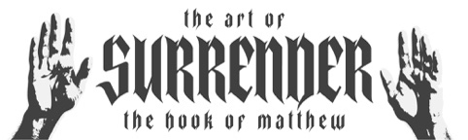
northcoastchurch.com/sermons

Can Your Jesus Save You?

Who did Jesus think that He was?
Matthew 16:13, Daniel 7, John 1:1-14, 8:58, 10:25-33, 14:6-9, Colossians 1:16-17, 2 Peter 3:9

Jesus claimed to be the ONE TRUE God and our EXCLUSIVE Savior and source of ETERNAL life.

Who did the crowds think that Jesus was?
Matthew 16:14-23

The crowds knew that He was uniquely DIFFERENT in GREAT ways.

Peter knew He was the SAVIOR and the LIVING GOD.


Can’t we all just ?

Logic asserts that two CONTRADICTIONS cannot be TRUE at the same time.

Which Jesus can actually save us?
Matthew 16:24-28, Acts 2,10, Philippians 2:5-11, Galatians 2:20, Romans 3:23-24, 6:23, 10:9-13, 12:1-2

Jesus promises eternal life and a better life here to all who:

Deny themselves = Say no to SELF-CENTERED living.

Take up their cross = Embrace DEATH to your old LIFE.

Follow Him = Keep walking in OBEDIENCE.

