

SPRING WEEK 4 | April 18-19, 2026
rch 1, 2026

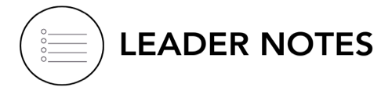

Leader Reminder: Focus on What Matters Most
From Essentials Training, we know:
People > Content
It can be tempting to:
• get through every question
• keep things on track
• “teach” the material well

But the win isn’t finishing the guide.
The win is:
• people who are seen and known
• people feeling safe to contribute to conversation
• people taking a step toward Jesus

Success this week is:
Hearing from everyone at every meeting and keeping God’s Word at the center.

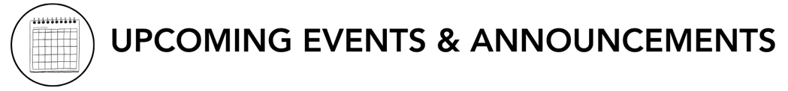
- Ready to Make an Impact? – Each Life Group quarter we invite all of our Life Groups to make an impact through serving together with one of our Local Impact partners. Has your Life Group picked an Impact Project yet? From packing toiletry kits and sack lunches to hosting bingo nights at the senior center, building beautification, meal delivery and so much more, the North Coast Impact website has hundreds of service opportunities in your area! Learn more in the North Coast Church app or at northcoastchurch.com

LEADER DISCUSSION GUIDE
_____________________________

April 18-19, 2026

WARM UP

1. This weekend we learned about the storms of life, when things don’t go as we predicted. Often, good stories are not predictable. What’s something small, funny, or unbelievable that didn’t go according to your plan but made for a good story?
- Additional Question: What keeps perseverance from becoming discouragement?
- Conversational Cautions: Be aware of the conversation drifting due to the following:
  - Reducing perseverance to “Just Try Harder”
  - Confusing perseverance with passivity
  - Over-spiritualized answers

2. Ricky asked us what we do in a storm and pointed out what we do naturally might be different than what God wants us to do in a storm. When something gets unexpectedly hard, what’s your default reaction: fix it, avoid it, vent about it, or something else?
- Additional Question: What do you think you're trying to protect or control in that moment?
- Additional Verse: Philippians 4:6-7 - Do not be anxious about anything, but in every situation, by prayer and petition, with thanksgiving, present your requests to God. And the peace of God, which transcends all understanding, will guard your hearts and your minds in Christ Jesus.

3. Was there a moment, story, or point that especially resonated with or challenged you from this weekend’s message?


KNOW IT

Read James 1:2-4, 12, 19-26
1. James 1 talks about trials producing “steadfastness” (or some Bible translations say “perseverance”). Hebrews 12:1-3 also gives us a picture of perseverance as well. How would you explain in your own words what that means?
- Conversational Cautions: Biblical perseverance is dependence on God, not just personal strength. Be alert as the group examines perseverance, some may see it as willpower.
- Additional Question: What's the difference between perseverance and simply enduring something?
- Additional Verse: Hebrews 12:1-3 - Therefore, since we are surrounded by such a great cloud of witnesses, let us throw off everything that hinders and the sin that so easily entangles. And let us run with perseverance the race marked out for us, fixing our eyes on Jesus, the pioneer and perfecter of faith. For the joy set before him he endured the cross, scorning its shame, and sat down at the right hand of the throne of God. 3Consider him who endured such opposition from sinners, so that you will not grow weary and lose heart.

2. Ricky emphasized that trials are not about “if” but “when.” (See also 1 Peter 4:12-13). Why do you think it’s important to accept that trials are inevitable instead of being surprised by them? How might that change the way we respond when they come?
- Additional Questions: What expectations do people usually have about how life should go? Think of a time you were caught off guard by a trial - how did that affect your response?
- Additional Verse: John 16:33 - In this world you will have trouble. But take heart! I have overcome the world.

3. Verses 22-25 call us to be “doers of the Word, not hearers only.” What’s the difference between being a hearer of the Word and a doer? Why do you think that matters even more in difficult seasons?


SHARE IT

1. Ricky talked about how setbacks can become setups for something God wants to do. Can you think of a time in your life a setback turned out to be a setup? What did God do with it that you didn’t see coming?
- Additional Thought: God often does His best work in situations we would never choose.
- Conversational Cautions: Watch out for the “Everything Works Out” oversimplification. Avoid the conversation drifting into neat and predictable conclusions. In reality, not all setbacks feel resolved neither are all outcomes are what we hoped for.
- Additional Question: What does it take to trust God when you don't yet see the "setup"?

2. Looking at the three items on the “Checklist in the Storm,” when you’re in a stressful or painful situation, what’s hardest for you: embracing the interruption, obeying what you know is right, or continuing to pray?

- Additional Thought: Spiritual maturity is often revealed in how we respond in the middle of the storm—not after it.


LIVE IT

1. Ricky defined worry vs. prayer: worry is a conversation with yourself; prayer is a conversation with God. What would it look like to intentionally shift one area of worry into prayer this week?

- Additional Question: What could remind you to shift from worry to prayer in the moment?

2. When it comes to obedience, Ricky challenged us to move from “working on it” to just “doing it”. Is there something in your life, big or small, you’ve been “working on” that you need to just “do”? What would it look like to “do it”?

Pastor Ricky Jenkins
April 18-19, 2026
Message #46/ James 1:2-4, 12, 19-26
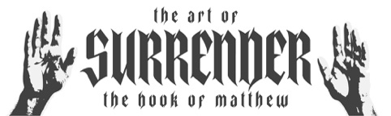
northcoastchurch.com/sermons

A Checklist In The Storm

What Do You Do In A Storm?

Embrace the INTERRUPTIONS.

God does NOT move in straight lines.

Obey God’s INSTRUCTIONS.

If you want MORE of God, obey ALL of God.

Don’t stop INTERCESSION.

Worry is a conversation you have with YOURSELF about things YOU CAN’T CHANGE.

Prayer is a conversation you have with GOD about things HE CAN CHANGE.

