

SPRING WEEK 8 | May 16-17
rch 1, 2026

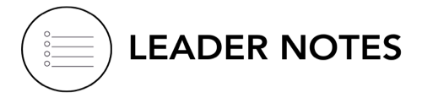

Leaders,

As your group gathers for the final meeting of the year, we simply want to say thank you. Thank you for opening your homes, making room in your schedules, showing up consistently, praying for one another, listening well, and creating spaces where people could experience community and grow closer to Jesus. Over this past year, God has worked through ordinary conversations, shared meals, honest moments, laughter, tears, encouragement, and faithful presence. Some of the impact you’ve seen, and some of it you may never fully know this side of heaven. But your willingness to keep saying yes has mattered deeply. We are grateful for the way you have helped make church feel personal, relational, and full of care.

With great appreciation,
Life Groups Ministry

We want to hear from your group!
The Life Group Member Check-In (formerly called the feedback form) was emailed out to each group member last week. If you couldn’t complete them as a group last week, we’d love your help encouraging participation this week. Please set aside 5–10 minutes during group for members to complete it together. This greatly helps participation and allows you to assist anyone who may have trouble accessing it. Our hope is to hear from group members so we can better support both your group and your leadership.

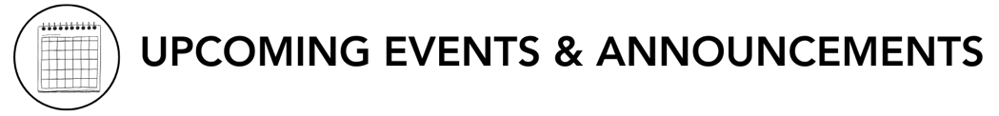
- 2026 Men’s Conference – Join us for the North Coast Men's Conference at the Vista Campus on Friday, June 19 and Saturday, June 20, 2026, for a weekend designed to help men recharge and refocus on God's call, featuring three sessions team-taught by Pastor Chris Brown and guest speaker Pastor Larry Acosta, along with worship, food, events. Bring your friends, neighbors, son, or Life Group, and choose to stay overnight with onsite camping for campers or tents. Go to northcoastchurch.com or the North Coast app to register.

LEADER DISCUSSION GUIDE
_____________________________

May 17, 2026

WARM UP

- Looking back at the past year, what is one way you have seen God at work in this group?
- Group Dynamic: Is the group having a hard time getting started? You might need to go first. A simple, sincere answer from you can lower any pressure and help others reflect more honestly.

- Without looking at your notes, what is one thing from the weekend’s message that really stuck with you?

- Larry said forgiveness is not a feeling but a settled decision. How does that challenge the way our culture usually talks about forgiveness?
- Conversational Caution: Forgiveness is not
  - Excusing sin
  - Removing consequences
  - Tolerating abuse
  - Instant trust


KNOW IT

When it comes to forgiveness, Jesus gives us the ultimate example of mercy, and often the most challenging one to follow. Read 1 Peter 2:21-25 together and discuss the following.
- Which part of Jesus’ response to suffering and mistreatment feels hardest for you personally to live out in your own life? Why?

- Verse 23 says instead of retaliating, Jesus “entrusted Himself to God,” or like Larry said, He “let go and let God.” Why do you think trusting God is an important part of forgiving someone who has wronged you? How does trusting God impact our ability to forgive?
- Additional Thought: Forgiveness often involves releasing revenge, bitterness, personal vengeance, obsession over fairness, and control of the outcome. And entrusting justice, healing, restoration, and vindication to God.
- Additional Scripture: Psalm 55:22 - Cast your cares on the Lord and he will sustain you; he will never let the righteous be shaken.

- Peter ends this chapter with a reminder that we were like wandering sheep who went astray before returning to the Shepherd. How does remembering what we’ve been forgiven of, or like Larry said, “getting a good mirror” help us respond differently to those who wrong us?
- Additional Thought: Humility grows when we remember we also wandered, needed rescue, and received undeserved mercy. Forgiveness becomes possible when we recognize how deeply we ourselves have been forgiven.


SHARE IT

1. Which (if any) of the four myths about forgiveness in the message have you believed or struggled with the most in the past? Did this message challenge or reshape your perspective, and how?

2. Larry talked about praying a “prayer of permission” and allowing God to change us from the inside out. Have you ever experienced God changing your heart toward someone in a way you couldn’t have produced through willpower alone?


LIVE IT

Let’s take a moment to reflect on the debt we ourselves have been forgiven. As a group, we are going to take Communion, which is essentially a symbolic practice that helps us remember what Jesus did to secure our forgiveness.
As you take the bread or cracker representing His body that was broken for you and the juice that represents the blood that He shed for you, remember the grace Jesus has shown you and ask God to help you “let go and let God” with the hurts you may still be carrying.

COMMUNION

Communion is an opportunity to pause and remember who Jesus is, what He has done for us, and the hope we have because of Him. Through His death and resurrection, we have received grace, forgiveness, and new life.

This week, your Life Group will end by taking Communion together. Before you do, read through the verses below and reflect on Jesus’ love, sacrifice, and faithfulness.

Isaiah 53:3-6

Ephesians 2:4-9

Luke 22:19-20

Take Communion with us this week! If you are not in a Life Group and would like to take Communion with us, see northcoastchurch.com/communion to follow along.

Dr. Larry Osborne
May 16-17, 2026
Message #50/ Matthew 18:15-35

northcoastchurch.com/sermons

Why Only A Fool Refuses To Forgive

Three-In-One:

The Passage: Matthew 18:15-35
Deuteronomy 19:15/ 1 Corinthians 5:9-13

Forgiving: What It Isn’t
Blasting Away The Myths

1. Forgiving isn’t a FEELING
Matthew 18:35

2. Forgiving isn’t FORGETTING
Jeremiah 31:34, Psalm 103:11-12 & Micah 7:19/ Genesis 8:1

3. Forgiving isn’t TRUSTING again
Proverbs 14:15

4. Forgiving doesn’t remove all the CONSEQUENCES
2 Samuel 12:7-14/ Romans 13:1-7

Forgiving: What It Is

1. Forgiving is basically letting GO and letting GOD
Romans 12:17-21 & 1 Peter 2:21-23/ Ephesians 4:30-32 & Proverbs 2:21-23

Forgiving: How To Get There

1. Get a good MIRROR

2. Pray the prayer of PERMISSION

