

WINTER 2026 WEEK 1 | January 11, 2026

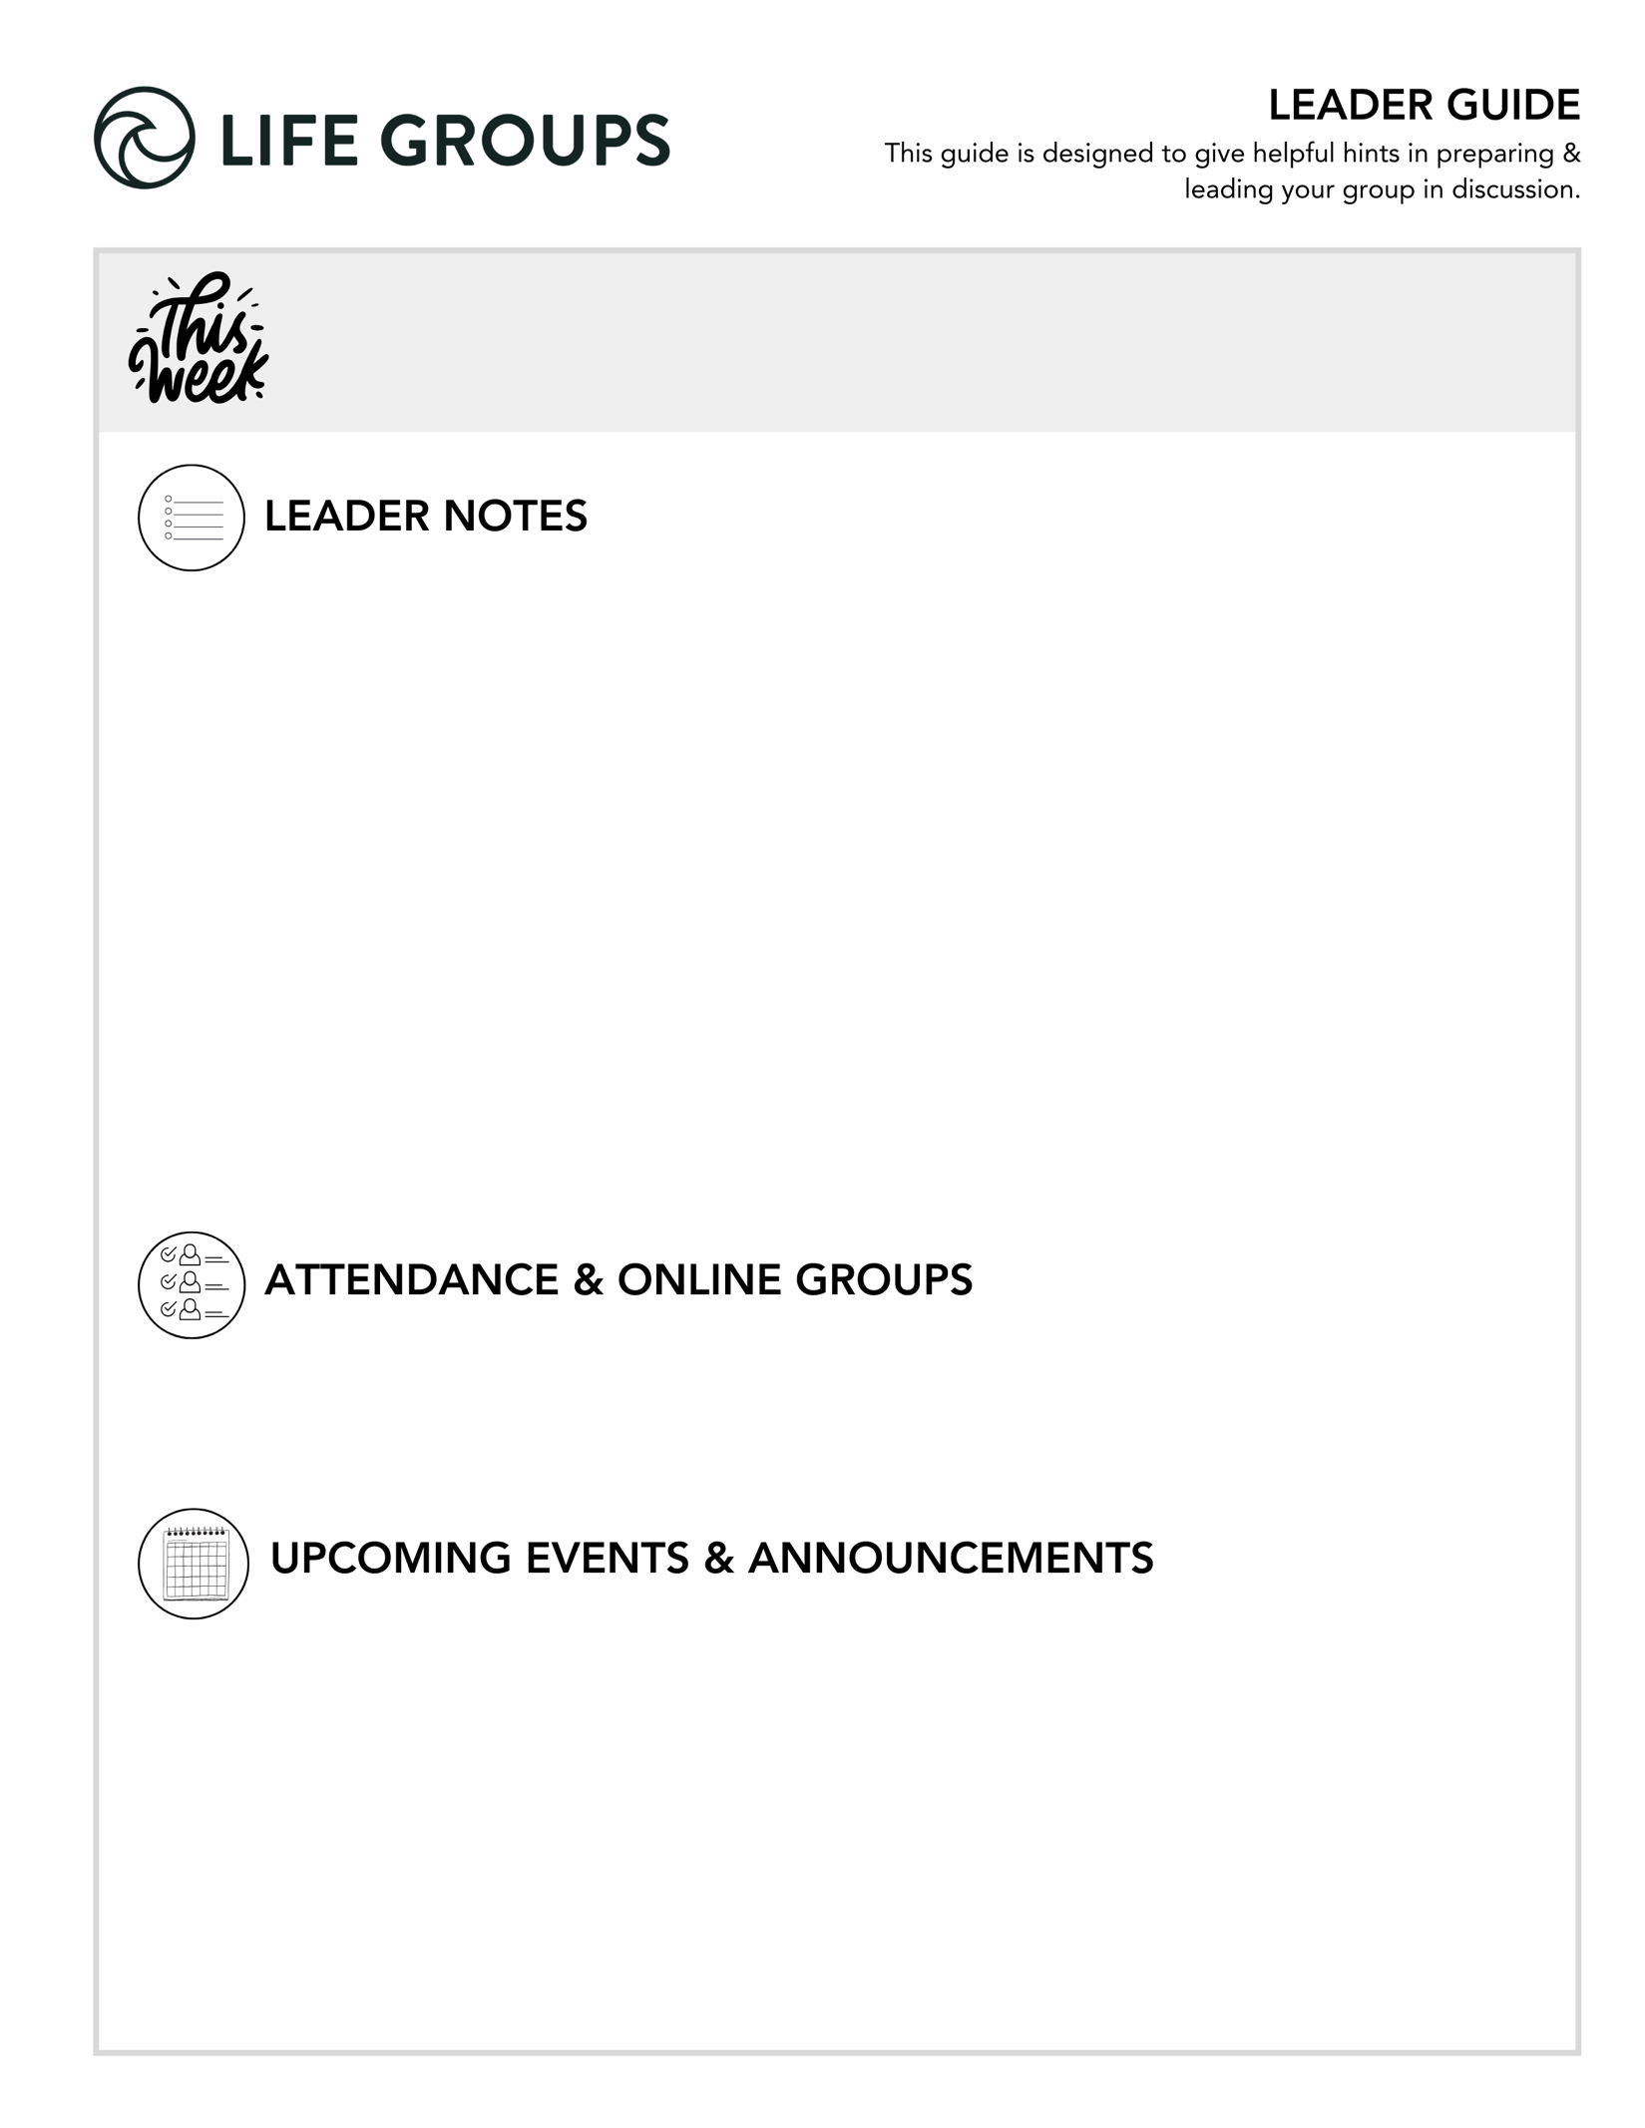
getting ready for youR first meeting
Each week in this section you’ll find the most important information for your group.
- Goals of the First Meeting
- Re-connect with existing members and meet new members
- Cast vision for the quarter with your group
- Clarify your group’s direction/expectations/commitments using the Life Group Commitment Form
- Briefly discuss the sermon topic (if there is time)
- Pray for the building of relationships and the spiritual growth of the group
- Items Needed for the First Meeting
- Life Group Commitment Form– Review this with your group. This was mailed to you last week in your leader packet, and can also be found online here: lifegroups.northcoastchurch.com/life-group-covenants/
- Nametags for in-person groups (print or write them out ahead of time).
- Contact Your Group in Advance
- Contact all members before the first meeting to welcome them to the group. You can check your roster online to see all the members of your group and their contact information. Simply login to your account and look for Groups on the bottom right of the screen. https://my.northcoastchurch.com
- In-person groups - Inform members of the location and time of your group and how you’re handling food.
- Online groups – Make sure you send the link to your meeting well in advance and preferably again on the day you meet.
  - Pro-Tips to Maximize the Online Groups Experience – Review a curated list of how-to’s at this link: Pro-Tips & Facilitation Tips to maximize your Online Experience.

ABOUT POLITICS IN LIFE GROUP - We believe it’s important for Jesus-followers to thoughtfully consider how they engage in politics. However, because of how polarizing our current climate is, we ask that Life Group discussions remain free of politics and focused on relationships, unity, and God’s Word. Our desire is to present the Good News of Jesus to everyone and protect the unity we share as believers. Each election cycle political comments—even jokes or prayer requests—can unintentionally divide or offend. We never want to imply that someone is unwelcome because of how they vote or what they believe politically. If a conversation begins to drift toward politics, gently redirect by reminding the group that the body of Christ includes followers of Jesus from many political perspectives, and our focus is on Christ, not political outcomes.

AGENDA for your first meeting
Looking for more guidance on your first meeting? You can find the “First Night Agenda” on how to make your first night great on the Leader Tools page of our website. (lifegroups.northcoastchurch.com/make-your-first-night-great/)
How We Measure our Success Week to Week: Hearing from everyone at every meeting and keeping God’s Word at the center.
- Welcome & Eat – Potluck is a great option. Online groups can try a virtual dinner option.
- Group Sharing – Because you will spend extra time getting to know each other or reconnecting, make sure you have enough time to spend on the Purpose of Life Groups and Life Group Commitment Guide.
- KNOW, SHARE, LIVE IT Sections (optional – only if you have time)
- Review the Life Group Commitment Form – This is a tool to help your group is set clear expectations and create shared ownership for the health of the group.
- Close in prayer.
- Mingle afterward.

- Need help? Reach out to your Life Group Pastor any time!
- You don’t have to answer every question. Pick the ones that fit your group best.
- Encourage everyone to share. Set time limits if needed.
- Use the audio guide for more insights: Leader Tools
- Finalizing social and service projects? Check out:
  - Service project ideas
  - Social ideas
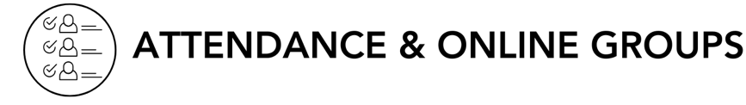
- Submit attendance: Post attendance
- Online Groups: Get tips and tutorials!

Serve as a Buddy for an Honored Guest at Night to Shine
North Coast Church has the honor of hosting Night to Shine, sponsored by the @Tim Tebow Foundation, on Friday, February 13, 4pm-9pm at the Vista Campus!
It takes hundreds of Buddy Volunteers to make Nigπht to Shine an unforgettable prom night experience centered on God’s love for people with special needs ages 14 and older.
Attendees are our Honored Guests! Each Honored Guest is partnered with a Buddy who is with them throughout the night from 4pm-9pm. The role of a Buddy is a vital part of making this event a success!
Over 156 Buddy Volunteers are still needed to make Night to Shine possible. Learn more or register to serve as a Buddy at https://my.northcoastchurch.com/nts

Desert Rat Experience 2026 - The Desert Rat Experience is a man’s weekend designed for guys who are into all kinds of off-roading. You can count on lots of riding time, great Desert Rat messages from our own Chris Brown and three hot meals! And as always great raffle prizes (grand prize motorcycle) with all proceeds raised going to our local Women's Resource Center, which helps women in distress!!!! Click here for more details - https://www.northcoastchurch.com/calendar/the-desert-rat-experience/


LEADER DISCUSSION GUIDE
_____________________________

WARM UP

Your first meeting is designed for getting acquainted, connecting and enjoying a meal together, and discussing how to make your Life Group meetings great! The questions have been shortened this week to allow ample time for this.

Each week, “Warm Up” questions help us break the ice, get to know each other, get the conversation started, and/or share our initial impressions from the weekend’s message.
Discussion Note: Add these questions if you have new people in your group or a completely new group. If it hasn’t come up in conversation before the meeting officially starts, have everyone in the group share how long they have been attending North Coast, if they have been in a Life Group before and their favorite hobby.

Discussion Tips: These are effective for both in-person and online groups. Remember to set time limits to ensure everyone has an opportunity to answer the questions. Possibly use the “Tag— You’re It” method to ensure everyone can share. Once one person is finished sharing, they select the next person to share.

1. What is a highlight from your holiday season?
- Additional Question for established groups: How did you see God at work during the holiday season?

2. Do you do anything to reflect or reset at the start of a new year?
- Additional Question: Do you tend to look back, look ahead, or both at the start of a new year?

3. What are some reasons you joined a Life Group or came back to your Life Group? What are you looking forward to this quarter?
Additional Thought: Encourage your entire group to respond to this question. In addition to being a great segway to the next section, it sets the stage for your group to identify the shared reasons they participate in a Life Group.

KNOW IT

Each week, “Know It” questions help us understand or further unpack the Scripture from the message.

1. This weekend, we saw the Pharisees ask Jesus for a sign. In a similar moment, Jesus’ disciples ask Him for a sign as well, yet Jesus gives a completely different answer. Read that story in John 6:30-38 and notice what is similar and different about the two stories, their motives, and Jesus’ response.
- Additional Scripture: Mark 8:11–13 – The Pharisees came and began to question Jesus. To test him, they asked him for a sign from heaven. 12He sighed deeply and said, “Why does this generation ask for a sign? Truly I tell you, no sign will be given to it.” Then he left them, got back into the boat and crossed to the other side.
- Additional Question: Am I more like a person asking Jesus to prove himself or someone who trusts Him?

2. Both passages end with what Jesus believes truly matters: doing the will of God. Since that’s what Life Groups are all about, how would you explain what doing the will of God means? What encouragement do you need to live that out daily in your life?
- Additional Question: What tends to help you stay aligned with God’s will?
- Additional Scripture: Romans 12:1–2 – Therefore, I urge you, brothers and sisters, in view of God’s mercy, to offer your bodies as a living sacrifice, holy and pleasing to God—this is your true and proper worship. Do not conform to the pattern of this world, but be transformed by the renewing of your mind. Then you will be able to test and approve what God’s will is—his good, pleasing and perfect will.


SHARE IT

Each week, “Share It” questions help us reflect and share our personal life experiences about the topic at hand, considering how it works or has worked out in our lives.

1. Israel experienced a miracle every day for forty years and still rebelled, showing us that seeing God at work isn’t the same as surrendering to Him. Have you ever wanted a sign from God or felt like seeing would help you believe? What do you think you were hoping that “sign” would give you in that moment?
- Additional Question: Where do you find it hardest to surrender control and move forward in faith?

2. Chris reminded us that the Pharisees had all the Bible knowledge and understanding of God’s character, but Jesus said it all comes down to the condition of our hearts. If we know how good it is to surrender, what keeps people from truly surrendering their hearts to God?
- Additional Question: What are some subtle things—good or bad—that can slowly take hold of our hearts without us even realizing it?
- Additional Scripture: Proverbs 4:23 – Above all else, guard your heart, for everything you do flows from it.


LIVE IT

Each week, “Live It” questions help us think through how we can apply the topic or put it into action in our lives.

1. The Pharisees genuinely believed they were pleasing God, but Jesus showed that knowledge and religion are not the same as surrender. If someone new to Christianity asked you what it means to surrender, how would you explain in your own words what living a surrendered life looks like?
- Additional Question: Where do you see surrender showing up most clearly in the everyday choices, relationships, or reactions?

Leader’s Guide to life group COMMITMENT

- Download this and other Commitments: lifegroups.northcoastchurch.com/life-group-covenants
- When discussing, use the proactive leadership style – clear direction, yet flexible

Small groups thrive on participation! The purpose of this commitment is to help you to discuss and
clarify your group’s goals, expectations and commitments.

LIFE GROUPS: THEIR PURPOSE
Life Groups exist to promote spiritual maturity and personal growth through meaningful Christian relationships and the study of God’s Word (Romans 8:29 & Hebrews 10:24-25). We’ll do this by focusing on four primary activities:

SHARE
Each week we’ll take time to share what is happening in our lives. At first this sharing will include planned “sharing questions,” but after the first few weeks, it will become more informal and personal as we feel more comfortable.

STUDY
Each week we’ll study a section from God’s Word that relates to the previous weekend’s sermon or an appropriate personal growth topic. Our goal is to learn how to live out our Christianity in everyday life.
⇒ Our goal is to interact interpersonally on the topic and how we can practically follow Christ, not to answer all the questions.

SUPPORT
Each week we’ll learn how to take care of one another as Christ commanded (John 15:9-13). This care can take many forms, such as prayer, encouragement, listening, challenging one another and meeting real needs.

SERVE
Spiritual growth is fostered not only by what we gain through the support and input of others, but also through service to others. The role each of us fills is important to the health of the church and for us to be the hands and feet of Jesus to our community (Ephesians 4:11-16). Throughout the quarter, it is our hope you can find and/or be affirmed in the ways God has designed you to serve and make a difference in God’s Kingdom.

FIVE MARKS OF A HEALTHY GROUP
For our group to be healthy, we need to…

- Make spiritual growth our number one priority (Romans 8:29).
⇒ Tangents – they are okay sometimes, but sometimes we need to be refocused. We’ll need to keep spiritual growth our focus and stay on topic.

- Accept one another (Romans 15:7).
⇒ We will have different preferences.

- Take care of one another (John 13:34).
⇒ When crisis happens, we’re there to help with support, prayer, encouragement, listening, meals etc.

- Treat each other with respect (Ephesians 4:25-5:2).
⇒ Listening to one another, if one’s talking let’s all listen, nothing worse than two conversations going on at once.
⇒ Our goal is to listen, not give advice. (Advice is given when asked for) We are not here to judge or fix – unless someone asks. An example of giving advice is by saying, “Well this is what I think you should do.” On the other hand, that doesn’t mean we can’t question what is said or what someone is doing.
⇒ Some of us have the gift of gab, also known as a dominator – be careful, I as a leader might have to help you.
⇒ Be careful of gossip prayers. For example, “we need to pray for (person’s name) because they are doing this …”
⇒ No put-downs.
⇒ What is said here, stays here – of course we never promise confidentiality if something shared would be harmful to yourself or someone else and/or if I, as the leader, need to seek counsel on how to respond to an issue in the group.

- Keep our commitments to the group (Psalm 15:1-2, 4b).
⇒ Please give us a call if you can’t make it to Life Group so we know what’s going on and how to pray for you.

GUIDELINES & COMMITMENT

1. | Dates | We’ll meet on ______________ nights for _____ weeks. Our final meeting of this quarter will be on ___________. Fill in blanks
2. | Time | We’ll arrive between _______ & _______ and begin the meeting at _______. We’ll spend approximately _____ minutes in singing (optional), _____ minutes in study/discussion and _____ minutes in prayer/sharing. Fill in blanks
3. | Children | Group members are responsible to arrange childcare for their children. Nursing newborns are welcome provided they are not a distraction to the group.
4. | Study | Our studies will focus on the same topic covered in the previous weekend’s sermon or an appropriate personal growth topic. Our goal is to hear from everyone every night and keep God’s Word at the center.  ⇒ Not to answer every question.
5. | Prayer | Praying for one another.  ⇒ You’ll go over tips on topical prayer the second week of group. Remember - being forced to pray in a group or just the idea of it can cause people to not want to come to your group. If you have new people in your group, you might want to say something like this: “It’s exciting to see how God works in our lives through prayer. We also realize prayer in groups is something many have never done. Know that you will never be forced to pray.” Let them know you’ll talk more in the weeks to come on how we do group prayer and that we break a lot of the stereotypes of what it means to pray.
6. | Questions & Attendance | Joining a Life Group requires a commitment to attend each week and do the discussion questions ahead of time. Obviously, allowances are made for sickness, work conflicts and other special events—but not much more!  ⇒ This commitment is the key to a healthy group.  If we cannot come to a meeting, we will call or text ________________________.  ⇒ Emphasize the importance of the commitment to attendance and preparation. (A good group starts with good preparation)  ⇒ Make sure that everyone is with you. (Do we agree? Is this what we want? Make eye contact, etc.)  ⇒ Most weeks require 20-30 minutes of homework to prepare for the group study and discussion.
7. | Dessert | Have everyone sign up for a night to do dessert.
8. | Social & Service Projects | Emphasize the importance of a quarterly social and service project. As a leader and host, have 2 or 3 suggestions ready and 2 or 3 potential dates. Choose a date or ask the group to bring their calendars next week. New groups are preferred to have their social by mid-quarter.

We agree to honor this commitment throughout the quarter.
(To be decided by each person on or before the third week.)

 |  | Pastor Chris Brown  January 10-11, 2026  Message #32/ Matthew 12:38-50
 |  | northcoastchurch.com/sermons

Why The Devil Loves Our Religion

A sign for the times:
Matthew 12:14-37, 1 Kings 10:1-13, 2 Chronicles 9:1-12
Jesus’ Family: Matthew 13:55, Mark 6:3, John 7:3-5, Galatians 1:19, Acts 1:14

Pharisees:

Jonah:

Solomon:

Evil Spirits:

Jesus’ Family:

Trying to get it right:
Matthew 12:46-50, 12:33-35, 1 John 4:7-17, John 3:16-17, Romans 3:21-24

This truly is all about a LIVING RELATIONSHIP, not a religion that can help you get your ACT TOGETHER.

Our first step into this relationship is SURRENDER.

