

WINTER WEEK 3 | January 24-25, 2026

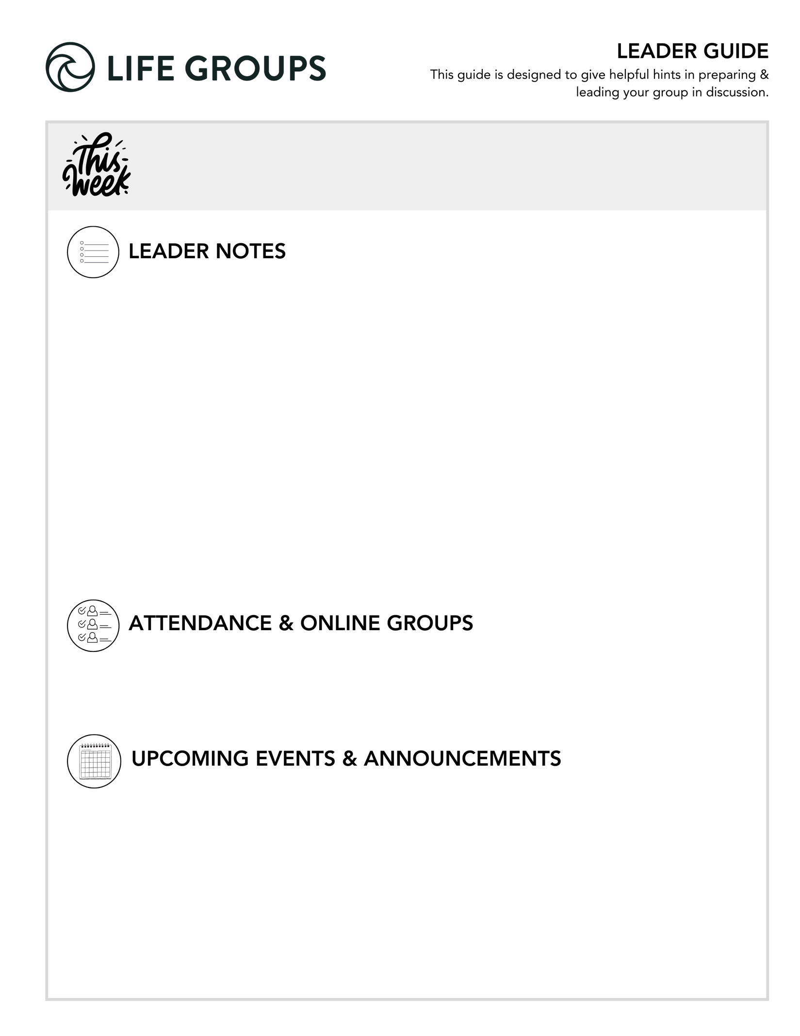
- Reminder: A successful night is hearing from everyone during the meeting.
- There is more than one way to ask a question. Check out the Empowering Interaction at the end of this Leader Guide.
- A social event has the potential to supercharge connection within your group! Check out: Life Group social ideas
- An Impact project is a great way to serve and build stronger friendships! Take a look: Impact Projects

- Serve as a Buddy for an Honored Guest at Night to Shine - North Coast Church has the honor of hosting Night to Shine, sponsored by the Tim Tebow Foundation, on Friday, February 13, 4pm-9pm at the Vista Campus! It takes hundreds of Buddy Volunteers to make Night to Shine an unforgettable prom night experience centered on God’s love for people with special needs ages 14 and older. Attendees are our Honored Guests! Each Honored Guest is partnered with a Buddy who is with them throughout the night from 4pm-9pm. The role of a Buddy is a vital part of making this event a success! Buddy Volunteers are still needed to make Night Shine possible. Learn more or register to serve as a Buddy in the North Coast Church app or at northcoastchurch.com.

- Rock Solid Finances - Join Eric Weight, North Coast Executive Pastor and Chief Financial Officer, for “Rock Solid Finances,” a four-week journey to understanding and managing money God’s way February 22 – March 15. Designed for adults of all ages, this free class draws from biblical principles to help you create a solid financial foundation. Eric will cover practical topics including budgeting, saving and investing, and navigating money biblically. Each week builds on the last to equip you with essential tools and strategies for managing finances in a way that honors God and promotes lasting peace. Whether you’re looking to align financial decisions with your faith or gain practical skills for financial health, this course will help you gain confidence and clarity with your finances. Learn more or register in the North Coast Church app or at northcoastchurch.com.

LEADER DISCUSSION GUIDE
_____________________________

WARM UP

1. Jesus spoke in parables, which were stories that taught a truth about God. What was your favorite story to read or listen to as a child or youth? Why did you love it so much?

- Additional questions for established groups: What book or movie from earlier in life still holds meaning for you today? Is there a story that has meant different things to you at different seasons of life?

2. The parables talked about everyday occurrences as examples of God working in the world. Are you more of a garden person, a baking person, or a “buy it at the store” person?
- Additional question: Do you enjoy the process of making something, or do you prefer the finished product? Why?

3. What has stuck with you the most from this week’s sermon— a phrase, image, or idea? Why do you think that stood out?
- Additional question: What from the sermon made you pause, reflect, or feel something?


KNOW IT

Parables were intended to encourage Jesus’ listeners to lean in and dig more. Let’s do just that! Re-read Matthew 13:24-43 together and answer the questions below.

1. Jesus gave us several analogies for what the kingdom of heaven is like. Come up with your own modern-day analogy for the kingdom and explain it to your group. How does it represent what following Jesus is like?

- Conversation Caution: The goal isn’t to create the perfect analogy. It’s to help us see how Jesus’ kingdom reshapes everyday life.
- Additional question: If your neighbor, co-worker, or fellow student asked you what life in God’s kingdom feels like, what everyday image would help them understand it?

2. Jesus says that God will direct the angels to do the weeding, not us. Why is it important that God is the one who ultimately separates weeds from wheat? Even so, why is it often difficult for us to leave the weeding to God?
- Thought: There are two important parts to the above questions. First, these questions challenge one’s motivation for doing the weeding. Second, they should lead your group to begin to think through the unintended harm our actions could have on those around us.
- Additional verse: 2 Peter 3:9 - The Lord is not slow in keeping his promise, as some understand slowness. Instead he is patient with you, not wanting anyone to perish, but everyone to come to repentance.
- Additional verse: Psalm 103: 8-10 - The Lord is compassionate and gracious, slow to anger, abounding in love. He will not always accuse, nor will he harbor his anger forever; he does not treat us as our sins deserve or repay us according to our iniquities.


SHARE IT

1. The parable of the mustard seed shows how God uses little things to accomplish great things. In your own life, can you think of something you thought was small, ordinary, or inconsequential that God used to have a huge impact on your life?
- Thought: Some additional wording to expand the scope of the question could be “anything you almost dismissed, delayed, or underestimated.”
- Additional question: Where might God be inviting you to be faithful in something small right now?
- Additional verse: Luke 16:10 – “Whoever can be trusted with very little can also be trusted with much…”

2. Sometimes we can write off people as “weeds” when God is not done working in their lives before the harvest truly comes. Have you ever been surprised that someone you knew became a Christian because they once looked like a weed? What did it teach you?
- Additional question: You could use the following question to prepare your group to answer question 2 above. Who are the kinds of people we’re most tempted to assume God is “done with”?
- Additional verse: 1 Timothy 1:15–16 - Here is a trustworthy saying that deserves full acceptance: Christ Jesus came into the world to save sinners—of whom I am the worst. But for that very reason I was shown mercy so that in me, the worst of sinners, Christ Jesus might display his immense patience as an example for those who would believe in him and receive eternal life.
- Additional question: How can we stay hopeful and loving toward people whose growth we can’t yet see?
- Additional verse: Luke 19:9–10 - Jesus said to him, “Today salvation has come to this house, because this man, too, is a son of Abraham. For the Son of Man came to seek and to save the lost.”


LIVE IT

1. These parables were Jesus’ way of teaching us about God’s kingdom on earth. Imagine you were having coffee with a friend and they asked, “What does kingdom living look like?” What would you tell them to do to live like a citizen of God’s kingdom?
- Thought: The above question could be a powerful reminder to your group of what a citizen truly lives like. Consider making a list off everyone’s contribution that could serve as a visual reminder – one you could send digitally to your group during the week.
- Additional question: What’s one small, tangible action that would reflect kingdom values this week?
- Additional verse: Romans 14:17 - For the kingdom of God is not a matter of eating and drinking, but of righteousness, peace and joy in the Holy Spirit

2. Larry mentioned three things to take away from this weekend’s passage. Which of those resonates most with you in your current season of life, and why?
- Additional question: How could this truth shape the way you think, pray, or act this week?
- Additional verse: Psalm 119:105 - Your word is a lamp for my feet, a light on my path.

EMPOWERING INTERACTION – An excerpt from the Essentials Training booklet

DIFFERENT WAYS TO ASK QUESTIONS: The goal is to get others to share, not ourselves.

ANYONE ANSWERS - All or a few answer. You decide and let them know what you expect. This is great for the extraverts as it gives them a chance to spread their wings a bit.

GO AROUND THE CIRCLE - Gives everyone a chance to talk and to plan what they are going to say.

DIRECTED AT ONE PERSON – “Oliva, I’m interested in hearing what you think. What are your thoughts?” Be mindful of those who are quiet or introverted - avoid intimidating and focus on inviting them to join the discussion.

PIGGYBACK QUESTIONING - After one person is done, ask someone else how they would answer. What would be the same? What would be different? Do they agree or disagree?
Dr. Larry Osborne
January 24-25, 2026
Message #34/ Matthew 13:24-43

northcoastchurch.com/sermons

Godly Living In A Godless World

The Passage
Matthew 13:24-43

Three Things We Need To Know About
God’s Kingdom Here On Earth

1. The Parable About Weeds
Leave the WEEDING to God.

Never forget
1. Jesus is in the business of turning
what looks like WEEDS into WHEAT.
Ephesians 2:1-3

2. Our primary job is to live like a CHRISTIAN.
Not to make NON-CHRISTIANS live like a CHRISTIAN.
1 Peter 2:11-12 / 1 Peter 3:15/ Matthew 7:12

3. The Bible is supposed to be our MIRROR, not our BINOCULARS.
James 1:22-25/ Matthew 7:1-5/ 1 Corinthians 5:12-13

4. Without CONTACT we can’t have IMPACT.
1 Corinthians 5:9-10

2. The Parable About A Tiny Seed
God uses LITTLE THINGS to accomplish GREAT THINGS.

3. The Parable About Yeast
God is at WORK even when we can’t SEE IT.

