

WINTER WEEK 4 | January 31-February 1, 2026

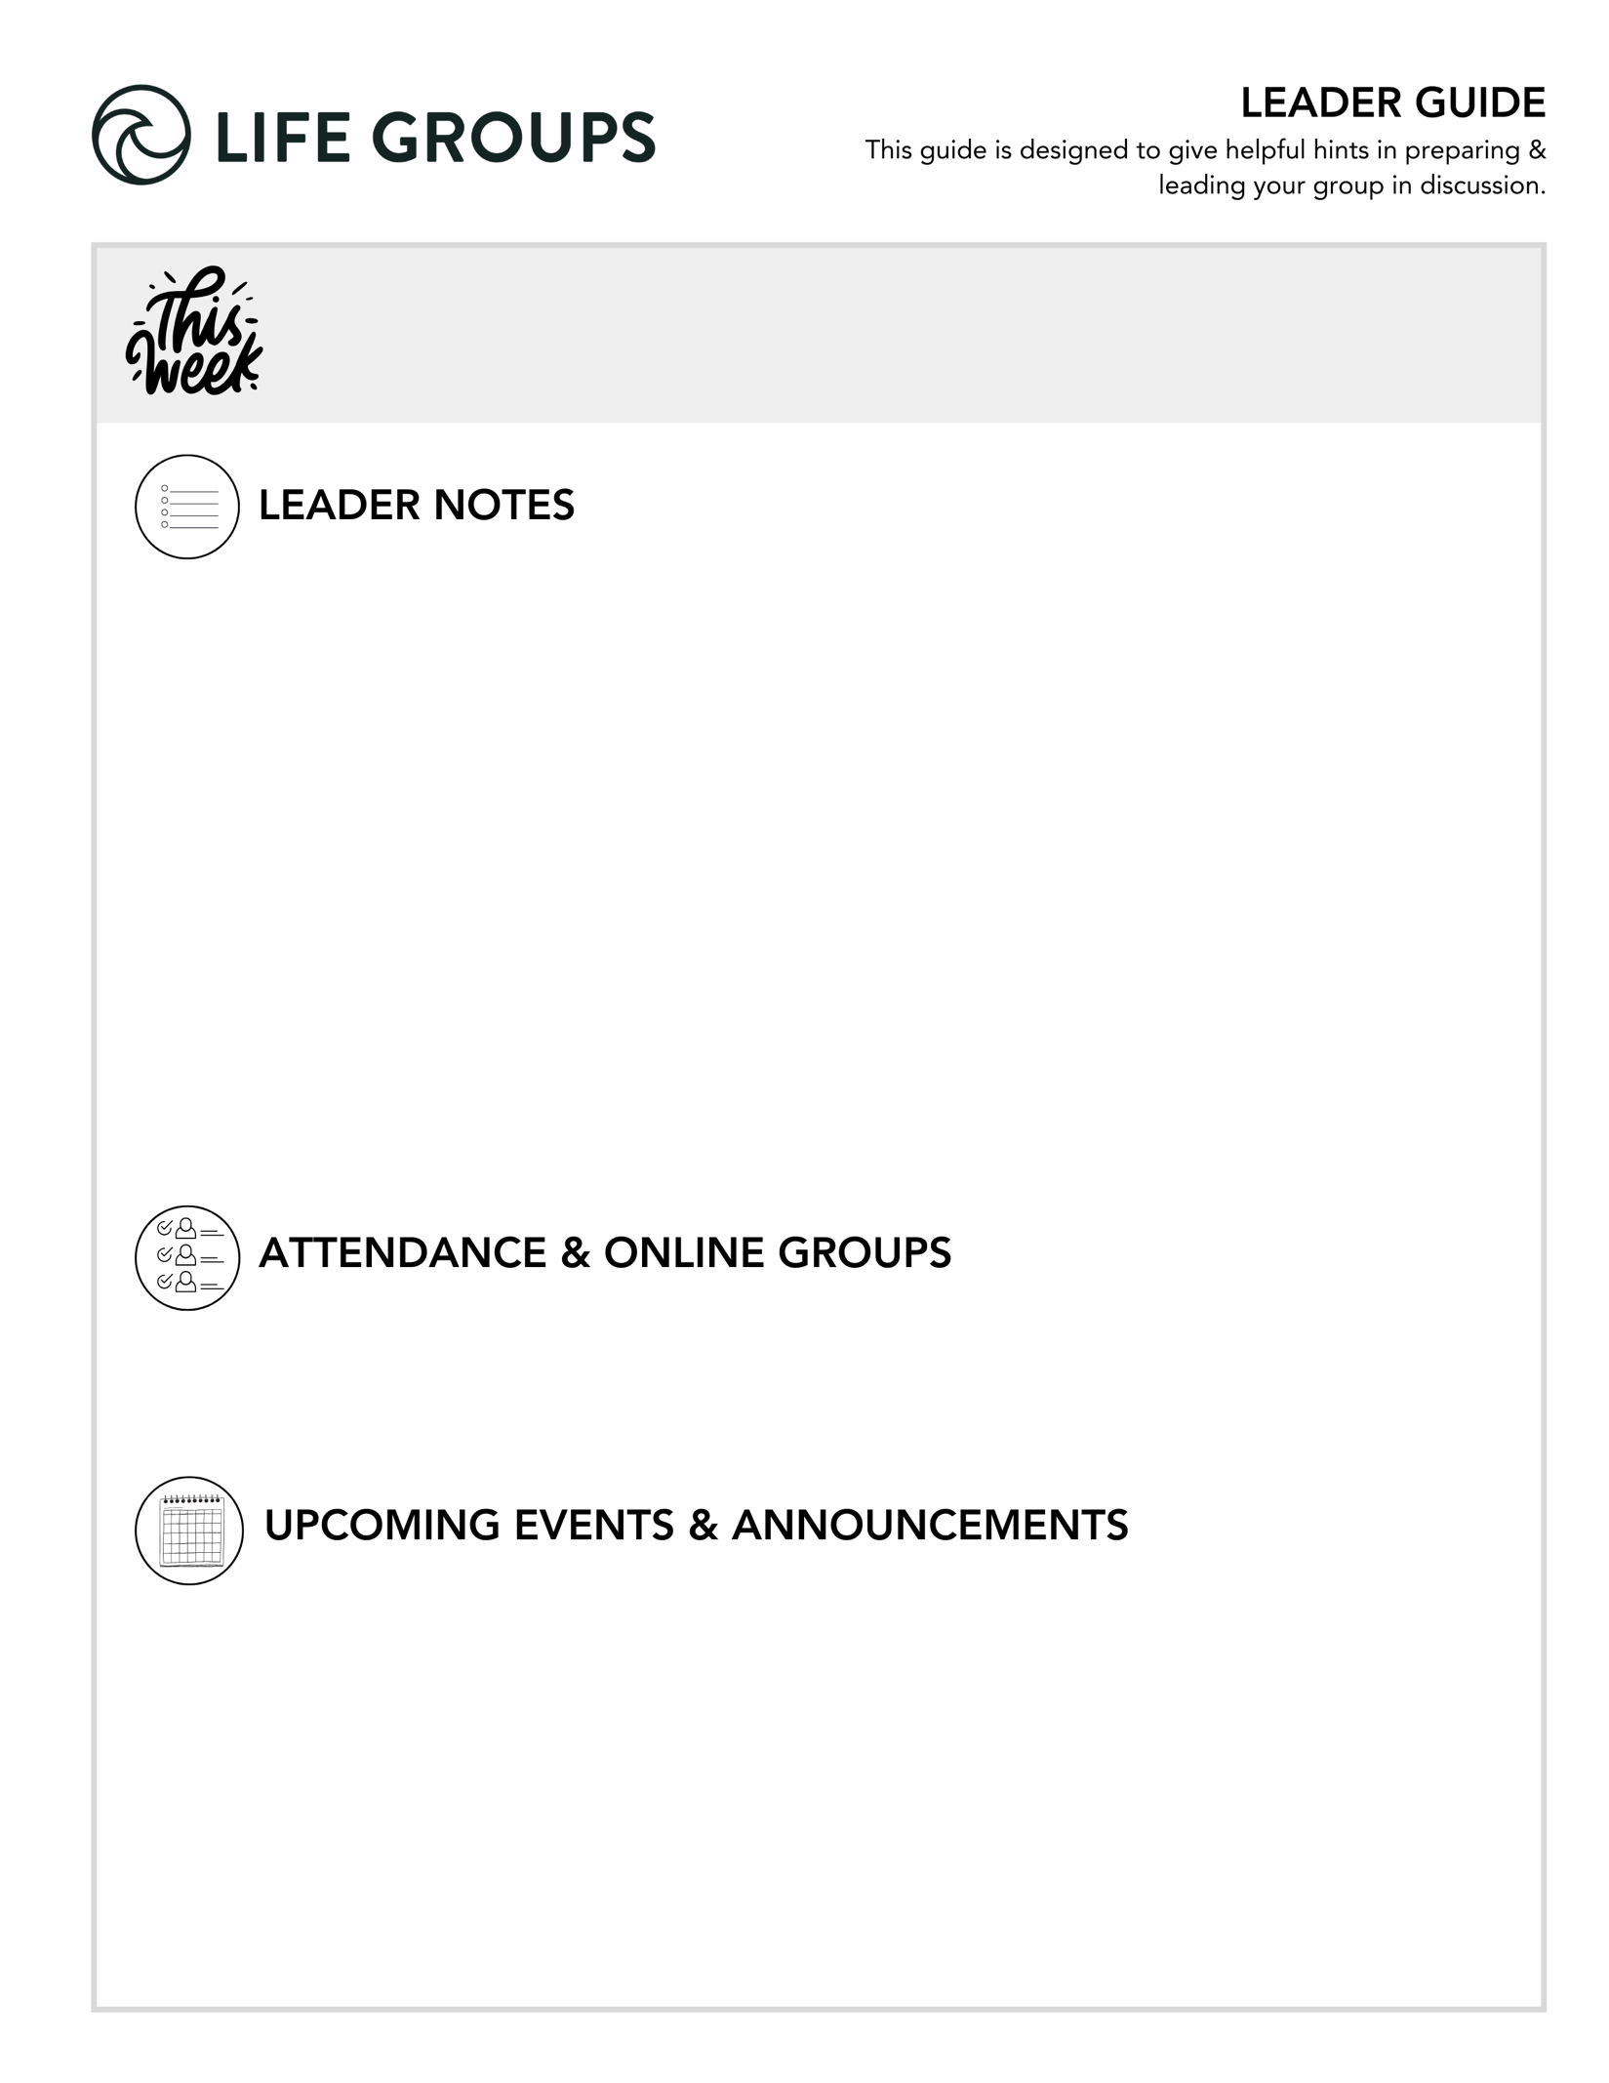
- HOW IS A LIFE GROUP MEETING MEASURED? Hearing from everyone during the meeting.
- THE MISSION OF LIFE GROUPS: to create a space for meaningful relationships to develop through discussion that is centered on God’s word.
- UNDERSTAND THE RISK LEVEL OF DISCUSSION QUESTIONS
An excerpt from the Essentials Training booklet:
  - Low Risk = WARM UP Section These questions are designed to help your group to get to know each other.
  - Medium Risk = KNOW IT/SHARE IT Sections Questions here lean towards being informative. For example, giving space to talk through opinions, beliefs, points of view, and interpretations of situations.
  - Higher Risk = SHARE IT/LIVE IT Sections – These sections tend to open the door to discussing growth areas, weaknesses, and accountability.

- Rock Solid Finances - Join Eric Weight, North Coast Executive Pastor and Chief Financial Officer, for “Rock Solid Finances,” a four-week journey to understanding and managing money God’s way February 22 – March 15. Designed for adults of all ages, this free class draws from biblical principles to help you create a solid financial foundation. Eric will cover practical topics including budgeting, saving and investing, and navigating money biblically. Each week builds on the last to equip you with essential tools and strategies for managing finances in a way that honors God and promotes lasting peace. Whether you’re looking to align financial decisions with your faith or gain practical skills for financial health, this course will help you gain confidence and clarity with your finances. Learn more or register in the North Coast Church app or at northcoastchurch.com.

- North Coast Women's Conference 2026 - Join the women of North Coast Church in 2026 for this two-day event hosted at the Vista Campus. Over two days you'll experience inspiring messages from guest speakers, engaging activities that vary from relaxing and creative to fun and action-packed. Meals, snacks and beverages are also included. Merchandise available online now! SIGN UP ONLINE IN THE APP or at northcoastchurch.com

LEADER DISCUSSION GUIDE
_____________________________

WARM UP

1. In the message this weekend, when Jesus asked His disciples if they understood what He was saying, they said “yes,” which seems questionable. At times we’ve all pretended to understand or know something so we didn’t look foolish. Was there a time for you that backfired or seems funny now in hindsight?
- Conversation Caution: You will need to read the room when each person is sharing, including the one who shares. Be ready to help soften the response by the group if the person who shares doesn’t see their experience as funny. Being prepared and alert will help you to prevent a group member from shutting down for the rest of the meeting.

2. Was there one particular parable that stood out to you? Did you hear anything new or surprising in the explanation or application?
- Additional questions for established groups: Which parable is God using to get your attention? Why do you think that is? Did any of them challenge or stretch you differently than they might have in earlier seasons of your faith?

3. What is one quote, point or idea from this weekend’s message or the daily videos in the app that you’d want to write on a sticky note to remember later?


KNOW IT

Let’s re-read Matthew 13:44-52.
1. In verse 51, Jesus’ disciples didn’t seem to have any questions, but perhaps they should have to gain a deeper understanding. Is there anything in the parables that you’re still unsure about? Come up with at least one question you still have about Jesus’ stories and share it in your group for a chance for us to all gain deeper understanding.

- New members or New group? Here’s a warm-up before diving into the above question. What keeps us from asking honest questions about Jesus’ teaching?
- Conversation caution: You don’t need to hold each person accountable to responding. The goal of this question is to generate a few questions your group could dialogue about. If any of those questions are not easily answered, don’t feel pressured to camp here. In fact, we urge you to allow the group to take time outside of the group meeting to wrestle, process, and search for the answer. If you go this route, name it. And share with the group that there will be sometime during the next meeting to hear what has been discovered.

2. No matter which way you read this parable, the fact remains that Jesus gave everything for us because of our great value to Him. What does it look like for us to genuinely delight in and find joy in Him in return? What are the things you can point out in your time, talents and treasures that show you truly have joy in investing in His kingdom?

- Thought: Some people may struggle to identify what true joy in Jesus looks like. You can help by asking your group to name what joy is not. With a list of what joy is not, gently guide the group to examine joy through the lens of relationship with Jesus.
- Additional verse: Psalm 37:4 - Take delight in the LORD, and he will give you the desires of your heart.


SHARE IT

1. Thinking about the image of treasure lost in a field that needed to be discovered, where did Christ find you? What was your life like when you first became aware of Him or decided to follow Him?
- Additional question: How does remembering where Jesus met you help you appreciate His grace more today?
- Additional verse: Ephesians 2:4–5 - But because of his great love for us, God, who is rich in mercy, made us alive with Christ even when we were dead in transgressions—it is by grace you have been saved.

2. If someone asked you why you surrendered to Jesus at that time and why you have such joy in following Him now, what would be your three-sentence answer? (Think about using verse 52 and the storehouses in your own life, for example: your testimony, your relationship with Jesus, your joy, lessons you’ve learned, moments of faith, success, failures, etc.)
- Thought: If any of your group members seem timid about sharing their three-sentence answer, break down the question into smaller ones. For example, “When did you surrender to Jesus?”
- Conversation caution: Be vigilant in maintaining the overall focus on Jesus. Comparison can easily misdirect the group discussion.
- Additional verse: Philippians 1:3-6 - I thank my God every time I remember you. In all my prayers for all of you, I always pray with joy because of your partnership in the gospel from the first day until now, being confident of this, that he who began a good work in you will carry it on to completion until the day of Christ Jesus.


LIVE IT

1.Jesus reminds us that there is an end of the age, and that who is gathered with Him matters. Who in your life do you want to be gathered with you when the time comes, or as Chris said, your “plus one”? As a group, pray over these names.
- Conversation caution: This question could usher a very vulnerable moment for each group member. Your group will be watching closely to how you respond to those who don’t have a name or aren’t ready to share that name. Don’t be tempted to “draw a line in the sand” and expect each member to share a name regardless. Instead, be prepared to help the group gently and respectfully pass to the next person.
- Additional verse: Colossians 4:2-3 - Devote yourselves to prayer, being watchful and thankful. And pray for us, too, that God may open a door for our message, so that we may proclaim the mystery of Christ, for which I am in chains.

2. If Jesus gave everything to share the kingdom with us, what could you do to share the kingdom with the person you just mentioned? Don’t let this intimidate you. Start with one simple step you can reasonably do in the near future and speak it out loud in your group.
- Thought: Encourage your group that sharing the kingdom with your “plus one” can simply start with presence and availability.
- Additional question: What is one simple step that feels faithful and not forced?

f |  | Pastor Chris Brown  January 31 - February 1, 2026  Message #35/ Matthew 13:44-52
f |  |   northcoastchurch.com/sermons

Is Hell A Real Possibility?

The search for hidden treasure:
Matthew 13:44-46, Philippians 3:7-8, Romans 3:10-11
God’s treasure: Exodus 19:5-6, Deuteronomy 7:6, 14:2, Psalm 135:4, Malachi 3:17

Two things are for certain from these two stories:

The incredibly HIGH VALUE of the found treasure.

The GREAT JOY and SATISFACTION of the one who found them.

Do we really believe the end of the story?
Matthew 13:47-52, Revelation 5:9, 2 Peter 3:9-10

If Jesus is telling the truth, then:

Our world is not going to get MORE PEACEFUL.

Our ultimate purpose here is to FISH for OTHERS, not FEND for OURSELVES.

Our greatest passion should be KINGDOM EXPANSION.

