

WINTER WEEK 5 | February 7-8, 2026

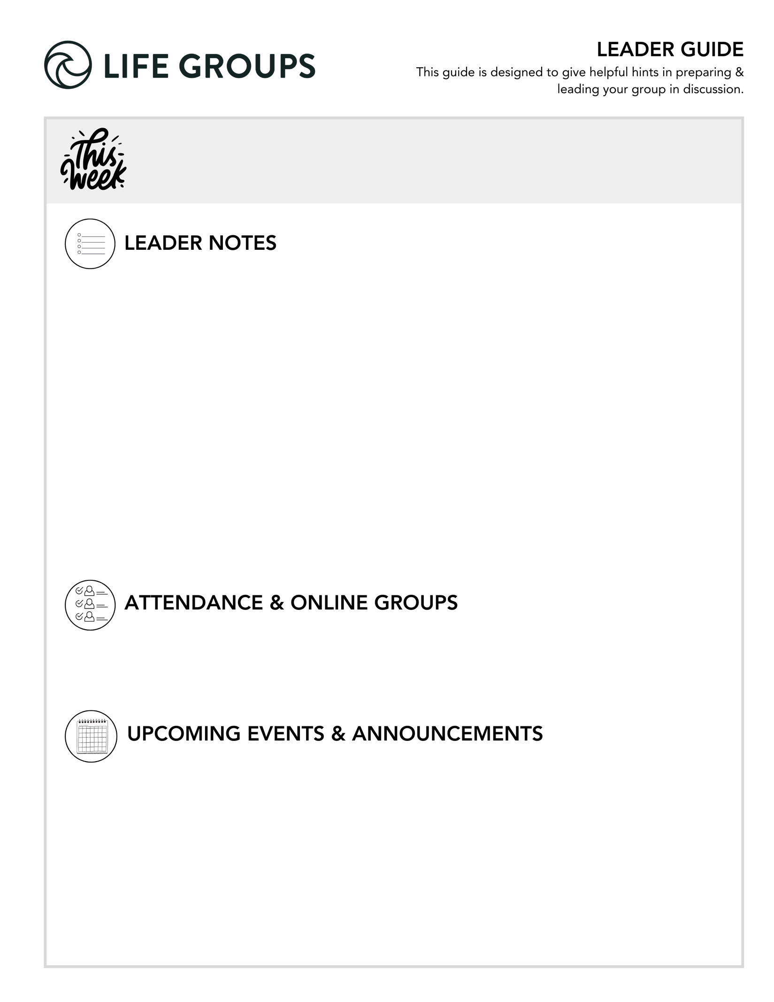
- Reminder: A successful night is hearing from everyone during the meeting.
- A social event has the potential to supercharge connection within your group! Check out: Life Group social ideas
- An Impact project is a great way to serve and build stronger friendships! Take a look: Impact Projects

- Ready to Make an Impact? - Each Life Group quarter we invite all of our Life Groups to make an impact through serving together with one of our Local Impact partners. Has your Life Group picked an Impact Project yet? From packing toiletry kits and sack lunches to hosting bingo nights at the senior center, building beautification, meal delivery and so much more, the North Coast Impact website has hundreds of service opportunities in your area! Learn more in the North Coast Church app or at northcoastchurch.com.

- Rock Solid Finances - Join Eric Weight, North Coast Executive Pastor and Chief Financial Officer, for “Rock Solid Finances,” a four-week journey to understanding and managing money God’s way February 22 – March 15. Designed for adults of all ages, this free class draws from biblical principles to help you create a solid financial foundation. Eric will cover practical topics including budgeting, saving and investing, and navigating money biblically. Each week builds on the last to equip you with essential tools and strategies for managing finances in a way that honors God and promotes lasting peace. Whether you’re looking to align financial decisions with your faith or gain practical skills for financial health, this course will help you gain confidence and clarity with your finances. Learn more or register in the North Coast Church app or at northcoastchurch.com.

LEADER DISCUSSION GUIDE
_____________________________

WARM UP

1. Larry talked about Jesus being a “homeboy who made it” in Nazareth. Is there anyone from your hometown or childhood who went on to become successful or well-known? What’s weird about seeing them now?

2. In Nazareth, familiarity led people to dismiss Jesus. Can you think of a time when being too familiar with someone (or something) caused you to overlook their value or take them less seriously?

3. What has stuck with you the most from this weekend’s sermon or the daily videos in the app?


KNOW IT

1. Read Matthew 13:53–58 and Luke 4:14–24. Larry explained what Nazareth was like and why Jesus’ hometown struggled to accept Him. Based on his explanation and what we read in these passages, what do you think the people expected Jesus to be or do, and why did those expectations become a problem? Where do we see similar expectations of Jesus today?

- New Groups/Groups with New Members: What could it look like to approach Jesus with curiosity rather than expectation?
- Thought: Nazareth’s rejection of Jesus wasn’t rooted in lack of information, but in expectations that left no room for who He truly was.
- Additional question: Can you think of a season when your expectations of Jesus shaped your focus so much that you missed His presence or work in your life?

2. What kind of faith do you see in James 2:19-24? How does that compare to how faith is often understood in our world, or even among Christians?

- Established Groups: What’s the difference between knowing something is true about God and trusting Him with your life?
- Additional question: What is the difference between a faith that is like an intellectual agreement versus one that reflects wholehearted allegiance?

3. Larry said, “Doubt is not the opposite of faith; disobedience is.” How does that land with you? Is it encouraging, surprising, challenging, confusing, etc.?
- Thought: This question can be a powerful catalyst for increasing engagement in the discussion. One suggestion is to have each person use one word as the questions states. There could be several in your group that feel the same way about Larry’s statement. That can create shared experience and connection. Then ask a few to share why they choose that word.
- Established Groups: Where do you see doubt most often turning into disobedience—and why? Are there any factors that increase one’s resistance to obey?


SHARE IT

1. Larry names three spiritual danger zones and faith killers. Which of these have you encountered in your own life most often, and why do you think that one is especially dangerous? Is there another “faith killer” or obstacle you would add?

- New Groups/Groups with New Members: Larry mentioned spiritual danger zones and faith killers this past weekend. What do you think people commonly struggle with—and what makes it challenging?
- Established Groups: If you were discipling a newer believer, what faith killer would you warn them about and why?
- Additional Verse: 1 Peter 5:8 - Be alert and of sober mind. Your enemy the devil prowls around like a roaring lion looking for someone to devour.
- Additional Verse: Psalm 139:23-24 - Search me, God, and know my heart; test me and know my anxious thoughts. See if there is any offensive way in me, and lead me in the way everlasting.

2. When the Jesus we want or expect isn’t the Jesus we get, it often results in disappointment. If someone you care about was struggling because God didn’t meet their expectations, what would you say (or not say) to encourage them?
- Additional Question: What kinds of well-meaning responses can actually deepen someone’s hurt or shut them down when they’re disappointed with God?
- Established Groups: What does it look like to pursue hope in the midst of disappointment? When you look back on times of disappointment, what helped sustain or restore your hope?


LIVE IT

1. Larry talked about faith that trusts God enough to do what He says. What motivates you or helps you to obey God when you’re not sure it will work or it’s just hard?

- New Groups/Groups with New Members: When you’re unsure or hesitant, what usually helps you move forward rather than get stuck?
- Additional Verse: John 14:23 - Jesus replied, “Anyone who loves me will obey my teaching. My Father will love them, and we will come to them and make our home with them.
- Additional Verse: Proverbs 3:5-6 - Trust in the Lord with all your heart and lean not on your own understanding; in all your ways submit to him, and he will make your paths straight.
- Established Groups: In what ways can obligation drain obedience of joy? In what ways does love restore the job of obedience?

2. The people in Nazareth admired Jesus, believed He was wise and even acknowledged His power, but when it came to actually following Him, they couldn’t get there. What’s one teaching of Jesus that you find easier to believe than to obey?

- Additional question: What makes obedience to Jesus feel costly? What do you fear you might lose?
Established Groups: How does delay or partial obedience quietly keep us from fully following Jesus?
- Additional verse: James 1:22 - Anyone who listens to the word but does not do what it says is like someone who looks at his face in a mirror
- Additional verse: John 15:5 - “I am the vine; you are the branches. If you remain in me and I in you, you will bear much fruit; apart from me you can do nothing.

Dr. Larry Osborne
February 7-8, 2026
Message #36/ Matthew 13:53-58

northcoastchurch.com/sermons

The Day Jesus Couldn’t Pull Off A Miracle
When The Jesus We Get, Isn’t The Jesus We Want

The Passage:
Matthew 13:53-58/ Isaiah 61:1-2

The Rest Of The Story:
Luke 4:14-30

The Kind Of Faith Jesus Responds To:
Matthew 13:47-52/ Revelation 5:9/ 2 Peter 3:9-10

1. Faith that trusts Him to REWARD our OBEDIENCE.
Hebrews 11:6

2. Faith that trusts Him enough to DO WHAT HE SAYS.
James 2:19-24/ 2 Kings 5:1-14

Three Spiritual Danger Zones & Faith Killers

1. When the Jesus we get isn’t the Jesus we EXPECTED.
Romans 12:1-2

2. When the Jesus we get isn’t the Jesus we WANTED.
John 6:14-15/ John 6:66/ John 18:40

3. When we cry out for HELP but refuse to SURRENDER.

