

WINTER WEEK 5 | February 14-15, 2026

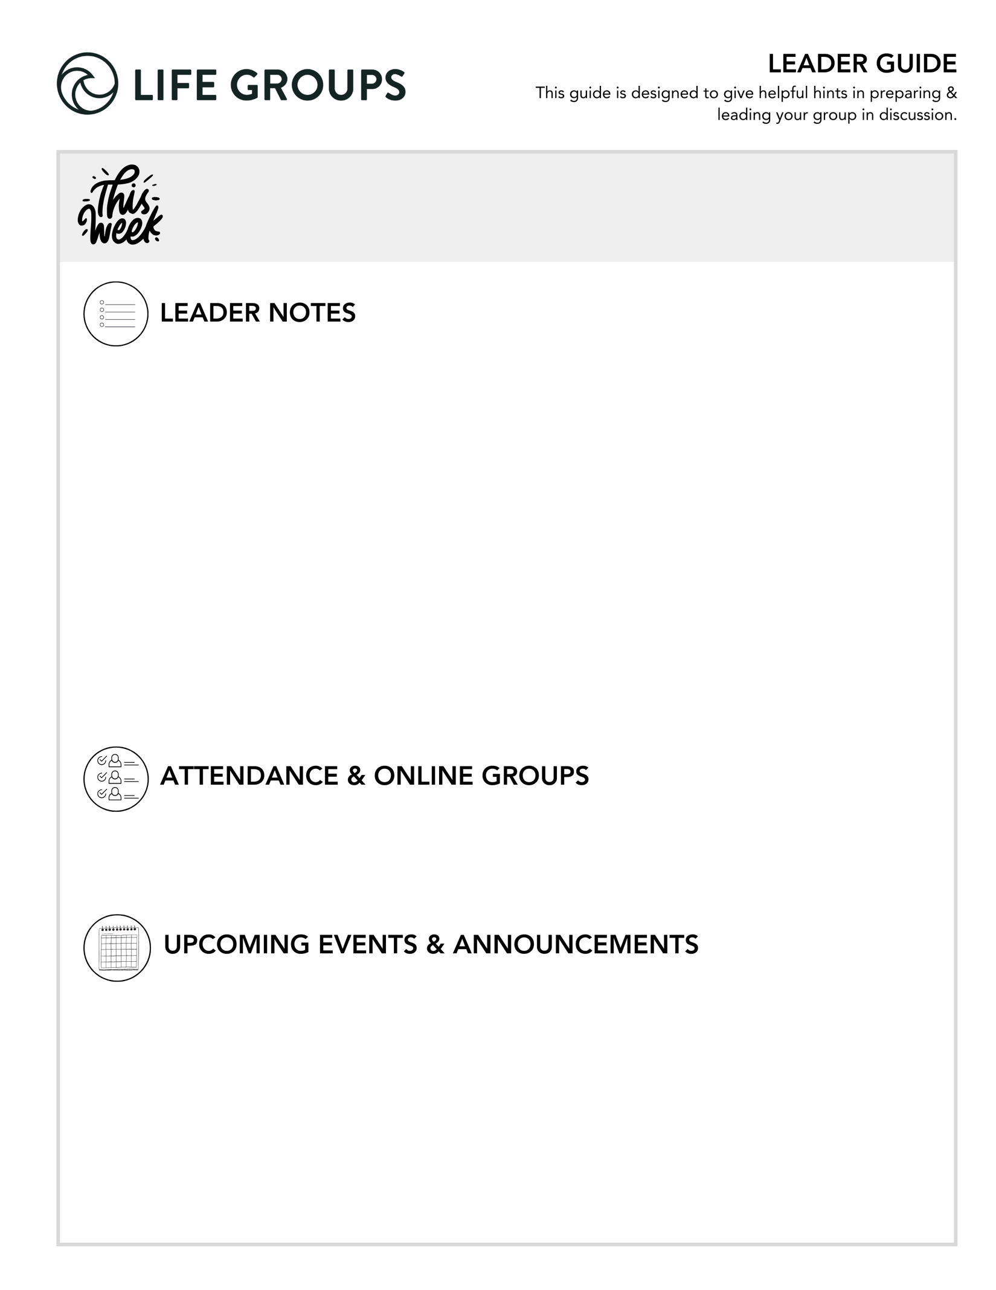
- What does a successful meeting look like? Hearing from everyone during the meeting.

- An excerpt from Essentials Leader training – “Depth Over Coverage”

Remember:

Healthy groups prioritize interaction over information and conversation over completion.

You don’t need to finish every question.

Your role is to create space for honest engagement.

- Ready to Make an Impact? – Each Life Group quarter we invite all of our Life Groups to make an impact through serving together with one of our Local Impact partners. Has your Life Group picked an Impact Project yet? From packing toiletry kits and sack lunches to hosting bingo nights at the senior center, building beautification, meal delivery and so much more, the North Coast Impact website has hundreds of service opportunities in your area! Learn more in the North Coast Church app or at northcoastchurch.com

- Rock Solid Finances – Join Eric Weight, North Coast Executive Pastor and Chief Financial Officer, for “Rock Solid Finances,” a four-week journey to understanding and managing money God’s way February 22 – March 15. Designed for adults of all ages, this free class draws from biblical principles to help you create a solid financial foundation. Eric will cover practical topics including budgeting, saving and investing, and navigating money biblically. Each week builds on the last to equip you with essential tools and strategies for managing finances in a way that honors God and promotes lasting peace. Whether you’re looking to align financial decisions with your faith or gain practical skills for financial health, this course will help you gain confidence and clarity with your finances. Learn more or register in the North Coast Church app or at northcoastchurch.com.

LEADER DISCUSSION GUIDE
_____________________________

WARM UP

1. Jesus multiplied the loaves and fishes to feed the people. If you could make food multiply, at what event would you use this newfound power, and which cuisine would you multiply?

2. Two weeks ago, we talked about identifying and praying for a “plus one,” someone you hope to bring with you to Heaven. This week, Jeff reminded us that we are called to give Jesus away. Has anything progressed or shifted in how you see or care for your “plus one” since we last talked about it?
- Conversational caution: Has anyone in your Life Group already shared progress regarding their “plus one”? If so, consider asking them before the meeting if they’d be willing to share during this discussion. Having someone go first can help break the ice. At the same time, avoid requiring everyone to respond—keeping the question open-ended reduces pressure and creates a safer environment for sharing.

3. What from this message or the daily videos in the app has stuck with you this week?


KNOW IT

1. Re-read Matthew 14:1-21. Is there anything you noticed hearing it a second time?
- Additional question: Did you notice any contrast between Herod's banquet and Jesus feeding the 5,000? What stands out about the difference between those two "kings" and their tables?

2. In Matthew 14:16, Jesus says, “You give them something to eat.” Why do you think Jesus involved the disciples instead of feeding the crowd Himself without them?

- Established Groups: What are some ways that responsibility can stretch and strengthen faith?
- Additional question: How does being given responsibility-even when you don't feel ready-impact your faith?

3.What stands out to you about the difference between the disciples’ perspective (“send them away”) and Jesus’ perspective?
- Additional question: How does one’s perspective change when you see people to care for instead of a problem to fix?
- Established Groups: When are you most tempted to move away from something or someone rather than step toward?
- Additional verse: Galatians 6:2 - Carry each other’s burdens, and in this way you will fulfill the law of Christ.


SHARE IT

1. Jeff pointed out that every follower of Jesus is in ministry no matter what their vocation is. What is your initial reaction to that? What do you think ministry could look like in your life, job, neighborhood, and relationships, etc.?
- Additional question: Where in your current rhythms (work, family, friendships) are there already opportunities for ministry?
- Established Groups: What are some ways one can prioritize presence over performance when serving others?
- Additional Verse: Colossians 3:23-24 - Whatever you do, work at it with all your heart, as working for the Lord, not for human masters, since you know that you will receive an inheritance from the Lord as a reward. It is the Lord Christ you are serving.

2. The disciples underestimated what Jesus could do with the little they had. Is there an area or situation where you tend to underestimate what God could do through you?
- Additional Question: What would it look like to offer what you have to God before knowing how He will use it?
- Additional Verse: Ephesians 3:20-21 - Now to him who is able to do immeasurably more than all we ask or imagine, according to his power that is at work within us, to him be glory in the church and in Christ Jesus throughout all generations, for ever and ever! Amen.


LIVE IT

1. When the disciples wanted to send the crowds away, Jesus told them to give them something to eat. Is there anywhere in your life where Jesus might be saying to you right now, “You give them something”?
- Thought: To add variety, divide into pairs or groups of three and invite each person to write down their response. After sharing, swap written responses with another group member so each person has someone intentionally praying for and encouraging them in the days ahead.
- Additional Verse: James 2:14-17 - What good is it, my brothers and sisters, if someone claims to have faith but has no deeds? Can such faith save them? 15 Suppose a brother or a sister is without clothes and daily food. 16 If one of you says to them, “Go in peace; keep warm and well fed,” but does nothing about their physical needs, what good is it? 17 In the same way, faith by itself, if it is not accompanied by action, is dead.

2. The disciples didn’t think they had enough to feed the crowd. Sometimes we can feel the same way. What kinds of things (fear, busyness, tiredness, self-doubt, etc.) might keep you from stepping into ministry where you already are?
- Additional question: Nowadays, it’s easy to fall into the trap of comparison. In what ways does comparing yourself to others limit your willingness to step forward into opportunities to serve?
- Additional verse: Ephesians 5:15-16 - Be very careful, then, how you live—not as unwise but as wise, 16 making the most of every opportunity, because the days are evil.
- Established Groups: When you feel spiritually or emotionally tired, what helps you continue to love and serve others?

Pastor Jeff Whye
February 14-15, 2026
Message #37 / Matthew 14:1-21

northcoastchurch.com/sermons

Are You Looking For A Miracle?

MAIN POINT #1: Compassion Doesn’t Wait Until I Feel Ready
Matthew 14:13–14

Compassion is not based on my ENERGY, but on Jesus’ HEART.

MAIN POINT #2: Jesus Doesn’t Dismiss the Need, He Assigns It
Matthew 14:15–16

Ministry begins when I stop saying SEND THEM AWAY and start saying SEND ME.

MAIN POINT #3: The Miracle Starts When I Let Go
Matthew 14:17–19

Jesus only asks for what I HAVE, not what I DON’T.
What I place in Jesus’ HANDS, He places under His POWER.

MAIN POINT #4: I’m Not Just a Believer, I’m a Distributor
Matthew 14:19–21, Ephesians 4:12

Church is not a place to CONSUME; it’s a place to be EQUIPPED.
Ministry is giving Jesus, the Bread of Life, to the people AROUND me.

