

WINTER WEEK 7 | February 21-22, 2026

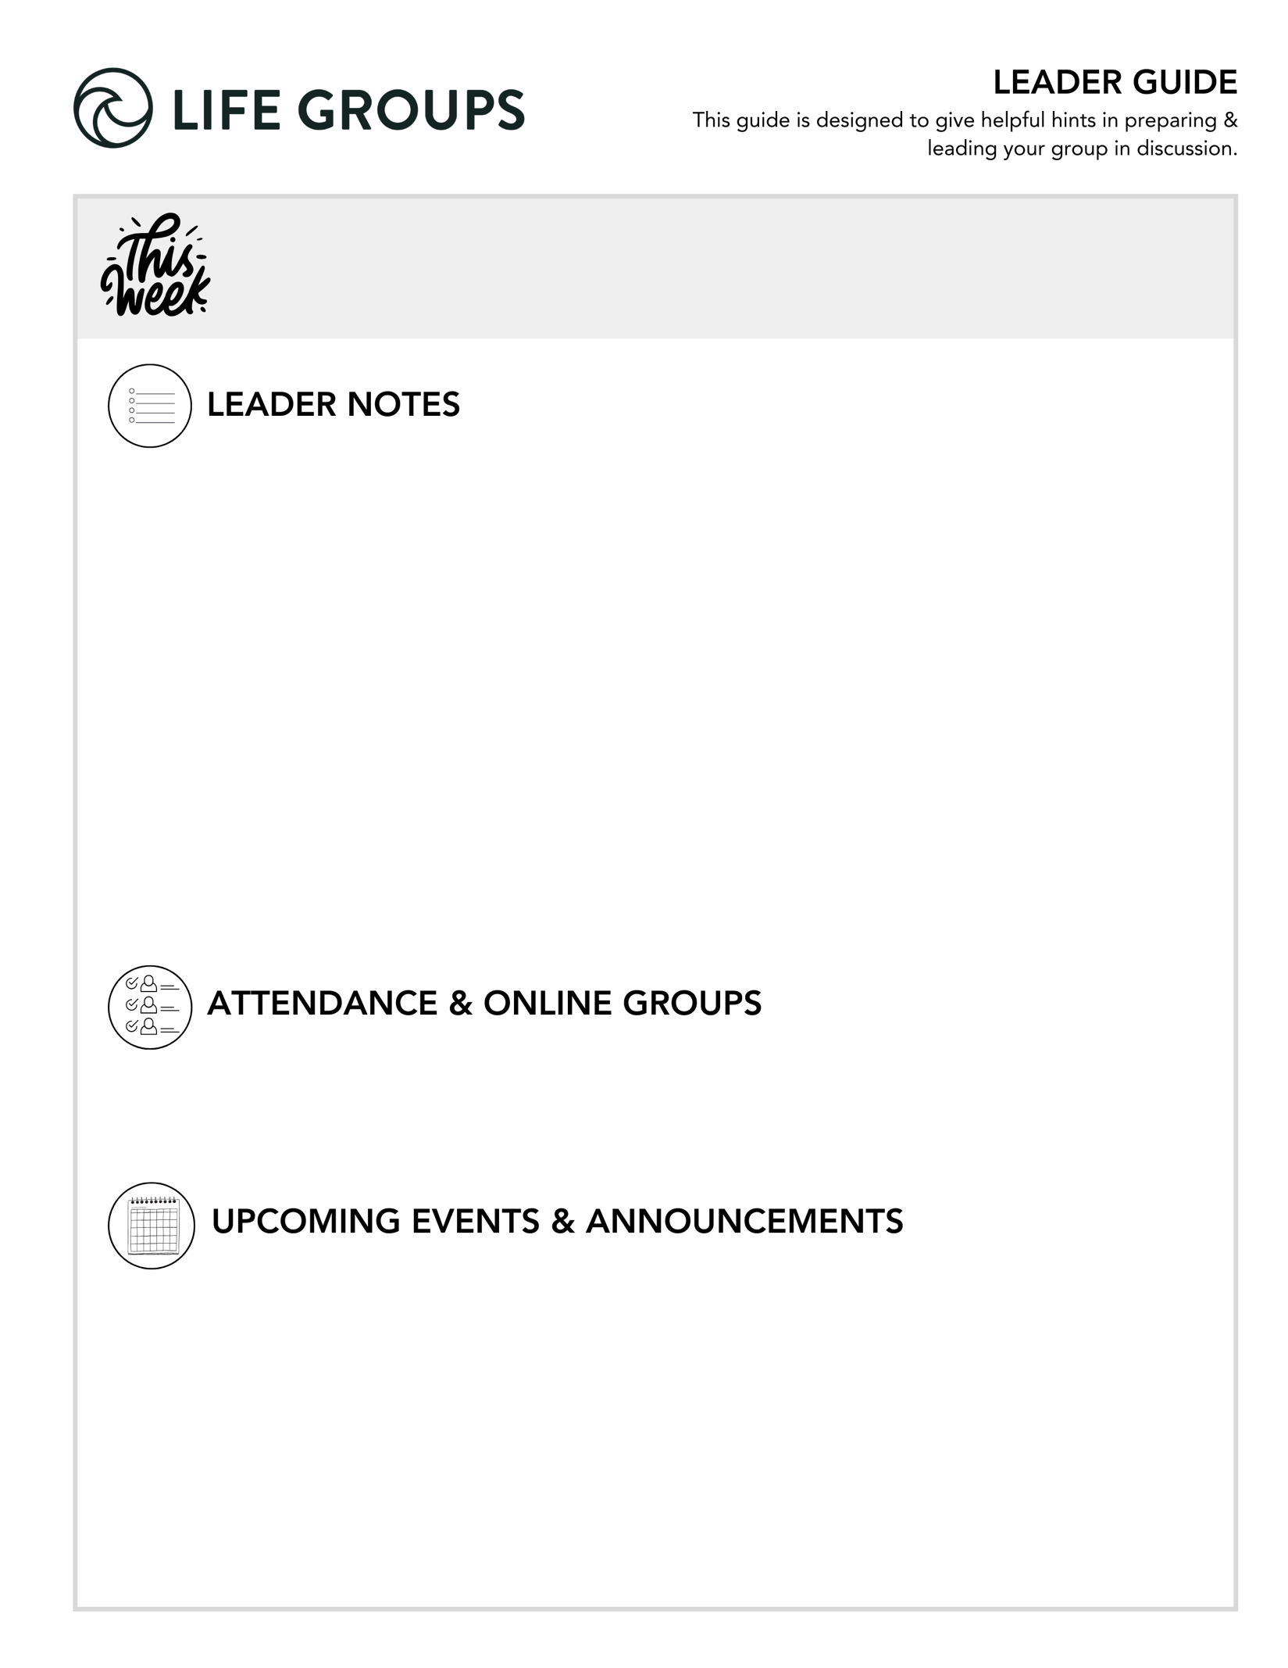
- What does a successful meeting look like? Hearing from everyone during the meeting.

- An excerpt from Essentials Leader training – “Depth Over Coverage”

Remember:

Healthy groups prioritize interaction over information and conversation over completion.

You don’t need to finish every question.

Your role is to create space for honest engagement.

- Send a Student to Camp – Every summer, camp becomes the place where students step away from the noise of everyday life and step into something transformative. For many, it's the first time they experience genuine community, encounter Christ, and discover they truly belong. Your scholarship gift removes the financial barrier that stands between a student and a life-changing week — one that shapes their faith, friendships, and future for years to come. Learn more in the North Coast Church app or at northcoastchurch.com

- Ready to Make an Impact? – Each Life Group quarter we invite all of our Life Groups to make an impact through serving together with one of our Local Impact partners. Has your Life Group picked an Impact Project yet? From packing toiletry kits and sack lunches to hosting bingo nights at the senior center, building beautification, meal delivery and so much more, the North Coast Impact website has hundreds of service opportunities in your area! Learn more in the North Coast Church app or at northcoastchurch.com

LEADER DISCUSSION GUIDE
_____________________________


WARM UP

1. Faith, like skill in any sport, grows the more we practice it. The Winter Olympics just ended, and while some events look simple, they take years to master. If you were thrown into the Olympics with no training, which sport would you try, and which would you avoid at all costs? Why?

2. This weekend, we talked about the figurative storms we may face in life. Have you ever experienced a literal storm or extreme weather event that genuinely scared you? What made it so terrifying?

3. What’s the main thing that stuck with you from this weekend’s message?


KNOW IT

1. Read Matthew 14:22-23. Earlier in this chapter, we saw Jesus pause His alone time to serve others (verses 13-14), but here He makes it a priority again. Why do you think Jesus intentionally made time for prayerful solitude between busy moments? What is so important about getting alone time with God in the midst of your busy schedule?

- New Groups/New Members: Start with the first half: "Why do you think Jesus made time for solitude?" Let them talk about Jesus before talking about themselves. Also, normalize the struggle. Maybe something like this rhythm that Jesus models can be hard in today’s world.
- Conversational Caution: This is a moderate-to-high risk question. It’s reflective and could be potentially convicting. Watch out for the following:
- Shame spirals ("I'm terrible at this.")
- The one overly spiritual voice that could dominate this question
- Unsolicited advice giving
- Sharing of time-management hacks
Prepare beforehand how you might pivot if group discussion veers towards any of the above.
- Additional Questions: "When have you felt the cost of neglecting solitude?" "What does solitude restore in you?"
- Additional Verse: Psalm 119:105 – Your word is a lamp for my feet, a light on my path

2. In Matthew 14, the disciples obeyed Jesus and witnessed a miracle. Later in the same chapter, they obeyed again and found themselves in a storm. With that in mind, read James 1:2-4. How might God use both blessings and difficulties to strengthen your faith?

- Additional Thought: Obedience does not determine outcomes, it shapes formation. Both the miracle and the storm were invitations to deeper trust.
- Conversational Caution: Be sensitive to those currently walking through hardship. Avoid offering quick theological explanations or advice. Allow space for vulnerability. Don’t allow the group to minimize suffering. If the discussion turns philosophical, i.e. God’s role in suffering, redirect - “That’s an important theological question. For tonight, let’s stay with what this passage says about how God uses difficulty to form us.”
- Group Dynamic Tip: In light of any hardship that your group might be facing, consider splitting into pairs for a few minutes before sharing in the larger group. Smaller circles increase safety.
- Additional Verse: 1 Peter 1:6-7 - In all this you greatly rejoice, though now for a little while you may have had to suffer grief in all kinds of trials. These have come so that the proven genuineness of your faith—of greater worth than gold, which perishes even though refined by fire—may result in praise, glory and honor when Jesus Christ is revealed.


SHARE IT

1. This weekend, we were reminded that faith happens when we step out of our comfort zone based on what the Bible is telling us to do. Before Peter stepped out to meet Jesus on the water, he said, “Lord, if it’s you…” Have you ever taken a step of faith while still doubting, or held back because of doubt, and later wished you hadn’t? What happened?
- Conversational Caution: Avoid the comparison trap as it could lead to measuring one’s courage. If someone shares a big leap of faith early on, some in your group might shrink back or choose not to answer.

2. Jesus calls us to grow our “little faith” into stronger faith. Whether you’ve followed Him for years or are just beginning to explore, growth is part of the journey. What has helped your faith grow, or take its first steps? How has it moved you from little faith toward deeper trust?
- New Groups:/New Members: Start by widening the groups filter - Growth doesn’t have to mean something dramatic. It can be small steps like praying for the first time, asking honest questions or inviting someone to church. Even attending Life Group consistently could be growth.
- Established Groups: A temptation for those following Jesus for a long time is to recite their “spiritual resume,” reflecting only on significant growth seasons. Gently steer the group to identify recent growth. Ask “what has shaped your trust recently?”
- Additional Verse: Philippians 1:6 - being confident of this, that he who began a good work in you will carry it on to completion until the day of Christ Jesus.


LIVE IT

1. Jesus modeled “practicing the presence of God” by taking time alone to be with the Father. Prayer, reading Scripture, worship, attending church, going to the beach, resting, hiking, drawing, playing sports, or anything you love doing with and for God are meaningful, life-giving ways to connect with Him. How will you practice His presence this week?

- Thought: Provide clarity if the phrase “practicing His presence” is unclear or foggy. Another way to introduce this idea is “creating space to be aware of Him.”
- Group Dynamic: Consider going first. If you share something small but realistic, it could lower the pressure for those who need it.
- Additional questions: Is your current rhythm life-giving or draining? What would deepen awareness, not just add activity?
- Additional verse: John 15:4 – Remain in me, as I also remain in you. No branch can bear fruit by itself; it must remain in the vine. Neither can you bear fruit unless you remain in me.

2. Chris pointed out that Peter’s problem wasn’t fear; it was losing focus on Jesus. What are the things in life that tend to take your focus off of Jesus and put it on yourself? Where are you inclined to focus on what you can do, and whether you have what it takes?
- Thought: This question is about self-reliance vs. reliance on Christ. This question presents the opportunity for the group to walk with each member this week. For example, how could the group support someone who shares an incredibly strong “pull” in their life affecting their ability to focus on Jesus? A simple text, bible verse, or prayer can go a long way in encouraging your group.

f |  | Pastor Chris Brown  February 21-22, 2026  Message #38 / Matthew 14:22-36
f |  |   northcoastchurch.com/sermons

Why Does God Allow Chaos?

What the Bible says:
Matthew 14:22-36, 8:23-27, John 6:14-15, Deuteronomy 18:15-19

Struggling with OBEDIENCE when things aren’t going well
is the true test of DISCIPLESHIP.
“We measure OBEDIENCE by OBEDIENCE, not in things going
better for us.”

Jesus uses storms and setbacks, to show His disciples
a DEEPER UNDERSTANDING of who He is.

God can use storms to either CORRECT or PERFECT us.

What does this mean for me?
Matthew 14:22-36, James 1:2-4, Hebrews 12:1-2

Regardless of the CAUSE of the STORM, the way through it
remains the same.

How to take little faith to greater faith:

Greater faith happens when we step out of our COMFORT ZONE
based on what THE BIBLE is telling us to do.

Little faith is not a result of FEAR, but the wrong FOCUS.

How to change our doubts that sink us to a conviction that saves us:

We have to surrender our new FEARS to an OLD and PROVEN God.

