

WINTER WEEK 8 | February 28-March 1, 2026

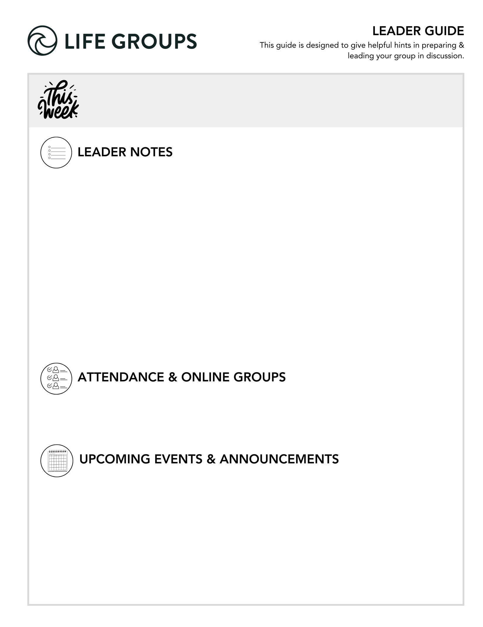
- An excerpt from Essentials Leader training – “Long-Haul Growth & Sustainable Rhythms”

Spiritual growth is typically built over time through small, consistent steps — not dramatic, short-lived intensity. When you ask your group how they will “draw near to God” this week, remember:

- The goal is direction, not perfection.

- The goal is relationship, not performance.

- The goal is sustainable rhythm, not spiritual sprinting.

- Encourage realistic steps.

- North Coast Women’s Conference – Join the women of North Coast Church in 2026 for this two-day event hosted at the Vista Campus. Over two days you’ll experience inspiring messages from guest speakers, engaging activities that vary from relaxing and creative to fun and action-packed. Meals, snacks and beverages are also included.
Questions? Contact conferenceinfo@northcoastchurch.com.
Interested in being a volunteer at the event? Email conferenceinfo@northcoastchurch.com.
- Ready to Make an Impact? – Each Life Group quarter we invite all of our Life Groups to make an impact through serving together with one of our Local Impact partners. Has your Life Group picked an Impact Project yet? From packing toiletry kits and sack lunches to hosting bingo nights at the senior center, building beautification, meal delivery and so much more, the North Coast Impact website has hundreds of service opportunities in your area! Learn more in the North Coast Church app or at northcoastchurch.com

LEADER DISCUSSION GUIDE
_____________________________

WARM UP

1. The Pharisees were upset that the disciples didn’t follow the ceremonial handwashing tradition. What is something small that people can get surprisingly intense about if you don’t do it “the right way”?
Conversational Caution: Be alert to the tone of the room. Humor is welcome, but sarcasm or subtle criticism can quickly turn the discussion into venting or judging.

2. The handwashing practice was a “tradition of the elders” (Matthew 15:2). What’s a tradition from a previous generation that either makes you laugh or that you wish we still did today?

3. If you were to tell a friend something you learned or were encouraged by in this weekend’s message, how would you say it in your own words?


KNOW IT

1. Throughout this series in the book of Matthew, we’ve seen Jesus teaching His disciples what surrender looks like, and we’ve also seen the Pharisees resist surrender. After reading Matthew 15:1-20 and what Jesus says about the heart, why do you think the heart matters so much when it comes to surrender?
Additional Thought: Jesus’ concern wasn’t whether the Pharisees followed rules. It was whether their hearts were aligned with God. True surrender begins internally and flows outward.
Established Groups: Established groups can move quickly to self-examination. A helpful push in the right direction could start with asking this question: Where can we look surrendered but still resist internally?
Additional Verse: Proverbs 4:23 - Above all else, guard your heart, for everything you do flows from it

2. Jesus emphasizes what comes out of our hearts. In Galatians 5:16-26, Paul explains what flows from a heart led by the flesh versus a heart led by the Spirit. When you compare the works of the flesh with the fruit of the Spirit, what stands out to you? Which list feels more common in our world today? Where and how do you see some of these show up regularly?
Additional Thought: The flesh grows when we succumb to a self-led life. The fruit of the Spirit describes what grows when we stay connected to Jesus. The real question is whether we are connected to the right source.
New Group/New Member: New groups often feel safer critiquing “the world” than examining their own hearts. Gently redirect the discussion toward self-reflection. A question to help redirect: It’s easy to see this in culture. Have you noticed any of these tendencies in any areas of your own life?
Established Groups: Watch out for those who overshare or turn the discussion into confession time. Use this question to help refocus the discussion if oversharing or confession begin to grip the discussion: Which fruit feels hardest to sustain when life gets stressful?


SHARE IT

1. Even though the Pharisees were doing the “right” things, their hearts were not aligned with God’s heart. Have you ever had a time when you realized your heart was not aligned with God or His ways? If so, how did you recognize it, and what did you do next?
Additional Thought: Alignment means:
- My desires reflect God’s desires.
- My attitude reflects God’s character.
- My obedience flows from love, not performance.
Additional Questions: What are some early warning signs that your heart is drifting? What helps you realign when you notice drift? What practices help guard your heart?
Additional Verse: Hebrews 10:22 – let us draw near to God with a sincere heart and with the full assurance that faith brings…

2. Jesus says what comes out of us reveals what’s in our heart. If you think about your thoughts, reactions, and conversations over the last couple of days, what has been filling your heart?
New Group/New Member: It would be easy to remain surface level when answering the above. It may be reassuring to remind them that this question isn’t about running their last few days under a microscope. It’s intended to be a filter to help them notice patterns.
Additional Thought: The question behind question is: What are you feeding your heart?
Additional Questions: What have you been consuming mentally or emotionally? What has most influenced your mood this week?
Additional Verse: Philippians 4:8 – Finally, brothers and sisters, whatever is true, whatever is noble, whatever is right, whatever is pure, whatever is lovely, whatever is admirable—if anything is excellent or praiseworthy—think about such things.
Colossians 3:2 - Set your minds on things above, not on earthly things.


LIVE IT

1. Arnold challenged us to pause and examine the condition of our hearts, and gave three examples of a heart that surrenders. Which of those resonates with you, or is there another way you'd describe your heart right now?
New Group/New Member: You might need to lower the intimidation factor of this question due to newer groups or members who are still asking themselves:
- Is this safe?
- How honest can I be?
Additional Thought: A surrendered heart trusts God’s authority, submits its desires, and seeks alignment.
Additional Verse: Psalm 51:10 – Create in me a pure heart, O God, and renew a steadfast spirit within me.
Group Dynamic Tip: Invite each person to describe their heart in one word before describing any further. This can lower pressure and keeps participation broad.

- Jesus told the Pharisees their problem was that their hearts were far from God. James 4:8 tells us God comes near to us when we come near to Him. What is one practical way you can draw near to God this week and make sure your heart is aligned with Him?
Additional Thought: This question is framed as an invitation. Drawing near doesn’t mean having a multiple step plan ready to implement. It could be as simple as choosing to be intentional with your walk with Jesus each morning.
Additional Question: Is your current daily rhythm lifegiving or draining?
Pastor Arnold Camacho
February 28-March 1, 2026
Message #39 / Matthew 15:1-20

northcoastchurch.com/sermons

A Heart That Surrenders

What the Bible says:
Man-made rules
Matthew 15:1-9

Jesus DISRUPTS the man-made BOUNDARIES between GOD and His PEOPLE.

When CORRECTED by the Word of God, we can choose PRIDE or HUMILITY.

At the heart of the matter is the HEART.
Matthew 15:10-20

It’s not about behavior ADJUSTMENT, but a heart CHANGE.

A heart FAR FROM God is what DEFILES A PERSON.

A HEART that surrenders

God can GIVE you a NEW heart.

God can HEAL a BROKEN heart.

God can REVIVE an APATHETIC heart.

When was the last time you examined the condition of your heart?

