

WINTER WEEK 9 | March 7-8, 2026
rch 1, 2026

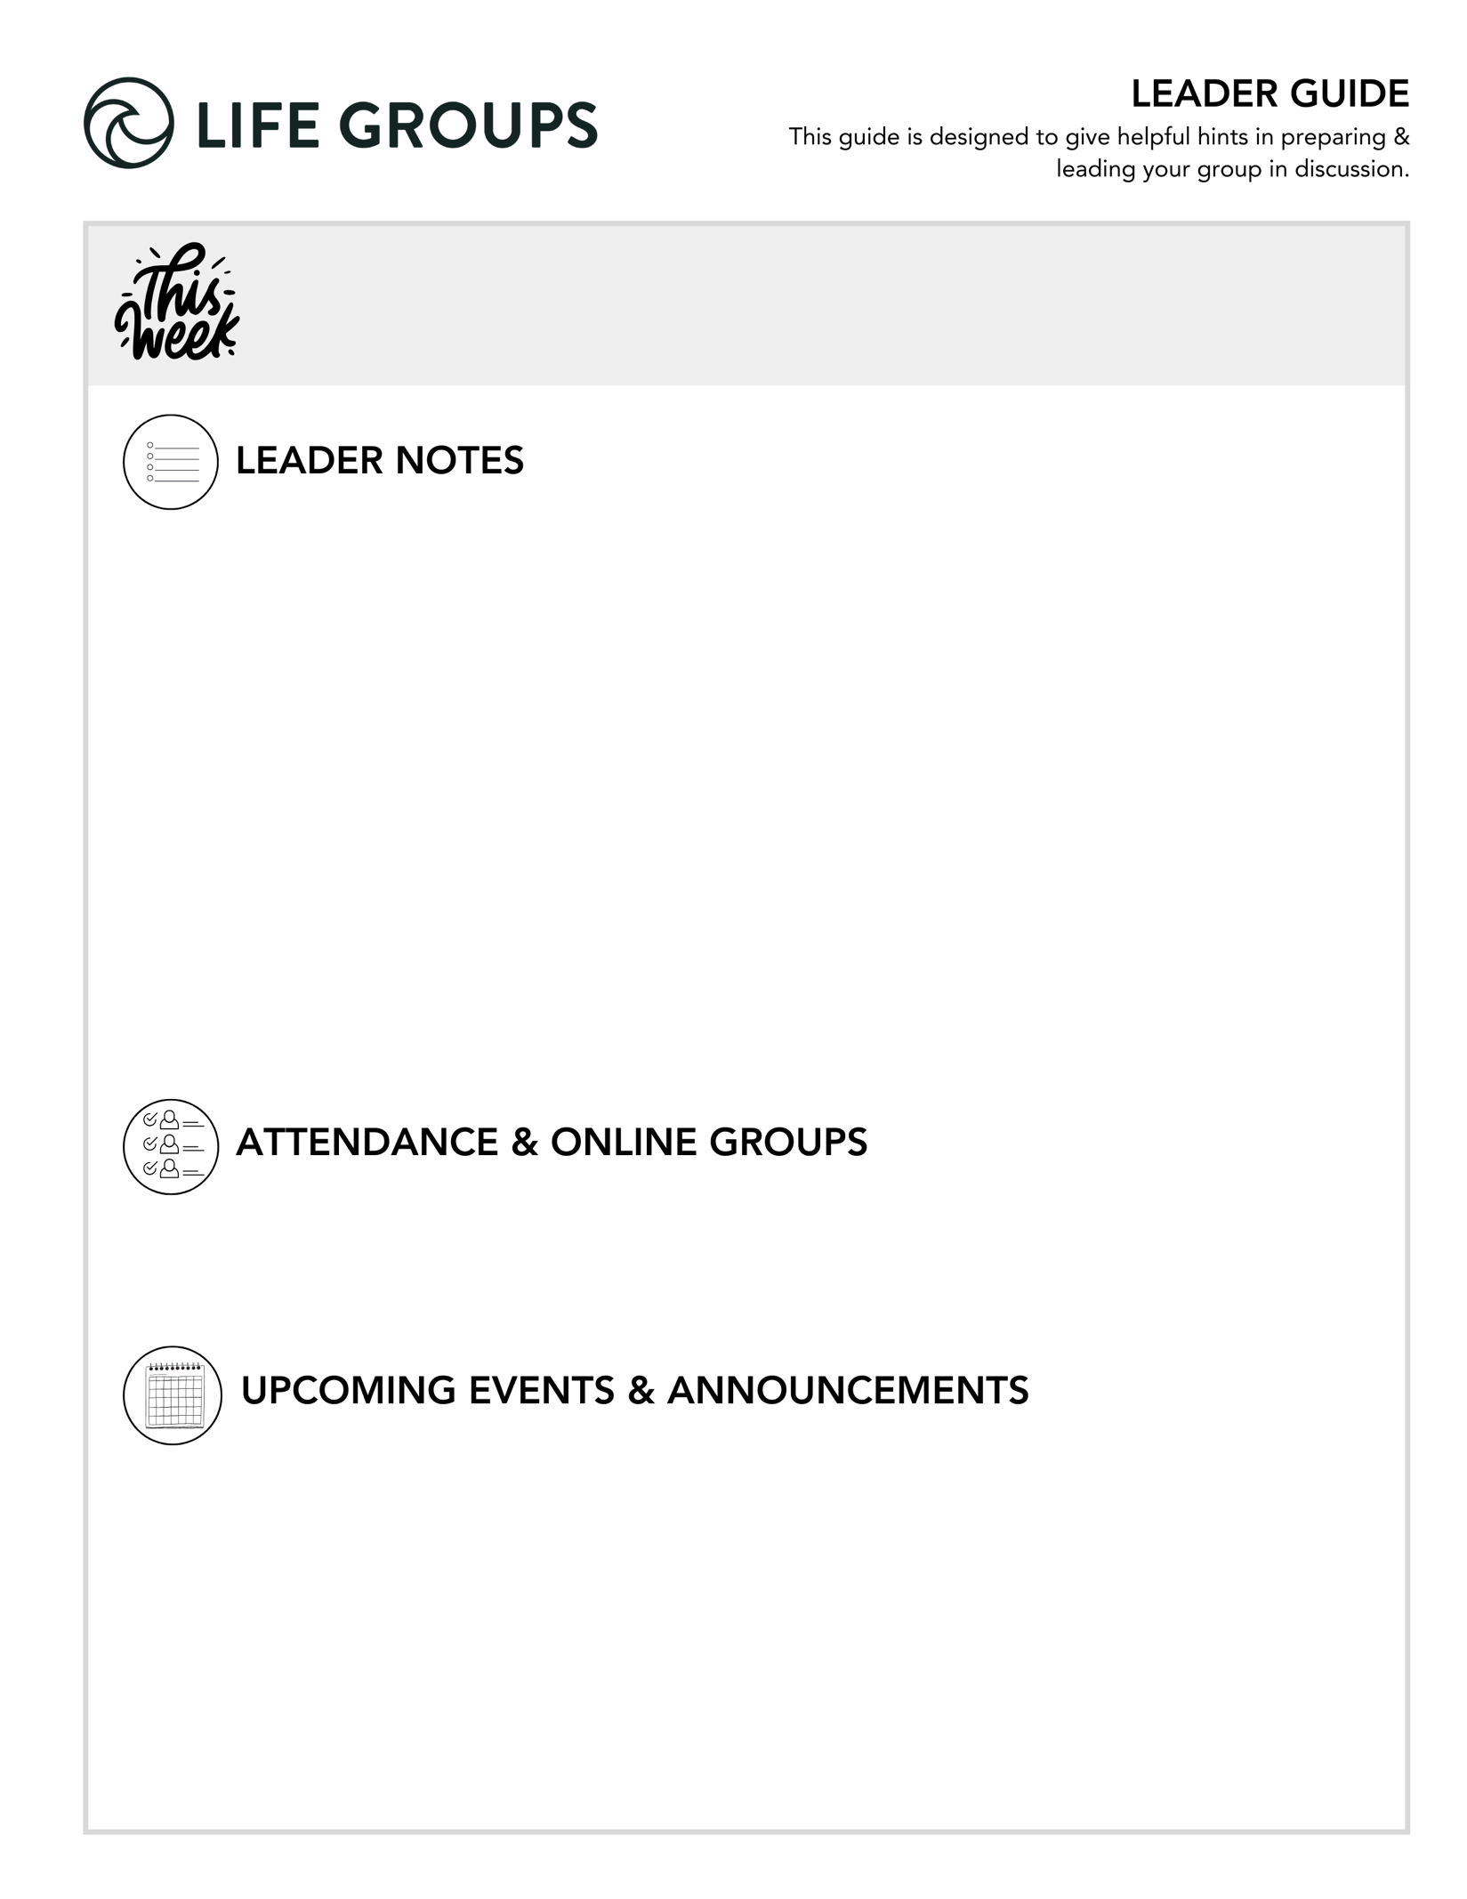

Leader Note
As we wrap up this quarter, we hope it has been a meaningful season for your Life Group. Thank you for the time, care, and faithfulness you’ve invested in creating space for people to grow in their relationship with Jesus and with one another.
Even though this is the final week, we encourage you not to skip the discussion questions. Some of the most meaningful conversations can happen when groups take time to reflect on what God has been doing and how He is continuing to work in each person’s life. Thank you for leading so faithfully this quarter. What you’re doing matters!

Communion
Jesus wants us to remember what He has done for us and that He is here to walk through life with us. That’s why He told the disciples at the Last Supper to keep coming together and taking Communion. Communion is about remembering all that Jesus accomplished through His death and resurrection. It’s through His sacrifice that we receive His grace and mercy.

This week, your Life Group will wrap up by doing what the disciples did - taking Communion together. To get ready for this, read the following verses and think about Jesus’ commitment and work in your life. Jot down a few thoughts on how each verse impacts you.

Romans 5:7-8

John 15:12-17

1 Corinthians 11:23-27

Roster Confirmations and Feedback forms
Ask your group about their plans for the spring quarter and let us know when you turn in your roster confirmation. Also take some time and ask your group to fill out the feedback form- this is a huge help to the ministry.

Spring Quarter Dates
This is the last week of the Winter Quarter. Life Groups will take a two-week break from March 15 – March 29 and Spring Quarter is March 29 – May 23.

- Ready to Make an Impact? – Each Life Group quarter we invite all of our Life Groups to make an impact through serving together with one of our Local Impact partners. Has your Life Group picked an Impact Project yet? From packing toiletry kits and sack lunches to hosting bingo nights at the senior center, building beautification, meal delivery and so much more, the North Coast Impact website has hundreds of service opportunities in your area! Learn more in the North Coast Church app or at northcoastchurch.com

LEADER DISCUSSION GUIDE
_____________________________

WARM UP

1. The disciples were slow to understand Jesus’ mission and needed a lot of re-teaching. When is a time you tried something new that took a long time to learn? Maybe a subject in school, a hobby, or a new job? Did you stick with it or move on?

2. For many of us, this weekend’s passage is one of the most difficult and confusing in the Bible. Was there any part that you found challenging or encouraging? Did it change how you view Jesus, faith, or the people He chose to serve?
- Conversational Caution: The story of the Canaanite woman may bring up sensitive experiences like unanswered prayer, silence from God, and discouragement. Be alert! You may need to protect the safety you have helped create through discussion over the last 8 weeks.


KNOW IT

1. Read Luke 18:1–8. Reflecting on the Canaanite woman in Matthew 15 and the persistent widow in Luke 18, how do these women challenge and deepen our understanding of persistent prayer? What do their boldness and refusal to give up teach us about faith when God seems silent or distant?
- Conversational Caution: There is most likely pain connected to some of the unanswered prayers of your group. Unanswered prayers for healing, restoration within a relationship, or a prodigal child are extremely painful. Be careful that no one implies that persistence guarantees a desired answer.

2. As we heard this weekend, Jesus explicitly calls someone’s faith “great” only twice: the Roman centurion in Matthew 8, and the Canaanite woman in Matthew 15. Both belonged to groups in conflict with Israel and were looked down on in their society. What does it say about Jesus that He chose to recognize, heal, and honor the most reviled and rejected among them?
- Additional Questions: What barriers might have discouraged these individuals from approaching Jesus? Are there people today whose faith might surprise us?


SHARE IT

1. The Pharisees were baffled and offended by Jesus’ care for outsiders and His disregard for the traditions of man (Matthew 9:10-13, 12:1-2, 12:9-14, 12:38-39, 15:1-3). Have you ever been surprised or even unsettled by God’s grace toward someone you didn’t think deserved it? Since we are commanded to love our enemies (Matthew 5:44), how would it feel to pray for God to bless and heal those who frustrate or upset you?
Conversational Caution: This is a high-risk question that puts a spotlight on the daily friction you and I face as a disciple: extending grace to those we struggle to love. Don’t allow your group to camp in judgement or resentment. Guide them to reexamining God’s grace and its power to reshape our hearts and transform our reactions to our enemies.

2. Jesus went 50 miles out of His way to show the true reach of His redemptive love by healing the Canaanite woman’s daughter. Share 2-3 ways God has gone out of His way for you.
Additional Thought: This is an important question and could become a pivotal part of your overall discussion. This question promotes spiritual reflection by giving your group the opportunity to share God’s faithfulness and to remember His work in their lives.
Additional Verse: Luke 19:12 - For the Son of Man came to seek and to save the lost.
Group Dynamic Tip: If discussion stalls, invite people to think about different parts of their life:
- Before they started following Jesus
- Difficult season, trial, or hardship
- Unexpected provision (help, encouragement, wisdom)
- Moment of conviction (something they needed to change)
- Life redirected (a significant change of plan)


LIVE IT

1. Think about something you’ve prayed for that never received an answer, or that got an answer you didn’t want. In other words, a time when you felt like you were getting the silent treatment from Jesus. In light of this study, how can you surrender that situation or feeling to God this week?
Group Dynamic Tip: Consider giving a moment of quiet reflection before your group answers this question.
Additional Thought: This question invites your group to recognize that faith includes seasons of uncertainty. Scripture is full of faithful people who experienced:
- waiting
- silence
- unanswered prayer
Yet their faith deepened through those seasons. The goal is not to attempt to determine the reason for God’s silence in one’s life, but to hopefully assist them in how to bring disappointment honestly before God.

2. This week, your Life Group will take communion. The bread represented Jesus’ body and the wine His blood (1 Corinthians 11:23-26). The Canaanite woman came for crumbs, yet Jesus gave her (and us) the fullness of Himself. As you take communion, remember: He offers not crumbs, but all of Himself.

Pastor Chris Brown
March 7-8, 2026
Message #40 / Matthew 15:21-28

northcoastchurch.com/sermons

What To Do When Jesus Seems Unloving?

The Jesus many don’t want to talk about:
Matthew 15:21-28, 8:5-13, Luke 18:1-8

Mercy is NOT GETTING what I DO DESERVE.

What does this mean for me?
Matthew 15:21-28, Micah 6:8, Romans 11:11-24, Ephesians 2:11-22

Great faith will:

Still WORSHIP God before it receives ANSWERS.

Persist in PRAYER and OBEDIENCE when it faces OBSTACLES or SILENCE.

Put its trust in God’s CHARACTER, not the CIRCUMSTANCES.

Never confuse God’s SILENCE with God’s REJECTION.

