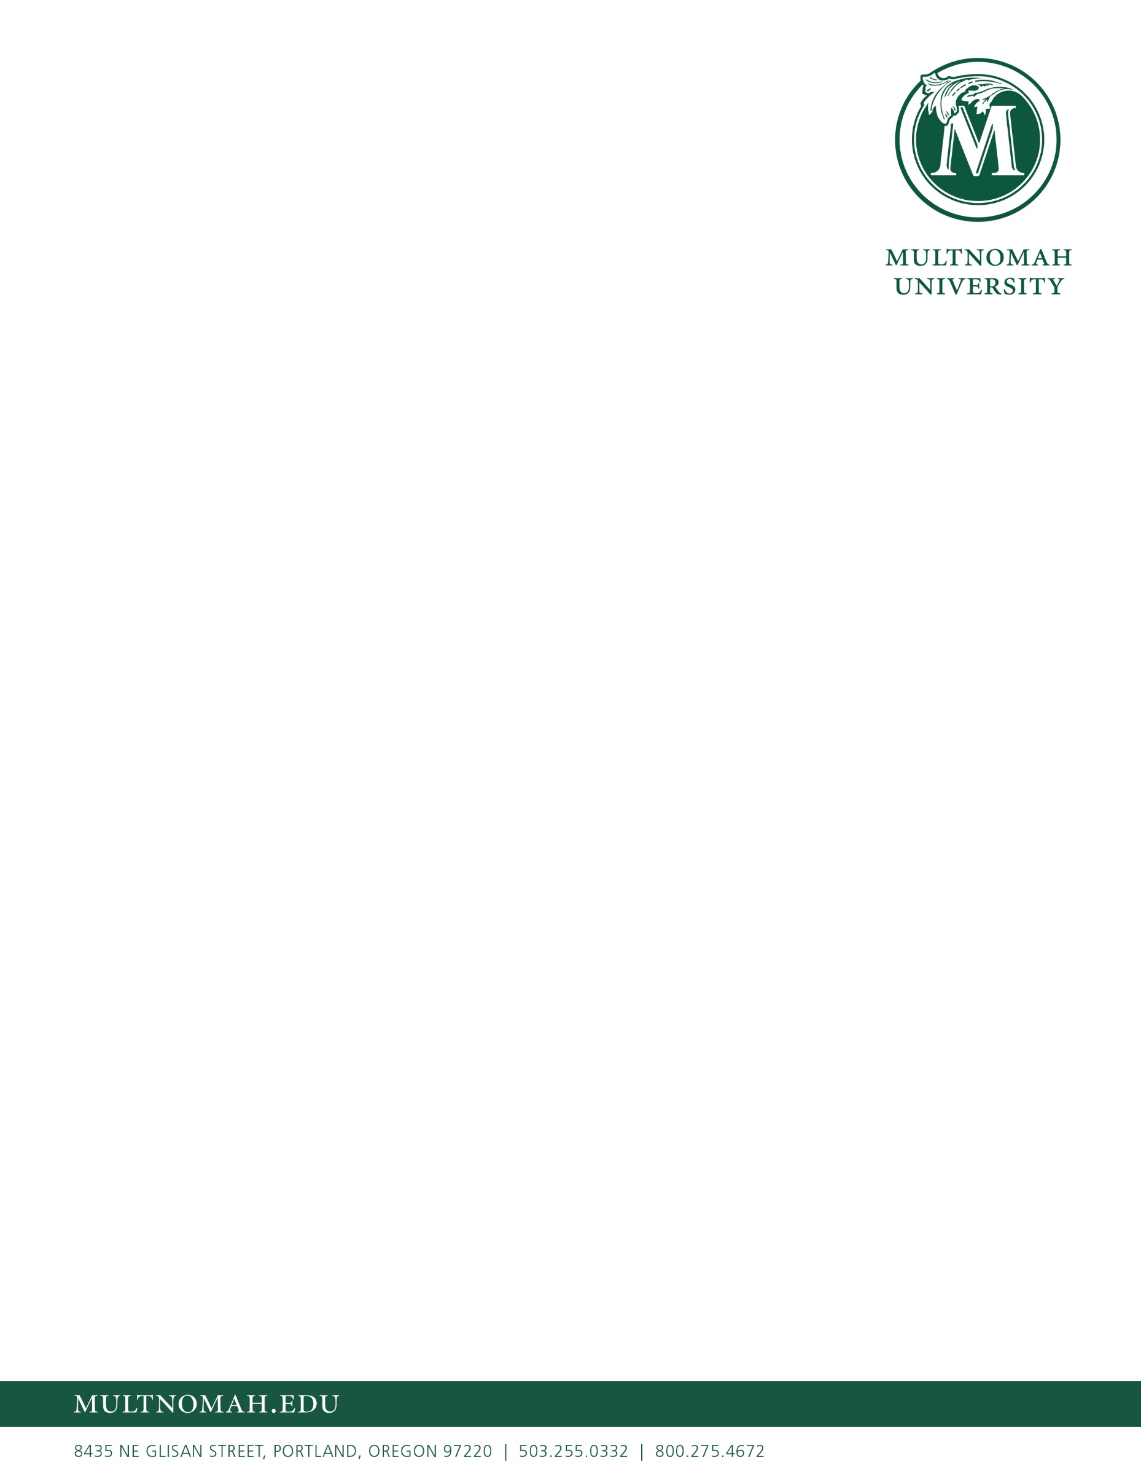

October 2021

Dear Multnomah Community,  
  
The Presidential Search Committee is pleased to report that the search for Multnomah’s next president is going well. Since launching the search in August, we have had a significant response to the [opportunity profile](https://carterbaldwin.com/opportunities/multnomah-pres/). Our partners at CarterBaldwin Executive Search have posted the opportunity to various higher education job boards and sent it out to their extensive networks. Many from the Multnomah community have helped us get the word out as well. This has resulted in over 200 conversations with potential candidates about the position and over 30 who have applied so far.  
  
Later this month, the search committee will meet to review and discuss each applicant. If you know someone you think we should consider, there is still time. Please encourage them to visit the [presidential search webpage](https://www.multnomah.edu/presidential-search/) and follow the instructions about applying as soon as possible.  
  
Would you continue to pray with us as we review applicants this month? We know that the Lord holds Multnomah in His hands. Pray that we would listen well to Him. Our goal is to identify a group of around 8-10 candidates to further interview this fall. Thank you for praying!

**Blessings,**

**Nathan Nymeyer**  
Presidential Search Committee Chair    
(503) 251-5352 |[presidentialsearch@multnomah.edu](mailto:presidentialsearch@multnomah.edu)