Valley Water Stream Maintenance Program Renewal

Background, Purpose, and Need for the SMP-3 Renewal
As stewards of Santa Clara County’s watersheds and hundreds of miles of streams, Valley Water administers the Stream Maintenance Program (SMP or Program) to ensure streams, flood control channels, and related facilities function properly. Valley Water owns and manages approximately 275 miles of streams and channels. Routine maintenance is necessary to reduce flood risks, ensure structural integrity, enhance ecologic function, and improve public safety. Maintenance activities are prioritized and scheduled based on several factors including Board policies; condition assessments; stream maintenance guidelines; regulatory permit requirements; county and municipal code compliance; and Valley Water’s Safe, Clean Water and Natural Flood Protection Program commitments.
The Stream Maintenance Program’s Evolution Over Time
2001: Stream Maintenance Program (SMP-1)*
2011: 2014-2023 Stream Maintenance Program (SMP-2)**

*CEQA EIR certified in 2002
**Subsequent EIR certified in 2012

Valley Water first established the SMP and associated Manual in 2001 (referred to as “SMP-1”) and later updated the Program and Manual in 2011 (referred to as “SMP-2”). The environmental impact report (EIR) for SMP-1 was certified in 2002 and a subsequent EIR (SEIR) for SMP-2 was certified in 2012. Periodic updates to the Program Manual include modifications to maintenance techniques and activities, work limits, best management practices, mitigation approaches, and mitigation monitoring, among other things. The Program Manual is updated to reflect lessons learned, mitigation feasibility, and represents a collaborative dialogue with regulatory agencies and stakeholders. The latest update, “SMP-3” or “SMP Renewal”, will cover activities for the 2024-2033 period. A SEIR will be prepared for SMP-3.

Program Location and Key SMP-3 Updates
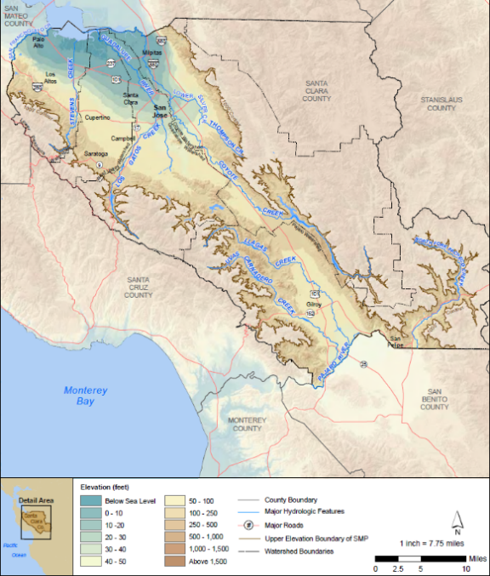
The Program area includes the portions of Santa Clara County below the 1,000 foot elevation contour (see map).

For SMP-3, Valley Water proposes to expand the set of existing maintenance activities covered under SMP-2, shown in bold:
- sediment removal
- vegetation management
- bank stabilization (e.g., to address erosion during high water flows)
- management of animal conflicts
- minor maintenance (e.g., fence installation and repair, trash and debris removal)
- large woody debris management
- routine work at maintenance yards
- hazardous tree management
- trash boom installation and maintenance

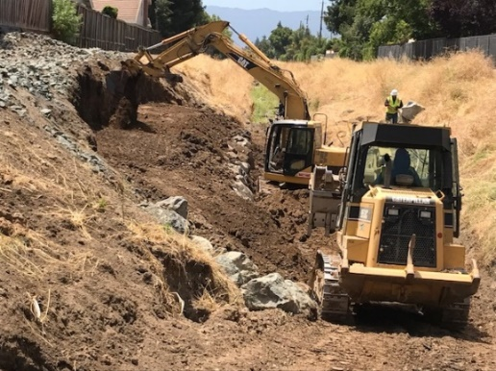
Valley Water proposes to modify the work limits for tree removal activities, revise the list of herbicides and surfactants that may be applied, and modify the bank stabilization limits. Valley Water also plans to expand the Program’s mitigation options to include trash and homeless encampment clean-up activities and payment of impact fees through the Santa Clara Valley Habitat Plan. Additionally, Valley Water seeks to expand the permanent mitigation areas (PMAs) originally established in SMP-1 to offset anticipated future impacts to wetlands and waters of the U.S./State that are not covered under existing PMAs.

Maintenance activities will continue to be conducted in a manner that minimizes impacts to the environment, sensitive species, and habitat. For example, ground-disturbing maintenance activities in the channel will continue to occur during the dry season to avoid and minimize adverse effects on water quality and aquatic species.

Schedule
Below is the current timeline for the SMP-3 Manual, environmental compliance, and permitting processes.

Notice of Preparation (NOP) publication: May 27, 2022
CEQA scoping: May 27-June 27, 2022
Draft SMP-3 Manual and Draft SEIR: Spring 2023
Final SMP-3 Manual and Final SEIR: Fall 2023
Permitting: Spring 2022-Fall 2023

Submittal of Scoping Comments
Written comments concerning the scope and content on the Draft SEIR for SMP-3 are welcome and may be submitted through June 27, 2022. Written comments may be sent via email or letter to:
Santa Clara Valley Water District
Attn: Billy Williams
SMP Renewal Scoping Comments
5750 Almaden Expressway
San Jose, CA 95118

Email: BWilliams@valleywater.org
Subject Line: SMP Renewal Comments

The NOP is available for review at: (insert web link). For relevant Program updates and to get involved, visit:
https://www.valleywater.org/project-updates/stream-maintenance-program

