Wake County Department of Environmental Services
Reduced Oxygen Packaging of Raw MEAT, Raw POULTRY, Cheeses, Raw & Frozen FISH, and/or Raw Vegetables/Cook Chill/Sous-Vide
HACCP Application Packet

Name of Establishment: ____________________________Big Bob’s BBQ___________________

Plan Date: ____________________MM/DD/YYYY___________________________

Address of Establishment: __123 Street Name Raleigh, NC 12345_______________________

Name of Primary Contact: ____John Smith____________________________________________

Email of Primary Contact: __________ILuvFoodSafety@gmail.com______________________

Phone Number of Primary Contact: _____________919-555-5555_______________________

Signature of Primary Contact: __________ John Smith, Executive Chef____________________

____________Big Bob’s BBQ____________
[Name of Establishment(s)-If multiple locations, list all]

____________________________04092019999_________________________________
[Facility ID Number(s)-If multiple locations, list all]

Reduced Oxygen Packaging of Raw Meats
[HACCP Process(es)]

Table of Contents
Intent & Validation | Page 4
Overview of Processes | Page 5
Process Description | Page 6
Flowchart | Page 7
Hazard Analysis | Page 8
Critical Control Points | Page 9
Labeling | Page 10
Verification & Record Keeping Procedures | Page 11
Standard Operating Procedures | Pages 12-37
- Eliminating Bare Hand Contact When Working With Ready-To-Eat Food | Pages 12-13
- Designated Work Area | Page 14
- Cleaning & Sanitizing of Food Contact Surfaces | Pages 15-17
- Food Safety Training Program and Verification | Page 18
- Critical Control Point (CCP) Monitoring Procedures | Page 19
- Records Retention & Review | Page 20
- Corrective Action, Disposal, & General Exceptions | Pages 21-22
- Employee Health Policy | Pages 23-25
- Employee Illness Reporting Agreement | Pages 26-27
- Employee Personal Hygiene Policy | Pages 28-29
- Approved Source | Pages 30-31
- FIFO/Receiving Procedures | Pages 32-33
- Washing Hands | Pages 34-35
- Using & Calibrating Thermometers | Pages 36-37
Monitoring Logs | Pages 38-41
- Labeling | Page 38
- Cold Holding | Page 39
- Corrective Action | Page 40
- Employee Training | Page 41
Equipment Specification Sheets | Pages 42-45
- Food Thermometers | Page 42
- Ambient Air Thermometer | Page 43
- Vacuum Packager | Page 44
- Vacuum Packager Bags | Page 45

Intent

The purpose of vacuum packaging pork shoulders and ribs is to reduce ice crystal formation during freezer storage. This extends our freezer shelf life. In creating a packaging atmosphere with reduced oxygen we limit the growth of spoilage bacteria. This increases our quality but removes common indicators of time/temperature abuse in meat (off color; texture; odor). Reduced oxygen does NOT limit the growth of pathogens and also creates an environment that allows for the growth of Clostridium botulinum which causes botulism and Listeria monocytogenes which is known to cause miscarriage in pregnant women. The intent of this HACCP plan is to control for the growth of pathogens.

Validation

Refrigerated temperatures (41°F) will control the growth and/or toxin production of some pathogens but Clostridium botulinum and Listeria monocytogenes are able to multiply well in refrigeration. For this reason, C. botulinum and L. monocytogenes become the pathogens of concern for Reduced Oxygen Packaging. In controlling for their growth we will control the growth of other foodborne pathogens as well. Raw meat has high levels of competing (spoilage) bacteria. This acts as a secondary barrier to pathogen growth as most foodborne pathogens don’t compete well with other microorganisms. When followed as written, the methods in this plan will control for the growth and/or toxin production of C. botulinum and L. monocytogenes. (Food Code Annex 3, page 432).

Overview of Processes

Menu Item | Process | Ingredients
Beef Ribs | Raw Meat ROP | Beef Ribs
Pork Shoulder | Raw Meat ROP | Pork Shoulder, spices

The intended consumer:
- On-site consumption, general population

Shelf life: 14 days
Vendor: US Foods
Equipment/Materials list: (see attached specification sheets for specialized equipment)
- Walk in cooler
- Walk in freezer
- Food & Ambient Air Thermometers
- Vacuum packer
- Vacuum packer bags

HACCP Team
Owner
General Manager
Kitchen Manager
Shift Leader (Kitchen)

Process of Reduced Oxygen Packaging (ROP) of Raw MEATs:
Ingredients: Raw Pork Shoulder, Beef Ribs, Spices, Marinade
Materials: Vacuum sealer bags, labels
Equipment: Vacuum sealer, walk-in cooler, walk-in freezer
- Receiving of Raw MEATs (1)
  - Pork shoulder and beef ribs to be vacuum packaged must be received at 41°F. If above 41°F it will not be accepted by restaurant operator.
- Cold Storage of Raw MEATs (2)
  - Pork shoulder and beef ribs will be stored below 41°F in the walk in cooler.
- Preparation (3)
  - Pork shoulder and beef ribs will be prepared in small batches to assure temperatures don’t exceed limits (41°F or below), keep items for vacuum sealing in the cooler as long as possible, removing for the shortest period of time possible for packaging (less than 30 minutes).
- Vacuum Packaging (4)
  - Once vacuum sealed, the temperature of the product being packaged must be verified at or below 41°F using properly calibrated thermometer at the time of packaging. Take a temperature reading between two packages, pressing them together on the thermometer probe and record temperature in the Cold Holding Log. If meat is above 41°F either open it up and use it immediately or rapidly chill it to 41°F (within 30 minutes).
- Labeling (5)
  - After product temperature is measured, product is labeled. If product will be frozen the freeze date must be written on label.
- Cold Storage (6)
  - Once vacuum sealed temperature of product must not exceed 41°F.
- Cooking (7)
  - Product pulled for thawing the day prior to cooking, the date the product is pulled from the freezer is written on label. (Pre-freeze and post-thaw dates may not exceed 14 days).
  - Within 14 days product is cooked to at least 145°F.
- Hot Holding (8)
  - Product is held hot at 135°F or above.
- Served To Customer (9)
  - Product is served directly to customer.

NOTE: Any exceptions to the above process must be recorded in appropriate logs.
Flowchart-Reduced Oxygen Packaging (ROP) of Raw MEATs

Hazard Analysis-ROP of Raw MEATs
Process Step | Potential Hazards  (B) Biological  (C) Chemical  (P) Physical | Is this hazard significant? | Justification of Decision | Preventative Measures | Is this step a Critical Control Point (CCP)?
Receiving Raw MEATs  (1) | (B) Clostridium botulinum, Listeria monocytogenes, Clostridium perfringens, Escherichia coli STEC/VTEC, Salmonella, Staphylococcus aureus, Yersinia enterocolita | Yes | Fresh meat and poultry are known to contain pathogens | Meat and poultry will be purchased from approved suppliers and received at proper temps. | No
Cold Storage of Raw MEATs | (B) Clostridium botulinum, Listeria monocytogenes, Clostridium perfringens, Escherichia coli STEC/VTEC, Salmonella, Staphylococcus aureus, Yersinia enterocolita | Yes | Potential Growth or survival of Pathogens | All meat and poultry will be immediately stored in coolers and freezers. | No
Preparation  (3) | (B) Clostridium botulinum, Listeria monocytogenes, Clostridium perfringens, Escherichia coli STEC/VTEC, Salmonella, Staphylococcus aureus, Yersinia enterocolita | Yes | Potential Growth of Pathogens | ROP packaging will be opened prior to cooking and time product will be in the temp. danger zone during assembly - minimized and monitored. | No
Vacuum Packing (4) | (B) Clostridium botulinum, Listeria monocytogenes, Clostridium perfringens, Escherichia coli STEC/VTEC, Salmonella, Staphylococcus aureus, Yersinia enterocolita | No | Potential Growth of Pathogens due to cross-contamination is likely. | Time product will be in the temp. danger zone during assembly will be minimized and monitored. | No
Labeling (5)  CCP #1 | (B) Listeria monocytogenes, Clostridium botulinum, Clostridium perfringens, Escherichia coli STEC/VTEC, Salmonella, Staphylococcus aureus, Yersinia enterocolita | Yes | Improperly Labeled Products will Result in Outdated or Unsafe Products | Each bag with be properly labeled with product name, date packaged, and ‘Use-By’ date | Yes  CCP #1
Cold Storage (6)  CCP #2 | (B) Clostridium botulinum, Listeria monocytogenes, Clostridium perfringens, Escherichia coli STEC/VTEC, Salmonella, Staphylococcus aureus, Yersinia enterocolita | Yes | Potential Growth of Pathogens if Proper Temperatures are Not Maintained. | ROP packaged and labeled products will be monitored for time and temperature control. | Yes  CCP #2
Cooking (7) | (B) Listeria monocytogenes, Escherichia coli STEC/VTEC, Salmonella, Staphylococcus aureus, Yersinia enterocolita, Taenia spp., Toxoplasma gondii, Trichenella spiralis, Hepatitis A | Yes | Survival of Bacterial Spores if Products are not Properly Cooked to Correct Internal Temperatures. | Products will be cooked to the appropriate minimum internal temperatures | No
Hot Holding (8) | (B) Clostridium perfringens, Escherichia coli STEC/VTEC, Salmonella, Staphylococcus aureus, | Yes | Potential Growth of Bacteria and Toxin Production if Proper Temperatures are Not Maintained | Products will be held at 135F or above | No
Served to Customer (9) | Norovirus, Hepatitis A | Yes | If food isn’t handled properly after cooking contamination could occur | Gloves or utensils will be used a barrier. Bare hand contact will be prohibited. | No

Critical Control Points (CCPs) Chart-ROP of Raw MEATs
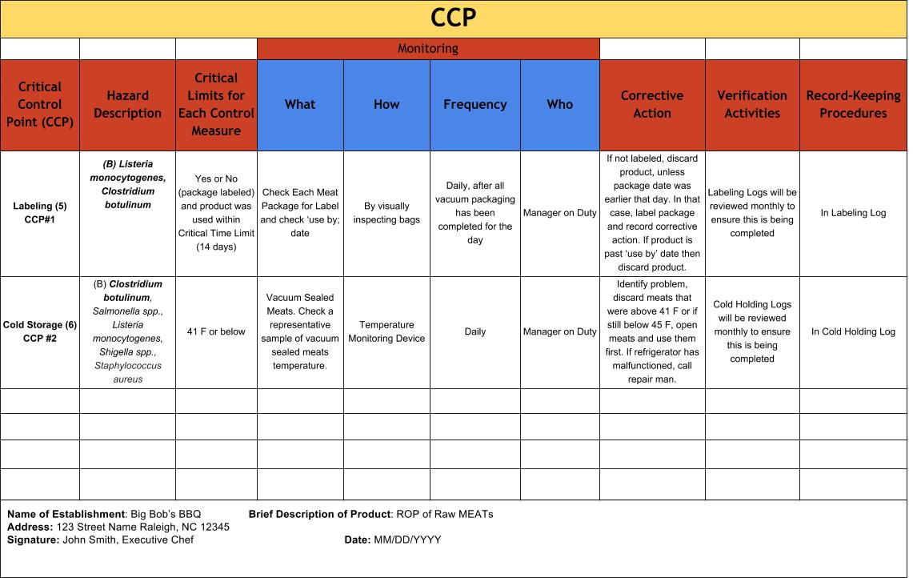

Labeling
Meats, once packaged, will be labeled so the package shall be prominently and conspicuously labeled on the principal display panel in bold type on a contrasting background, with instructions written on label to:
- Maintain the food at 41°F or below, and (b) Discard the food if within 14 calendar days of its packaging it is not served for on-premises consumption, or consumed if served or sold for off-premises consumption
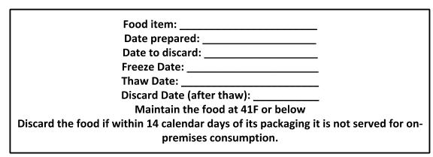

Verification & Record Keeping Procedures
- HACCP team members will verify that the HACCP protocols are being followed as required by routinely observing employees and confirming monitoring logs are being completed.
- Forms and logs will also be reviewed monthly to ensure they are being completed as required.
- HACCP team will review the HACCP plan to determine if modifications are needed
  - Annually
  - When there are emerging concerns about the safety of the product.
  - When foods have been implicated as a vehicle of foodborne disease.
  - To confirm that changes have been implemented correctly after a HACCP plan has been modified.
  - To assess whether a HACCP plan should be modified due to a change in the process, equipment, ingredients, etc.
- Wake County Environmental Services will be notified any time that there is a modification to the HACCP plan
- All completed forms and logs will be maintained in an organized fashion in the HACCP Binder, chronologically, for a minimum of six months, records will be purged as needed during the monthly review.

Standard Operating Procedures: Eliminating Bare Hand Contact When Handling Ready-To-Eat Foods
PURPOSE: To prevent foodborne illness due to hand-to-food cross-contamination.
SCOPE: This procedure applies to foodservice employees who prepare, handle, or serve food.
KEY WORDS: Ready-to-Eat Food, Cross-Contamination
1. READY-TO-EAT FOOD means food that:
- Is in a form that is edible without additional preparation to achieve food safety or a raw or partially cooked animal food and the customer is advised of the hazard.
- Ready-to-Eat Food includes but is not limited to:
  - Animal FOOD that is cooked as required in Cooking and Reheating SOP
  - Raw fruits and vegetables which are thoroughly washed to remove soil and other contaminants.
  - Fruits and vegetables which are cooked and held for hot holding, as required in Cooking and Reheating SOP
  - All potentially hazardous food that is cooked as required in the Cooking and Reheating SOP, and cooled as required in the Cooling SOP.
  - Plant food for which further washing, cooking, or other processing is not required for food safety, and from which rinds, peels, husks, or shells, if naturally present are removed.
  - Substances derived from plants including but not limited to spices, seasonings, and sugar, that will not be cooked.
  - A bakery item including but not limited to bread, cakes, pies, fillings, or icing for which further cooking is not required for food safety.
  - Commercially processed food for which further cooking is not required for food safety.
2. CROSS-CONTAMINATION means the passing of bacteria, microorganisms, or other harmful substances indirectly from one surface to another through improper or unsanitary EQUIPMENT, procedures, or products.
INSTRUCTIONS:
1. Train foodservice employees on using the procedures in this SOP.
2. Follow North Carolina Health regulations.
3. Use proper hand washing procedures to wash hands and exposed arms prior to preparing or handling food or at any time when the hands may have become contaminated. See Washing Hands SOP.
4. Do not use bare hands to handle ready-to-eat foods at any time.
5. Use suitable utensils when working with ready-to-eat food. Suitable utensils may include:
- Single-use gloves
- Deli tissue
- Foil wrap
- Tongs, spoons, spatulas, and other dispensing equipment

MONITORING:
A designated foodservice employee(s) will visually observe that bare hand contact of ready-to-eat-food is eliminated and that gloves or suitable utensils are used and changed at the appropriate times during all hours of operation.
CORRECTIVE ACTION:
- Retrain any foodservice employee found not following the procedures in this SOP.
2. Discard ready-to-eat food touched with bare hands.

VERIFICATION AND RECORD KEEPING:
The General Manager will verify that foodservice workers are using suitable utensils by visually monitoring foodservice employees during all hours of operation. The designated foodservice employee responsible for monitoring will record any discarded food in the Corrective Action Log. Corrective Action Log is to be kept on file for a minimum of 6 months.
DATE IMPLEMENTED: _______________BY: ___________________________________
DATE REVIEWED: ___________________BY: ___________________________________
DATE REVISED: _____________________BY: __________________________________

Standard Operating Procedures: Designated Work Area
PURPOSE: To prevent cross contamination of designated reduced oxygen packaging area.
SCOPE: This procedure applies to foodservice employees who prepare, handle, or serve food.
DESIGNATED WORK AREA: Vacuum sealer is located on back prep line. The prep table on which it is stored is designated for ROP use only.
CLEANING: Vacuum sealer is washed, rinsed, and sanitized after each species of meat as described in Cleaning and Sanitizing Food Contact Surfaces SOP. Employees will wash hands properly and switch gloves in between each species of meat packaged. Proper cleaning and hand washing will reduce the risk of cross contamination.
TRAINING: Employee may not perform vacuum packaging or work with the equipment unless they have completed ROP HACCP training. If employees are observed not following procedures, they will be retrained. If retraining proves ineffective, they will be removed from vacuum sealer duties. Training courses will be required every 6 months to ensure equipment is being used properly.
VERIFICATION: Manager on duty will periodically monitor designated area throughout their shift to verify that only trained employees are using equipment. When untrained employees are observed using equipment they will be reprimanded.
EMPLOYEE TRAINING LOGS: Make sure to write employee training information in employee training logs so that every manager on duty can easily verify who is trained to use vacuum sealer.
DATE IMPLEMENTED: __________________ BY: _______________________
DATE REVIEWED: _____________________ BY: _______________________
DATE REVISED: _______________________ BY: _______________________

Standard Operating Procedures: Cleaning and Sanitizing of Food Contact Surfaces
PURPOSE: To prevent foodborne illness by ensuring that all food contact surfaces are properly cleaned and sanitized.
SCOPE: This procedure applies to foodservice employees involved in cleaning and sanitizing food contact surfaces.
INSTRUCTIONS:
1. Train foodservice employees on using the procedures in this SOP.
2. Follow state and local health department requirements.
3. Follow manufacturer’s instructions regarding the use and maintenance of equipment and use of chemicals for cleaning and sanitizing food contact surfaces
4. Wash, rinse, and sanitize food contact surfaces of sinks, tables, equipment, utensils, thermometers, carts, and equipment:
- Before each use
- Between uses when preparing different types of raw animal foods, such as eggs, fish, meat, and poultry
- Between uses when preparing ready-to-eat foods and raw animal foods, such as eggs, fish, meat, and poultry
- Any time contamination occurs or is suspected
5. Wash, rinse, and sanitize food contact surfaces of sinks, tables, equipment, utensils, thermometers, carts, and equipment using the following procedure:
- Wash surface with detergent solution.
- Rinse surface with clean water.
- Sanitize surface using a sanitizing solution mixed at a concentration specified on the manufacturer’s label.
- Place wet items in a manner to allow air drying.
6. If a 3-compartment sink is used, setup and use the sink in the following manner:
- In the first compartment, wash with a clean detergent solution at or above 110 ºF or at the temperature specified by the detergent manufacturer.
- In the second compartment, rinse with clean water.
- In the third compartment, sanitize with a sanitizing solution mixed at a concentration specified on the manufacturer’s label or by immersing in hot water at or above 171 ºF for 30 seconds. Test the chemical sanitizer concentration by using an appropriate test kit.

7. If a dishmachine is used:
- Check with the dishmachine manufacturer to verify that the information on the data plate is correct.
- Refer to the information on the data plate for determining wash, rinse, and sanitization (final) rinse temperatures; sanitizing solution concentrations; and water pressures, if applicable.
- Follow manufacturer’s instructions for use.
- Ensure that food contact surfaces reach a surface temperature of 160 ºF or above if using hot water to sanitize.

MONITORING:
Foodservice employees will:
1. During all hours of operation, visually and physically inspect food contact surfaces of equipment and utensils to ensure that the surfaces are clean.
2. In a 3-compartment sink, on a daily basis:
- Visually monitor that the water in each compartment is clean.
- Take the water temperature in the first compartment of the sink by using a calibrated thermometer.
- Test the sanitizer concentration by using the appropriate test kit for the chemical.
3. In a dishmachine, on a daily basis:
- Visually monitor that the water and the interior parts of the machine are clean and free of debris.
- Continually monitor the temperature and pressure gauges, if applicable, to ensure that the machine is operating according to the data plate.
- Check the sanitizer concentration on a recently washed food-contact surface using an appropriate test kit.

CORRECTIVE ACTION:
- Retrain any foodservice employee found not following the procedures in this SOP.
- Wash, rinse, and sanitize dirty food contact surfaces. Sanitize food contact surfaces if it is discovered that the surfaces were not properly sanitized. Discard food that comes in contact with food contact surfaces that have not been sanitized properly.

- In a 3-compartment sink:
- Drain and refill compartments periodically and as needed to keep the water clean.
- Adjust the water temperature by adding hot water until the desired temperature is reached.
- Add more sanitizer concentrate or water, as appropriate, until the proper concentration is achieved.
- In a dish machine:
- Drain and refill the machine periodically and as needed to keep the water clean.
- Contact the appropriate individual(s) to have the machine repaired if the machine is not reaching the proper wash temperature indicated on the data plate.
- Check the level of sanitizer remaining in bulk container. Fill, if needed. “Prime” the machine according to the manufacturer’s instructions to ensure that the sanitizer is being pumped through the machine. Retest. If the proper sanitizer concentration level is not achieved, stop using the machine and contact the appropriate individual(s) to have it repaired. Use a 3-compartment sink to wash, rinse, and sanitize until the machine is repaired.

VERIFICATION AND RECORD KEEPING:
Foodservice employees will record any corrective action taken on the Corrective Action Log. The General Manager will verify that foodservice employees have taken the required temperatures and tested the sanitizer concentration by visually monitoring foodservice employees during the shift. The log will be kept on file for at least 6 months.
DATE IMPLEMENTED: __________________ BY: _______________________
DATE REVIEWED: _____________________ BY: _______________________
DATE REVISED: _______________________ BY: _______________________

Standard Operating Procedures: Food Safety Training Program and Verification
Big Bob’s BBQ will have an on-going process in place for verification that the food safety program is operating as intended and effectively controlling risk factors. A member or members of the HACCP team will:
- Hold HACCP training as needed to accommodate new employees and at least every 6 months and require employees to complete HACCP training at least every 6 months.
- Observe employees performing tasks, especially at critical control points (CCPs) (labeling and cold holding).
- Establish appropriate verification inspection schedules.
- Check CCP and monitoring log records. Review critical limits to verify that they are adequate to control hazards.
- Check corrective action records to review deviations and their resolutions.
- Check process and finished product. Check equipment calibration records.
- Verify accuracy of equipment that continuously monitors temperatures, such as freezers and refrigerators.
- Review the entire food safety program quarterly. Review hazard analyses and related CCPs. Review written record of verification inspections.
- Validate food safety program through on-site review and verification of the flow diagrams and CCPs.
- Review modifications of the food safety program, ensuring that the training for reduced oxygen packaging operators is complete for them to understand the concepts required for safe operation of the equipment and procedures.
- Review and Sign Employee Health Policy Agreement. (attached behind the SOP’s)
- Have each employee sign Employee Training Log as they complete training.

DATE IMPLEMENTED: __________________ BY: _______________________
DATE REVIEWED: _____________________ BY: _______________________
DATE REVISED: _______________________ BY: _______________________

Standard Operating Procedures: Critical Control Point (CCP) Monitoring Procedures
Purpose: To monitor critical control points and control food hazards.
Critical Control Points: Labeling, Cold Holding Temperatures (once raw meats are vacuum packaged)
What: Labeling and Cold Holding CCPs will be monitored daily to ensure food safety.
- Labeling: Check each meat package for label, at least daily
- Cold Holding: Temperature of vacuum packaged product
How:
- Labeling: By visually inspecting bags, daily
- Cold Holding: Using a calibrated thermometer, to measure the temperature in between two packages of vacuum packaged meat
Frequency:
- Labeling: Daily, after all vacuum packaging has been completed for the day
- Cold Holding: After each package is sealed and daily to ensure temperatures do not rise above 41°F
Who:
- Labeling: Manager on Duty or HACCP Team Member
- Cold Holding: Manager on Duty or HACCP Team Member
CORRECTIVE ACTIONS: It will be verified that corrective actions are taken as required by reviewing CCP monitoring logs daily and by observing staff complete logs/verification procedures. If CCPs are not being adequately monitored employees will be reprimanded and retrained. Adulterated food will be discarded and all exemptions will be recorded.
DATE IMPLEMENTED: __________________ BY: _______________________
DATE REVIEWED: _____________________ BY: _______________________
DATE REVISED: _______________________ BY: _______________________

Standard Operating Procedures: Records Retention & Review
Verification Procedures
Maintaining proper HACCP records is an essential part of the HACCP system. Records must be kept a minimum of 6 months, in an orderly fashion.
Purpose: It serves as written documentation for potentially serious situations. It allows us to trace ingredients or narrow the scope of a recall, should problems arise, and it helps identify trends and correct them in a timely fashion – or before a problem develops. It also helps new members learn the HACCP system quickly and effectively.
Bi-annual review of all HACCP procedures will be held by the HACCP Team.
1) Validation:
Test that the processes in all portions of the HACCP plan are accurate and up to date and properly followed.
2) Verification:
Assure that all required information is written down and documented. This includes corrective action logs, CCP charts, and all monitoring logs.
3) Reassessment:
Consider potential new hazards. Examine changes in the preparation, raw materials or raw ingredients, personnel, packaging of the finished product, or any other changes that could affect the risk factor control. Notify Health Department of any changes in the HACCP plans.
4) Year End:
Bi-annually, the Executive Chef will redistribute the HACCP Plan, Health & Safety Training Manual, logs, and hold a new training class.
DATE IMPLEMENTED: __________________ BY: _______________________
DATE REVIEWED: _____________________ BY: _______________________
DATE REVISED: _______________________ BY: _______________________

Standard Operating Procedures: Corrective Action, Disposal, & General Exceptions
PURPOSE: To establish a system that allows and promotes rapid response to deviations from a critical limit; Correct and eliminate the cause of the deviation and restore process control; Maintain accurate documentation and records; and Identify affected product and determine appropriate disposition.
SCOPE: This procedure applies to foodservice workers.
INSTRUCTIONS:
- Stop the process, and segregate affected product.
- Adjust process to bring the CCP back under control and correct the cause of the deviation, if this relates to a CCP
- Document and record the action(s) taken
- Consult with the HACCP team (and any others deemed appropriate).
- Conduct a product disposal analysis
  - Determine if the product presents a safety hazard. This may involve expert evaluation of product sampling and testing.
  - If no hazard exists release the product
  - If a potential hazard exists, determine whether the product can be reworked (e.g., recooked, repackaged, reconditioned)
- If the product presents a hazard and cannot be reworked, it must be disposed of. Products requiring disposal will be placed in the trash, unpackaged and denatured with bleach. Discarded product will be recorded in the Corrective Action Log.
- Determine whether modification of the HACCP plan is necessary.
- Notify Wake County Environmental Services of any modifications to the HACCP plan.
MONITORING:
Deviations from a critical limit will be recorded in the Corrective Action Log (attached) and will be maintained on file for a minimum of six months.

CORRECTIVE ACTION:
Corrective actions are listed in the CCP chart for CCPs. Other Corrective Actions should be ascertained on a case-to-case basis and discussed with Manager On Duty. Once a Corrective Action has been identified to correct a problem, it MUST be recorded in the Corrective Action Log.
VERIFICATION AND RECORD KEEPING:
Deviations from a critical limit or from the HACCP plan will be recorded in the Corrective Action Log (see attached) and will be maintained on file for a minimum of six months.
GENERAL EXCEPTIONS:
General Manager will maintain a Corrective Action log where all procedural variations and corrective actions are logged by a HACCP Team member as general exceptions occur. The General Manager will review these weekly and implement appropriate actions as needed. Critical Exceptions must be handled immediately. Immediate need, will receive immediate action, by any member of the trained HACCP Team. In the case of an exception:
- The issue must be logged, recording the date, time, explanation, and severity of the issue in Corrective Action Log (ATTACHED).
- In serious exceptions contact the General Manager immediately.
- Steps must then be taken by the HACCP Team to ensure that the problem is resolved/corrected.
- Further discussion and training may be required to prevent future exceptions.
- If equipment repair is needed, contact repair team immediately.
- If a process has frequent general exceptions, HACCP process may need to be re-evaluated to prevent hazards more effectively.
- Corrective Action Logs must be kept for at least 6 months. All general exceptions MUST be recorded in Corrective Action Logs.

DATE IMPLEMENTED: _______________BY: ___________________________________
DATE REVIEWED: ___________________BY: ___________________________________
DATE REVISED: _____________________BY: __________________________________

Standard Operating Procedure: Employee Health Policy

PURPOSE: To institute a system that identifies employees who present a risk of transmitting disease through food being prepared and restricts or excludes those employees to prevent foodborne illness.
SCOPE: This procedure applies to all persons who may be a Person in Charge (PIC)
INSTRUCTIONS:
- Train all food employees that may be a Person in Charge (PIC) on using the procedures in this SOP

- Become familiar with and recognize diseases that are transmitted by foods, in particular, the ‘Big 6”
- Norovirus
- Salmonella typhi (typhoid fever)
- Salmonella (non-typhoidal Salmonella)
- Shigella spp. infection
- E. coli infection (Escherichia coli 0157:H7 or other EHEC/STEC infection)
- Hepatitis A

- Become familiar with the common symptoms of illnesses that can be easily spread by food

- Diarrhea
- Sore throat with fever
- Vomiting
- Discharges from the eyes, nose, and mouth
- Infected wounds and boils
- Jaundice

- Inform employees of reporting requirements regarding their health. Food employees will be notified of their legal responsibility to report illnesses and symptoms to the person in charge by the reading and completion of form 1B (attached) which will be kept on file in the office. Form 1B will also be posted in a conspicuous area and employees will be made aware of its placement for their reference.

- Exclude, or prevent from working, food workers that are

- symptomatic with vomiting or diarrhea and diagnosed with an infection from Norovirus, Shigella spp., E. coli EHEC/STEC, or nontyphoidal Salmonella
- Diagnosed with an infection from Hepatitis A within the previous 14 days (symptomatic or asymptomatic)
- Diagnosed with an infection from Salmonella typhi with the past 3 months (symptomatic or asymptomatic)
- jaundiced, and the onset of the jaundice occurred in the last 7 days.
- suffering with vomiting or diarrhea within the last 24 hours

- Restrict food employees in the food establishment from working with exposed food; clean equipment; utensils and linens; and unwrapped single service and single-use articles if the food employee

- Has been diagnosed with but are asymptomatic for Shigella spp, E. coli STEC, nontyphoidal Salmonella, or Norovirus
- is suffering from sore throat with fever,
- has discharges from the eyes, nose, and mouth
- has a lesion containing pus, such as a boil or infected wound that is open or draining and cannot be properly covered

- Reinforce and ensure compliance with the following SOPs for all food employees that report an exposure to one of the ‘Big 6’

- Employee Hygiene SOP
- symptom reporting requirements from form 1B
- Handwashing SOP
- No Bare Hand Contact with Ready to Eat Foods SOP

- Notify the Health Department when an employee is diagnosed with a

- Salmonella typhi,
- Shigella spp.;
- Enterohemmorhagic or Shiga-toxin producing E. coli,
- Hepatitis A,
- Norovirus
- Nontyphoidal Salmonella

- Reinstate affected food workers who are restricted or excluded. Reinstatement will be performed in the following manner:

- Employees excluded or restricted because of any of the “Big 6” or jaundice may only be reinstated with written medical documentation from a health practitioner AND approval from the Health Department.
- Employees excluded due to symptoms of vomiting or diarrhea may be reinstated by the PIC after the employee has been asymptomatic for at least 24 hours, or provides the PIC with written medical documentation from a health practitioner that states the symptom is from a noninfectious condition.
- Employees restricted due to sore throat with fever may be reinstated by the PIC after the Food Employee has had a negative Strep test, has received antibiotic therapy for Streptococcus pyogenes infection for more than 24 hours or is otherwise determined to be free of a Strep infection by a Health Practitioner
- Food employees that exhibit symptoms such as diarrhea; sore throat with fever; vomiting; and, jaundice as a result of a chronic noninfectious condition may be reinstated by the PIC with written documentation from a physician (to be kept on file).
- A restricted food employee who exhibits persistent sneezing, coughing, or runny nose may be reinstated by the PIC once the symptoms cease.

MONITORING:

- PICs will visually observe that employees are not displaying reportable symptoms.
- Employee illness reporting requirements will be reviewed at monthly staff meetings.

CORRECTIVE ACTION:

- Employees observed reporting to work with excludable symptoms will be sent home.
- Reporting requirements will be reviewed with employee upon their reinstatement.

VERIFICATION AND RECORD KEEPING:

If SOPs for Employee Health are not followed, record activities and solutions in Corrective Action Log. Corrective Action Log must be kept for at least 6 months.

DATE IMPLEMENTED: __________________ BY: _______________________
DATE REVIEWED: _____________________ BY: _______________________
DATE REVISED: _______________________ BY: _______________________

Employee Illness Reporting Agreement
Reporting: Symptoms of Illness I agree to report to the manager when I have:
- Diarrhea
- Vomiting
- Jaundice (yellowing of the skin and/or eyes)
- Sore throat with fever
- Infected cuts or wounds, or lesions containing pus on the hand, wrist, an exposed body part (such as boils and infected wounds, however small).
Reporting: Diagnosed Illnesses I agree to report to the manager when I have:
- Norovirus
- Salmonella typhi (typhoid fever)
- Salmonella (non-typhoidal Salmonella)
- Shigella spp. infection
- E. coli infection (Escherichia coli O157:H7 or other EHEC/STEC infection)
- Hepatitis A
Note: The manager must report to the Health Department when an employee has one of these illnesses.
Reporting: Exposure of Illness I agree to report to the manager when I have been exposed to any of the illnesses listed above through:
- An outbreak of Norovirus, typhoid fever, Shigella spp. infection, E. coli infection, or Hepatitis A.
- A household member with Norovirus, typhoid fever, Shigella spp. infection, E. coli infection, or hepatitis A.
- A household member attending or working in a setting with an outbreak of Norovirus, typhoid fever, Shigella spp. infection, E. coli infection, or Hepatitis A.
Exclusion and Restriction from Work If you have any of the symptoms or illnesses listed above, you may be excluded* or restricted** from work. *If you are excluded from work you are not allowed to come to work. **If you are restricted from work you are allowed to come to work, but your duties may be limited.
Returning to Work: If you are excluded from work for having diarrhea and/or vomiting, you will not be able to return to work until more than 24 hours have passed since your last symptoms of diarrhea and/or vomiting. If you are excluded from work for having jaundice (yellowing of the skin and/or eyes), Norovirus, Salmonella Typhi (typhoid fever), Salmonella (non-Typhoidal Salmonella), Shigella spp. infection, E. coli infection, and/or Hepatitis A, you will not be able to return to work until Health Department approval is granted.
Agreement: I understand that I must:
- Report when I have or have been exposed to any of the symptoms or illnesses listed above; and
- Comply with work restrictions and/or exclusions that are given to me. I understand that if I do not comply with this agreement, it may put my job at risk.

Food Employee Name (please print) _________________________________________
Signature of Employee ______________________________________ Date __________
Manager (Person-in-Charge) Name (please print)_______________________________
Signature of Manager (Person-in-Charge) ________________________ Date ________

Standard Operating Procedures: Employee Personal Hygiene Policy
PURPOSE: To prevent contamination of food by foodservice employees
SCOPE: This procedure applies to foodservice employees who handle, prepare, or serve food.
INSTRUCTIONS:
- Train foodservice employees on using the procedures in this SOP.
- Follow State or local health department requirements.
- Follow the Employee Health Policy.
- Report to work in good health, clean, and dressed in clean attire.
- Change apron when it becomes soiled.
- Wash hands properly, frequently, and at the appropriate times.
- Keep fingernails trimmed, filed, and maintained so that the edges are cleanable and not rough.
- Avoid wearing artificial fingernails and fingernail polish.
- Wear single-use gloves if artificial fingernails or fingernail polish are worn.
- Do not wear any jewelry except for a plain ring such as a wedding band.
- Treat and bandage wounds and sores immediately. When hands are bandaged, single-use gloves must be worn.
- Cover a lesion containing pus with a bandage. If the lesion is on a hand or wrist, cover with an impermeable cover such as a finger cot or stall and a single-use glove.
- Eat, use tobacco, or chew gum only in designated break areas where food or food contact surfaces may not become contaminated.
- Employees may drink from a covered beverage container if the container is handled to prevent contamination of the employee’s hand, the container, and exposed food, clean equipment, utensils and linens and unwrapped single service items.
- Taste food the correct way:
  - Place a small amount of food into a separate container.
  - Step away from exposed food and food contact surfaces.
  - Use a teaspoon to taste the food. Remove the used teaspoon and container to the dish room. Never reuse a spoon that has already been used for tasting.
  - Wash hands immediately.
- Wear suitable and effective hair restraints while in the kitchen.

MONITORING:
- A designated foodservice employee will inspect employees when they report to work to be sure that each employee is following this SOP.
- The designated foodservice employee will monitor that all foodservice employees are adhering to the personal hygiene policy during all hours of operation.
CORRECTIVE ACTION:
1. Retrain any foodservice employee found not following the procedures in this SOP.
2. Discard affected food.
VERIFICATION AND RECORD KEEPING:
The General Manager will verify that foodservice employees are following this SOP by visually observing the employees during all hours of operation. Foodservice employees will record any discarded food on the Corrective Action Log. The Corrective Actions Logs are to be kept on file for a minimum of 6 months..
DATE IMPLEMENTED: __________________ BY: _______________________
DATE REVIEWED: _____________________ BY: _______________________
DATE REVISED: _______________________ BY: _______________________

Standard Operating Procedures: Approved Source
PURPOSE: To prevent foodborne illness caused by unsafe food sources.
SCOPE: This procedure applies to managers whose duties include ordering product and foodservice staff.
INSTRUCTIONS:
- Train managers on using the ordering procedures in this SOP.
- Train foodservice workers on recognizing approved products (required labeling).
- Follow North Carolina Health regulations.
- Managers will only order foods that comply with NC Law.
- Grade A milk and milk products from distributors that are willing and able to supply Letters of Guarantee from the suppliers upon request.
- Processed foods from a regulated food processing plant.
- Food service employees will review product to be sure that all meats, game animals, and poultry have a stamp of inspection or Public Law Exemption number on cases or individual packaging.
- All milk and milk products are labeled “Grade A”
- Eggs are in a clean container labeled with the applicable consumer grade (i.e, Grade A), the size or weight class, the word "eggs," the numerical count of the contents name, and address of the packer or distributor Safe Handling Instructions
MONITORING:
Foods will be examined upon receiving for required labeling. Invoices will be kept on file.
CORRECTIVE ACTION:
- Retrain any foodservice employee found not following the procedures in this SOP.
- Set aside for return or discard any foods that do not comply with law.
- Notify the Health Department of any delivered foods that do not meet requirements of the laws.

VERIFICATION AND RECORD KEEPING:
The General Manager will verify that foods are approved by visually examining product. Any product that does not appear to meet the requirements will be set aside and clearly labeled for return to the distributor and review by the health department. All invoices for products received will be kept on file for a minimum of 6 months.

DATE IMPLEMENTED: _______________BY: ___________________________________
DATE REVIEWED: ___________________BY: ___________________________________
DATE REVISED: _____________________BY: __________________________________

Standard Operating Procedure: Receiving/FIFO Policy
All food should be checked for proper conditions as it is received in the facility.
Procedure: Employees receiving food should:
General Principles:
- Receive only one delivery at a time from approved suppliers.
- Check to make sure frozen food is solid, and shows no evidence of thawing and re-freezing.
- Check to ensure that refrigerated foods are received below 41ºF.
- Record the date received on the outside of each package, and a use-by date, if applicable.
- Remove potentially hazardous foods from the temperature danger zone (41ºF to 135ºF) and place in storage as quickly as possible.
- Accept only pasteurized dairy products.
- Reject potentially hazardous foods that are not at acceptable temperature and cans with swelled tops or bottoms, leakage, incomplete labels, flawed seals, rust, or dents.
- Evaluate quality of products by odor, sight, and touch. Reject unacceptable products. Products must meet order specifications and quality requirements. If any foods are deemed unacceptable, they should be rejected and put in a designated area for credit.
Receiving Frozen and Refrigerated Foods:
- Check temperature with a calibrated thermometer to assure that cold foods (especially potentially hazardous foods - foods in which microorganisms are able to grow rapidly, often moist, high in protein, and/or have a neutral or slightly acidic pH) are below 41°F.
- Reject, with the exception of fresh shell eggs (45°F), all foods that should be stored below 41°F that are delivered above 41°F.
- Check at random and record the temperature of three different types of food items immediately for each delivery. Record date, employee initials, vendor, product name, and temperature of these products in the Receiving Temperature Log.
- Place foods in the proper storage area (cooler or freezer) quickly to avoid potential bacterial growth. Proper cooler temperatures are 41ºF or lower. Proper deep chill storage temperatures are from 26ºF to 32ºF or below. Proper freezer temperatures are 0ºF. Proper dry storage temperatures are between 50ºF and 70ºF at 50 to 60 percent humidity.
- Use First In First Out (FIFO) inventory rotation of products in all storage areas to assure that oldest products are used first. Products with the earliest use-by or expiration dates are stored in front of products with later dates.
- Keep products in original packages until use.
Receiving Dry Goods:
- Check dry goods for leaks, flaws, or broken packages. Dry goods should be dry, free of mold, and free of insects. If the packages are flawed, they should be rejected and put in a designated area for credit.
- Inspect cans for leaks, incomplete labels, dents, bulges, and other visible signs of damage. Notify the manager if a damaged can is found.
- Date boxes and cans with receiving date.
- Separate chemicals from foods.
- Check delivery invoice against the items delivered, and the purchase order.
- When damages items are found, the manager or designee should call the distributor so the product can be picked up and returned and a credit issued, or make similar arrangements with delivery personnel. Do not accept delivery.
- Note on the invoice any items rejected.
The General Manager will:
- Assure that all foods come from approved vendors and sources.
- Schedule deliveries for off-peak hours and make sure enough trained staff are available to receive, inspect, and store food promptly.
- Assure that no home-prepared foods are accepted or used.
- Check Receiving Temperature Log (for delivery days) to ensure proper procedures are being followed.
- Follow up with staff as necessary.
- File HACCP records.

DATE IMPLEMENTED: __________________ BY: _______________________
DATE REVIEWED: _____________________ BY: _______________________
DATE REVISED: _______________________ BY: _______________________

Standard Operating Procedures: Washing Hands
PURPOSE: To prevent foodborne illness by contaminated hands.
SCOPE: This procedure applies to anyone who handles, prepares, and serves food.
INSTRUCTIONS:
- Train foodservice employees on using the procedures in this SOP.
- Follow State or local health department requirements.
- Post handwashing signs or posters in a language understood by all foodservice staff near all handwashing sinks, in food preparation areas, and restrooms.
- Use designated handwashing sinks for handwashing only. Do not use food preparation, utility, and dishwashing sinks for handwashing.
- Provide warm running water, soap, and a means to dry hands. Provide a waste container at each handwashing sink or near the door in restrooms.
- Keep handwashing sinks accessible anytime employees are present.
- Wash hands:
  - Before starting work
  - During food preparation
  - When moving from one food preparation area to another
  - Before putting on or changing gloves
  - After using the toilet
  - After sneezing, coughing, or using a handkerchief or tissue
  - After touching hair, face, or body
  - After smoking, eating, drinking, or chewing gum or tobacco
  - After handling raw meats, poultry, or fish
  - After any clean up activity such as sweeping, mopping, or wiping counters
  - After touching dirty dishes, equipment, or utensils
  - After handling trash
  - After handling money
  - After any time the hands may become contaminated
- Follow proper handwashing procedures as indicated below:
  - Wet hands and forearms with warm, running water at least 100 ºF and apply soap.
  - Scrub lathered hands and forearms, under fingernails, and between fingers for at least 10-15 seconds. Rinse thoroughly under warm running water for 5-10 seconds.
  - Dry hands and forearms thoroughly with single-use paper towels.
  - Dry hands for at least 30 seconds if using a warm air hand dryer.
  - Turn off water using paper towels.
  - Use paper towel to open door when exiting the restroom.
- Follow FDA recommendations when using hand sanitizers. These recommendations are as follows:
  - Use hand sanitizers only after hands have been properly washed and dried.
  - Use only hand sanitizers that comply with the 2001 FDA Food Code. Confirm with the manufacturers that the hand sanitizers used meet these requirements.
  - Use hand sanitizers in the manner specified by the manufacturer.
MONITORING:
- A designated employee will visually observe the handwashing practices of the foodservice staff during all hours of operation.
- The designated employee will visually observe that handwashing sinks are properly supplied during all hours of operation.
CORRECTIVE ACTION:
- Retrain any foodservice employee found not following the procedures in this SOP.
- Ask employees that are observed not washing their hands at the appropriate times or using the proper procedure to wash their hands immediately.
- Retrain employee to ensure proper handwashing procedure.
VERIFICATION AND RECORD KEEPING:
If handwashing procedures are out of compliance, corrective action must be taken (such as retraining) and recorded in Corrective Action Log. The General Manager will review the Corrective Action Log daily and they are to be kept on file for a minimum of 6 months.
DATE IMPLEMENTED: __________________ BY: _______________________
DATE REVIEWED: _____________________ BY: _______________________
DATE REVISED: _______________________ BY: _______________________

Standard Operating Procedures: Using & Calibrating Thermometers
PURPOSE: To prevent foodborne illness by ensuring that the appropriate type of thermometer is used to measure internal product temperatures and that thermometers used are correctly calibrated for accuracy.
SCOPE: This procedure applies to foodservice employees who prepare, cook, and cool food.
KEY WORDS: Thermometers, Calibration
INSTRUCTIONS:
- Train foodservice employees on using the procedures in this SOP.
- Follow State or local health department requirements.
- Follow the food thermometer manufacturer’s instructions for use. Use a food thermometer that measures temperatures from 0 ºF (-18 ºC) to 220 ºF (104 ºC) and is appropriate for the temperature being taken. For example:
  - Temperatures of thin products, such as hamburgers, chicken breasts, pizza, filets, nuggets, hot dogs, and sausage patties, must be taken using a thermistor or thermocouple with a thin probe.
  - Bimetallic, dial-faced stem thermometers are accurate only when measuring temperatures of thick foods. They may not be used to measure temperatures of thin foods. A dimple mark located on the stem of the thermometer indicates the maximum food thickness that can be accurately measured.
  - Use only oven-safe, bimetallic thermometers when measuring temperatures of food while cooking in an oven.
- Have food thermometers easily-accessible to foodservice employees during all hours of operation.
- Clean and sanitize food thermometers before each use. Refer to the Cleaning and Sanitizing Food Contact Surfaces SOP for the proper procedure to follow.
- Store food thermometers in an area that is clean and where they are not subject to contamination.
MONITORING:
- Foodservice employees will use either the ice-point method or boiling-point method to verify the accuracy of food thermometers. This is known as calibration of the thermometer.
- To use ice-point method:
  - Insert the thermometer probe into a cup of crushed ice.
  - Add enough cold water to remove any air pockets that might remain.
  - Allow the temperature reading to stabilize before reading temperature.
  - Temperature measurement should be 32 ºF (⁺ 2 ºF) [or 0 ºC (⁺ 1 ºC)]. If not, adjust according to manufacturer’s instructions.
- To use boiling-point method:
  - Immerse at least the first two inches of the probe into boiling water.
  - Allow the temperature reading to stabilize before reading temperature.
  - Reading should be 212 ºF (⁺ 2 ºF) [or 100 ºC (⁺ 1 ºC)]. This reading may vary at higher altitudes. If adjustment is required, follow manufacturer’s instructions.
- Foodservice employees will check the accuracy of the food thermometers:
  - At regular intervals (at least once per week
  - If dropped
  - If used to measure extreme temperatures, such as in an oven
  - Whenever accuracy is in question
CORRECTIVE ACTION:
- Retrain any foodservice employee found not following the procedures in this SOP.
- For an inaccurate, bimetallic, dial-faced thermometer, adjust the temperature by turning the dial while securing the calibration nut (located just under or below the dial) with pliers or a wrench.
- For an inaccurate, digital thermometer with a reset button, adjust the thermometer according to manufacturer’s instructions.
- If an inaccurate thermometer cannot be adjusted on-site, discontinue using it, and follow manufacturer’s instructions for having the thermometer calibrated.
- Retrain employees who are using or calibrating food thermometers improperly.
VERIFICATION AND RECORD KEEPING:
Foodservice employees will any corrective action taken while calibrating thermometers, if applicable, in the Corrective Action Log. The General Manager will verify that foodservice employees are using and calibrating thermometers properly by making visual observations of the employees during the calibration process and all operating hours. The foodservice manager will review and initial the Corrective Action Log daily. The Corrective Action Log will be kept on file a minimum of 6 months.

DATE IMPLEMENTED: __________________ BY: ______________________
DATE REVIEWED: _____________________ BY: _______________________
DATE REVISED: _______________________ BY: ________________________

Labeling Log
 |  | Use-By Date?
Location | Date | Yes | No | Corrective Action (if No) | Initials
Walk-in Cooler | MM/DD/YYYY | ✔ |  |  | JH
Walk-in Cooler | MM/DD/YYYY |  | ✔ | Found 3 bags that were not labeled. Since pack date was unknown, items were discarded. | KC
Walk-in Cooler | MM/DD/YYYY |  | ✔ | Found 5 bags of vacuum packaged meat that were 17 days old (shelf-life is 14 days). Items were discarded. | JH

Cold Holding Log
 | Vacuum sealed meats temp. ≤41°F?
Date | Yes | No | Corrective Action (if No) | Initials
MM/DD/YYYY | ✔ |  |  | JH
MM/DD/YYYY |  | ✔ | Vacuum sealed meats were 45°F. All meats that were vacuum packaged were opened. Walk-in cooler repair man was called. | KC
Corrective Action Log
Date | HACCP Plan Issue | Corrective Action Taken | Initials
MM/DD/YYYY | Employee working vacuum sealer was not cleaning in between species of meat. | Retrained employee to follow SOPs for proper cleaning and sanitization of equipment. | KC
Employee Training Log
Date | Employee Name | Trainer Name | Initials
MM/DD/YYYY | Jane Doe | John Smith, Executive Chef | JS

Food Thermometer Specification

Digital Pocket Test with Temperature Alarm
Model #: DFP450W
Our DFP450W Digital Pocket Test with adjustable Temperature Alarm was specifically designed for the harshest foodservice environments. The Instrument can be programmed to provide a visual alarm (blinking display) once the set temperature is reached. The initial default alarm temperature is 140oF (60oC). Potentially hazardous mercury thermometers are often used to check the extreme water temperature of commercial dish water. Eliminate the risk of a mercury spill; the DFP450W stores the maximum heat registered and is waterproof. Guaranteed Accurate for Life means there is no need of field adjusting of calibration settings and no risk of introducing error into the instrument.
Product Specifications
Auto Off | After 10 minutes of non use
F/C Switchable | Yes
Certifications | NSF, CE, WEEE, RoHS
Warranty | Lifetime warranty
Response Time | Reduced tip for delicate products and quick (<6 seconds) response time.
Calibration | Accurate for Life
Features | Maximum and Minimum Temperature Memory, plus Hold Mode
Alarm | Adjustable Temperature Alarm
Temperature Range | -40° to 450°F (-40° to 232°C)
Temperature Accuracy | ±2°F (1°C)
Resolution | 0.1°
LCD Height | .25" (6.35cm)
Waterproof Rating | IPX7 Waterproof Rating - Dishwasher Safe
Housing Material | Anti-microbial additive
Sensor Type | Thermistor
Shaft Length | 4.75" (121mm), .75" (19mm) tip
Shaft Diameter | 0.046" (1.19 mm) at Sensor
Battery Type | 1.5v LR44
Battery Life | 500 hrs
Weight | 0.7 oz
Dimensions | 1 5/16" x 3/4" x 6 1/4" (33.3 mm x 19 mm x 158.8 mm) (w/sheath)

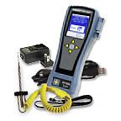
Ambient Air Thermometer

HACCP Manager Kit
Model #: 93710
The HACCP Manager Kit provides the software, hardware and PC interface for the collecting, reporting, analyzing and storing of product temperature records and checklist documentation. The Handheld is a data-collecting instrument designed to simplify the gathering of temperatures and the documentation of corrective actions as well as managing standard checklist processes. The database software allows for customizing up to 300 menu items and the Handheld can store up to 3000 temperature readings, 1500 checklist records (150 questions).
Product Specifications
Kit Includes | Handheld (37100), MicroNeedle Probe (50209-K), Battery Charger (9382), USB Cable (9383), Software CD-ROM (9384), Soft Carrying P
Certifications | CE, WEEE, RoHS, Traceable to standards of NIST
Total System Accuracty | ±2°F (±1°C) Handheld and 50209-K MicroNeedle Probe (when validated in a properly constructed ice bath)
Accuracy | ±1°F (±0.5°C) or ±0.2% of reading
Response Time | 1 second (liquid)
Ambient Operating Range: | 32° to 122°F (0° to 50°C)
Housing | ABS Plastic with rubber boot with probe storage slot
Temperature Range | -100° to 500°F (-73° to 260°C) w/50209-K Probe
Warranty | Five-year instrument warranty, One year probe. One year rechargeable battery
Battery | Rechargeable lithium ion battery (8 hr.)
Waterproof Rating | Water resistant
Checklist Feature | Stores 1500 checklist records (150 questions)

Vacuum Sealer-The Vacmaster packaging machine
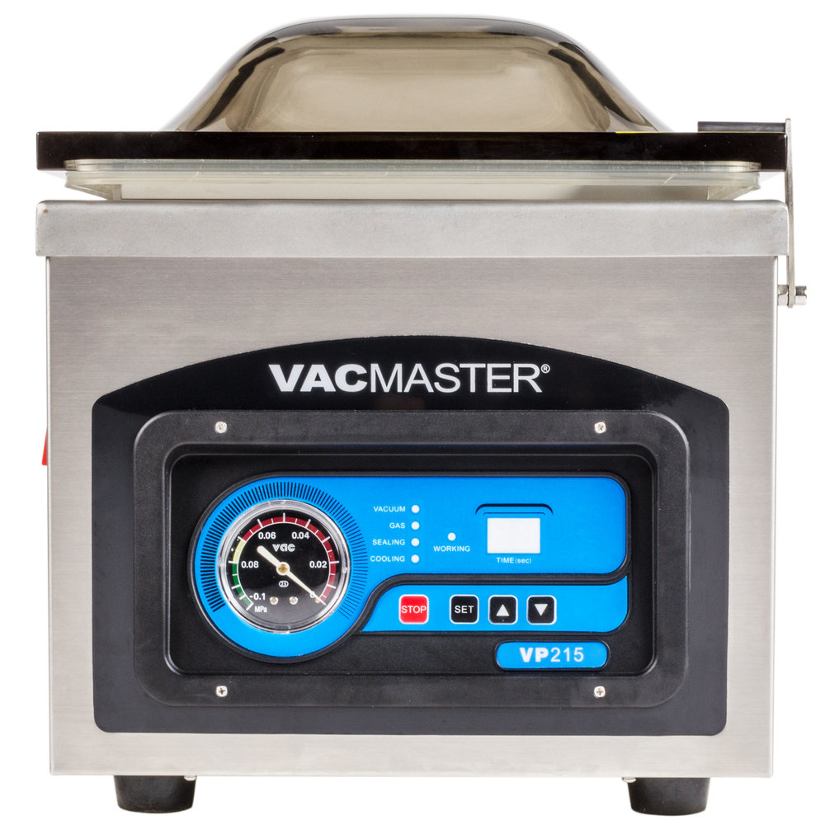

The Vacmaster VP215 chamber vacuum packaging machine provides all the great features of the VP210, but with added power! It can apply up to 29 3/4"Hg of suction, when most competitors' models can only reach 26" at most! This powerful tabletop chamber vacuum package machine is ideal for liquids and liquid-rich foods since air is sucked out of the entire chamber when sealing, not just the bag itself. By doing so, the air pressure is equalized both inside and outside of the bag, keeping liquids in and ensuring a superior seal every time.
The Vacmaster vacuum packer features a 1/4 hp oil pump and a 10" wide double seal wire for optimum results and long-lasting use. It's easy to use and clean too, thanks to its crystal clear digital display and stainless steel construction. The smoky-clear lid makes it easy to see and monitor the vacuum process. This unit works best with soups, stews, and marinades, and can keep game meat and fish fresh over a long period of time. By storing meats scent-free, users can preserve their favorite dishes and help eliminate waste of bulk quantities of foods.
This item requires a 110V electrical connection and comes with a cord and NEMA 5-15P plug.
Overall Dimensions:
eft to Right: 12 1/2"
Front to Back: 20"
Height: 15 1/2"
Chamber Dimensions:
Left to Right: 11"
Front to Back: 15 1/2"
Height: 5"
Seal Bar: 10"
NEMA Plug

Vacuum Packager Bags-ARY VacMaster 30608 6" x 8" Chamber Vacuum Packaging Pouches / Bags 4 Mil
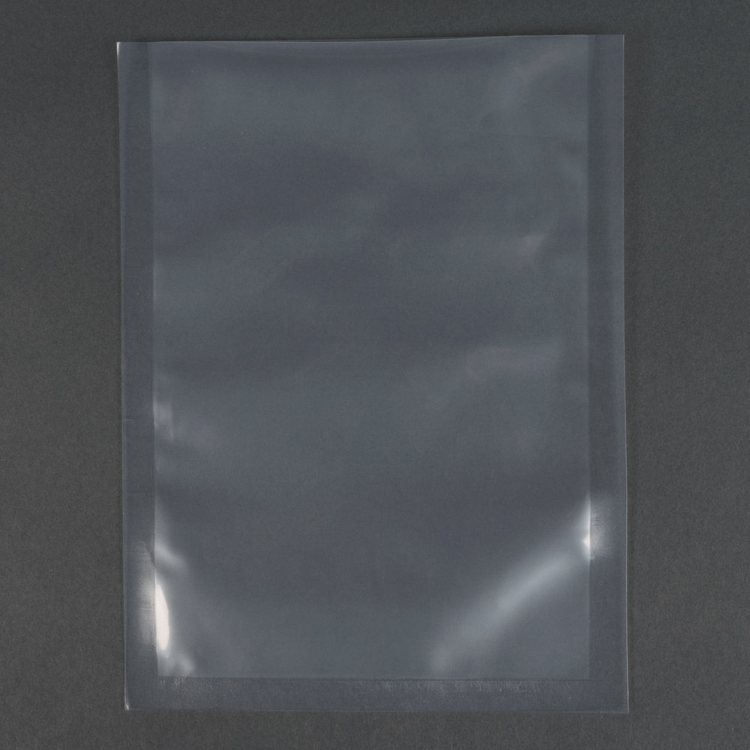
Details
These 6" x 8" industrial strength, 4 mil chamber vacuum packaging bags help keep food fresh up to five times longer than traditional storage methods! The chamber pouches seal securely with any chamber vacuum packaging machines to ensure long lasting freshness. Made of 80% polyethylene and 20% nylon, these pouches can be frozen, refrigerated and even microwaved with resistance to puncture and abrasion in all forms! The bags are also great for sous vide cooking for added versatility. The bags can be boiled for up to 20 minutes. BPA Free.
The 6" side of this bag is the open end, for sealing.
Certifications:

End of HACCP Plan

This page was intentionally left blank

