December FFY2021 PEARS Updates

Please keep in mind the following:

- Always Choose an Option for the COVID-19 Impact Field
For any module that includes the COVID-19 Impact field, going forward, please make sure to always have an option selected. Specifically, if your intervention has not been impacted by COVID-19, instead of choosing nothing or the “--------” option, please choose the “No Impact due to COVID-19” option instead.

We’re finding that analysis and reporting to EARS is affected if nothing is chosen.

- 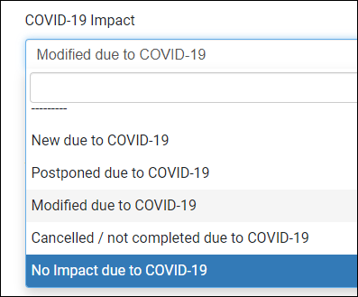

- Please ensure ALL entries in 2022 PEARS modules are Marked as Complete

Data marked incomplete will not be pulled for end-of-quarter reporting.

- The Intervention Name “Health Promotions” is no longer going to be used in WA SNAP-Ed. This change is to help clearly connect indirect activities to the direct education and PSE activities taking place within each agency. This change should only affect your reporting of Indirect Activities.

As you’re entering indirect activities, please choose the intervention name that correlates with the work being done.
(I.e. for recipes or handouts distributed at a food bank, you’d choose “Access to Healthy Foods” as your intervention name)

For your social media entries, please choose the intervention name that best represents the majority of the posts you’re creating or sharing.
(I.e. in WSU Whatcom County, we primarily post physical activity ideas and food access and recipe information on Facebook but we’re aiming toward boosting our local food access promotion and focusing the majority of our posts sharing this type of info – so in this case, “Access to Healthy Foods” would be the intervention name best suited for WSU Whatcom’s Facebook page entry in Indirect Activities)

