Custom Melbourne eCommerce Development Services for Businesses

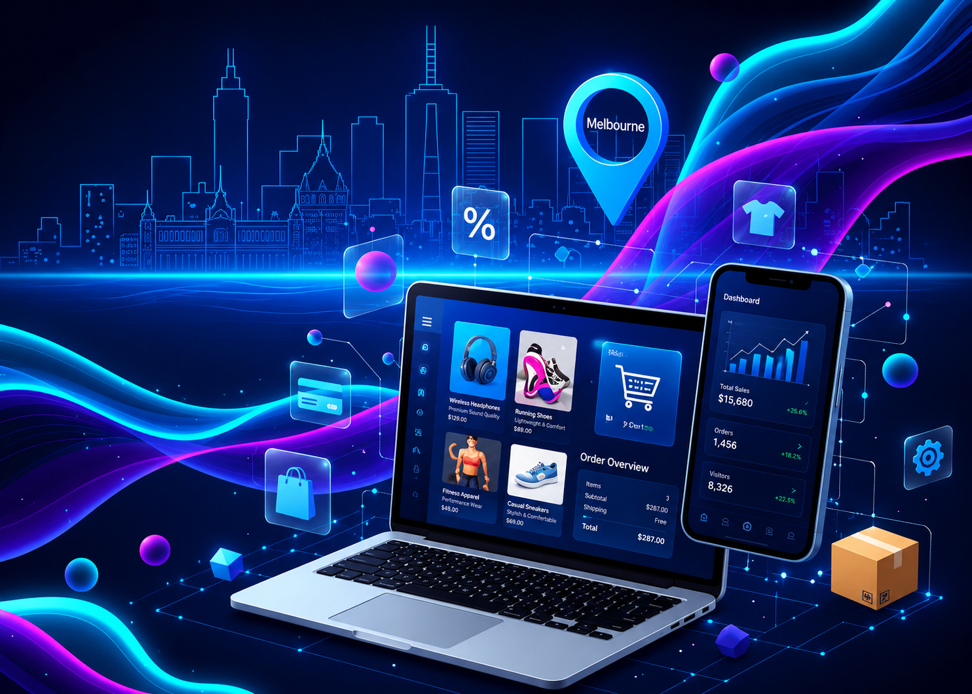

However, running an efficient online shop is not only about having an appealing website. The loading speed, intuitive navigation, secure payments, and convenient checkout process are all very important in order not to lose potential buyers who simply go to another website without buying anything. Professional e-commerce development agencies from Melbourne provide you with an opportunity to create efficient and user-friendly stores of different kinds for any kind of business.

There are several ways of creating your online store depending on the type of your business and whether it is a brand new store or a migration from one website to another. Every business has its own goals, and therefore, the online store has to be created according to your needs.

Why Choose Melbourne eCommerce Development Services?

An efficient eCommerce site ensures an improved experience for customers while making life simpler for your staff. Each feature from product management to order management must function properly without adding complications.

By using Melbourne eCommerce development solutions, you can get:

- Responsive design for computer, tablet and mobiles
- Faster loading time for a good experience
- Integration of secure payment gateway
- Product management
- Smooth checkout
- Customer account management
- Website that is SEO friendly
- Scalable solutions for business expansion in future

All these factors will contribute towards enhanced customer satisfaction and increased conversion rates.

Custom eCommerce Development for Your Business

Each business is unique and sells differently. For some, a basic eCommerce store is enough, but there are cases where advanced features are required – subscription support, multi-vendor store, wholesale, or custom options for products.

Custom development lets you develop specific features according to your needs rather than change your business model to accommodate a ready-made solution.

Some examples are:

- Custom online store development
- Multivendor platforms
- B2B websites
- Subscription stores
- Marketplace integration
- Inventory and warehouse management
- CRM & ERP integration
- Shipping & logistics management

eCommerce Platforms We Support

Choosing the right platform is crucial for achieving success online. We assist companies in selecting a platform depending on their products, traffic, budget and expansion plans in the future.

Here is what we can offer:

Shopify Development

Shopify Development is used by businesses that want an easy-to-use platform offering hosting services and simple store management options.

It suits the following businesses:

- Startups
- Retailers
- Fashion products
- Beauty products
- Lifestyle products

Being flexible, businesses can easily introduce new functionalities through its wide range of apps.

Magento Development

Magento is more flexible for businesses requiring advanced functionalities.

Magento is suited for the following business models:

- Large online retailers
- B2B businesses
- Multi-store retailers
- Enterprise-level businesses
- Businesses having large catalogue of products

It is ideal for businesses planning to keep growing due to its scalability features.

WooCommerce Development

WooCommerce is the perfect platform for businesses having already a website based on WordPress.

Advantages of using WooCommerce include:

- Effective product management
- Flexible customisation
- Wide range of plugins
- SEO-friendly architecture
Cost-effective development process

WooCommerce is mostly chosen by many small and medium size businesses.

BigCommerce Development

There are many in-built features in BigCommerce which do not require the installation of any more plugins.

Some of its features are:

- Multichannel selling
- Product management
- High performance
- Flexible APIs
- Enterprise-level

It is ideal for expanding e-commerce businesses.

Shopware Development

Shopware offers flexibility to businesses which want to provide their customers with personalised shopping experiences and at the same time, maintain high performance on their websites.

Build an Online Store That Supports Business Growth

An expertly designed eCommerce site can help you expand your customer base, sell online, and streamline your business processes. Be it a new or upgraded online store, our Melbourne eCommerce Development Services give you everything you need for building your online business that will continue thriving as your business grows.

Conclusion

Our Melbourne eCommerce Development Services offer the solution to create an online store that provides the seamless customer experience but is built according to the business needs at the same time. Whether it is your first attempt to enter the online market or you need to develop an improved version of the existing website, we provide you with the services needed for the further development of your company.

Every business has its unique requirements for online representation. The fashion retailer needs other things in his web store compared to the wholesale supplier. A Melbourne-based business will have another set of needs in comparison with the national one. That's why we always offer our customers to get a tailor-made eCommerce solution rather than a standard template.

